Mlrows: vanilla, HIIVE fork better,

1. Opt: k-coloring, 4-peaks, flip flop. Highlight one of three algorithms for each problem: # of iteration, wall clock.
Plots: fitness score per iteration (fitness in x axis, iteration on y). varying problem size is simple – rudementary algorithm. Higher problem size needs other algorithm
wall clock
mimic: function eval: could be single func eval or many func eval. function evaluation per iteration
2. NN: take NN and inject randomized opt with backprop and compare.
Loss curve
convergence
Generalization – learning curve
performance metric/conf metrix
why interesting? Focus on structure of opt poblem. Hypothesize why it might be interesting
k-coloring natural fit for some of these algorithms. Genetic and MIMIC the same class

TSP:
problem size = 32:
GA model: Based on the plots below, population size of 200 and mutate_rate of 0.3 result in higher fitness score so these parameters are used for the model.

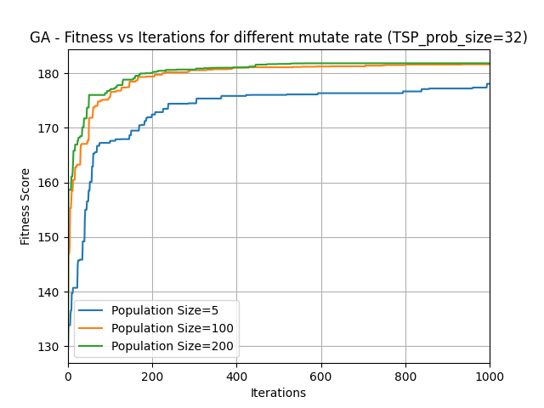

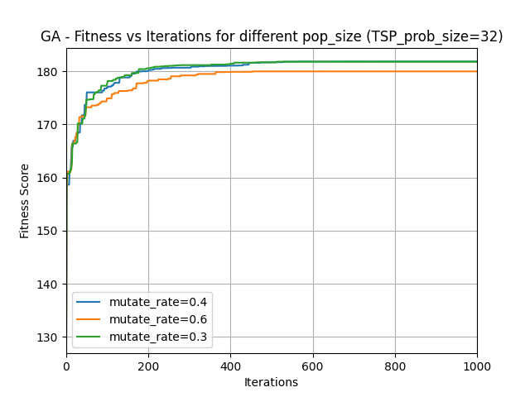

RHC:

Based on the plots below restart value of 0 results in fitness score convergence while the algorithm is not able to converge for values of 5 and 20, so restart of 0 is used for the model.
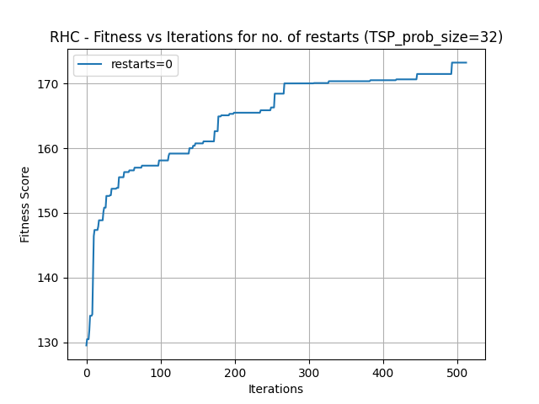

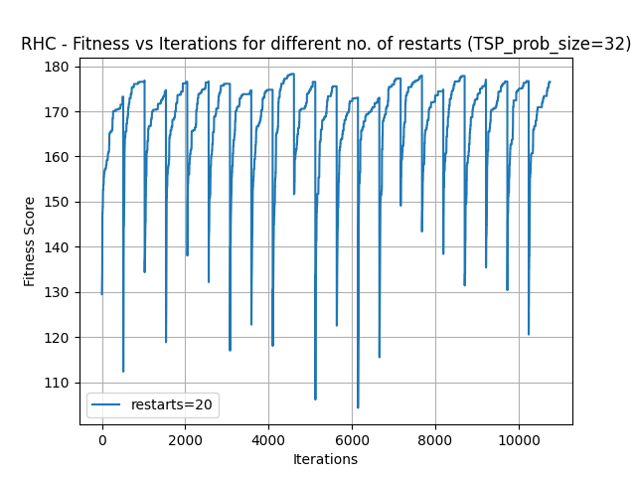

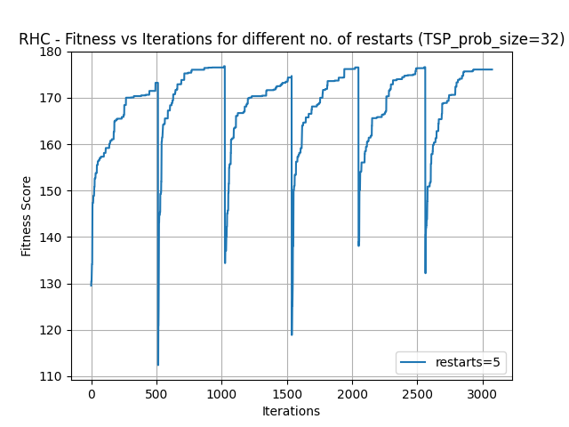

SA:
Temperature of 0.01 shows better convergence and smoother trend so it was used for the algorithm. Max attempt of 2000 and init_temp=1.0, exp_const=0.005, min_temp=0.001 were used.

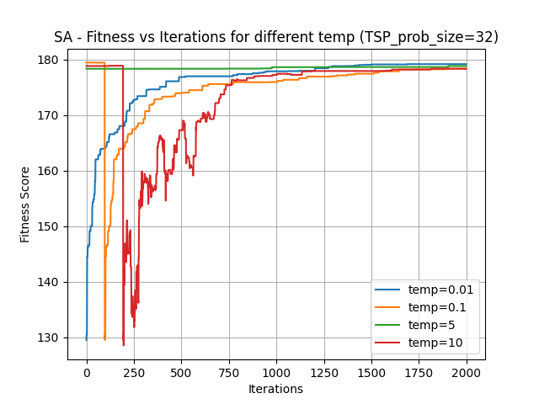
MIMIC:
Based on the plots below, keep% of .75 and population size of 400 result in higher fitness score. Max attempt was limited to 500.

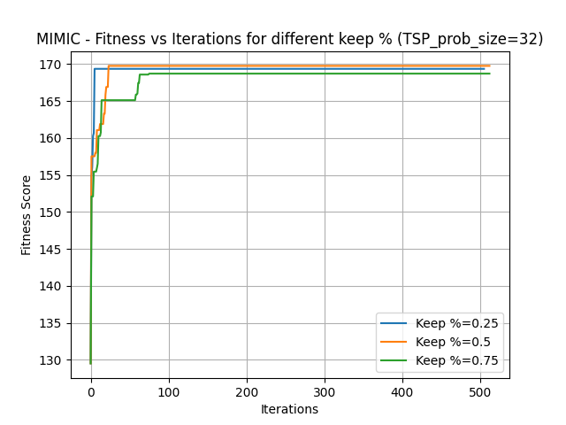

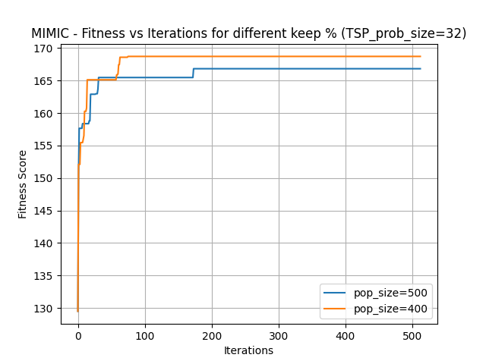

Model Comparison:
Among the three algorithms, GA results in higher fitness score with only slightly higher run time compared to SA. GA is the recommended algorithm. This was expected as TSP is a more complex problem and more complicated algorithms such as GA are expected to perform better.

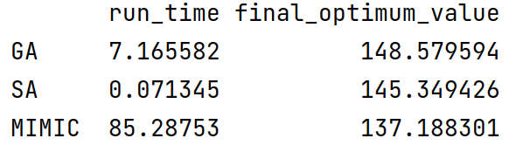

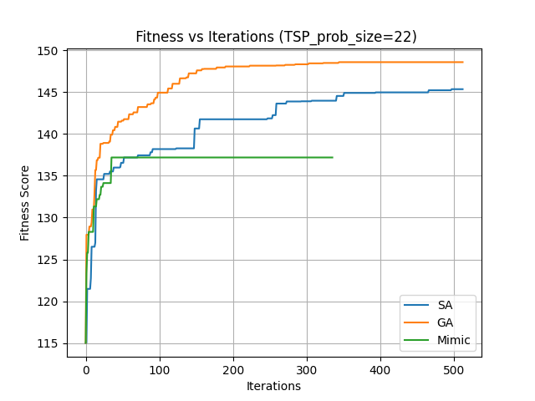

Function evaluation curve shows higher function evaluation for mimic, which is higher than GA and SA has the lowest. This was expected as mimic usually involves a lot more computation and SA has minimal computations.

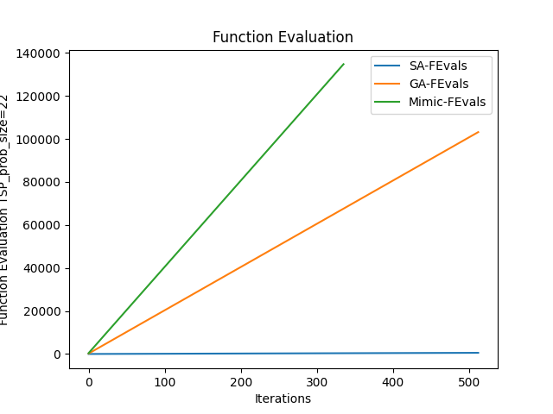

At higher problem sizes, GA continues to outperform the other two optimizations. However, the run time keeps going up. SA performs slightly worse than GA but with shorter run time. Depending on the computing power, one may make a trade off and choose to use SA with slightly lower optima and save on the run time.
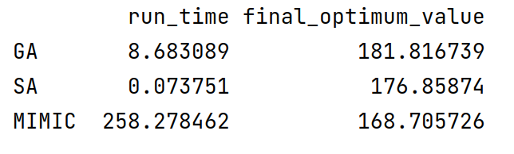
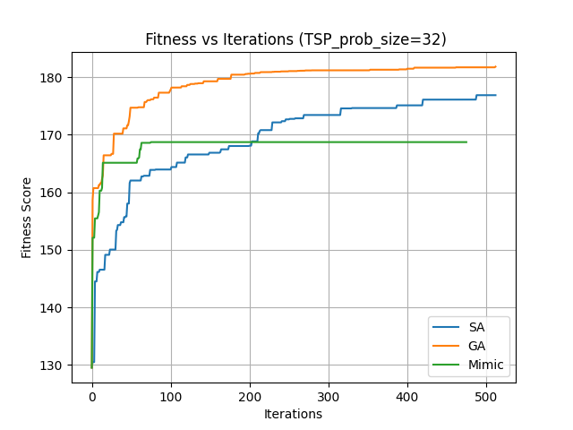

Four Peaks_ problem size = 20:
GA: population size of 200 and mutate rate of 0.3 result in higher fitness score so are used here. Max attempt was limited to 500.

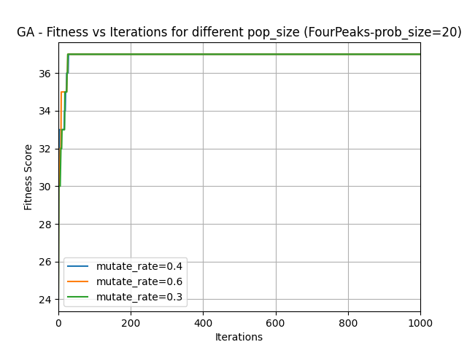

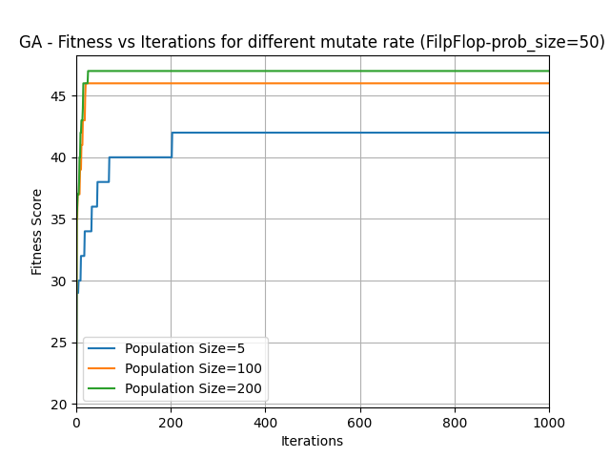

SA
Temperature of 0.01 shows better convergence and smoother trend so it was used for the algorithm. Max attempt of 2000 and init_temp=1.0, exp_const=0.005, min_temp=0.001 were used.

MIMIC:

keep % of 0.25 results in higher fitness function. Population size does not see to impact the fitness score so population of 200 is used.

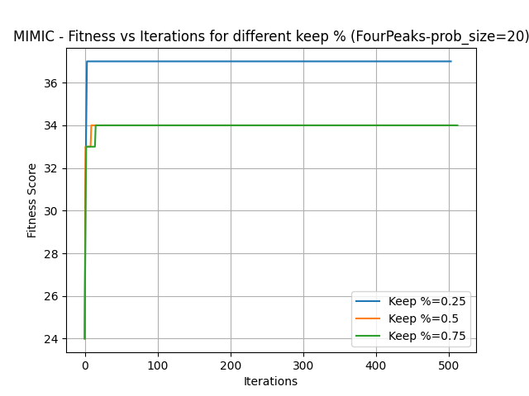

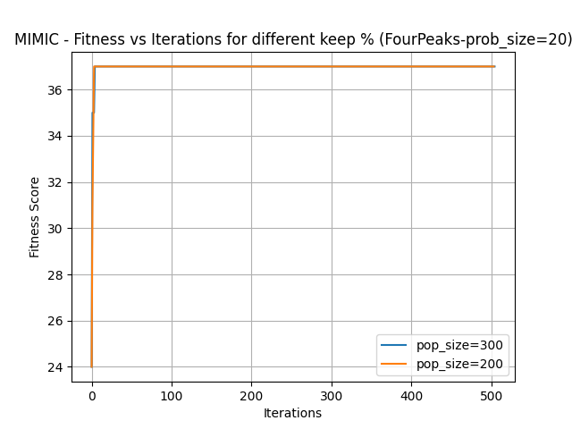

Algorithm Comparison – problem size = 20:

All three algorithms converge at the same value. Although SA needs more iterations to converge compared to GA and mimic (figure below), the time it takes to converge is shorter. In addition, GA and mimic involve a lot more computation. This is also observed in the function evaluation curve below where mimic and GA have had significantly more function evaluations per iteration. FourPeaks is a simple problem so rudimentary optimizations as SA perform well. Complicated calculations in this case is unnecessary and only adds more time complexity. SA is therefore the recommended algorithm.
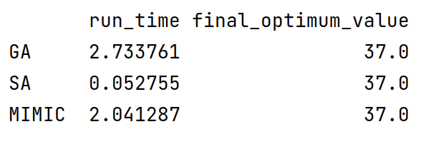
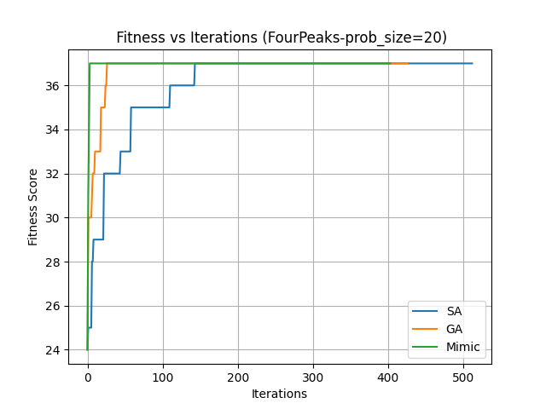

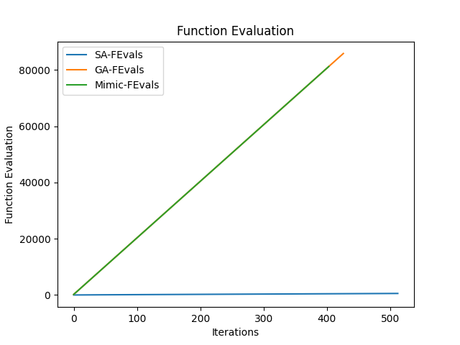

However, as the size of the problem increases, SA starts performing poorly and GA and mimic perform better. That is because size increase adds to the problem complexity and SA, which is a simple algorithm, is no longer able to find a solution. GA performs well for the bigger size problems with only slightly higher run time:

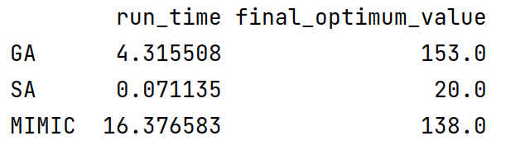

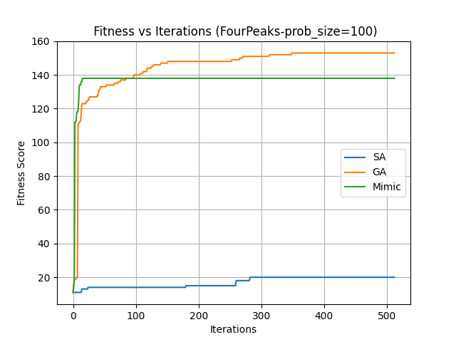

Flipflop problem size = 100
GA: population size of 200 and mutate rate of 0.4 result in higher fitness score so are used here. Max attempt was limited to 500.

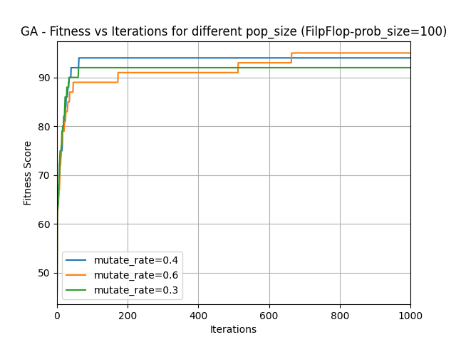

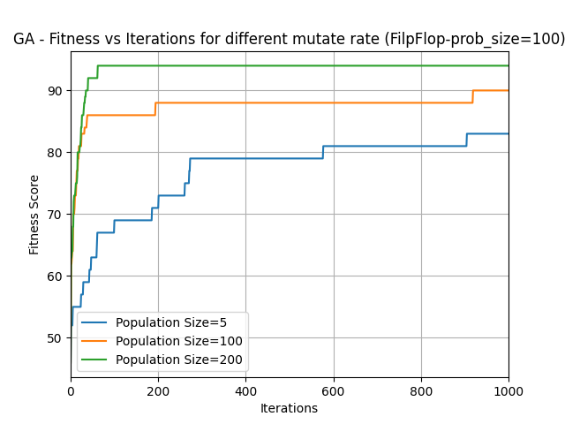

MIMIC:

Population size of 500 and keep % of 0.25 are used as they result in higher fitness score.

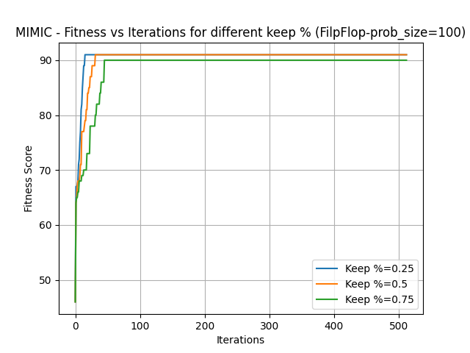

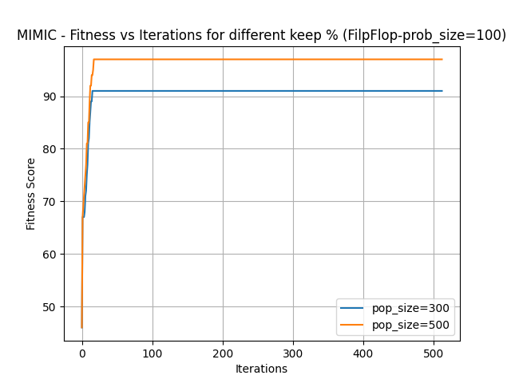

Comparison for problem size =50:
Mimic algorithm performs better so is recommended for this case. That is because FlipFlop is a more complex problem and simpler algorithms such as SA do not perform well like mimic and GA do. SA algorithm needs a lot more iterations to converge. However, each iteration of mimic and GA takes a lot longer run time. Since mimic and GA converge by fewer iteration, by setting a limit to the number of iterations required, the run time is reduced. The improved performance for this case justifies the slight higher run time of Mimic.
Sample size = 50:
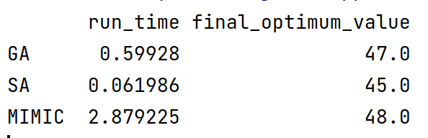

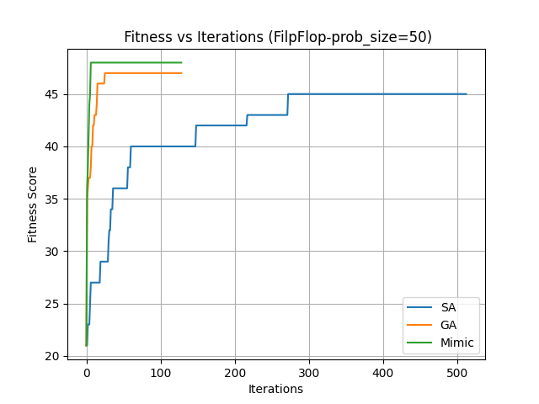

SA has had more function evaluations as the plot below shows. However, since it involves simpler functions than GA and mimic, the run time is still shorter.

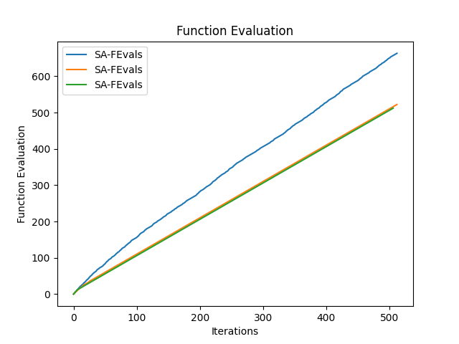

As the sample size increases, mimic takes longer to run and GA starts to outperform mimic. So, for bigger size problems, GA to be considered as a solution.

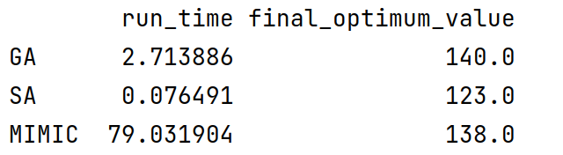
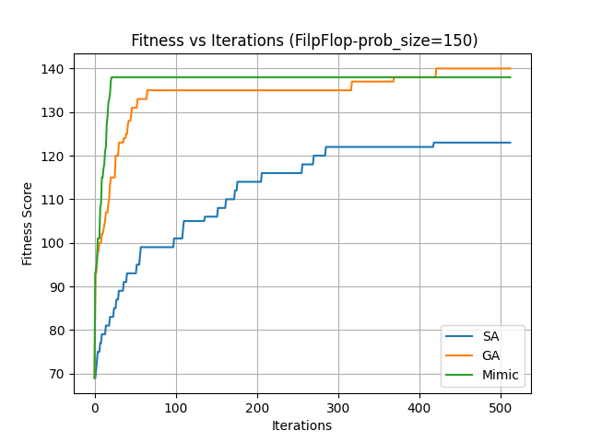

Neural Network
The second dataset (Wine quality data) from HW1 was used here. The hidden layer, number of nodes, and activation function are the same as HW1 (1 hidden layer with 4 nodes, relu activation, early stopping).
Tuned parameters:
- SA: temperature = 0.01 ; = ; learning_rate_init = 0.5 ; max_iters = 3500;

- RHC: restart = 0 ; max_iters = 3500; learning_rate = 0.1; clip_max=1, max_attempts=5000
- GA: pop_size = 400 ; mutation_prob = 0.25 ; learning_rate = 0.1 ; max_iters = 1000

As trend of loss curves for the three RO algorithms follows the same trend that we saw for back propagation case in HW1. All curves converge at around 0.55 loss. SA is struggling with learning at the beginning of the iterations, but it starts converging after 500 iterations. RHC shows a very smooth learning with the shortest training time.

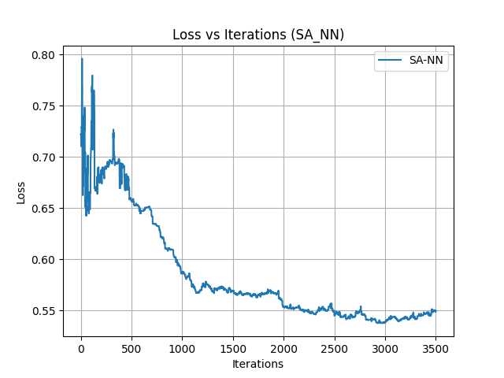

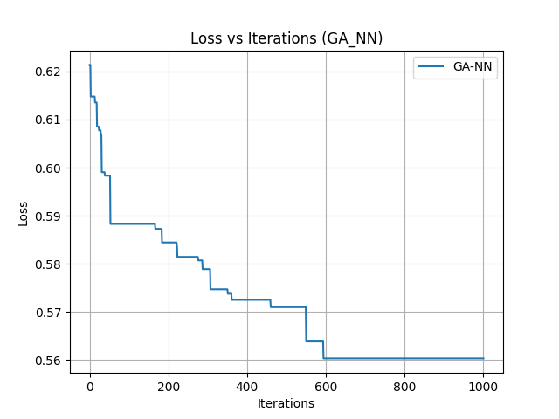
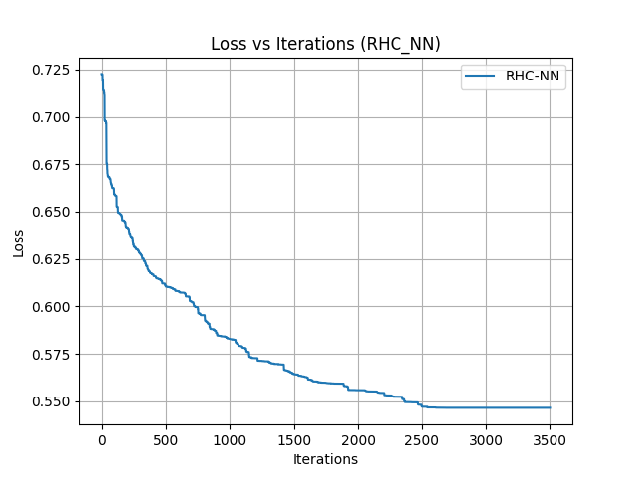
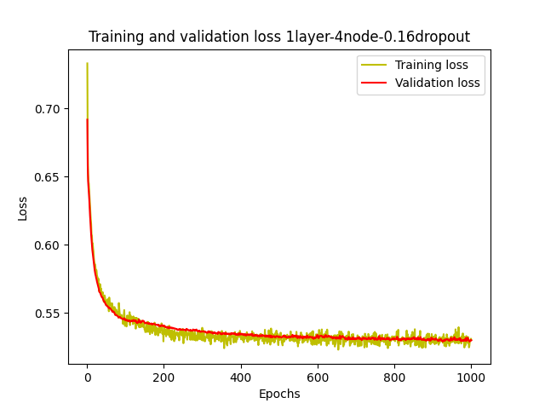

Comparing RO with back propagation, the simpler RO models such as SA and RHC require a lot more iteration to converge compared to back propagation. However, as the table below shows the overall run time for the iterations is lower for SA and RHC compared to back propagation. GA is a more complicated algorithm and hence is able to converge with fewer iterations. However, the total training time for those iterations is significantly higher, which is due to heavy computation involved in this algorithm.

[['SA_NN', 30], ['RHC_NN', 25], ['GA_NN', 1597.2490377426147], [back prop, 81]

