ladak@ladak-ThinkStation-P330:~$ ifconfig
eno1: flags=4163<UP,BROADCAST,RUNNING,MULTICAST> mtu 1500
inet 10.11.45.202 netmask 255.255.255.0 broadcast 10.11.45.255
inet6 fe80::555d:5a37:229e:2bac prefixlen 64 scopeid 0x20<link>
ether 00:d8:61:93:97:6d txqueuelen 1000 (Ethernet)
RX packets 37718 bytes 40481414 (40.4 MB)
RX errors 0 dropped 1 overruns 0 frame 0
TX packets 19046 bytes 1504344 (1.5 MB)
TX errors 0 dropped 0 overruns 0 carrier 0 collisions 0
device interrupt 17 memory 0xb5300000-b5320000

lo: flags=73<UP,LOOPBACK,RUNNING> mtu 65536
inet 127.0.0.1 netmask 255.0.0.0
inet6 ::1 prefixlen 128 scopeid 0x10<host>
loop txqueuelen 1000 (Local Loopback)
RX packets 1607 bytes 129157 (129.1 KB)
RX errors 0 dropped 0 overruns 0 frame 0
TX packets 1607 bytes 129157 (129.1 KB)
TX errors 0 dropped 0 overruns 0 carrier 0 collisions 0

ladak@ladak-ThinkStation-P330:~$ hostname
ladak-ThinkStation-P330

ladak@ladak-ThinkStation-P330:~$ hostname -I
10.11.45.202

ladak@ladak-ThinkStation-P330:~$ ping 192.168.0.10
PING 192.168.0.10 (192.168.0.10) 56(84) bytes of data.
64 bytes from 192.168.0.10: icmp_seq=1 ttl=64 time=0.197 ms

---------------------------------------------------------------------------------------------------------------------

neobotix@mp-500-exactec:~$ hostname
mp-500-exactec

neobotix@mp-500-exactec:~$ hostname -I
192.168.0.10 192.168.0.101

neobotix@mp-500-exactec:~$ ping 10.11.45.202
PING 10.11.45.202 (10.11.45.202) 56(84) bytes of data.
From 192.168.0.1 icmp_seq=9 Destination Net Unreachable

// set up sharing of Lenovo IPv4 and use the IPv4 address

--------------------------------------------------------------------------------------------------------------------

neobotix@mp-500-exactec:~$ ping 192.168.0.100
PING 192.168.0.100 (192.168.0.100) 56(84) bytes of data.
64 bytes from 192.168.0.100: icmp_seq=1 ttl=64 time=0.407 ms

--------------------------------------------------------------------------------------------------------------------
NEO – MASTER:

ROS_IP=192.168.0.10
ROS_MASTER_URI=http://192.168.0.10:11311 // master’s local

LENOVO:

ROS_IP=192.168.0.100
ROS_MASTER_URI=http://192.168.0.10:11311

- setting added to .bashrc

ladak@ladak-ThinkStation-P330:~$ printenv |grep 'ROS'
ROS_VERSION=1
ROS_PYTHON_VERSION=3
ROS_PACKAGE_PATH=/home/ladak/catkin_ws/src/ros_astra_camera:/home/ladak/catkin_ws/src/pcl_object_detection:/home/ladak/catkin_ws/src/pointing_gesture:/home/ladak/catkin_ws/src/task_control:/home/ladak/catkin_ws/src/urdf_rviz:/opt/ros/noetic/share
ROSLISP_PACKAGE_DIRECTORIES=/home/ladak/catkin_ws/devel/share/common-lisp
ROS_IP=192.168.0.100
ROS_ETC_DIR=/opt/ros/noetic/etc/ros
ROS_MASTER_URI=http://192.168.0.10:11311
ROS_ROOT=/opt/ros/noetic/share/ros
ROS_DISTRO=noetic

------------------------------------------------------------------------------------------------------------------

Getting Started with Neobotics MP-500 and the UR5 Robot

- Power on the robot arm amplifier on top of the mobile robot
- Power on the mobile robot by turning the key clockwise
- Power on the universal robot arm by pressing the power button on the teach pendant (touch screen)
- Make sure all the emergency stops are reset
- Unplug the power cable to the back of the mobile robot
- After the teach pendant is turned on, initialize the robot arm
- Click go to initialization screen
- Click the ON button
- Click the START button (the screen should say 'Brake Release' then 'Normal')
- Click the OK button in the bottom right part of the screen
- Make sure the USB video game controller is plugged into the back (next to the charger plug) of the MP-500 mobile robot
- Make sure the ethernet cable is plugged into the side of the MP-500 robot
- Turn the key on the side of the robot and test drive the robot with the controller, make sure to hold RT button
- Turn the wifi on the linux computer off – not needed
- Plug the ethernet cable into the small DELL computer
- MAKE SURE THE CABLE IS LONG ENOUGH THAT THE ROBOT DOESNT PULL THE COMPUTER OFF THE TABLE
- Open TERMINATOR command line app and type 'rosnode list' to confirm you are connected to the mobile robot (MP-500)
- 10 or so lines of outputs (i.e. /joint state publisher ...) should be listed

- network setting :

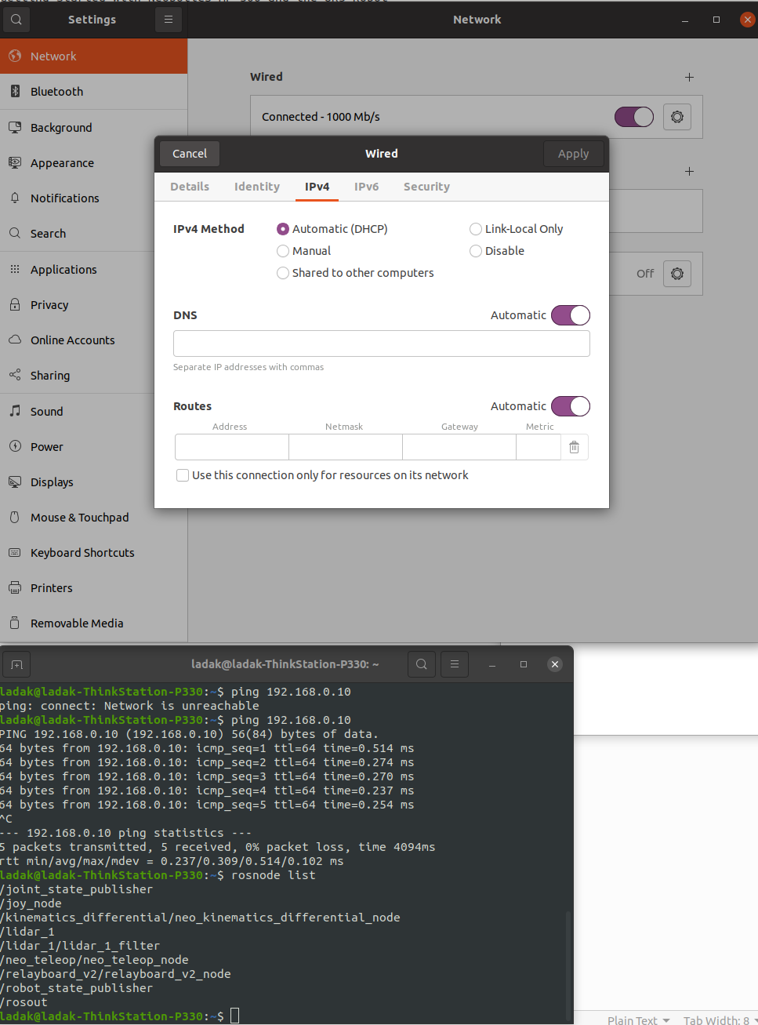

- On the DELL computer open VNC Viewer and connect to ROS on the robot
- On the VNC VIEWER open a new terminal tab and type 'nav_amcl'

- On the DELL computer open a terminal tab and type 'go_nav' rviz will now open for navigating autonomously

alias go_nav='roslaunch neo_mp_500 rviz_navigation.launch'
roslaunch neo_mp_500 rviz_navigation.launch

- Drive the robot around a bit so it can locate itself on the map – OK.
- Use the '2D Pose Estimate' set the robots approximate position
- Set a 'Nav goal' in RVIZ and then have the robot complete the navigation task

- To run the robot arm follow the below steps:
- Power on the robot arm
- Run the below command on the DELL computer
- roslaunch ur_robot_driver ur5_bringup.launch robot_ip:=192.168.0.104 kinematics_config:=$(rospack find ur_calibration)/etc/ur5_calibration.yaml
- Run the ROS.urp file on the robot teach pendant
- Run the below command on the DELL computer but wait for each to finish
- roslaunch ur5_moveit_config ur5_moveit_planning_execution.launch limited:=true
- Run this command on the DELL computer to move the arm
- rosrun robot_arm_sequence robot_arm_sequence.py

Email or text Mitchell on whatsapp if you have any issues:
- mrborch@gmail.com
- 1616-502-5411

-------------------------------------------------------------------------------------------------------------------

go_nav not found:

ladak@ladak-ThinkStation-P330:~/Desktop/dell$ cat .bash_history | grep 'install'

sudo apt install curl # if you haven't already installed curl
sudo apt install ros-noetic-desktop-full
sudo apt install curl
sudo apt install ros-noetic-desktop-full
sudo apt install python3-rosdep python3-rosinstall python3-rosinstall-generator python3-wstool build-essential
sudo apt-get install ros-noetic-slam-mapping sudo apt install ros-noetic-slam-gmapping
sudo apt-get install ros-noetic-slam-gmapping
sudo apt-get install ros-noetic-neo-local-planner
sudo apt install rosbash
sudo apt install ./<file>.deb
sudo apt install ros-noetic-desktop-full
sudo apt-get install ros-noetic-catkin
sudo apt-get install ros-noetic-catkin python-catkin-tools
sudo apt install python3-catkin-lint python3-pip
pip3 install osrf-pycommon
sudo pip3 install git+https://github.com/catkin/catkin_tools.git
sudo apt install ros-noetic-catkin python3-catkin-tools python3-osrf-pycommon
sudo apt install python3-wstool
sudo apt-get install ros-noetic-moveit-setup-assistant
sudo apt-get install ros-noetic-universal-robots
rosdep install --from-paths src --ignore-src -y
sudo apt-get -y install rviz
sudo apt-get install terminator
sudo apt-get install ros-melodic-navigation
sudo apt-get install ros-noetic-navigation
sudo apt-get install ros-noetic-navigation
sudo apt-get install ros-noetic-neo-local-planner
sudo apt-get install ros-noetic-slam-gmapping
sudo apt-get install ros-noetic-navigation
sudo apt-get install ros-noetic-openslam-gmapping
sudo apt-get install ros-noetic-ros-control ros-noetic-ros-controllers

- all yellow installed

- alias was missing:
alias go_nav='roslaunch neo_mp_500 rviz_navigation.launch'

