Orbbec Astra Calibration

http://www.yahboom.net/public/upload/upload-html/1637059883/Astra%20camera%20calibration.html

> lsusb

...
Bus 001 Device 005: ID 2bc5:0401 Orbbec(R) ORBBEC Depth Sensor
…

> roslaunch astra_camera astra.launch

> rostopic list

Checkboard 9x7, 35 mm:

1. RGB

> rosrun camera_calibration cameracalibrator.py image:=/camera/ir/image camera:=/camera/ir --size 8x6 --square 0.035

OK – save as /home/ladak/.ros/camera_info/rgb_Astra_Orbbec.yaml

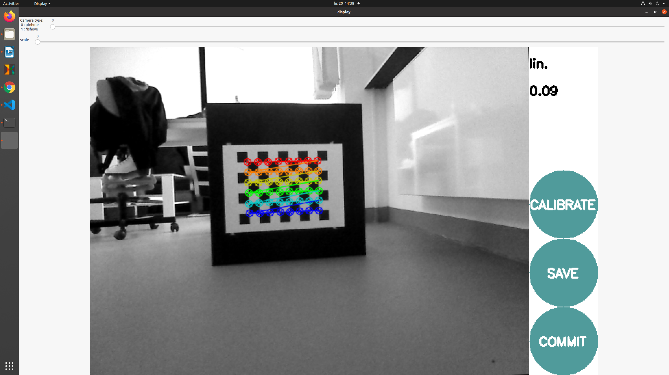

2. DEPTH
> rosrun camera_calibration cameracalibrator.py image:=/camera/rgb/image_raw camera:=/camera/rgb --size 8x6 --square 0.035

ONLY BLACK SCREEN:
