NAIL087: Informatics and Cognitive Science Lada Kudlackova
31st January 2024

Final project: Oscillations in basal ganglia

1. Summary of the results from article (Kumar et al 2011)

Kumar A., Cardanobile S., Rotter S. and Aertsen A.,
The role of inhibition in generating and controlling Parkinson's disease oscillations in the basal ganglia,
2011, Front. Syst. Neurosci.
https://doi.org/10.3389/fnsys.2011.00086

This paper focuses on the neural mechanisms underlying movement disorders in Parkinson's disease (PD).
These movement disorders are associated with slow oscillations and increased synchronization of neuronal activity in the basal ganglia.
Using a network model, the study shows that the most important parameter controlling oscillations is the strength of inhibitory inputs from the striatum to the globus pallidus externis (Gpe). It also reveals that the increase in striatal activity observed in PD is sufficient to release oscillations.
This finding may help to optimize the function of DBS protocols and leads to a unified explanation
- for the absence of oscillations in the healthy basal ganglia state,
- for oscillations in the dopamine-depleted state,
- for quenching of oscillations under deep-brain-stimulation (DBS).
Furthermore, exploration of the model behavior under a transient increase in activity of striatal neurons projecting to the indirect pathway contributes to a better understanding
- of the motor impairment observed in PD patients,
- of the reduced response inhibition in patients with DBS implants.

Large-scale spiking network model of GPe and STN

- Network of 3,000 neurons:
        - STN population: 1,000 excitatory neurons
        - GPe population: 2,000 inhibitory neurons

- Implemented as leaky-integrate-and-ﬁre (LIF) neurons.

- GPe neurons:
        - excitatory synaptic input from the STN (connection probability 5%).
        - inhibitory synaptic inputs from other GPe neurons (connection probability 2%).
- STN neurons:
        - inhibitory synaptic inputs from the GPe (connection probability 5%).
        - excitatory synaptic inputs from other STN neurons (connection probability of 2%).

- Input:
        - Background input:
            - STN: Poisson generator (Excitatory connection)
            - GPe: Poisson generator (Excitatory connection)

        - Striatum input:
            - GPe: Poisson generator (Inhibitory connection)

        - DBS input:
            - STN: Poisson type inhibition
STN Lesion
Periodic blancing of axons in STN
Periodic inhibition of STN

- Networks with slightly different ongoing activity states (corresponding to the healthy state):
        - can be obtained by using different combinations
of external (bachground) input to STN and GPe.

- Network activities with different degree of synchrony (corresponding to the PD state):
        - can be obtained by using different combinations
of external (bachground) input to STN and GPe and striatum input to GPe.
Simulation and data analysis tools
- python 1
- simulation environment NEST (using PyNN 2 as an interface)

Analysis of network activity – descriptors
- The ﬁring rate of individual neurons:
        - the average spike count over the full simulation period
(excluding the ﬁrst 500 ms of initial network transients).
- The mean network ﬁring rate:
        - the average of the ﬁring rates of all neurons in the network.
- The oscillation index (OI):
        - the relative power in frequency band 15-25 Hz
(oscillations introduce peaks in the power spectral density of the population activity).

Results: The striatum activity and oscillations in the basal ganglia network

Prediction:
The anatomy of the neural circuitry of the basal ganglia suggests that synaptic inputs play a key role in controlling the oscillatory activity in the network: if inhibitory input to an inhibitory population (striatum to GPe) exceeds a certain level, the strength of oscillatory modes should increase. Also, an increase of excitatory input to an excitatory population can induce oscillations.

Experimental results:
- oscillations were observed in the STN-GPe network immediately after an increase of the striatal activity (striatum to GPe)
- a progressive increase of the striatal activity strengthened the amplitude of oscillations in both STN and GPe neurons.
- increase on the oscillations is associated with:
        - an increase in ﬁring rate of STN neurons
        - a decrease in ﬁring rate of GPe neurons

- results confirm the prediction:
        - oscillations (and Parkinsonian symptoms) can be induced by increasing of striatal ﬁring rates.

Results: Spectrum of correlations within STN and GPe networks

Prediction (animal models of PD):
Exhibition of oscillatory cross-correlograms:
STN neuron pairs:
- a large fraction of pairs (Levy et al., 2002).
GPe neuron pairs:
- only 16.7% of pairs (Heimer et al., 2002).

Experimental results:
The oscillation index (OI) of cross-correlograms of the STN and GPe neuron pairs in non-oscillatory (OI = 0.15) and oscillatory (OI = 0.97) states was calculated:

GPe neurons:
- a wide distribution of pairwise correlations in both states (0.27 ± 0.17, 0.39 ± 0.19).
- ∼15% cross-correlograms showed OI ≤ 0.5.

STN neurons:
- a narrow distribution of pairwise correlation coefﬁcients.
- with small correlation in the non-oscillatory state (PwC STN = 0.12 ± 0.08).
- with high pairwise correlation in the oscillatory state (PwC STN = 0.51 ± 0.08).

Non-oscillatory state:
- the cross-correlograms were largely non-oscillatory in both STN and GPe populations.

Oscillatory state:
- the cross-correlograms were oscillatory in both STN and GPe populations.

Results didn’t confirm the prediction (the number of oscillatory cross-correlograms in the GPe network was larger).
Direct comparison with the animal models is difficult because they don’t provide all the necessary values (the oscillation index of the GPe activity, quantitative numbers on the strength of the cross-correlation and its oscillation index).
Result: Quenching of oscillations with DBS

Prediction:
DBS is an effective clinical approach to relieve PD symptoms in some patients.
Neuronal mechanism of DBS functioning:
- periodic high-frequency stimulation (HFS) of the STN is efﬁcient for the treatment of PD symptoms
- periodic low-frequency stimulation (LFS) may aggravate motor impairment

Experimental results:

Quenching of oscillations with periodic DBS methods:

- Periodic blanking of the excitatory inputs to STN:

  - only effective in measurably quenching the oscillations at stimulus frequencies larger than 100 Hz
  - low-frequency blanking of the STN input generated harmonics of the stimulation frequency in the STN-GPe network activity

- Periodic inhibitory synaptic input to STN neurons:

  - the efficiency of stimulation increased with stimulus frequency
  - no harmonics generated during stimulation at low frequencies

Quenching of oscillations with aperiodic DBS methods:

- Aperiodic stimulation:

  - 10 ms wide blanking pulses at random interpulse intervals, with an upper bound on the maximum interval
  - very effective:
      - more effective than periodic stimulation at the same mean pulse rate
      - less energy consuming than periodic stimulation
2. Experiments with a smaller network model

I reproduced the simplified experiment with a smaller network model. The parameters were adjusted to show similar behavior.

Smaller spiking network model of GPe and STN

- Network of 800 neurons:
        - STN population: 300 excitatory neurons
        - GPe population: 500 inhibitory neurons

- GPe neurons:
        - excitatory synaptic input from the STN.
        - inhibitory synaptic inputs from other GPe neurons.

- STN neurons:
        - inhibitory synaptic inputs from the GPe.
        - excitatory synaptic inputs from other STN neurons.

- Input:
        - Background input:
            - STN: Poisson generator (Excitatory connection)
            - GPe: Poisson generator (Excitatory connection)

        - Striatum input:
            - GPe: Poisson generator (Inhibitory connection)

        - DBS input:
            - STN: Direct current (-180 pA)

Code and figures:

- https://github.com/LadaKa/informatics-and-cognitive-science

Simulation and data analysis tools

- NEST Desktop
- Jupyter Notebook, kernel EBRAINS-23.09

Simulation time

- Total simulation time:
1000 ms

- Initial (not measured) time:
500 ms

Conditions intervals:

- Measured time interval: Condition:

500 – 650 ms No additional input
~ healthy state.

650 – 800 ms Additional inhibitory Poisson input to GPe
~ the dopamine-depleted striatum in PD.

800 – 950 ms Additional inhibitory Poisson input to GPe, DBS to STN
~ the dopamine-depleted striatum in PD with DBS

Results

Results are consistent with described oscillation mechanism:

Additional inhibitory Poisson input to GPe results in a slow increase in the activity in the STN network.
Increased excitation originating from STN leads to increasing of activity in GPe after a certain delay.
Increased GPe activity can stop STN ﬁring and resetting the system to the initial state.

1. Additional external inputs and activity changes

a) All three conditions:
No additional input (500 – 650 ms)
Additional inhibitory Poisson input to GPe (650 – 800 ms)
Additional inhibitory Poisson input to GPe, DBS to STN (800 – 950 ms)
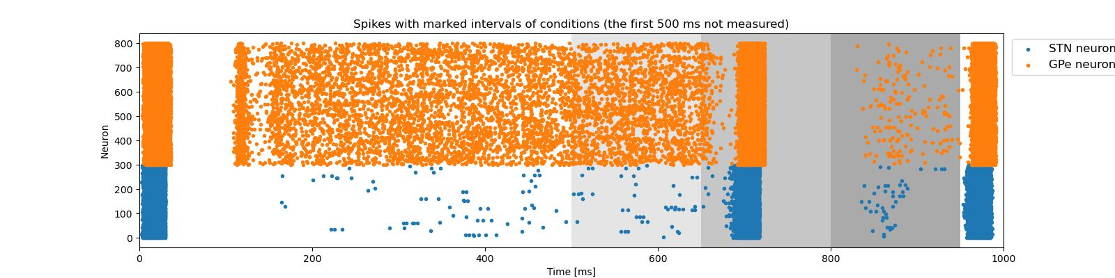

b) Without DBS:
No additional input (500 – 650 ms)
Additional inhibitory Poisson input to GPe (650 – 800 ms)
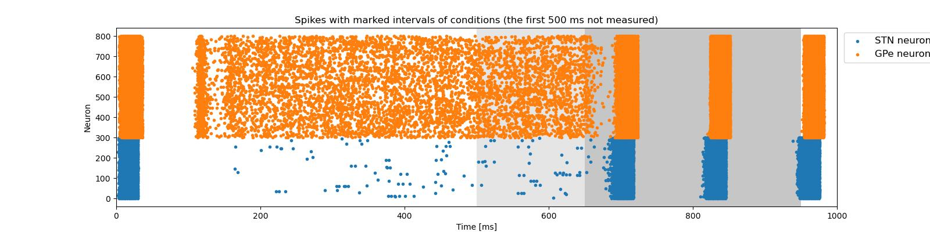

2. The distribution of single cell firing rates separately for each population in all three conditions

a) No additional input
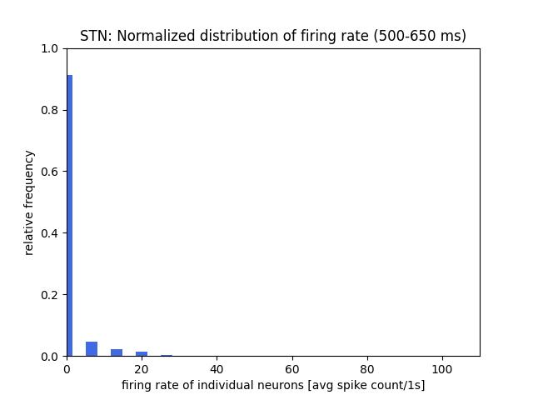
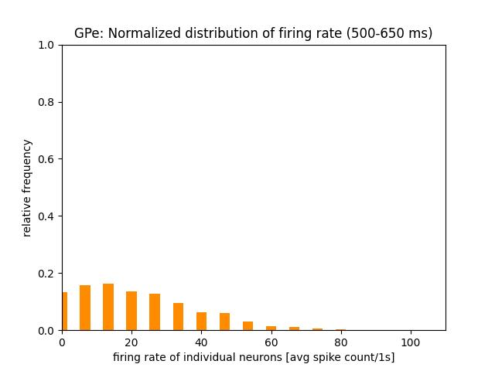

b) Additional inhibitory Poisson input to GPe
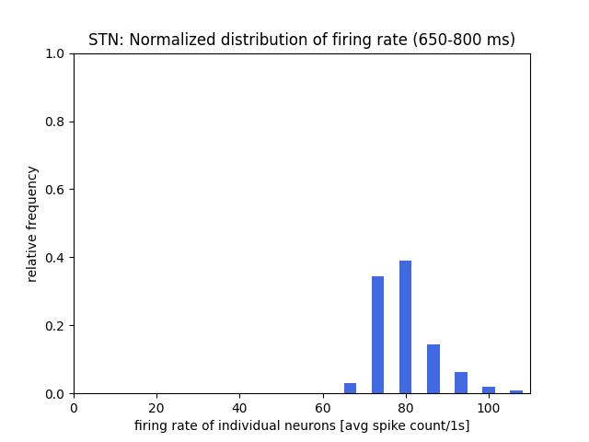
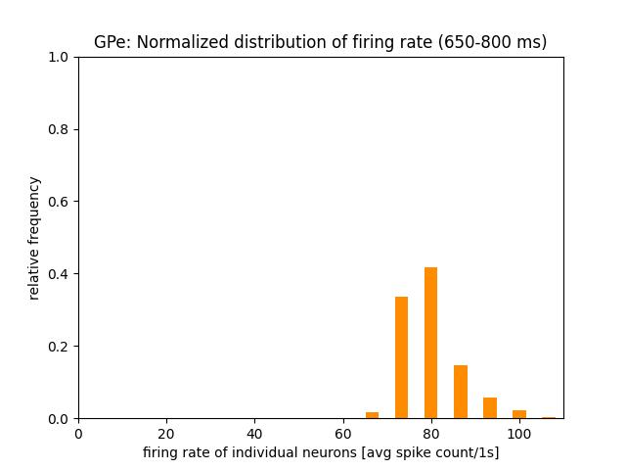

c) Additional inhibitory Poisson input to GPe, DBS to STN
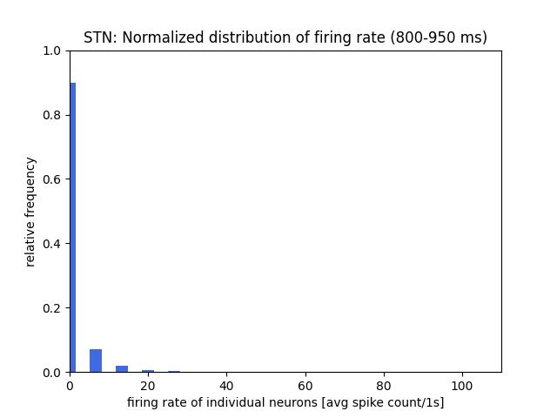
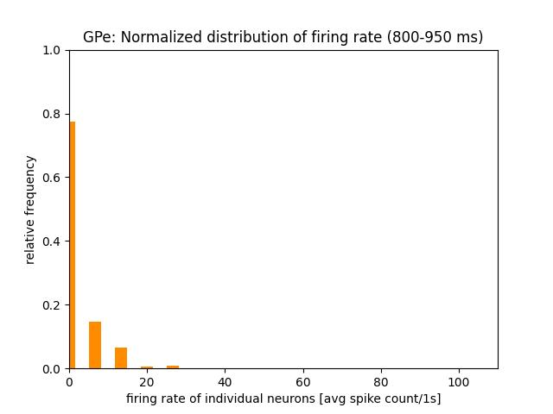

3. The power spectrum of the time-resolved population firing rate in all three conditions

a) No additional input
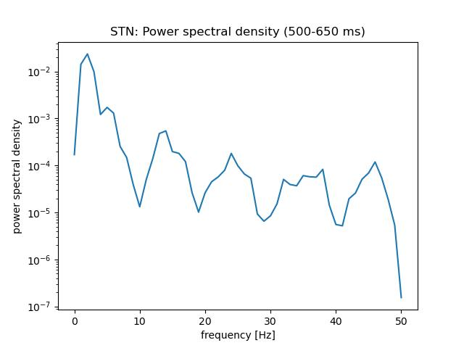
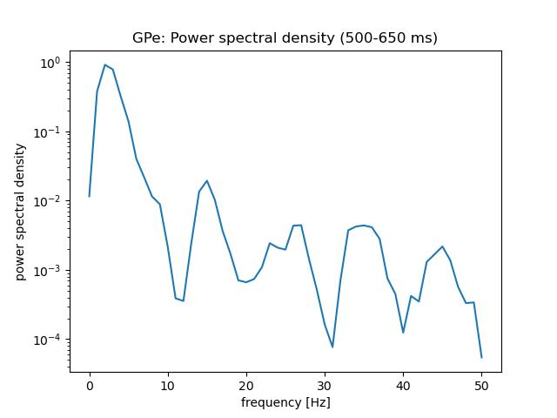

b) Additional inhibitory Poisson input to GPe

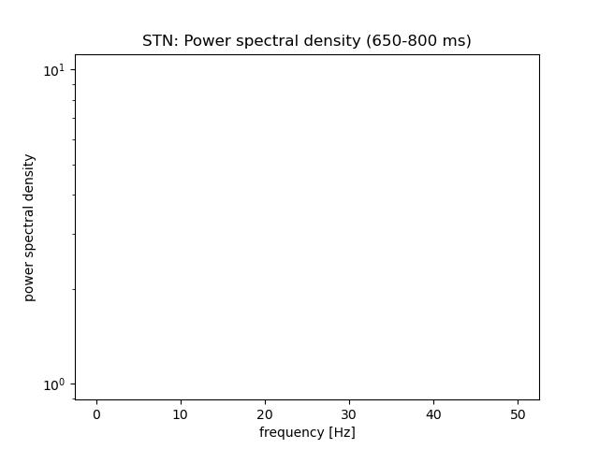
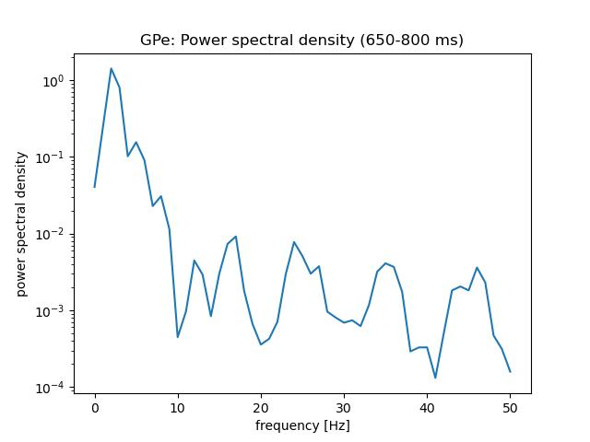

c) Additional inhibitory Poisson input to GPe, DBS to STN
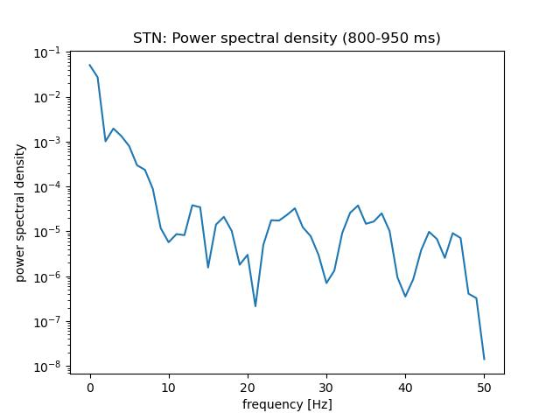
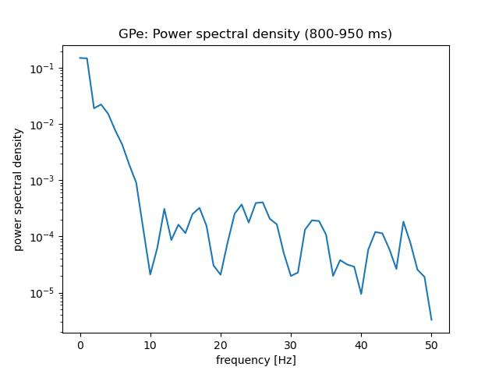

4. Different amplitudes of the DBS

Amplitude of current = 800 pA
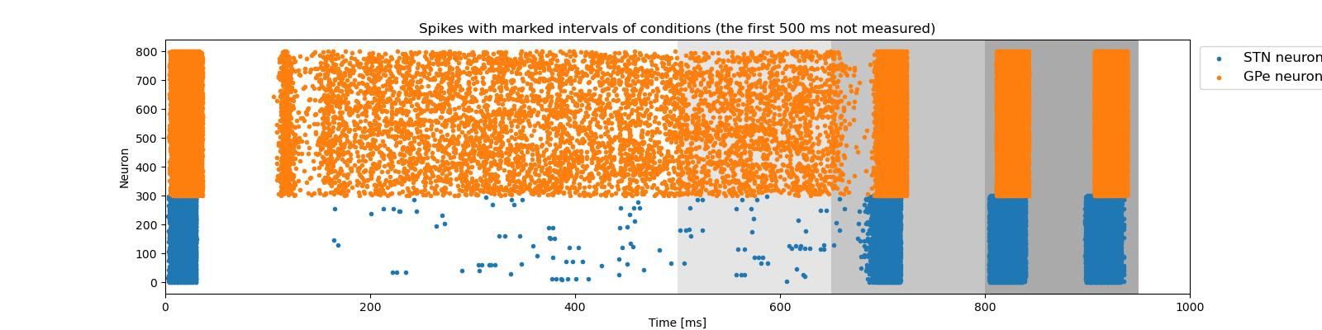
Amplitude of current = 0 pA
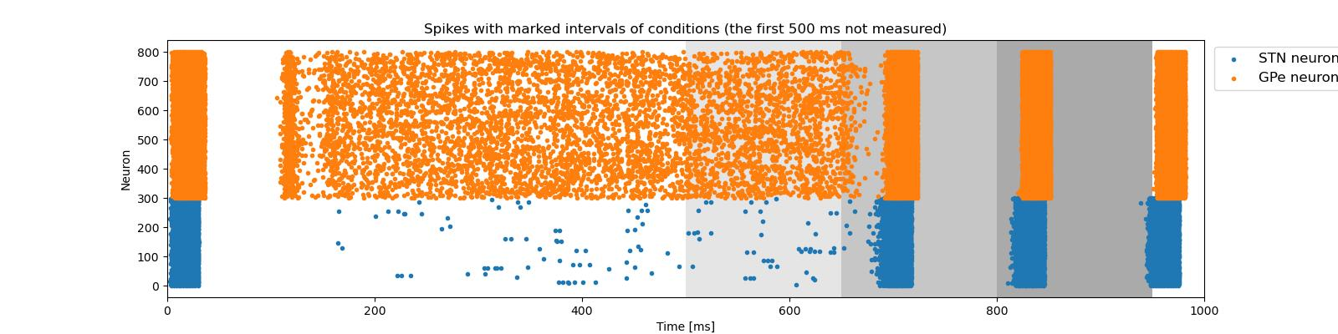
Amplitude of current = -170 pA
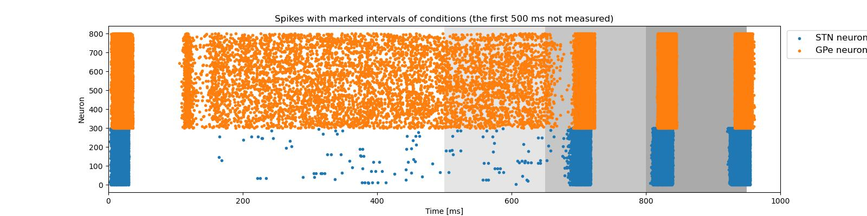
Amplitude of current = -180 pA
