**Kamery ve škole**

Prosilica GT6400C

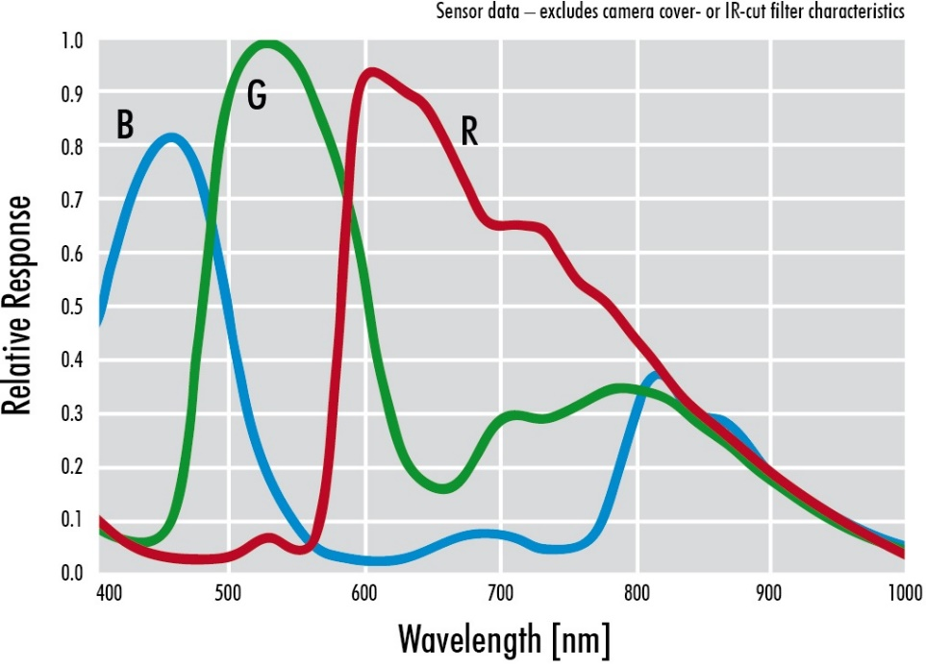

Chip: IMX342

Resolution: 31.5 Megapixel, 6480 x 4860

Len: F-mount

Basler acA4112-30-uc

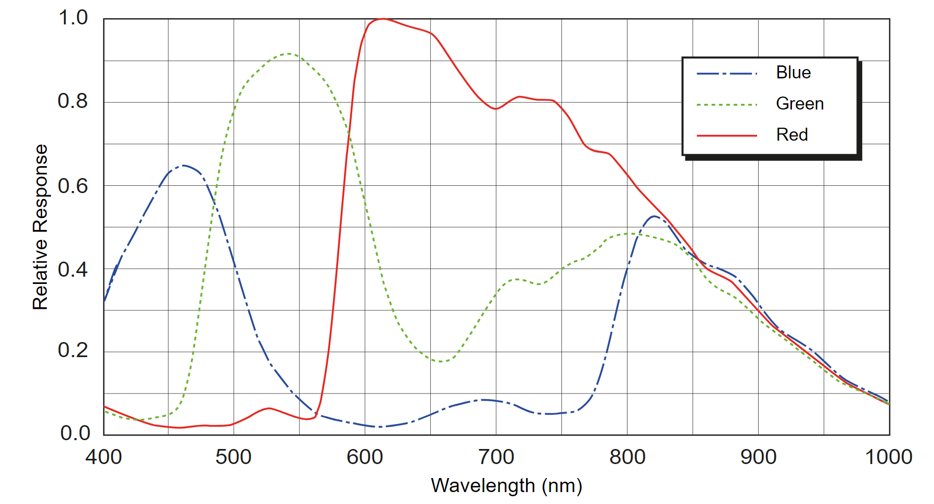

Chip: IMX253LQR

Resolution: 12,3 Megapixel, 4096x3008, 30.9 FPS

Len: C-mount

<https://docs.baslerweb.com/aca4112-30uc>

Basler acA5472-17um

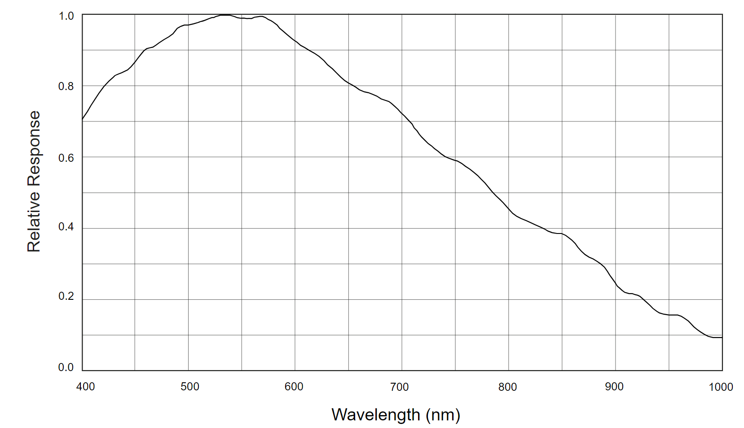

Chip: IMX183CLK-J

Resolution: 20 Megapixel, 5472x3648, 17FPS

Len: C-mount

<https://docs.baslerweb.com/aca5472-17um>

E-con systems

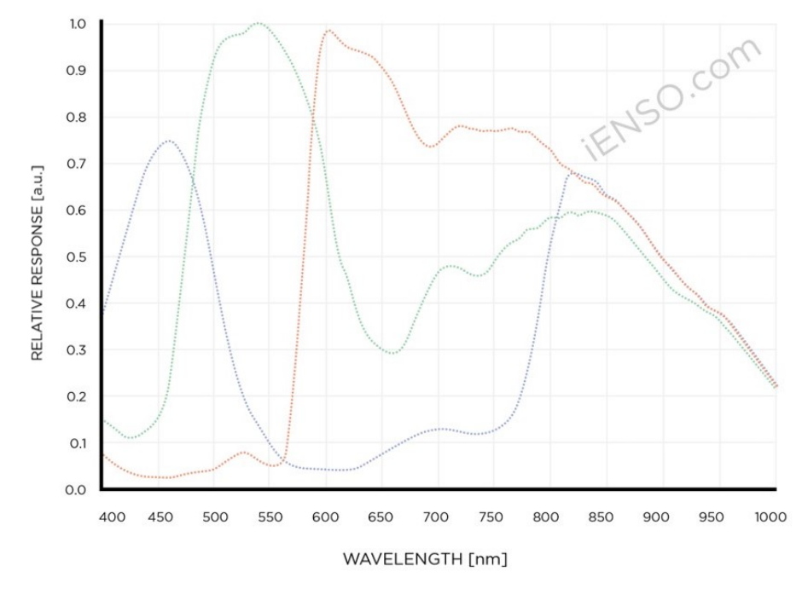

Chip: IMX415

Resolution: 8.46 MPix

Len: S-mount (M12)