Literatura
[1, 2015] https://www.cv-foundation.org/openaccess/content_iccv_2015/papers/Supancic_Depth-Based_Hand_Pose_ICCV_2015_paper.pdf
2018 version, https://hal.inria.fr/hal-01759416/file/hands_flat.pdf

[2, 2007] https://www.cse.unr.edu/~mircea/Publications/mn_cviu07.pdf - http://citeseerx.ist.psu.edu/viewdoc/summary?doi=10.1.1.76.6351

[3, 2016, references [2], references [1]] https://arxiv.org/pdf/1604.06195.pdf
[4, 2019, contains list of datasets] https://arxiv.org/pdf/1903.01013.pdf

[5, deep-prior] https://arxiv.org/pdf/1502.06807.pdf

Keywords: Hand pose estimation, Depth camera,
Přehled testovacích datasetů a použitých metod.
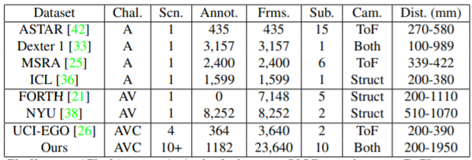
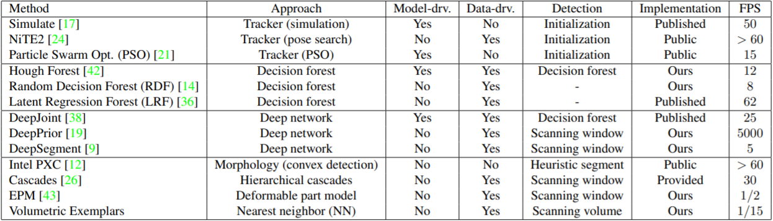

Plan
- zkusit si naprogramovat nějakou metodu a otestovat na ně jakém datasetu
- určit, v jakých podmínkách bude muj model fungovat (challenge u datasetu)
- vymyslet, jak zpracovávat vstup kamery in real time

Nápady: metoda nepracující se single framem, ale zpracováváji sekvenci (Tracker( a vylepšuje svoje odhady.
Trackery vs Single frame metody

Challenge v dosavadních metodách je v situacích, kdy ruka drží nějaký objekt. V takových případech ani člověk nedokáže přesně určit polohu.

Neznámé pojmy
Multi-cue features
Taxiomatic analysis
[2] – review on pose estimation (other older paper mainly concentrate on the gesture classification and therefore do not address pose estimation in detail)
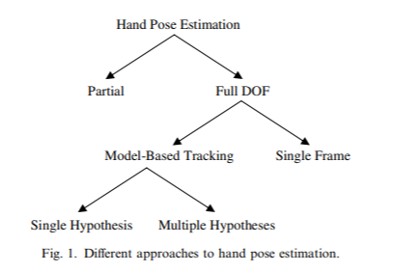
Obrázek 1 – from[2], Taxonomy of Hand Pose Estimation.
Note: Single Frame also known as appearance-based???

[2] Two types of research directions have emerged. One is based on gesture classification and aims to extract high-level abstract information corresponding to motion patterns or postures of the hand. The second is based on pose estimation systems and aims to capture the real 3D motion of the hand.

POJMY:
Human body pose estimation
Articulated Object Pose Estimation
Model-based (more online, optimization problém minimizing objective function) vs appearance-based (more offline)

[2] Difficulties in the design of hand pose estimation systems:
- High-dimensional problém
- Self-occlusions
- Processing speed
- Uncontrolled environments
- Rapid hand motion
[2] The alternative approach to a single best estimate at each frame is keeping multiple hypotheses at each frame to improve the robustness of tracking.

Hand gesture recoginition vs Hand pose estimation
[3] Hand gestures also might be beneficial to speed up hand pose estimation, for example if we know the current gesture we can reduce the search space on some of the algorithms that uses model or search based techniques.
Partial hand pose estimation is a subset of hand pose estimation and superset of hand gesture recognition. It may be enough to know the position of fingers and track the hand to determine the zooming, pointing and other dynamic gestures.
[3, s. 3] Hand pose estimation:
Appearance-based approach (similar to hand gesture which is a regression problem)
Model-based fitting (which tries to fit hand model to the observed data)
Hybrid approach (which uses both techniques in a single pipeline)
Discrimative vs Generative models

NOTES
Scan the hand N-times in target position. Let the user adjust the error threshold.
Then for testing images or realtime video sequence determine whether the gesture is the target one.
The N-times scan allows the user to define what postures are still fine and then set the error threshold low. It allows the user define priorities. In case the target gesture is a stretched palm with stretched fingers, we may not care about the distance between fingers, but we may care about one finger not properly stretched. In that case it would be in place to scan the hand multiple times each with allowed posture.

THINKING
Why didn’t I use color images? Because of the drawbacks coming with it.
Why did I choose RDF? Because it doesn’t the hand to be the most closest object to the camera. Many papers regarding hand pose estimation use this approach as it is the simplest one, yet in practise inadequate.

load_dataset(images = 1000, test_size=0.5)
Total positive: 6786.0 out of 200000 pixels
Precision: 0.8657015590200445
Recall: 0.5727969348659003
F1 score: 0.6894288754877615

load_dataset(images = 1000, test_size=0.8)
Total positive: 9968.0 out of 320000 pixels
Precision: 0.8596579476861167
Recall: 0.5143459069020867
F1 score: 0.6436103439618378

load_dataset(images = 200, test_size=0.9)
Total positive: 1398.0 out of 43200 pixels
Precision: 0.9206066012488849
Recall: 0.7381974248927039
F1 score: 0.8193727669710203

