Chapter 1: Introduction & Project Objectives

1.1 Project Overview
In TCP/IP computer networking, all host communication relies strictly on numerical IP addresses (such as 192.168.1.20). However, expecting human users to memorize 32-bit dotted-decimal IPv4 addresses or 128-bit IPv6 addresses for numerous internal departmental servers is impractical. The Domain Name System (DNS) solves this by operating as the distributed phonebook of computer networks, mapping human-friendly names (e.g., localrec) to routable IP addresses.
Paired with DNS is the Hypertext Transfer Protocol (HTTP), which governs the transmission of multimedia hypertext documents over Transmission Control Protocol (TCP) port 80. By implementing both services on an isolated campus network, educational institutions can deliver internal courseware, laboratory repositories, and administrative circulars with maximum reliability and security.

1.2 Motivation & Practical Relevance
Implementing a localized DNS and web hosting infrastructure offers significant enterprise benefits:
• Bandwidth Preservation: Eliminates unnecessary external traffic, keeping high-frequency campus intranet browsing local.
• High Availability & Offline Resiliency: Departmental portals remain fully accessible to staff and students even during complete Internet Service Provider (ISP) outages.
• Enhanced Data Security: Sensitive internal materials, grading databases, and departmental notices stay strictly within the local institutional perimeter.
• Sub-Millisecond Latencies: High-speed 100 Mbps / 1 Gbps switched LAN connections deliver instant page loads without wide-area transit delays.

1.3 Key Objectives
1. Design and deploy a star network topology using a Cisco Catalyst 2960 switch.
2. Formulate and assign an organized Class C private IPv4 addressing plan (192.168.1.0/24).
3. Configure a dedicated HTTP web server with a customized departmental portal HTML application.
4. Configure an authoritative DNS server with forward Address (A) and Canonical Name (CNAME) resource records.
5. Verify Layer-3 IP reachability via ICMP ping and validate domain resolution via nslookup.
6. Conduct packet-level discrete-event simulation to trace UDP DNS queries, TCP handshakes, and HTTP GET transactions.

1.4 Scope and Limitations
Scope: The project implements a fully functional local area network connecting two representative departments (Computer Science & Engineering and Electronics & Communication Engineering). It demonstrates the complete interaction between Application (DNS/HTTP), Transport (UDP/TCP), Network (IPv4/ICMP/ARP), and Data Link (Ethernet II) layers.
Limitations: The simulated setup operates on a single flat Layer-2 broadcast domain without inter-VLAN routing, Dynamic Host Configuration Protocol (DHCP), or external root-hints forwarding.

Chapter 2: Theoretical Background & Protocol Architecture

2.1 Domain Name System (DNS) Protocol
DNS functions at Layer 7 (Application Layer) of the OSI model and utilizes User Datagram Protocol (UDP) on well-known port 53 for standard name resolution queries. Because DNS queries and replies typically fit within a single packet (< 512 bytes), using UDP avoids the computational and latency overhead of establishing a connection-oriented TCP handshake.
Key DNS Record Types used in this project:
• A Record (Address Record): Directly binds a Fully Qualified Domain Name (FQDN) to an IPv4 address (e.g., localrec -> 192.168.1.20).
• CNAME Record (Canonical Name Record): Creates an alias pointing one domain name to another canonical domain name (e.g., www.localrec -> localrec).

2.2 Hypertext Transfer Protocol (HTTP) & TCP
HTTP operates over Transmission Control Protocol (TCP) on port 80. Unlike DNS lookups, transmitting HTML documents requires guaranteed, in-order, error-checked delivery. Therefore, HTTP relies on TCP's connection-oriented transport service, initiated via a 3-Way Handshake:
1. SYN: The client transmits a TCP segment with the SYN control flag set to synchronize sequence numbers.
2. SYN-ACK: The server responds acknowledging the client's sequence number and synchronizing its own.
3. ACK: The client acknowledges the server's sequence number. The socket state becomes ESTABLISHED, enabling HTTP GET requests.

2.3 Layer-2 Switching & Address Resolution Protocol (ARP)
The Cisco Catalyst 2960 switch forwards traffic based on hardware MAC addresses. As hosts transmit frames, the switch dynamically populates its Content Addressable Memory (CAM) table. Before an IP packet can be encapsulated into an Ethernet II frame, the sending host uses ARP to discover the destination MAC address corresponding to the destination IP.

2.4 IPv4 Addressing & Subnet Architecture
The project adheres to RFC 1918 private IPv4 standards, using the Class C network 192.168.1.0/24 with a 24-bit subnet mask (255.255.255.0). This provides 254 usable host addresses (192.168.1.1 through 192.168.1.254), reserving 192.168.1.0 as the Network ID and 192.168.1.255 as the Directed Broadcast Address.

Chapter 3: System Design & Network Topology

3.1 Network Topology
The system utilizes a physical Star Topology. The Cisco Catalyst 2960 switch acts as the central wiring hub, interconnecting two dedicated servers and two departmental client PCs via point-to-point FastEthernet links.
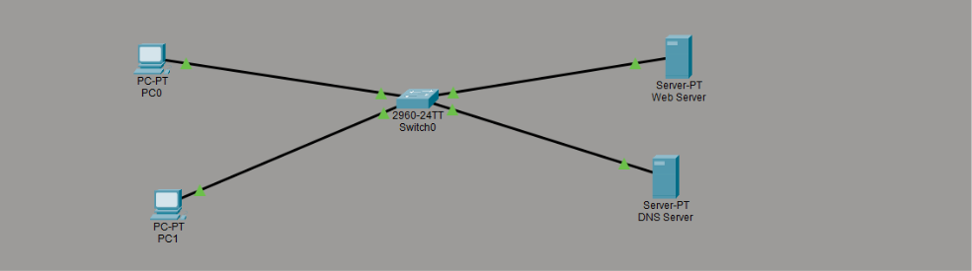

3.2 Hardware and Simulation Specifications
Component | Model / Spec | Port Count | Project Role
Central Switch | Cisco Catalyst 2960-24TT | 24x FastEthernet, 2x Gigabit | Layer 2 Star Frame Switching
DNS Server | Generic Server-PT | 1x FastEthernet | Authoritative Nameserver (UDP 53)
Web Server | Generic Server-PT | 1x FastEthernet | HTTP Intranet Web Host (TCP 80)
PC0 (CSE Dept) | Generic PC-PT | 1x FastEthernet | Client Workstation 1 (Computer Science)
PC1 (ECE Dept) | Generic PC-PT | 1x FastEthernet | Client Workstation 2 (Electronics & Comm)
Cabling | Copper Straight-Through | Cat6 100BASE-TX | Physical Layer Interconnects

3.3 Comprehensive IP Addressing Scheme
Device Name | Interface | IP Address | Subnet Mask | Default Gateway | DNS Server | Role
Switch0 | Fa0/1–4 | — (Layer 2) | — | — | — | Central Switch
DNS-Server | Fa0 | 192.168.1.10 | 255.255.255.0 | 192.168.1.1 | 192.168.1.10 | Authoritative DNS
Web-Server | Fa0 | 192.168.1.20 | 255.255.255.0 | 192.168.1.1 | 192.168.1.10 | HTTP Intranet Web Server
PC0 | Fa0 | 192.168.1.101 | 255.255.255.0 | 192.168.1.1 | 192.168.1.10 | CSE Department Host
PC1 | Fa0 | 192.168.1.102 | 255.255.255.0 | 192.168.1.1 | 192.168.1.10 | ECE Department Host

Network Engineering Note: Low-order host numbers (192.168.1.10, 192.168.1.20) are reserved for servers and infrastructure services, while high-order numbers (192.168.1.101+) are assigned to departmental workstations. All devices point to 192.168.1.10 as their DNS resolver.

Chapter 4: Implementation & Configuration Details

4.1 Physical Cabling and Port Allocations
Using Copper Straight-Through cables, the devices were connected as follows:
• DNS-Server (FastEthernet0) -> Switch0 (FastEthernet0/1)
• Web-Server (FastEthernet0) -> Switch0 (FastEthernet0/2)
• PC0 (FastEthernet0) -> Switch0 (FastEthernet0/3)
• PC1 (FastEthernet0) -> Switch0 (FastEthernet0/4)

4.2 Web Server Configuration & Portal Deployment
The Web-Server was provisioned with static IP 192.168.1.20 and mask 255.255.255.0. Under the Services tab, the HTTP and HTTPS daemons were activated. The stock index.html file was replaced with the custom departmental intranet portal code:
<html>
<head><title>Campus Portal</title></head>
<body style="font-family: Arial; text-align: center; margin-top: 50px;">
<h1>Welcome to Campus Departmental Intranet</h1>
<hr>
<p>Serving local department portals via local DNS resolution.</p>
<ul style="list-style: none;">
<li><a href="#">Computer Science Department</a></li>
<li><a href="#">Electronics & Communication Department</a></li>
</ul>
</body>
</html>

4.3 DNS Server Configuration & Resource Records
The DNS-Server was configured with static IP 192.168.1.10. Unused services (HTTP/HTTPS) were explicitly disabled to optimize performance and harden the server. Under the Services > DNS menu, the DNS Service was toggled ON and configured with two resource records:
Domain Name | Record Type | Resolved Target | Description
localrec | A Record | 192.168.1.20 | Primary address mapping to Web-Server IP
www.localrec | CNAME | localrec | Canonical name alias mapping to primary domain

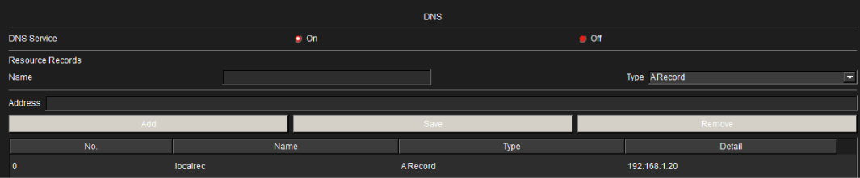

4.4 Client Workstations Configuration
PC0 (CSE Dept) was assigned static IP 192.168.1.101 and PC1 (ECE Dept) was assigned 192.168.1.102. Both clients were configured with subnet mask 255.255.255.0, default gateway 192.168.1.1, and DNS server address 192.168.1.10.

Chapter 5: Verification, Testing & Screenshot Evidence

5.1 Layer 3 Connectivity Verification (ICMP Ping)
To verify that all physical links, switch MAC learning, and IP stacks were active, ICMP echo requests were transmitted from PC0 to both servers. Both pings completed with 0% packet loss and round-trip times under 1 ms.
C:\>ping 192.168.1.10
Pinging 192.168.1.10 with 32 bytes of data:
Reply from 192.168.1.10: bytes=32 time<1ms TTL=128
Reply from 192.168.1.10: bytes=32 time<1ms TTL=128
Reply from 192.168.1.10: bytes=32 time<1ms TTL=128
Reply from 192.168.1.10: bytes=32 time<1ms TTL=128
Ping statistics for 192.168.1.10:
Packets: Sent = 4, Received = 4, Lost = 0 (0% loss)

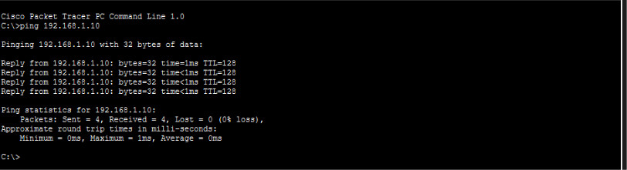

5.2 DNS Name Resolution Verification (nslookup)
To confirm that the client workstation correctly resolves domain names through 192.168.1.10, nslookup queries were executed on PC0. The DNS server successfully returned the A record mapping localrec to 192.168.1.20.
C:\>nslookup localrec
Server: 192.168.1.10
Address: 192.168.1.10
Name: localrec
Address: 192.168.1.20

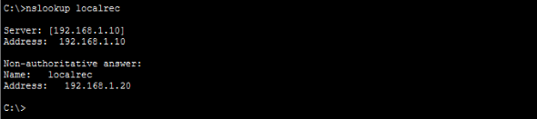

5.3 Web Browser HTTP Verification (Intranet Portal)
To confirm end-to-end integration, the Web Browser on PC0 was opened and the URL http://localrec was submitted. The browser seamlessly resolved the domain, connected via HTTP, and rendered the departmental portal.
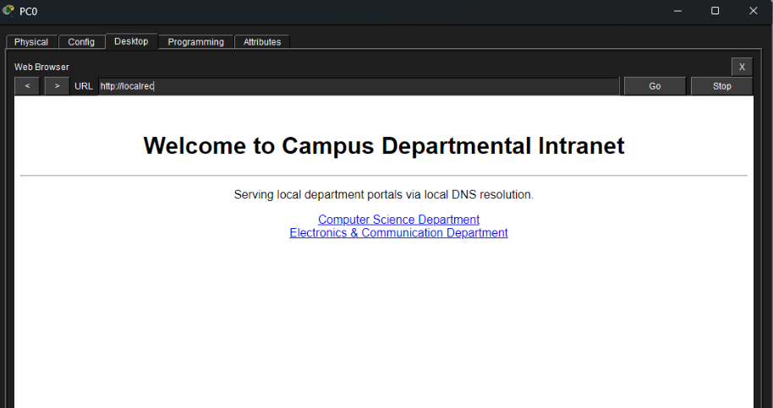

Chapter 6: Protocol Simulation & PDU Analysis
Cisco Packet Tracer's Simulation Mode was utilized to examine the discrete packet flow occurring across the network when a client accesses the intranet portal.

6.1 Chronological Event Sequence
1. DNS Query (UDP Port 53): PC1 crafts a DNS query datagram addressed to DNS-Server (192.168.1.10:53) requesting the A record for localrec.
2. DNS Response: The DNS Server inspects its database and responds with a UDP packet containing the resolved IP 192.168.1.20.
3. TCP 3-Way Handshake (Port 80): PC1 initiates a TCP connection to Web-Server (192.168.1.20:80) exchanging SYN, SYN-ACK, and ACK segments.
4. HTTP GET Request: PC1 transmits an HTTP GET / segment across the established TCP connection.
5. HTTP 200 OK & Content Delivery: The Web Server returns status code 200 OK with the index.html payload, and the client browser renders the page.
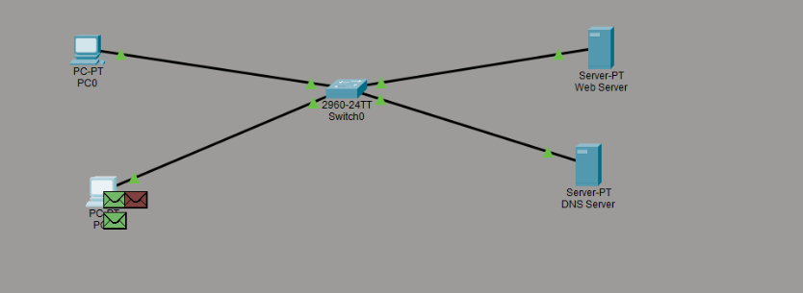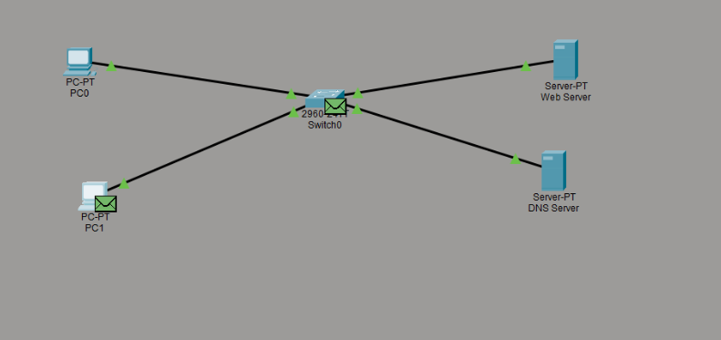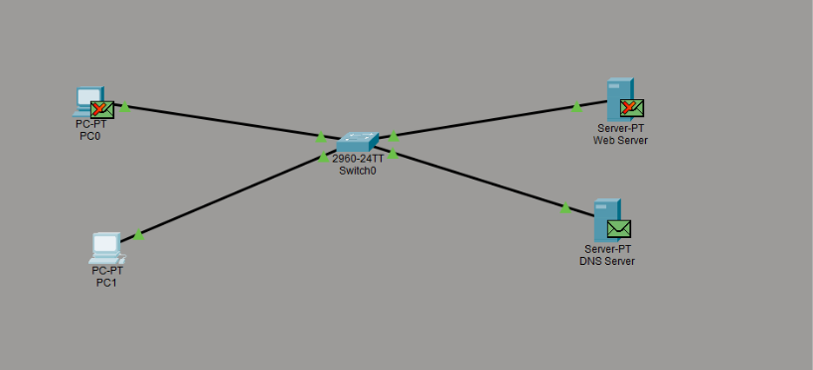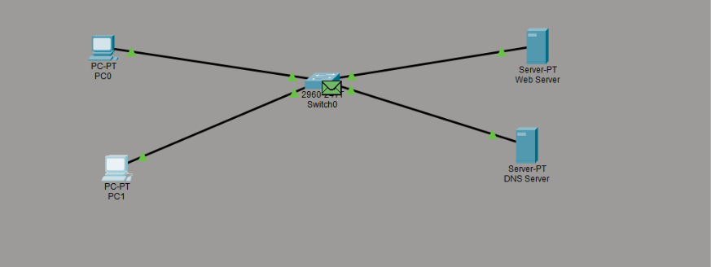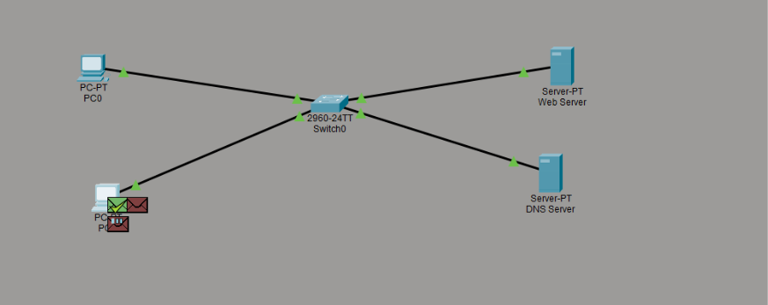

Chapter 7: Advantages, Challenges & Future Enhancements

7.1 Key Advantages
• High Speed: Direct Layer-2 switching provides near-zero latency (< 1 ms).
• Zero External Bandwidth Consumption: Internal browsing traffic remains 100% within the campus switch.
• Network Independence: Departmental communications remain active even during external telecommunication cable cuts or ISP failures.
• Simplified Management: Server IP address modifications only require updating one A-record on the DNS server.

7.2 Challenges & Practical Considerations
• Single Point of Failure: In this baseline setup, if the single DNS server fails, domain-based navigation halts (though direct IP browsing continues).
• Flat Network: Placing servers and student workstations in the same broadcast domain exposes servers to potential broadcast storms.

7.3 Future Enhancements
1. Dynamic Host Configuration Protocol (DHCP): Provisioning a DHCP server to automatically assign IP, mask, gateway, and DNS parameters.
2. Secondary Redundant DNS Server: Deploying a secondary nameserver with master-slave zone synchronization for fault tolerance.
3. Inter-VLAN Routing: Segmenting the CSE Department (VLAN 10), ECE Department (VLAN 20), and Server Farm (VLAN 30) using 802.1Q trunking.
4. HTTPS / TLS Encryption: Installing local digital certificates to protect authentication credentials and intranet data in transit.

Chapter 8: Conclusion
The mini project "Mini DNS Server with Local Website Hosting" was successfully engineered, configured, and analyzed in Cisco Packet Tracer. The project demonstrated how enterprise networks provide reliable, user-friendly access to internal resources using private DNS and HTTP hosting. Validation through ICMP pings, nslookup queries, browser rendering, and packet-level discrete-event simulation verified all theoretical concepts underpinning the TCP/IP suite.

References
1. Kurose, J. F., & Ross, K. W. (2021). Computer Networking: A Top-Down Approach (8th ed.). Pearson.
2. Tanenbaum, A. S., & Wetherall, D. J. (2014). Computer Networks (5th ed.). Prentice Hall.
3. Mockapetris, P. (1987). Domain Names - Concepts and Facilities (RFC 1034 / RFC 1035). IETF.
4. Fielding, R., et al. (1999). Hypertext Transfer Protocol -- HTTP/1.1 (RFC 2616). IETF.
5. Cisco Networking Academy. Packet Tracer Configuration & Lab Manuals, Cisco Systems.

