Assignment 01

Water in the Dam

Nadal Francisco Garcia

Enviornmental Modelling
Master in Geospatial Technologies
Universität Münster
May 02th, 2013

A small note about exercises: Each exercise describes a model in a way that could be written in a scientific paper. It means that not all details are presented in the description. It is up to the student to decide how such details will be implemented.

In the year of 1950, a given city has 100,000 inhabitants. A dam with a capacity of 5,000,000,000m3 of water produces hydroelectric energy for the whole city. In the region, two rainy seasons take place in each year. In the first season, the rains add 2,000,000,000m3 of water to the dam while in the second they add 1,500,000,000m3. In the beginning of 1950, the dam is full and each inhabitant consumes on average 10kWh of energy per month. Each kWh of energy requires 100m3 of water and the consumption of energy increases 5% each year.

Develop a model to investigate future scenarios for the dam. For each of the scenarios below, how long will it take until the dam is not able to provide all the energy required by the city?

- If nothing else happens.

Here is the source code for the model described above:

city = Cell {
population = 100000,
year = 1950,
energy_increase = 1.05,
consum_per_person = 10
}

dam = Cell {
max_cap = 5000000000,
current_water_status = 5000000000,
water_per_kWh = 100,
year_increase = 3500000000,
}

Observer {
subject = dam,
type = "chart",
attributes = {"current_water_status"}
}

damm:notify(1950)

t = Timer {
Event { time = 1950, action = function(e)
damm.current_water_status = damm.current_water_status - city.population * city.consum_per_person * damm.water_per_kWh)
damm.current_water_status = damm.current_water_status + damm.year_increase

if damm.current_water_status > damm.max_cap then
damm.current_water_status = damm.max_cap
end
if damm.current_water_status < 0 then
damm.current_water_status = 0
end

city.year = city.year + 1
city.consum_per_person = city.consum_per_person * city.energy_increase
damm:notify(e:getTime())
end
}
}

t:execute(2060)
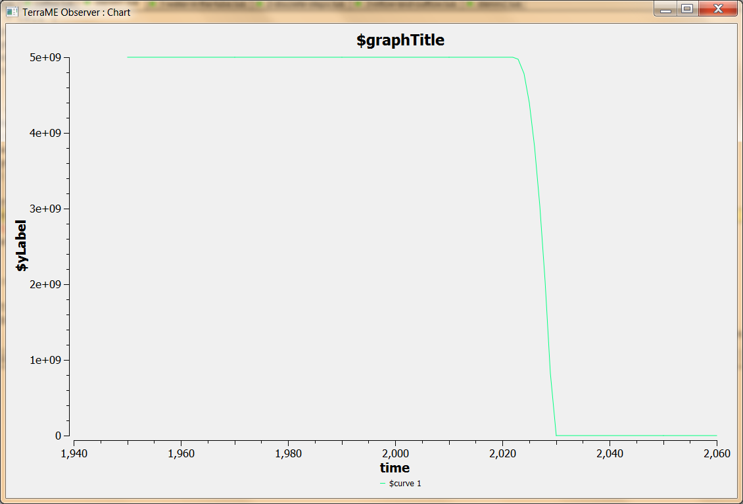

Image 1: Here we can see the evolution of the dam over the following years.

The damm will be empty in 80 years. That is in the year 2030.

- If the turbine would require only 80m of water to generate 1 kWh.

Here is the source code for the model described above:

city = Cell {
population = 100000,
year = 1950,
energy_increase = 1.05,
consum_per_person = 10
}

damm = Cell {
max_cap = 5000000000,
current_water_status = 5000000000,
water_per_kWh = 80,
year_increase = 3500000000,
}

Observer {
subject = damm,
type = "chart",
attributes = {"current_water_status"}
}

damm:notify(1950)

t = Timer {
Event { time = 1950, action = function(e)

damm.current_water_status = damm.current_water_status - (city.population * city.consum_per_person * damm.water_per_kWh)
damm.current_water_status = damm.current_water_status + damm.year_increase

if damm.current_water_status > damm.max_cap then
damm.current_water_status = damm.max_cap
end
if damm.current_water_status < 0 then
damm.current_water_status = 0
end

city.year = city.year + 1
city.consum_per_person = city.consum_per_person * city.energy_increase

damm:notify(e:getTime())
end }
}

t:execute(2060)

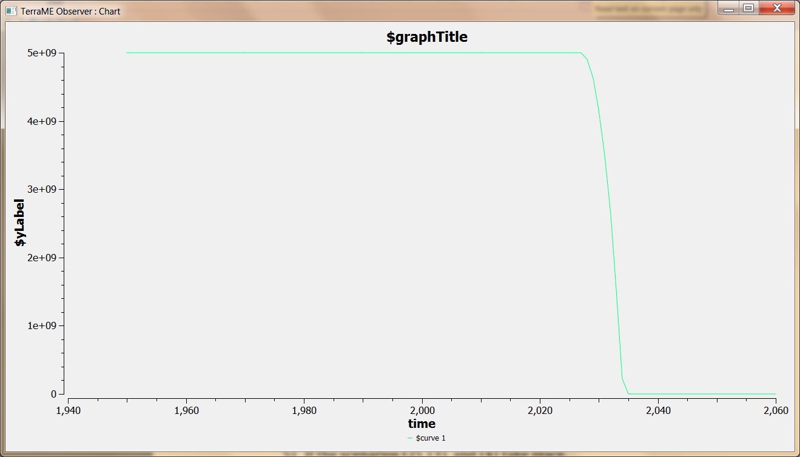

Image 2: Here we can see the evolution of the dam over the following years.

The damm will be empty in 85 years. That is in the year 2035.

- If the consumption growth falls by half.

Here is the source code for the model described above:

city = Cell {
population = 100000,
year = 1950,
energy_increase = 1.025,
consum_per_person = 10
}

damm = Cell {
max_cap = 5000000000,
current_water_status = 5000000000,
water_per_kWh = 100,
year_increase = 3500000000,
}

Observer {
subject = damm,
type = "chart",
attributes = {"current_water_status"}
}

damm:notify(1950)

t = Timer {
Event { time = 1950, action = function(e)
damm.current_water_status = damm.current_water_status - (city.population * city.consum_per_person * damm.water_per_kWh)
damm.current_water_status = damm.current_water_status + damm.year_increase

if damm.current_water_status > damm.max_cap then
damm.current_water_status = damm.max_cap
end
if damm.current_water_status < 0 then
damm.current_water_status = 0
end

city.year = city.year + 1
city.consum_per_person = city.consum_per_person * city.energy_increase

damm:notify(e:getTime())
end }
}

t:execute(2110)

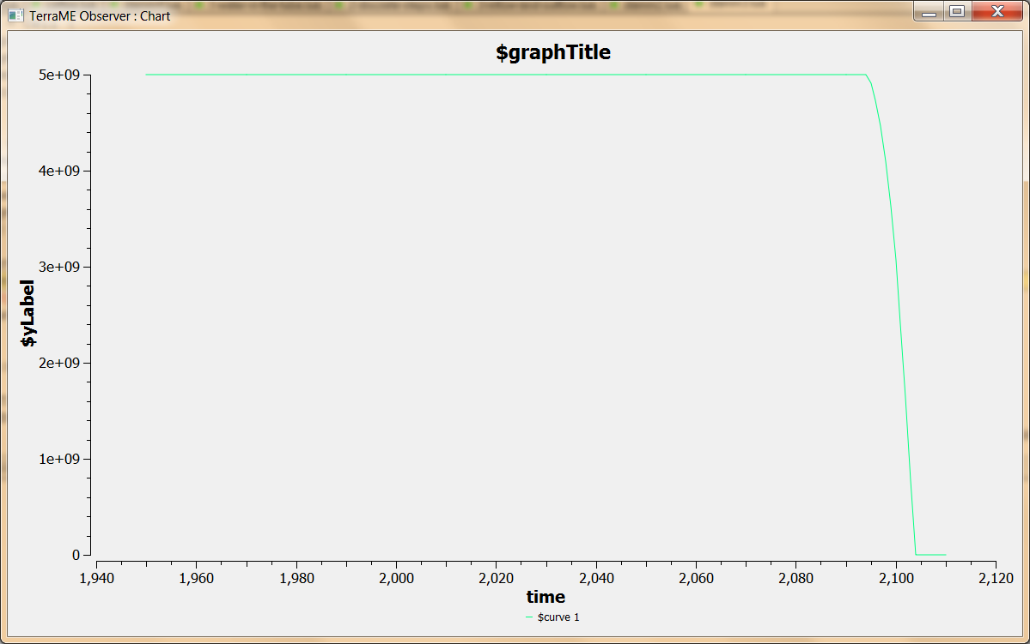

Image 3: Here we can see the evolution of the dam over the following years.

The damm will be empty in 154 years. That is in the year 2104.

- If the overall rain falls by half from 1970 onwards.

Here is the source code for the model described above:

city = Cell {
population = 100000,
year = 1950,
energy_increase = 1.05,
consum_per_person = 10
}

damm = Cell {
max_cap = 5000000000,
current_water_status = 5000000000,
water_per_kWh = 100,
year_increase = 3500000000,
}

Observer {
subject = damm,
type = "chart",
attributes = {"current_water_status"}
}

damm:notify(1950)

t = Timer {
Event { time = 1950, action = function(e)

city.year = city.year + 1

damm.current_water_status = damm.current_water_status - (city.population * city.consum_per_person * damm.water_per_kWh)

if city.year < 1970 then
damm.current_water_status = damm.current_water_status + damm.year_increase
else
damm.current_water_status = damm.current_water_status + damm.year_increase / 2
end

if damm.current_water_status > damm.max_cap then
damm.current_water_status = damm.max_cap
end

if damm.current_water_status < 0 then
damm.current_water_status = 0
end

city.year = city.year + 1

city.consum_per_person = city.consum_per_person * city.energy_increase

damm:notify(e:getTime())
end }
}
t:execute(2025)

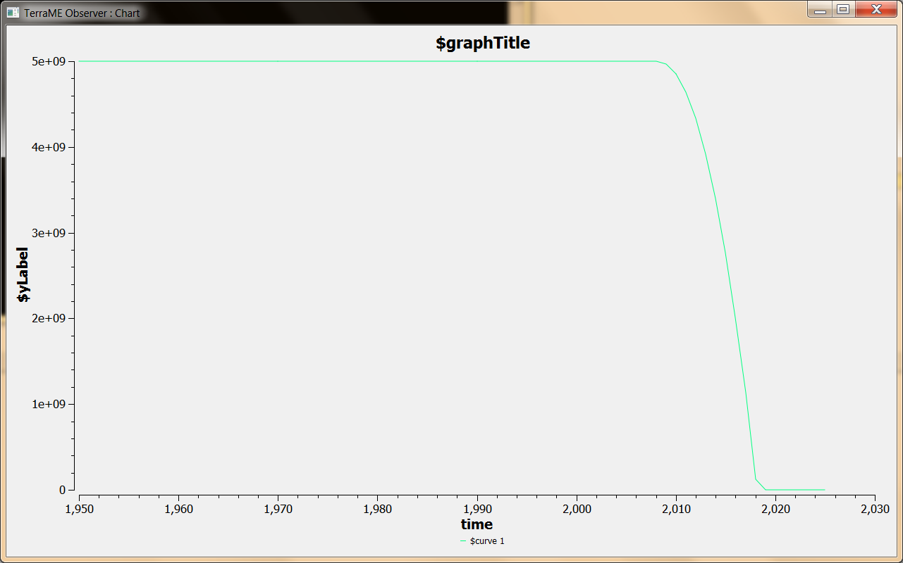

Image 4: Here we can see the evolution of the dam over the following years.

The damm will be empty in 68 years. That is in the year 2018.

- If the scenarios (2), (3), and (4) take place.

Here is the source code for the model described above:

city = Cell {
population = 100000,
year = 1950,
energy_increase = 1.025,
consum_per_person = 10
}

damm = Cell {
max_cap = 5000000000,
current_water_status = 5000000000,
water_per_kWh = 80,
year_increase = 3500000000,
}

Observer {
subject = damm,
type = "chart",
attributes = {"current_water_status"}
}

damm:notify(1950)

t = Timer {
Event { time = 1950, action = function(e)

city.year = city.year + 1

damm.current_water_status = damm.current_water_status - (city.population * city.consum_per_person * damm.water_per_kWh)

if city.year < 1970 then
damm.current_water_status = damm.current_water_status + damm.year_increase
else
damm.current_water_status = damm.current_water_status + damm.year_increase / 2
end

if damm.current_water_status > damm.max_cap then
damm.current_water_status = damm.max_cap
end

if damm.current_water_status < 0 then
damm.current_water_status = 0
end

city.year = city.year + 1

city.consum_per_person = city.consum_per_person * city.energy_increase

damm:notify(e:getTime())
end }
}
t:execute(2100)

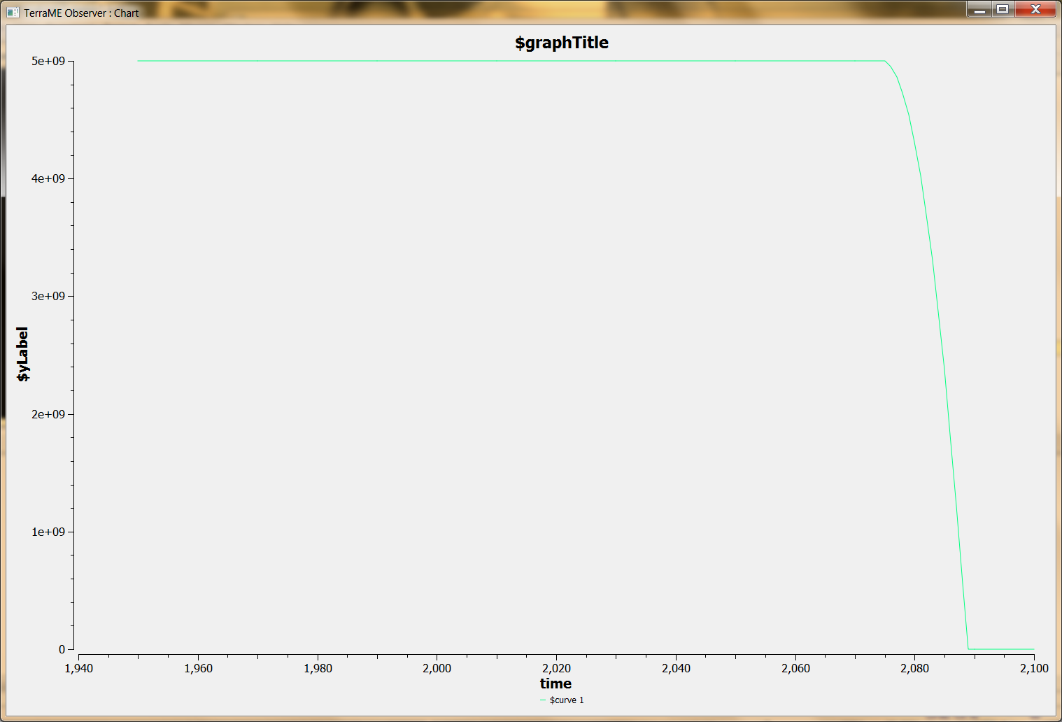

Image 5: Here we can see the evolution of the dam over the following years.

The damm will be empty in 139 years. That is in the year 2089.

