Assignment 02

Daisy World

Nadal Francisco Garcia

Enviornmental Modelling
Master in Geospatial Technologies - Universität Münster
May 23th, 2013

In this second assignment it has been implemented the Daisy World model and investigated the stable state of the system in four different scenarios.

- If a luminosity stays constant at 1.0.

In this first model we get that the temperature of the planet (and the local temperatures) all increase around 8 degrees until they all stabilize after 4 years.

The amount of bare ground does not change much over the time, but the area of the white daisy is reduced as the temperature grows, while the black daisy spreads thanks to the warmer climate until they both stabilize after around 4 years.

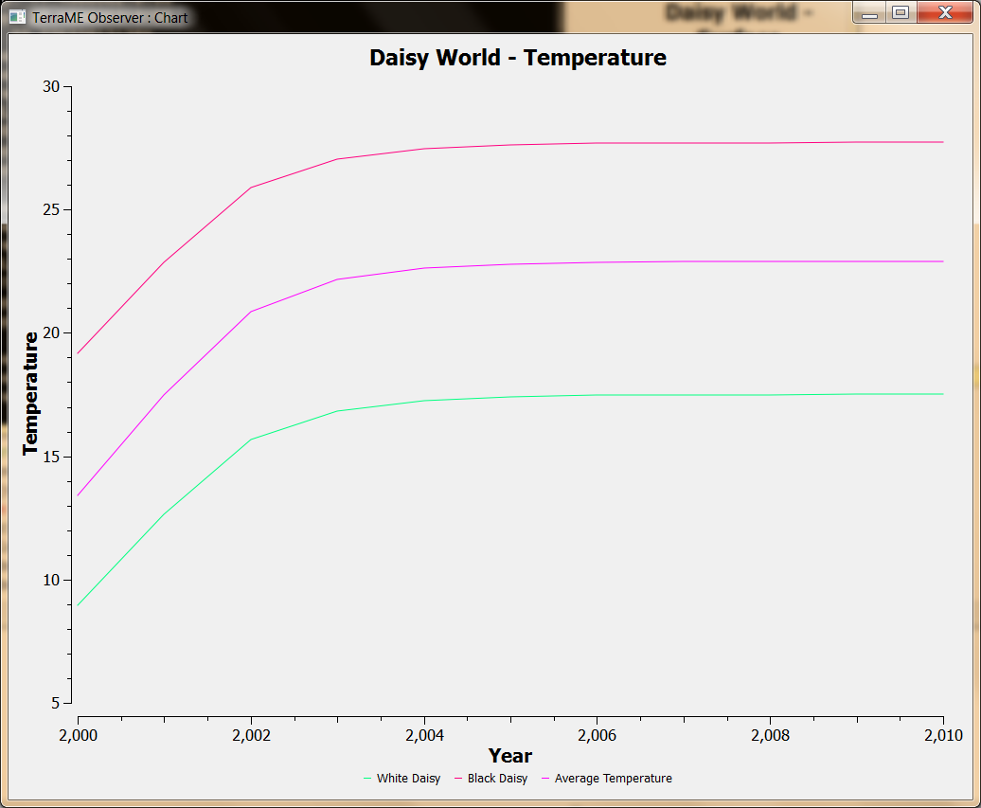

Image 1.1: This picture shows the planet's average temperature and the temperature of both of the daisies' local areas.

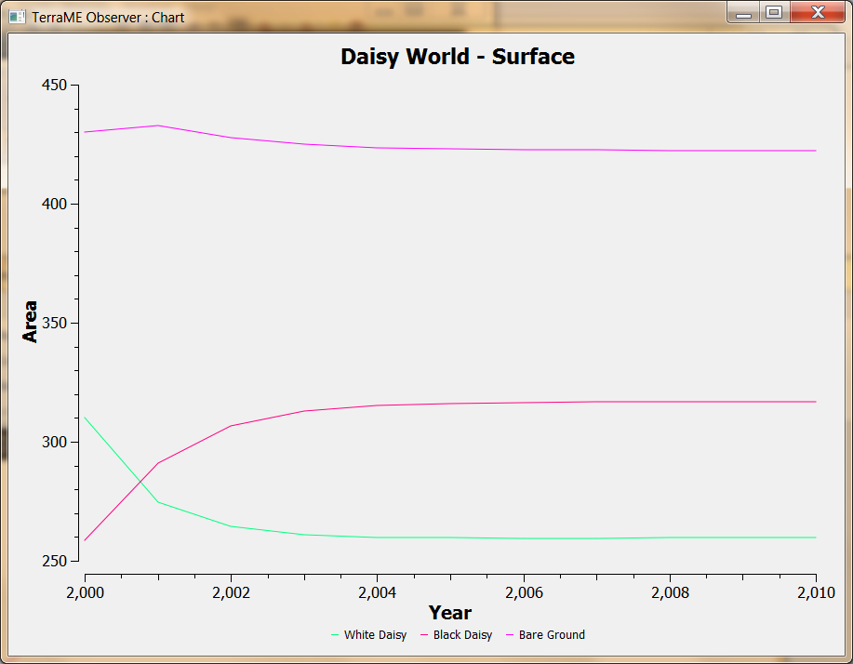

Image 1.2: This picture shows the area of each flower and the remaining bare ground (in hm²).

- If a heat shock occurs: Luminosity jumps to 1.10 in 2010.

In this second model, we clearly see that all the world is shocked by a sudden increase of temperature in 2010. Until that moment, the model of the world is similar as the first exercise

This extreme climate change causes the population of black daisies to be reduced from 300 hm² to 200 hm², while the white daisies increases its numbers. However, the temperature of the planet is slowly cooled by the fact that the white daisy reflects more the luminosity, causing that the world's temperatures return to the shock's previous climate average.

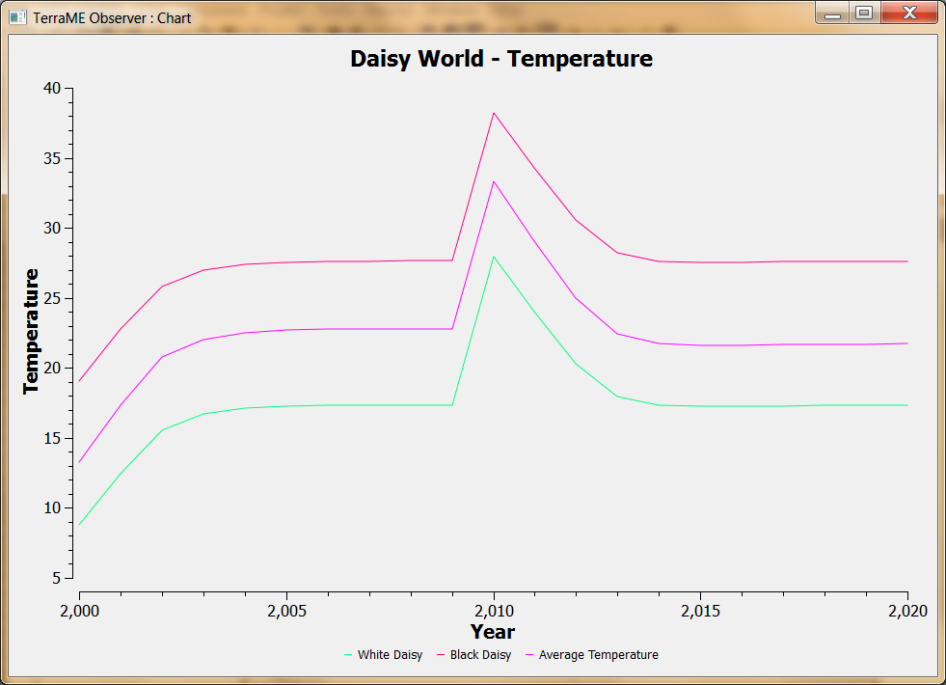

Image 1.1: This picture shows the planet's average temperature and the temperature of both of the daisies local areas.

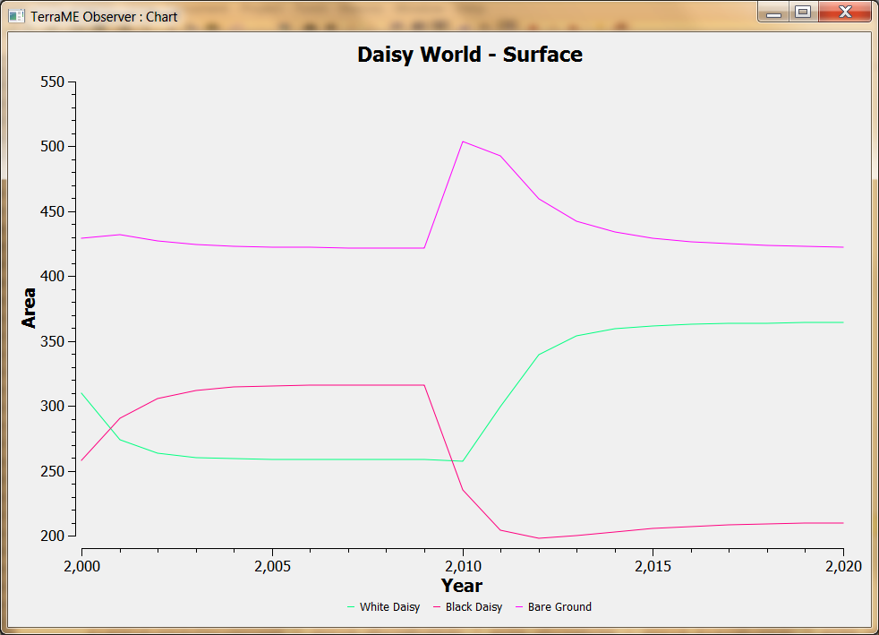

Image 1.2: This picture shows the area of each flower and the remaining bare ground (in hm²).

- If a cold shock occurs: Luminosity drops to 0.95 in 2010.

In this second model, we clearly see that all the world is shocked by a sudden increase of temperature in 2010. Until that moment, the model of the world is similar as the first exercise

This extreme climate change causes the population of black daisies to be increased and the the one of the white daisies reduced suddenly. As in the previous exercise, the planet's albedo causes that the temperature return to its normal averages after three or four years.

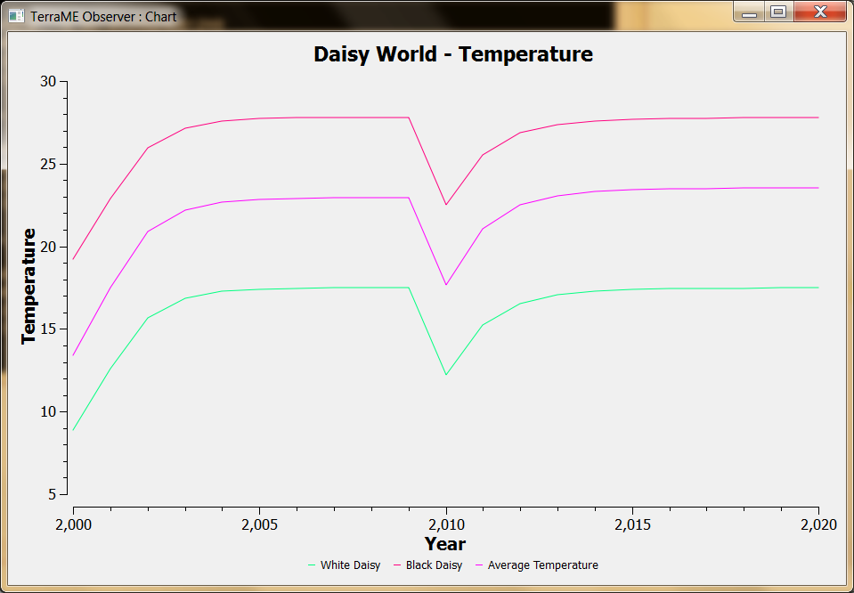

Image 1.1: This picture shows the planet's average temperature and the temperature of both of the daisies local areas.

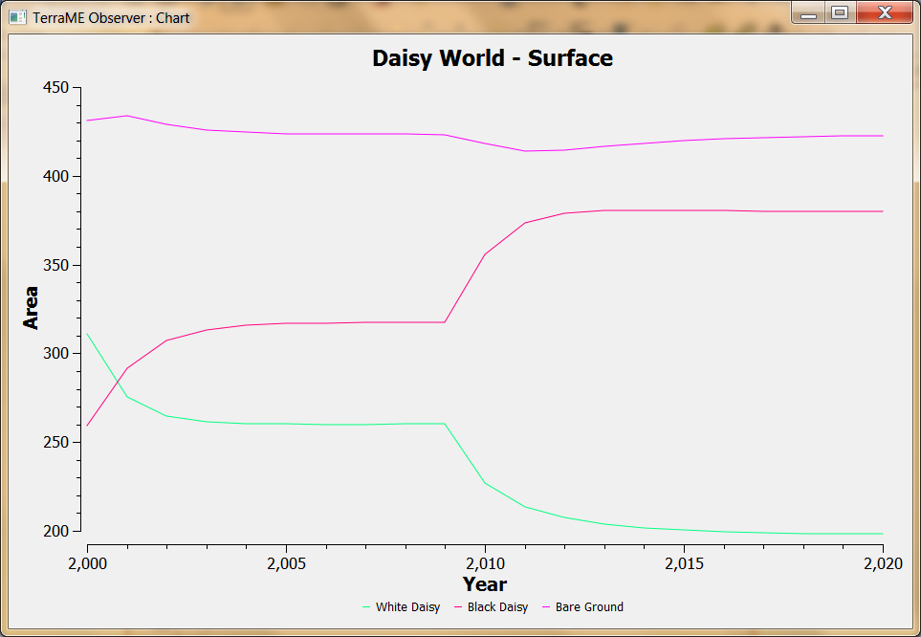

Image 1.2: This picture shows the area of each flower and the remaining bare ground (in hm²).

- If several heat shocks occur: Luminosity grows 4% each ten years from 2010 until 2040.

In this second model, we clearly see that all the world is shocked by four heat shocks of sudden increase of temperature every ten years from 2010 until 2040. Until 2010, the model of the world is similar as the first exercise

This extreme climate changes causes the population of black daisies to be reduced and the the one of the white daisies increased suddenly every ten years. As in the previous exercise, the planet's albedo causes that the temperature return to its normal averages after three or four years after each shock.

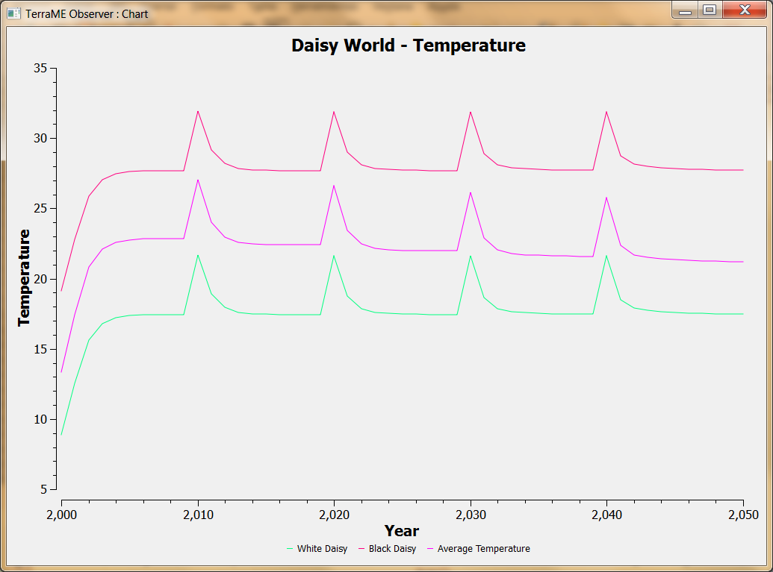

Image 1.1: This picture shows the planet's average temperature and the temperature of both of the daisies local areas.

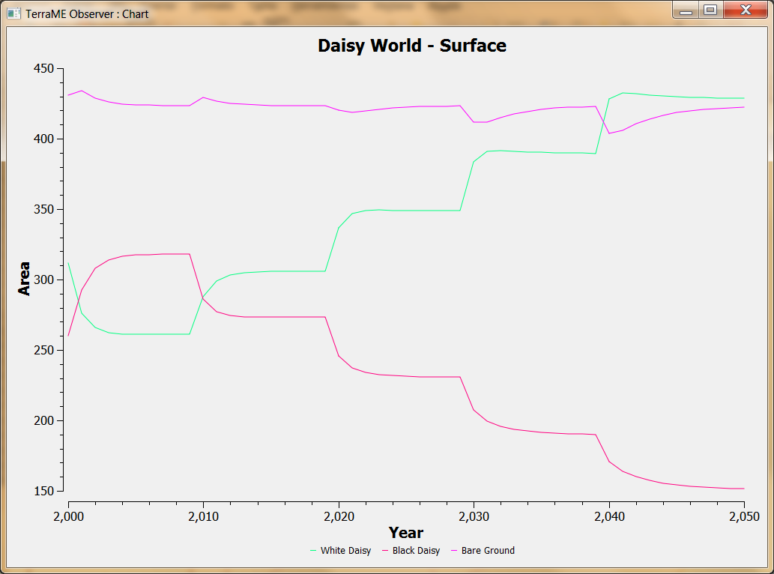

Image 1.2: This picture shows the area of each flower and the remaining bare ground (in hm²).

- Conclusions.

After modeling this four situations of the Daisy World, we can conclude that the flowers regulate the climate to maintain the conditions for its life in the planet. Every time that there is a climate change, the populations of Black Daisies and White Daisies is adapted to get a regular temperature for its survival.

However, as we can see in the Appendix, if a very extreme climate change occurs, it is possible that life in the planet is extinguished.

- Appendix.

This appendix models the planet's temperature and flower's area under a very extreme climate change.

During the implementation of the fourth exercise, I first misunderstood the question. I modeled heat shocks of 4% of luminosity increase every year from 2010 to 2040, instead of every ten years.

As we can see in the images, the population of Daisies can not adapt as fast as necessary to maintain a regular temperature for living, so all Daisies are extinguished after a few years of temperatures above 100º.

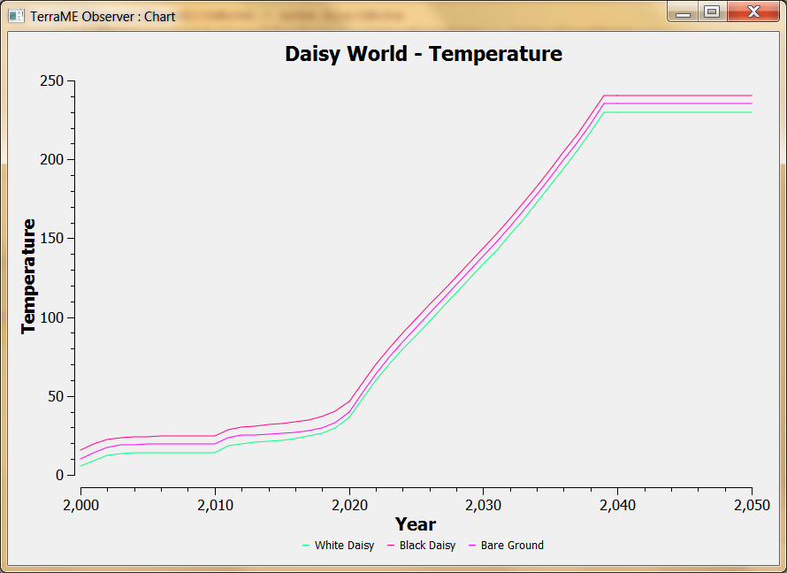

Image 1.1: This picture shows the planet's average temperature and the temperature of both of the daisies local areas.

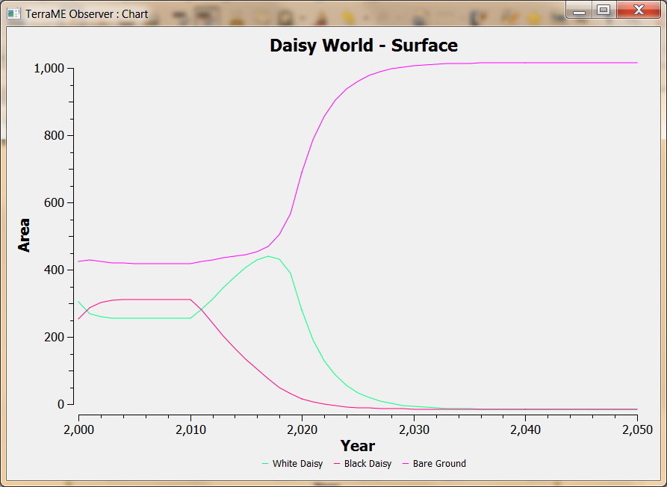

Image 1.2: This picture shows the area of each flower and the remaining bare ground (in hm²).

