1. A recent industry report from over a decade ago found that the average annual income
of freelance software developers was $74,914. An IT economics researcher believes that
this figure may have changed over time due to shifts in the tech job market, the rise of
remote work, and platform-based freelancing. To investigate this, the researcher collects
a random sample of 112 freelance software developers and records their annual incomes.
Assume that the population standard deviation of annual income for freelance developers
is $14,530. The sample of 112 developers yields a mean annual income of $78,695. The
researcher wants to check whether the average income of freelance software developers has
significantly changed from the previously reported value of $74,914. Use a significance
level of 𝛼 = 0.05 to test the researcher’s belief.

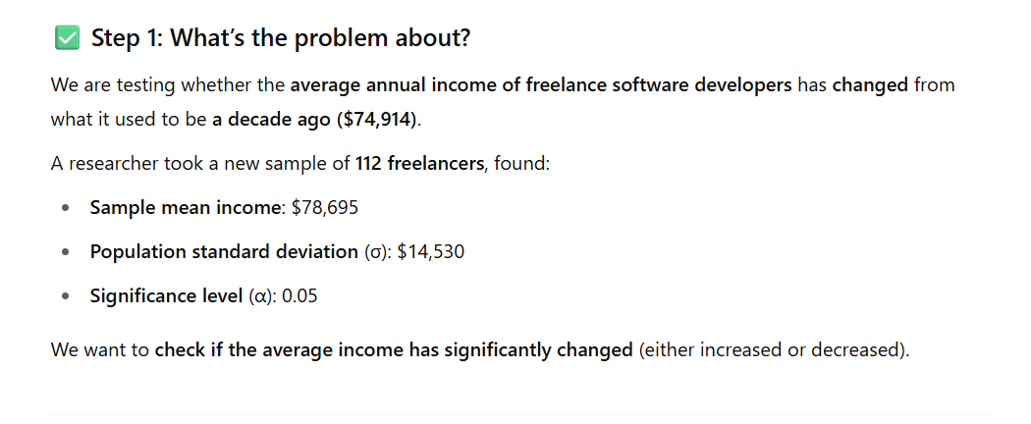

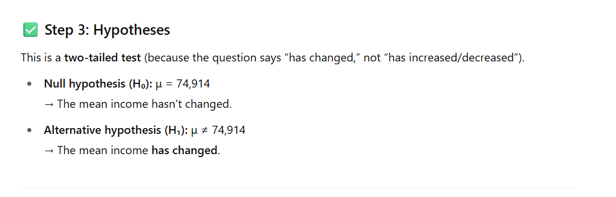

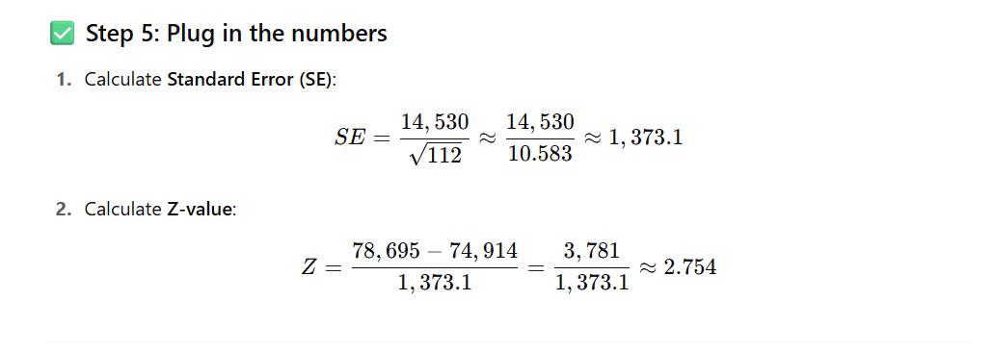

✅ Final Conclusion:
🎉 Yes, the average income of freelance software developers has significantly changed from $74,914, based on the sample data at a 5% significance level.

Formula version
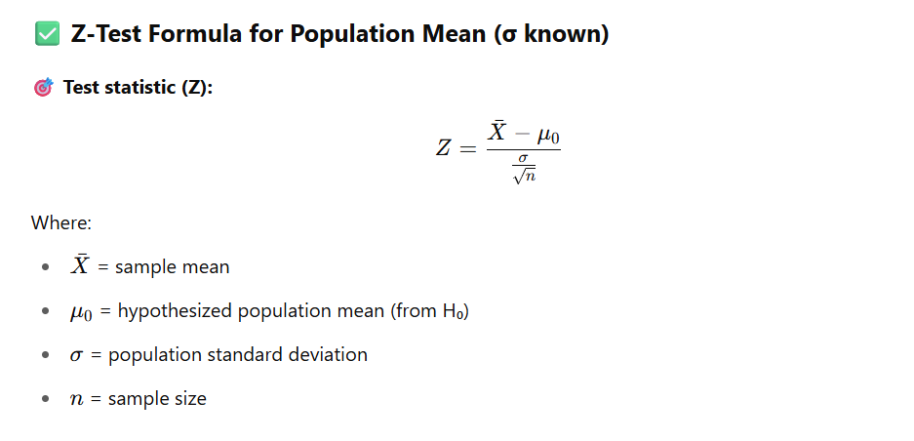

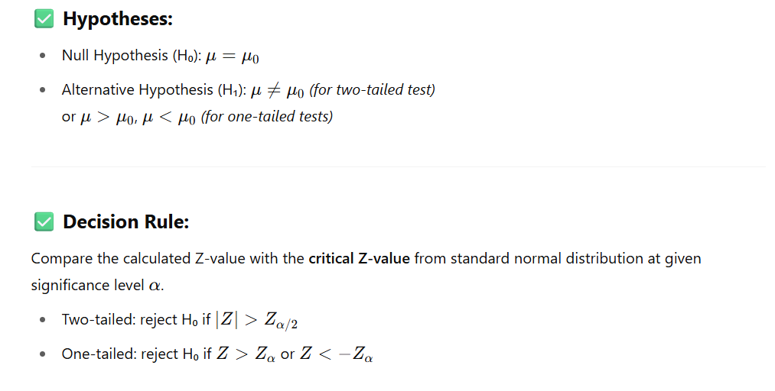
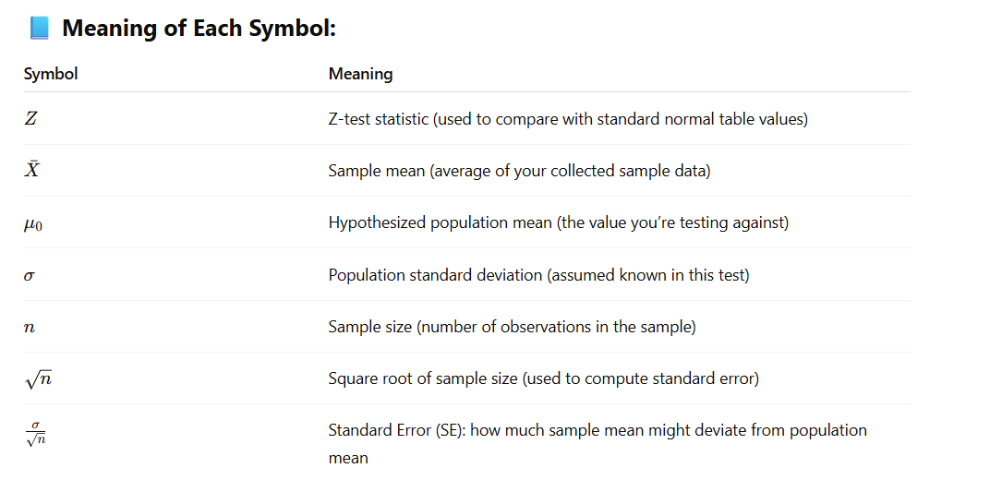

2. An IT company manages a server system that is expected to maintain an average response
time of 250 milliseconds per request. A system administrator suspects that the server
may no longer be maintaining this expected performance. To investigate, a random
sample of 20 recorded response times from the previous day was selected. The sample
yielded a mean response time of 255.1 milliseconds and a standard deviation of 21.93
milliseconds. Assuming that the response times are normally distributed, test whether
the server is operating outside the expected performance level. Use a significance level
of 𝛼 = 0.05.

