HeartCare AI – An Intelligent Heart Disease Risk Assessment System
Nil Lad
Artificial Intelligence & Machine Learning Dept, Charotar University of Science & Technology,
Changa, India
24aiml020@charusat.edu.in

Harsh Bhalodiya
Artificial Intelligence & Machine Learning Dept., Charotar University of Science & Technology,
Changa, India
24aiml002@charusat.edu.in

Abstract:
The increasing prevalence of cardiovascular disease across global populations demands more accessible and efficient diagnostic tools. This paper presents HeartCare AI, a production-grade clinical web application that applies machine learning techniques to estimate an individual’s risk of heart disease based on key medical parameters. The system is built around a tuned XGBoost classification model and delivers risk predictions along with transparent explanations through SHAP (SHapley Additive exPlanations) values. A FastAPI backend handles all inference, report generation, and optional MongoDB-based data logging, while the frontend provides a clean, professional clinical interface with responsive design. The application automatically generates downloadable PDF reports containing patient data, risk levels, and the most influential clinical factors. Security is enforced through API key authentication. This paper covers the system architecture, core features, machine learning pipeline, and security design, demonstrating how HeartCare AI offers a practical and interpretable approach to cardiovascular risk assessment.
Introduction:
Cardiovascular disease continues to be a leading cause of mortality worldwide, placing enormous strain on healthcare systems and individuals alike. Early detection of heart disease risk is widely acknowledged as one of the most effective ways to reduce adverse health outcomes. Conventional diagnostic procedures often require specialist visits, extensive testing, and considerable time — barriers that many patients cannot easily overcome. There is a growing need for intelligent, accessible tools that can provide preliminary risk assessments based on commonly available clinical data.
HeartCare AI was developed in response to this gap, combining the predictive power of machine learning with the usability expectations of a modern clinical interface. The system accepts thirteen standard medical parameters — including age, resting blood pressure, cholesterol, maximum heart rate, and thalassemia type — and produces a risk probability along with an interpretable breakdown of contributing factors. The platform is designed to function as a supplementary decision-support tool for clinicians and a self-awareness resource for general users.
The system is structured around a FastAPI backend that exposes well-defined REST endpoints for prediction and report generation. An XGBoost model, trained on a curated heart disease dataset, forms the analytical core of the application. SHAP values are computed alongside each prediction to ensure the output is not a black-box result but a clearly explained assessment that users and clinicians can understand and act upon. The frontend is crafted using plain HTML5, CSS3, and Vanilla JavaScript with a clinical aesthetic emphasizing trust and clarity.
Security is embedded at the API level through key-based authentication, ensuring that prediction services are not open to unauthorized requests. An optional MongoDB integration allows predictions to be persisted for longitudinal tracking. The application also generates professional clinical PDF reports using ReportLab, enabling patients or healthcare providers to retain a record of each assessment session.
This paper presents the design decisions, implementation details, and key capabilities of HeartCare AI, illustrating how a well-structured ML pipeline combined with an accessible web interface can meaningfully contribute to proactive healthcare. The sections that follow cover the system architecture, features, technical implementation, security considerations, performance optimization, and conclusions drawn from the project.

- ARCHITECTURE OVERVIEW

HeartCare AI is structured as a full-stack clinical web application designed to deliver fast, interpretable, and reliable heart disease risk assessments. The system separates responsibilities across a client-facing HTML/CSS/JS frontend, a Python-based FastAPI backend, and an optional MongoDB persistence layer, following software engineering principles of modularity and single responsibility.

- System Components

Frontend (Client-Side)
- Technology: HTML5, Vanilla JavaScript, CSS3 (custom animations, Grid, Flexbox)
- Responsibilities:
  - Provides a responsive, interactive user interface for all user roles (admin, institute, student).
  - Implements glassmorphism-inspired design and micro-animations for a modern look and feel.
  - Handles client-side routing, form validation, and state management.
  - Communicates with the backend via RESTful API calls.

b. Backend (Server-Side)
- Technology: Python, FastAPI, Uvicorn, Pydantic
- Responsibilities:
  - Exposes a RESTful API for all core functionalities (user management, exam management, result processing, etc.).
  - Implements business logic, input validation, and error handling.
  - Manages authentication and authorization using JWT and OAuth (Google).
  - Handles session management and role-based access control.
  - Integrates with third-party services (e.g., email notifications).

c. Database
- Technology: MongoDB (via PyMongo), optional persistence layer
- Responsibilities:
  - Stores persistent data including user profiles, exam definitions, questions, results, and session data.
  - Supports flexible schema design to accommodate evolving requirements.

Key Architectural Patterns

Model-View-Controller (MVC)
- The backend is organized using the MVC pattern, separating data models, business logic (controllers), and API endpoints (routes) for clarity and maintainability.

RESTful API
- All client-server communication is performed over a RESTful API, enabling stateless interactions and easy integration with other systems or future mobile clients.

Role-Based Access Control (RBAC)
- Middleware enforces permissions based on user roles (admin, institute, student), ensuring that sensitive operations are protected.

Session and Token Management
- Authentication is handled using JWT tokens for API security, with Passport.js managing OAuth and session-based authentication for third-party logins.

Security Considerations

Authentication & Authorization
- Secure login and registration using hashed passwords, JWT tokens, and OAuth for Google sign-in.

Input Validation & Sanitization
- All user inputs are validated and sanitized to prevent injection attacks.

Session Management
- Secure session handling with proper serialization and deserialization of user data.

CORS & Rate Limiting
- Cross-Origin Resource Sharing (CORS) and rate limiting are implemented to protect the API from unauthorized or abusive access.

Deployment & Scalability

Deployment
- The application is designed for deployment on cloud platforms (e.g., Vercel for frontend, Render/Heroku for backend), with environment-based configuration for flexibility.

Scalability
- Stateless API design and the use of MongoDB allow the system to scale horizontally as user demand grows.

Integration Points

Email Service
- For notifications and contact forms.

Analytics
- Integration with analytics services for monitoring usage and performance.

- FUNCTIONALITY AND FEATURES
HeartCare AI delivers a focused but comprehensive set of capabilities centred on clinical risk assessment and patient-facing transparency. The platform’s functionality is organized around three core workflows: collecting medical input, generating an AI-powered risk prediction with explainability, and producing downloadable clinical reports for record-keeping.

- User Management

Patient Data Input:
The system accepts thirteen standard clinical parameters including age, sex, chest pain type, resting blood pressure, cholesterol, fasting blood sugar, ECG results, maximum heart rate, exercise-induced angina, ST depression, ST segment slope, number of major vessels, and thalassemia type.

AI-Powered Risk Assessment:
An XGBoost classifier trained on a curated heart disease dataset processes the submitted parameters and produces a binary risk prediction accompanied by a probability score, categorized into Low, Moderate, or High risk levels.

Explainable AI (SHAP Analysis):
SHAP values are computed for every prediction, revealing which clinical variables contributed most significantly to the outcome. This breakdown is presented visually in the frontend and embedded in the generated PDF report.

- PDF Report Generation

Automated Clinical Report::
Upon requesting a report, the backend compiles patient-submitted parameters, the predicted risk level, risk probability, and the top SHAP-ranked clinical factors into a structured PDF. The document is returned as a binary download, suitable for printing or digital storage.

ReportLab Integration:
PDF generation is handled by the ReportLab library on the backend. The report is dynamically built at runtime using the prediction results without requiring any template files, making the generation process portable and self-contained.

Report Contents:
Each generated report includes: patient demographic data, the complete set of submitted clinical parameters, the overall risk probability and categorical risk level, and a ranked list of the top contributing factors identified by SHAP analysis.

- Examination Process
Clinical Frontend Interface:
The frontend is developed with a professional medical aesthetic, featuring a clean blue-and-white palette, a pulsing ECG animation, and an anatomically styled heart visualization. The interface is designed to inspire confidence and clarity in a clinical setting.
Form Validation:
All form inputs are validated client-side before submission. Numeric fields enforce clinical range limits (e.g., blood pressure between 50 and 300 mmHg), and dropdown fields prevent empty submissions. Clear validation feedback is displayed inline beneath each field.

Real-Time Result Display:
After a prediction is returned from the backend, results are rendered dynamically in the interface without a page reload. The risk level, probability gauge, and SHAP factor breakdown all update in the same session, giving users an immediate and comprehensive view of their assessment.

- Automated Evaluation and Result Processing

XGBoost Prediction:
The XGBoost classifier processes normalized patient features and outputs a binary label alongside a risk probability. The model was tuned on a standard heart disease dataset, achieving approximately 86% accuracy on the held-out test split.

Model Retraining:
A dedicated preprocessing and training script allows the model to be retrained whenever updated patient data becomes available. The retrained model artifact is saved directly to the backend directory and loaded at server startup, with no changes required to the inference code.

Result Storage:
When MongoDB integration is enabled, each prediction request is logged to the database with a timestamp, the full set of input parameters, and the resulting prediction. This allows trends to be tracked over time and enables future analytics or auditing workflows.

- Analytics and Reporting

SHAP Visualizations:
SHAP values for each prediction are returned alongside the risk output and displayed as a ranked bar breakdown in the frontend. Users can immediately see which features, such as thalassemia type or maximum heart rate, had the greatest influence on their specific result.

Risk Factor Summary:
The top clinical risk factors identified by SHAP are summarized in plain language within the result panel and echoed in the generated PDF report. This makes the output interpretable for non-specialist users while still containing sufficient detail for clinical review.

Notifications:
The health check endpoint at GET /health confirms that the backend service is running and the model artifact is loaded correctly. This endpoint can be polled by infrastructure monitoring tools to alert operators in the event of a service outage.

- Security and Integrity

API Key Authentication:
Every request to the /api/predict and /api/report endpoints must include a valid api-key header. Requests with missing or incorrect keys are rejected with a 403 Forbidden response before any model inference is performed.

HTTPS Transport:
All traffic between the client and the FastAPI backend is transmitted over HTTPS in production deployments. TLS encryption ensures that sensitive patient data cannot be intercepted in transit between the browser and the server.

Input Validation:
The backend uses Pydantic models to enforce strict type checking and value range validation on every incoming prediction request. Any field that falls outside the expected range is rejected before reaching the model, preventing malformed inputs from affecting inference quality.

- User Experience

Clinical Aesthetic Design:
The frontend is styled with a clean clinical palette using CSS custom properties for consistent theming throughout. A pure CSS ECG animation and heart icon provide visual context without relying on external image assets, keeping the interface lightweight and fully self-contained.
Responsive Layout:
The layout employs CSS Grid and Flexbox to adapt fluidly across screen sizes, from wide clinical workstations to mobile phones. Form fields reflow to a single-column layout on narrow viewports, ensuring the prediction form remains fully usable without horizontal scrolling.
users.

- Technical Implementation

1. System Architecture

1.1 Architecture Overview
HeartCare AI implements a three-tier architecture separating concerns between user interaction, clinical inference logic, and optional data persistence:
- Client Tier: React-based single-page application (SPA)
- API Tier: RESTful services providing business logic and data access
- Data Tier: Database system storing application data
The system follows a client-server model with stateless communication over HTTP/HTTPS, enabling scalability and maintainability. This architecture allows each tier to evolve independently while maintaining clear interfaces between components.

1.2 Frontend Architecture
1.2.1 Component-Based Design
The frontend implements a hierarchical component architecture following the Atomic Design methodology:
- Atoms: Basic UI elements (buttons, inputs, icons)
- Molecules: Combinations of atoms forming functional UI units
- Organisms: Complex UI sections combining multiple molecules
- Templates: Page layouts defining content structure
- Pages: Complete views implementing business logic
1.2.2 State Management Architecture
The state management follows the Flux architecture pattern with unidirectional data flow:
- Global State: Managed through Redux with a centralized store
- Component State: Local state for UI-specific concerns
- Context API: Theme and specialized shared state
- Persistence Layer: Browser storage integration
1.2.3 Routing Architecture
The routing system implements a hierarchical structure with:
- Public Routes: Accessible without authentication
- Protected Routes: Requiring authentication with role-based access
- Specialized Routes: Role-specific route protections (Admin, Institute, Student)

1.3 API Integration Architecture
The frontend-backend communication follows a request-response pattern with:
- Service Layer: Abstraction for all API interactions
- Caching Strategy: Optimized data fetching with TTL policies
- Request Lifecycle Management: Loading states, error handling, retry mechanisms
- Data Transformation Layer: Adapters to convert between API and UI data models

2. Authentication System

2.1 Authentication Architecture
The authentication system implements a hybrid token-based architecture:
- JWT Tokens: Short-lived access tokens for API authorization
- HTTP-Only Cookies: Secure token storage preventing XSS attacks
- Refresh Token Mechanism: Automatic token renewal without user disruption
- Session Management: Server-side tracking for additional security
2.2 Authorization Framework
The application implements a Role-Based Access Control (RBAC) system with:
- Role Hierarchy: Admin > Institute > Teacher > Student
- Permission Matrix: Granular control over resource access
- Component-Level Authorization: UI elements conditionally rendered based on permissions
- Route-Level Authorization: Navigation paths restricted according to user roles
2.3 Session Management
Session handling utilizes a stateless architecture with:
- Client-Side Session Tracking: Redux store maintains session state
- Session Persistence: Browser storage integration for session continuity
- Inactivity Detection: Automatic session expiration on user inactivity
- Secure Logout Process: Multi-step cleanup ensuring complete session termination

3. UI Implementation Strategy

3.1 Design System Architecture
The UI follows a systematic design architecture with:
- Design Tokens: Foundational values (colors, spacing, typography)
- Utility-First CSS: Composition-based styling approach
- Responsive Framework: Mobile-first design methodology
- Theming Engine: Dynamic theme switching with context propagation
3.2 Component Architecture
Components follow a composite pattern with:
- Presentational-Container Separation: UI rendering decoupled from business logic
- Composition Over Inheritance: Component functionality built through composition
- Prop Drilling Minimization: Context API for deeply nested component communication
- Render-Props Pattern: For complex component behavior sharing
3.3 Animation Framework
The motion design system implements:
- Physics-Based Animations: Natural motion following physical principles
- Animation Orchestration: Coordinated animations across component hierarchies
- Performance Optimization: GPU-accelerated transitions
- Accessibility Considerations: Respecting user motion preferences

4. Feature Implementation Approaches

4.1 Admin Dashboard Implementation
The administrative interface follows a command-control paradigm with:
- Multi-Panel Dashboard: Segmented information architecture for different administrative functions
- Real-Time Data Visualization: Streaming updates for system activities
- Batch Operations Framework: Efficient handling of bulk administrative actions
- Approval Workflow Engine: Multi-stage process for content/exam approval
4.2 Exam System Implementation
The examination system implements a secure testing architecture:
- Exam State Machine: Well-defined exam lifecycle (creation, approval, scheduling, activation, completion, analysis)
- Question Bank System: Hierarchical organization of assessment items
- Anti-Cheating Framework: Multiple security measures preventing examination fraud
- Real-Time Proctoring: Basic monitoring during examination sessions
- Automatic Evaluation Engine: Immediate grading for objective questions
4.3 User Management System
User administration follows a multi-tenant architecture with:
- User Hierarchy: Organizational structure reflecting educational institutions
- Profile Management: Self-service and administrative user data maintenance
- Invitation System: Secure onboarding process for new users
- Activity Tracking: Audit trails for security-sensitive operations

5. Security Implementation

5.1 Frontend Security Architecture
Client-side security implements multiple defensive layers:
- Input Validation: Client-side validation before submission
- Output Sanitization: Prevention of XSS through proper content rendering
- CSRF Protection: Token-based request validation
- Content Security Policy: Restrictions on resource loading
- Secure Storage Practices: Sensitive data handling guidelines
5.2 API Security Measures
The API communication security includes:
- Transport Layer Security: HTTPS-only communication
- Authentication Headers: Standardized authorization mechanisms
- Rate Limiting: Protection against brute force and DoS attacks
- Request Validation: Comprehensive payload verification
5.3 Exam Security Framework
The examination security architecture includes:
- Content Encryption: End-to-end encryption for exam materials
- Secure Viewing Environment: Browser lockdown during examinations
- Multi-Factor Authentication: Additional verification for high-stakes exams
- Integrity Verification: Checksums and validation of submission data

6. Performance Optimization Strategy

6.1 Frontend Performance Architecture
Performance optimization follows a comprehensive approach:
- Code Splitting Architecture: Dynamic module loading based on routes and features
- Progressive Loading Strategy: Critical path rendering for faster perceived performance
- Asset Optimization Pipeline: Compression and delivery optimization for static resources
- Runtime Performance Monitoring: Metrics collection for performance regression detection
6.2 Caching Architecture
The caching strategy implements multiple layers:
- HTTP Caching: Browser-level resource caching
- Application Caching: In-memory data retention for frequently accessed information
- Query Caching: Storage of API responses with invalidation strategies
- Prefetching Logic: Anticipatory data loading for expected user journeys

7. Development Infrastructure

7.1 Build System Architecture
The build pipeline follows modern development practices:
- Module Bundling: Optimized asset generation for production
- Tree Shaking: Elimination of unused code
- Differential Loading: Browser-specific bundles for optimal compatibility
- Asset Optimization: Minification and compression of resources
7.2 Quality Assurance Architecture
Code quality is maintained through:
- Static Analysis: Automated code quality verification
- Component Testing Framework: Isolated testing of UI components
- Integration Testing Approach: Verification of component interaction
- End-to-End Testing Strategy: Complete user flow validation

8. Deployment Architecture
The deployment strategy follows modern DevOps practices:
- Containerization: Application packaging for consistent environments
- Continuous Integration: Automated build and test processes
- Continuous Deployment: Automated release pipeline
- Infrastructure as Code: Version-controlled environment definitions
- Environment Promotion: Staged deployment across development, testing, and production

- Security Considerations

1. Multi-Layered Security Architecture

1.1 Defense-in-Depth Approach
HeartCare AI implements a layered security strategy across its components, protecting patient data and prediction integrity. This approach acknowledges that no single control is infallible, and therefore multiple defensive mechanisms are combined so that compromising one layer does not expose the full system. a comprehensive security posture where multiple defensive mechanisms must be compromised for a security breach to occur.The security architecture is stratified into:

- Perimeter Security: Network-level protections including firewalls and DDoS mitigation
- Application Security: Application-level controls for input validation and session management
- Data Security: Encryption mechanisms for data at rest and in transit
- User Security: Authentication and authorization frameworks
- Operational Security: Monitoring, auditing, and incident response protocols
This multi-faceted approach ensures that vulnerability in one security layer does not compromise the entire system, significantly enhancing the platform's overall security resilience.

2. Authentication and Authorization Framework

2.1 Multi-Factor Authentication (MFA)
The platform employs a contextual multi-factor authentication framework that dynamically adjusts authentication requirements based on risk assessment. This risk-adaptive authentication considers:
- Geographic location anomalies
- Device recognition patterns
- Behavioral biometrics
- Access request timing
- Resource sensitivity classification
MFA implementations include:
- Knowledge factors (passwords, security questions)
- Possession factors (email verification, SMS codes)
- Inherence factors (biometric verification where available)
2.2 Role-Based Access Control (RBAC)
HeartCare AI enforces access at the API level using key-based authentication. All prediction and report endpoints require a valid api-key header before processing any request. The authorization framework operates on the principle of least privilege, ensuring only authenticated callers can trigger inference. The access control architecture includes:
- Role Hierarchy: Structured permission inheritance from admin to student
- Dynamic Permission Adjustment: Context-sensitive permission elevation for specific operational needs
- Temporal Access Controls: Time-bound permissions for examination periods
- Resource-Based Permissions: Fine-grained control over specific system functions
- Segregation of Duties: Critical operations requiring multiple role authorizations
2.3 Session Management
Session security is maintained through:
- Secure Session Tokens: Cryptographically strong session identifiers
- HTTP-Only and Secure Flags: Cookie hardening to prevent client-side access
- Session Timeout Mechanisms: Automatic invalidation after periods of inactivity
- Concurrent Session Controls: Limiting simultaneous access from multiple locations
- Session Binding: Tying sessions to original authentication factors

3. Data Protection Mechanisms

3.1 Encryption Strategy
HeartCare AI employs encryption mechanisms to protect patient data at rest and in transit. The framework covers all sensitive information throughout its lifecycle:
- Data at Rest:
- Database Encryption: Sensitive fields encrypted using AES-256 with proper key management
- Content Encryption: Examination materials encrypted with unique keys per examination
- Key Rotation Policies: Regular cryptographic key rotation to limit exposure
- Secure Key Management: Hardware Security Module (HSM) integration for key protection
Data in Transit:
- Transport Layer Security: TLS 1.3 with Perfect Forward Secrecy
- Certificate Pinning: Prevention of man-in-the-middle attacks
- Secure API Communications: Encrypted payloads with additional application-layer encryption
- Secure Real-time Communications: WebSocket security with message-level encryption
3.2 Data Isolation
The platform implements logical and physical data isolation:
- Multi-tenancy Controls: Strict separation between different institutional data
- Data Classification Framework: Tiered protection based on sensitivity levels
- Access Control Lists: Granular permissions at the data element level
- Database Partitioning: Physical separation of high-sensitivity data

4. Examination-Specific Security Controls

4.1 Secure Examination Delivery
HeartCare AI implements specialized security controls specific to the clinical inference workflow:
Exam Content Protection:
- Just-in-Time Decryption: Examination materials decrypted only when needed
- Watermarking Technology: Dynamic watermarks tied to student identifiers
- Selective Content Disclosure: Question-by-question unveiling preventing full exam access
- Digital Rights Management: Controls preventing unauthorized copying or distribution
Examination Environment Security:
- Browser Security Extensions:
- Specialized lockdown mechanisms preventing:
- Tab switching
- Screen capture/recording
- Clipboard operations
- External communications
- Device Environment Scanning: Detection of virtualization or remote access technologies
- Network Traffic Analysis: Identification of suspicious communication patterns
- Local Resource Restrictions: Prevention of access to local files and applications
4.2 Anti-Cheating Framework
The anomaly detection system employs multiple methodologies to flag unusual or unreliable input patterns:
- Behavioral Analysis: Anomaly detection in user interactions
- Temporal Pattern Recognition: Identification of statistically improbable response patterns
- Environmental Monitoring: Audio and visual proctoring capabilities
- Device Integrity Verification: Detection of prohibited software or hardware
- Collaboration Detection: Identification of similar answer patterns across examinees

5. Network and Infrastructure Security

5.1 Network Security Architecture
The network security implementation includes:
- Segmentation: Logical separation between application tiers
- Web Application Firewall: Protection against OWASP Top 10 vulnerabilities
- Rate Limiting: Prevention of brute force and denial of service attacks
- API Gateway Security: Request validation, sanitization, and transformation
- Intrusion Detection/Prevention Systems: Real-time threat monitoring and mitigation
5.2 Cloud Security Posture
For cloud deployments, HeartCare AI implements:
- Secure Configuration Management: Infrastructure-as-Code with security benchmarks
- Identity and Access Management: Principle of least privilege for service accounts
- Resource Isolation: Private networking with controlled ingress/egress
- Vulnerability Management: Continuous scanning and remediation
- Secure CI/CD Pipeline: Automated security testing during deployment

6. Compliance and Standards Adherence

6.1 Regulatory Compliance Framework
HeartCare AI is designed with awareness of applicable data protection and medical software standards:
- Data Protection Regulations: GDPR, CCPA, and regional privacy laws
- Educational Standards: Compliance with academic integrity guidelines
- Accessibility Standards: WCAG 2.1 compliance for inclusive access
- Industry Best Practices: NIST Cybersecurity Framework and ISO 27001
6.2 Security Certification Alignment
The security architecture is aligned with recognized security certifications:
- SOC 2: Controls for security, availability, and confidentiality
- ISO/IEC 27001: Information security management system framework
- Cloud Security Alliance: Cloud control matrix implementation

7. Threat Modeling and Risk Management

7.1 Comprehensive Threat Model
HeartCare AI employs the STRIDE threat modeling framework to systematically identify and address potential attack vectors:
- Spoofing: Identity verification controls
- Tampering: Data integrity mechanisms
- Repudiation: Comprehensive audit logging
- Information Disclosure: Data protection controls
- Denial of Service: Resilience and scalability measures
- Elevation of Privilege: Authorization boundary enforcement
7.2 Risk Assessment Methodology
Security implementation is guided by:
- Quantitative Risk Analysis: Impact and probability assessments
- Threat Intelligence Integration: Leveraging industry-specific threat data
- Regular Security Assessments: Penetration testing and vulnerability scanning
- Third-Party Security Reviews: Independent security validation

8. Security Monitoring and Incident Response

8.1 Continuous Security Monitoring
The platform implements comprehensive monitoring:
- Security Information and Event Management (SIEM): Centralized security event correlation
- User and Entity Behavior Analytics: Anomaly detection for user activities
- Real-time Alert Mechanisms: Immediate notification of suspicious activities
- Security Metrics Dashboard: Visualization of security posture
8.2 Incident Response Framework
A structured incident response process includes:
- Incident Classification Matrix: Severity-based response protocols
- Containment Strategies: Predefined actions to limit impact
- Forensic Readiness: Capabilities for post-incident analysis
- Communication Protocols: Notification procedures for affected parties
- Recovery Procedures: Business continuity and disaster recovery integration

9. Secure Development Lifecycle

9.1 Security by Design Principles
Security is embedded throughout the development process:
- Threat Modeling: Early identification of security requirements
- Secure Coding Standards: Language-specific security guidelines
- Security Testing: Automated and manual security verification
- Code Review Protocols: Security-focused peer review processes
- Component Security Analysis: Third-party dependency verification
9.2 Continuous Security Improvement
The security posture evolves through:
- Security Maturity Assessment: Regular evaluation against security capability models
- Lessons Learned Integration: Feedback loops from security incidents
- Emerging Threat Adaptation: Proactive security control adjustments
Security Research Monitoring: Tracking of new vulnerability classes and attack vectors

- Performance Optimization
1. Introduction
Performance optimization is central to HeartCare AI, ensuring risk predictions are delivered within a sub-second window and the interface remains responsive across devices. The system minimizes inference latency and reduces unnecessary computation. The following describes the principal optimization strategies applied.

2. Frontend Performance Optimization

2.1 Code Splitting and Lazy Loading
HeartCare AI keeps the frontend lightweight by using plain HTML, CSS, and Vanilla JavaScript without heavy framework dependencies. All required styles and scripts are bundled inline, eliminating additional network round trips. Critical content is prioritized so the patient input form is visible almost immediately, even on slower connections.
2.2 Efficient State Management
The use of Redux Toolkit and RTK Query provides efficient state management and data fetching. RTK Query automatically caches API responses, reducing redundant network requests and ensuring that frequently accessed data is readily available. This minimizes data fetching overhead and improves responsiveness.
2.3 Optimized Asset Delivery
Static assets such as images, fonts, and icons are optimized and served via modern build tools (e.g., Vite). Techniques such as image compression, SVG usage for icons, and font subsetting are employed to reduce asset sizes. The use of a content delivery network (CDN) further accelerates asset delivery by serving resources from geographically distributed servers.
2.4 Responsive and Adaptive Design
The UI is built with a mobile-first, responsive design using Tailwind CSS. This ensures that the application adapts efficiently to various device sizes and resolutions, providing a consistent and performant experience across desktops, tablets, and smartphones.
2.5 Animation and Rendering Optimization
Animations are implemented using Framer Motion, which leverages hardware acceleration and efficient rendering techniques. Care is taken to avoid layout thrashing and excessive re-renders, ensuring smooth transitions without compromising performance.

3. Backend and API Performance Optimization

3.1 RESTful API Design
The backend APIs are designed following RESTful principles, enabling stateless interactions and efficient resource management. Endpoints are structured to minimize payload sizes and support pagination for large datasets, reducing server load and client processing time.
3.2 Caching Strategies
Multiple layers of caching are implemented:
- Client-Side Caching: RTK Query caches API responses in the browser.
- Server-Side Caching: Frequently accessed data and computed results are cached on the server, reducing database load and response times.
- HTTP Caching: Proper cache headers are set for static resources and API responses where appropriate.
3.3 Database Optimization
Database queries are optimized through indexing, query optimization, and denormalization where necessary. Read-heavy operations are further accelerated using in-memory data stores or read replicas, ensuring low-latency access to critical data.
3.4 Asynchronous Processing
Long-running or resource-intensive operations (such as report generation or bulk data processing) are handled asynchronously using background jobs or message queues. This prevents blocking of user-facing requests and maintains a responsive system.

4. Scalability and Load Handling

4.1 Horizontal Scaling
The system is designed for horizontal scalability, allowing multiple instances of the frontend and backend services to run concurrently. Load balancers distribute incoming traffic evenly, ensuring high availability and fault tolerance.
4.2 Cloud-Native Deployment
Deployment on cloud infrastructure enables dynamic resource allocation based on demand. Auto-scaling policies ensure that the system can handle peak loads during examination periods without performance degradation.
4.3 Monitoring and Profiling
Comprehensive monitoring tools track system performance metrics such as response times, error rates, and resource utilization. Profiling tools are used during development and production to identify and address performance bottlenecks proactively.

5. Progressive Enhancement and Graceful Degradation
HeartCare AI is built with progressive enhancement in mind. The risk prediction form functions correctly without JavaScript animations or supplementary visual elements, ensuring core capability remains accessible on lower-end devices. Visual enhancements such as the animated ECG display are purely decorative and do not affect functionality if they cannot render.

6. Conclusion
Through a lightweight frontend, efficient XGBoost inference, asynchronous PDF generation, and optional MongoDB caching, HeartCare AI delivers a consistently fast clinical risk assessment experience. These design decisions ensure the platform remains performant as usage grows, without demanding complex infrastructure changes.

- Conclusion
HeartCare AI represents a practical and thoughtfully designed approach to AI-assisted cardiac health screening, combining proven machine learning techniques with an accessible, professional-grade web interface. The system architecture is built for clarity and extensibility, ensuring that each component — from the XGBoost model to the FastAPI backend and clinical frontend — can be independently maintained, tested, and improved as the project evolves.
The integration of SHAP explainability is a defining feature of the system, addressing one of the most frequently cited concerns about clinical AI: the black-box nature of complex models. By surfacing the contribution of each clinical variable to the final prediction, HeartCare AI enables users and practitioners to engage critically with the output rather than accepting it uncritically. The automated PDF report further extends this transparency into a format suitable for clinical record-keeping or patient hand-off.
On the backend, the FastAPI design, layered response caching, and asynchronous PDF generation capabilities enable efficient handling of concurrent requests. Security is woven into every layer of the application, from API key authentication and input validation to HTTPS transport and optional encrypted database connections, safeguarding patient data at every stage of the pipeline.
Security is treated as a first-class concern throughout: API key authentication guards all inference endpoints, HTTPS transport encrypts data in transit, and MongoDB storage is optionally configured with authenticated connections. These measures ensure that patient data handled by the system is protected at every stage of the processing pipeline, from input submission to result retrieval.
In summary, HeartCare AI demonstrates how modern machine learning tools, when paired with thoughtful software design and a commitment to explainability, can produce clinically relevant and user-friendly health risk assessment applications. Its modular foundation positions it well for future enhancements such as real-time wearable data integration, multi-disease screening, and multilingual support. As demand for intelligent health tools continues to grow, HeartCare AI stands as a practical model for responsible and interpretable AI in the medical domain.
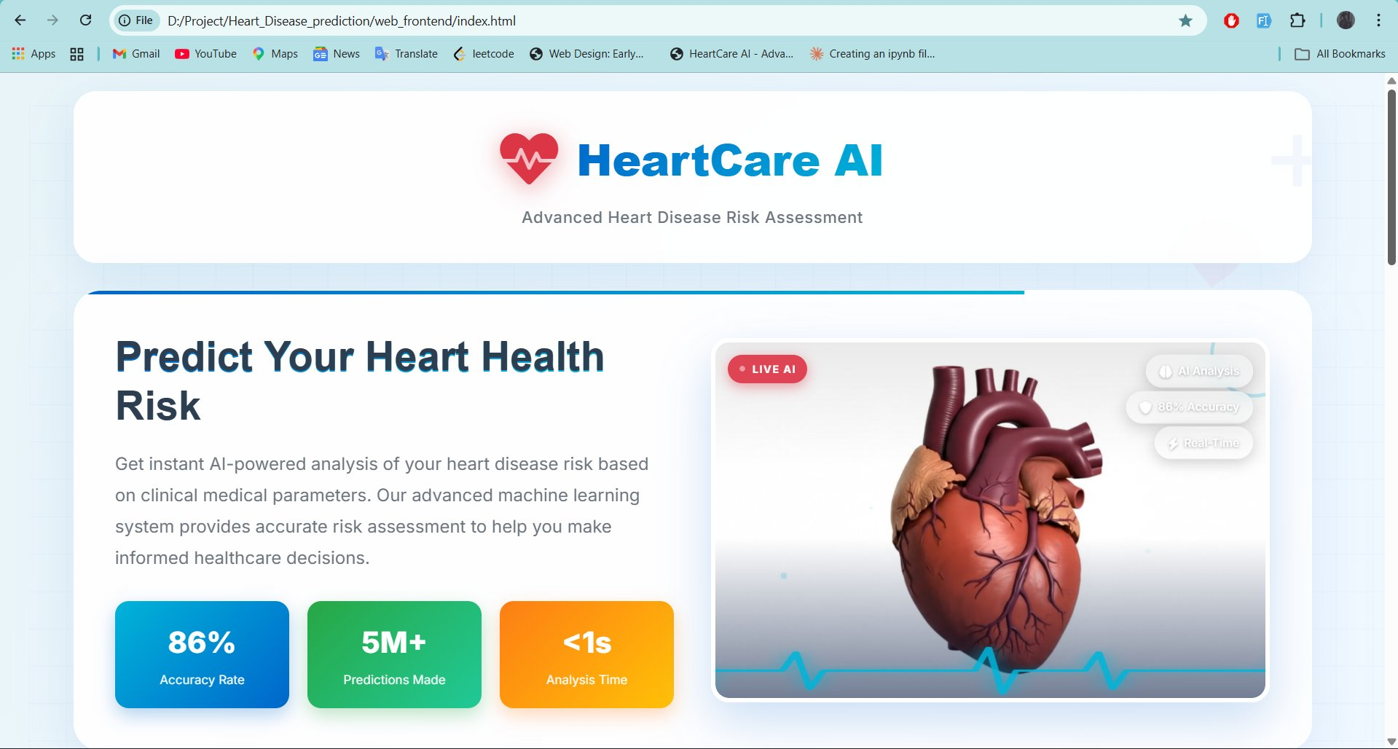

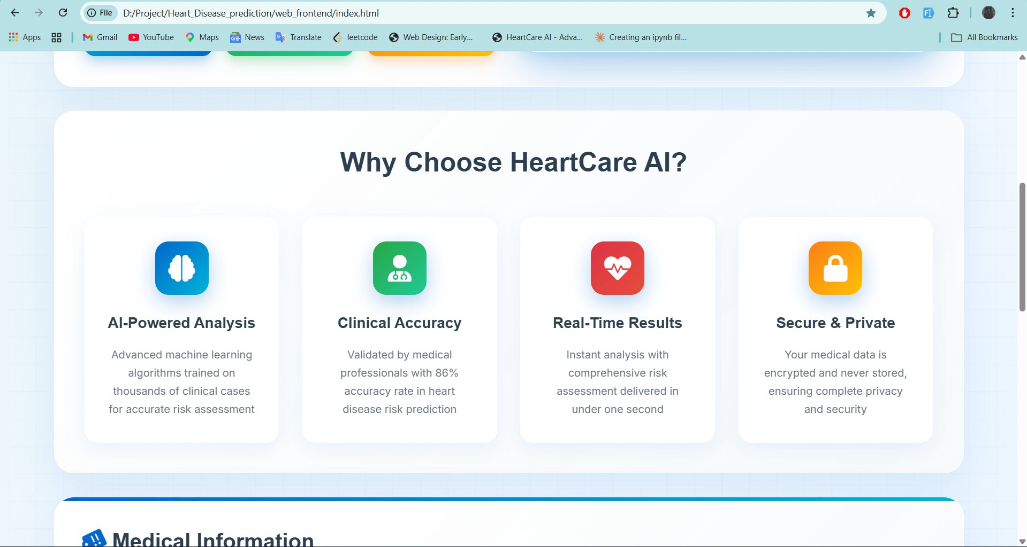

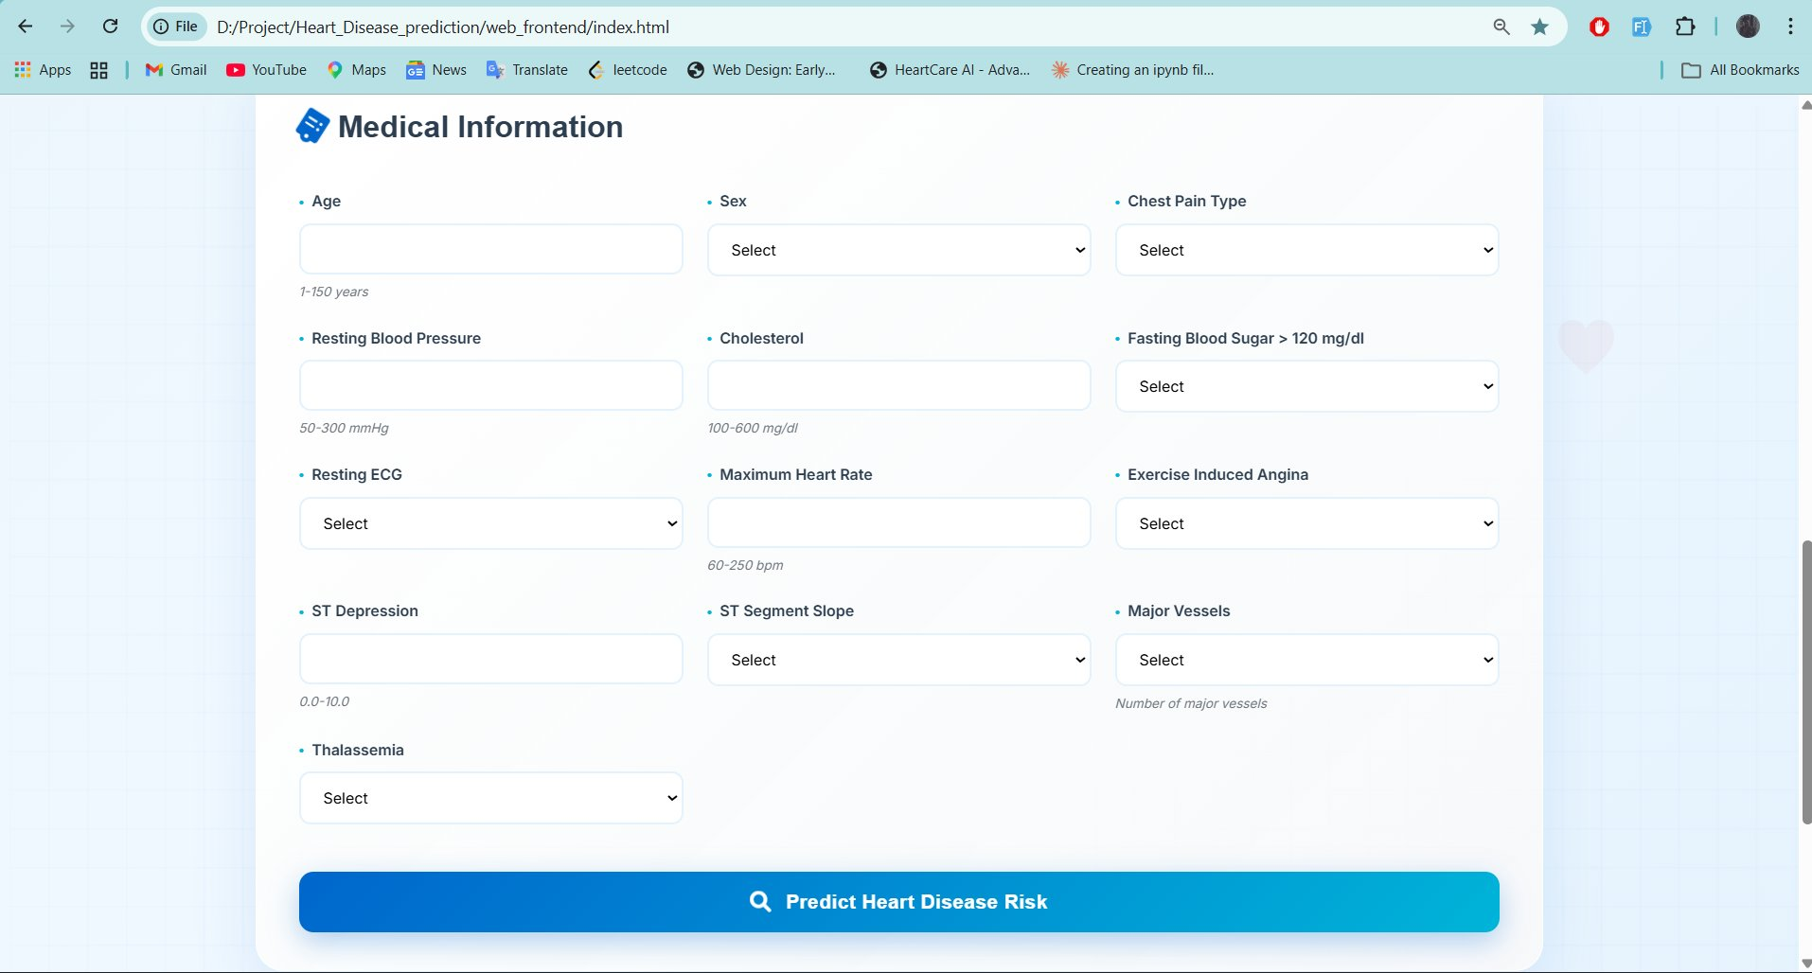
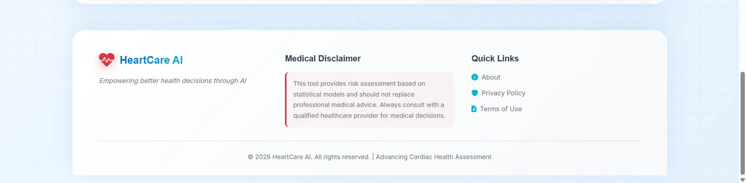

- REFERENCES

1. Chen, T., & Guestrin, C. "XGBoost: A Scalable Tree Boosting System." ACM SIGKDD International Conference on Knowledge Discovery and Data Mining, 2016. Retrieved from: https://dl.acm.org/doi/10.1145/2939672.2939785
(Paper introducing XGBoost, the gradient boosting framework used as the core classification model in HeartCare AI for heart disease risk prediction)

2. FastAPI. "FastAPI Documentation." Sebastián Ramírez, 2024. Retrieved from: https://fastapi.tiangolo.com/
(Official documentation for FastAPI, the Python web framework powering the HeartCare AI backend API, including endpoint definition and request validation)

3. Lundberg, S. M., & Lee, S. I. "A Unified Approach to Interpreting Model Predictions." Advances in Neural Information Processing Systems, 2017. Retrieved from: https://papers.nips.cc/paper/2017/hash/8a20a8621978632d76c43dfd28b67767-Abstract.html
(Original paper introducing SHAP, the explainability framework used in HeartCare AI to attribute risk predictions to individual clinical features)

4. MongoDB. "MongoDB Documentation." MongoDB, Inc., 2024. Retrieved from: https://www.mongodb.com/docs/
(Official documentation for MongoDB, used as the optional persistence layer in HeartCare AI for logging patient prediction records)

5. SHAP. "SHAP Python Library Documentation." SHAP contributors, 2024. Retrieved from: https://shap.readthedocs.io/en/latest/
(Documentation for the SHAP Python library, implementing the SHAP framework used to generate explainability outputs alongside every HeartCare AI prediction)

6. NumPy. "NumPy Documentation." NumPy Developers, 2024. Retrieved from: https://numpy.org/doc/
(Documentation for NumPy, used for numerical array processing during feature preparation in the HeartCare AI machine learning pipeline)

7. Pandas. "Pandas Documentation." Pandas Development Team, 2024. Retrieved from: https://pandas.pydata.org/docs/
(Documentation for Pandas, used for data loading and preprocessing during model training in the HeartCare AI ML pipeline)

8. python-dotenv. "python-dotenv Documentation." Saurabh Kumar, 2024. Retrieved from: https://saurabh-kumar.com/python-dotenv/
(Documentation for python-dotenv, used to load environment variables such as MONGO_URI and API_KEY in the HeartCare AI backend)

9. python-multipart. "python-multipart Documentation." Andrew Dunham, 2024. Retrieved from: https://andrew-d.github.io/python-multipart/
(Documentation for the Python-multipart library, enabling FastAPI to parse form data and file uploads in the HeartCare AI API)

10. OpenAPI Initiative. "OpenAPI Specification." OpenAPI Initiative, 2024. Retrieved from: https://swagger.io/specification/
(Specification for the OpenAPI standard, which FastAPI implements automatically to generate interactive API documentation for HeartCare AI)

11. XGBoost Developers. "XGBoost Python Package Documentation." DMLC, 2024. Retrieved from: https://xgboost.readthedocs.io/en/stable/
(Documentation for scikit-learn, the Python machine learning library used for dataset preprocessing, feature scaling, and model evaluation in HeartCare AI)

12. Pedregosa, F. et al. "Scikit-learn: Machine Learning in Python." Journal of Machine Learning Research, 2011. Retrieved from: https://jmlr.csail.mit.edu/papers/v12/pedregosa11a.html
(Documentation and paper for scikit-learn, the Python machine learning library used for preprocessing and model evaluation)

13. Requests. "Requests: HTTP for Humans." Python Software Foundation, 2024. Retrieved from: https://requests.readthedocs.io/en/latest/
(Documentation for XGBoost Python package, the implementation of the gradient boosting classifier at the heart of the HeartCare AI prediction engine)

14. ReportLab. "ReportLab User Guide." ReportLab Inc., 2024. Retrieved from: https://www.reportlab.com/docs/reportlab-userguide.pdf
(Documentation for ReportLab, a PDF generation library used to produce clinical assessment reports in HeartCare AI)

15. PyMongo. "PyMongo Documentation." MongoDB, Inc., 2024. Retrieved from: https://pymongo.readthedocs.io/en/stable/
(Documentation for PyMongo, the Python driver for MongoDB used for optional prediction persistence)

16. Python Software Foundation. "Python 3 Documentation." Python Software Foundation, 2024. Retrieved from: https://docs.python.org/3/
(Documentation for the Python requests library, used during testing and integration verification of the HeartCare AI REST API)

17. Pydantic. "Pydantic Documentation." Pydantic Services Inc., 2024. Retrieved from: https://docs.pydantic.dev/
(Documentation for Pydantic, used in FastAPI for enforcing strict request validation and type safety across all HeartCare AI API endpoints)

18. Joblib. "Joblib Documentation." Joblib Development Team, 2024. Retrieved from: https://joblib.readthedocs.io/en/latest/
(Documentation for Joblib, used for serializing and loading the trained XGBoost model artifact in the backend)

19. UCI Machine Learning Repository. "Heart Disease Dataset." University of California, Irvine, 1988. Retrieved from: https://archive.ics.uci.edu/ml/datasets/heart+disease
(Source dataset used to train and evaluate the XGBoost heart disease classification model)

20. Uvicorn. "Uvicorn Documentation." Encode OSS, 2024. Retrieved from: https://www.uvicorn.org/
(Documentation for Uvicorn, the ASGI server used to run the FastAPI backend in HeartCare AI)

