Module 4 Linux Essentials   
TASK 4.3

After you have logged into the system, do the following.   
1.Invoke pwd to see your current working directory (there should be your home directory).   
2. Collect output of these commands   
ls -l / *show owner, contents, and attributes files and subdirectories in the main direcrory ‘/’*  
ls *show all subdirectories and files in the current directory*ls ~ *showiall subdirectories and files in the owner’s directory*  
ls -l  *showfull data*  
ls -a *show hide files too*  
ls -la *show full* *data with all hide files and directories*  
ls -lda ~ *show full data only owner’s directory*  
Note differences between produced outputs. Describe (in few words) purposes of these commands.

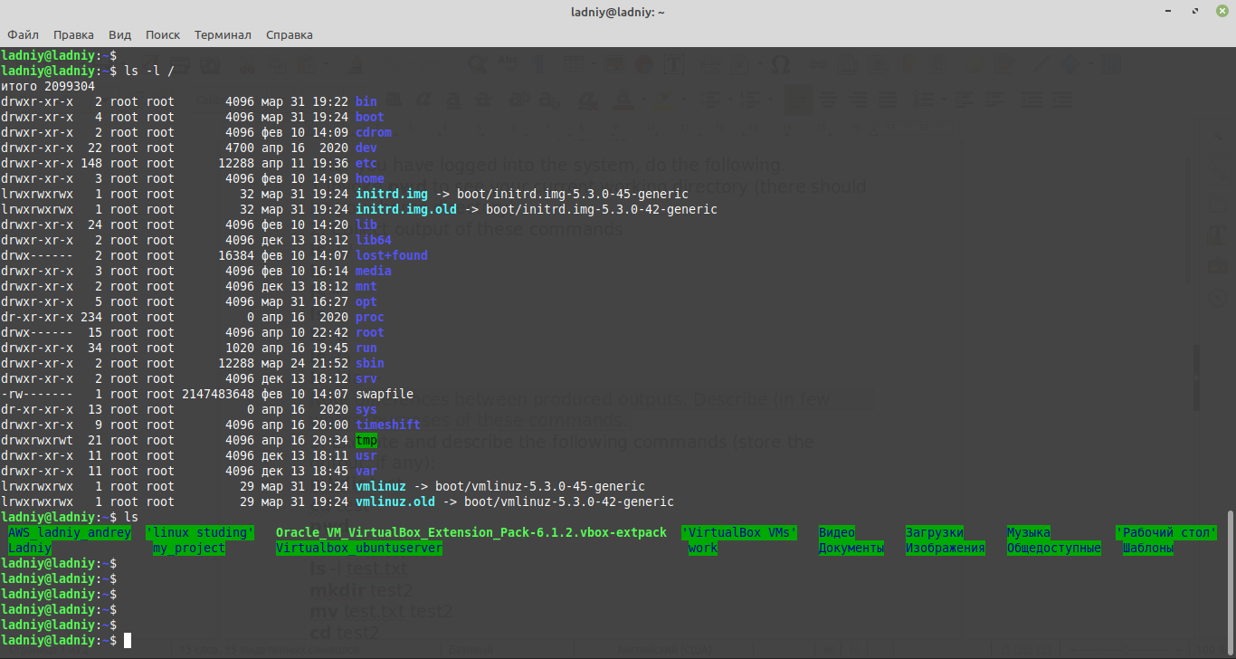

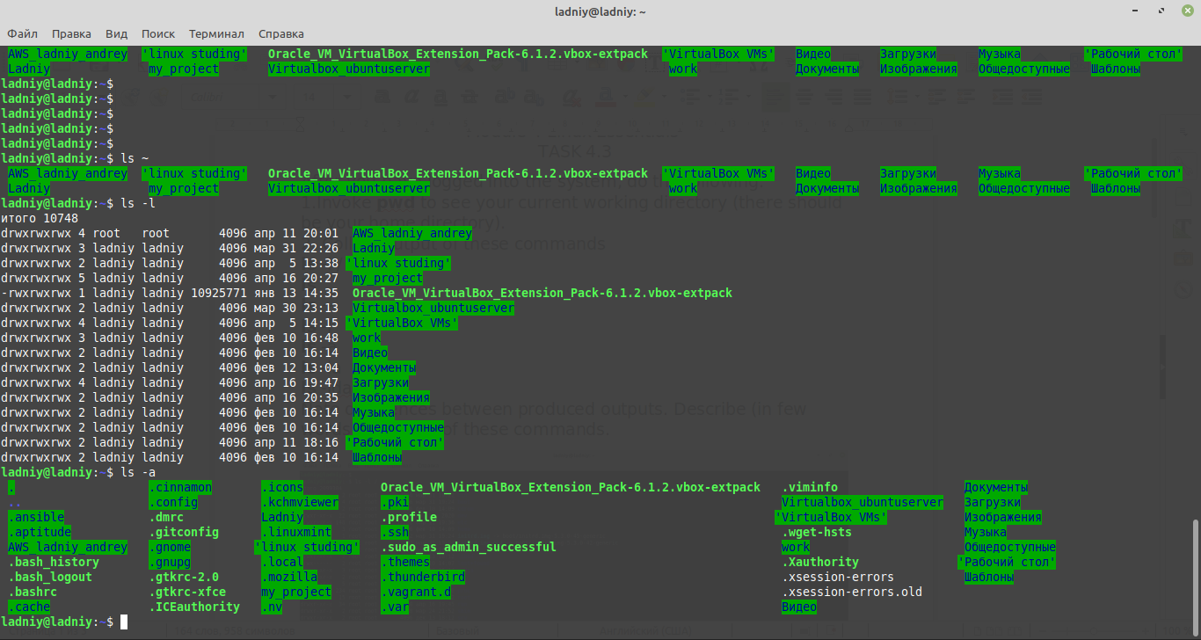

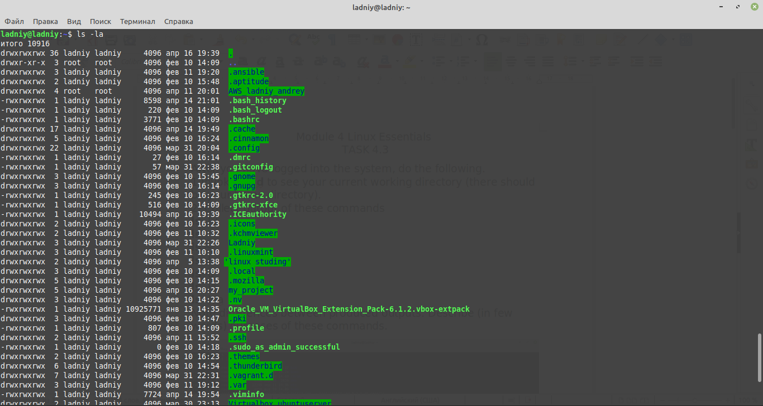



3. Execute and describe the following commands (store the output, if any):   
mkdir test *create ‘test’ directory*  
cd test *enter to ‘test’ directory*  
pwd *show current directory*touch test.txt *create .txt file ‘test.txt’*  
ls -l test.txt *show full data about ‘test.txt’*  
mkdir test2 *create ‘test2’ directory*  
mv test.txt test2 *move file ‘test.txt’ to directory ‘test2’*  
cd test2 *enter to ‘test2’ directory*  
ls *show content*mv test.txt test2.txt *rename ‘test.txt’ to ‘test2.txt’*  
ls *show content*cp test2.txt .. *copy file ‘test2.txt’ to previous directory*  
cd .. *enter to previous directory*  
ls *show content*rm test2.txt *delete file ‘test2.txt’*  
rmdir test2 *delete directory ‘test2’*

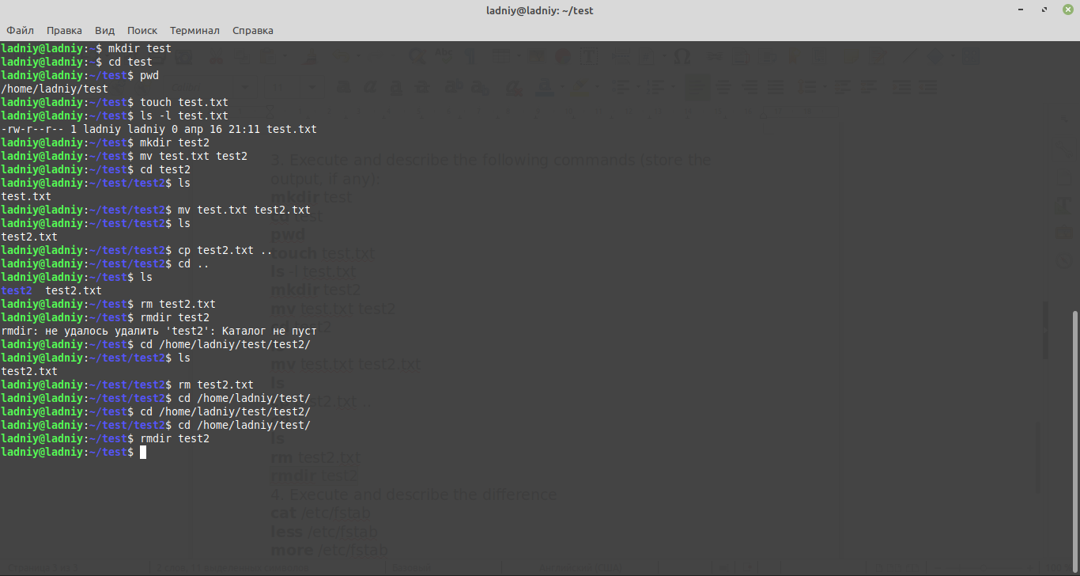

4. Execute and describe the difference   
cat /etc/fstab   
less /etc/fstab   
more /etc/fstab

*All of these command let you show file etc/fstab*

*An fstab file is a text file that contains information about various file systems and storage devices on your computer. This is just one file that defines how the disk and / or partition will be used and how it will be built into the rest of the system.*

5. Add to archive all ‘test’ directories.

a. to the pure ‘tar’;

b. to the zipped ‘tar’ with only tar command;

c. to the zipped ‘tar’ with gzip command;

extract from archives all above.

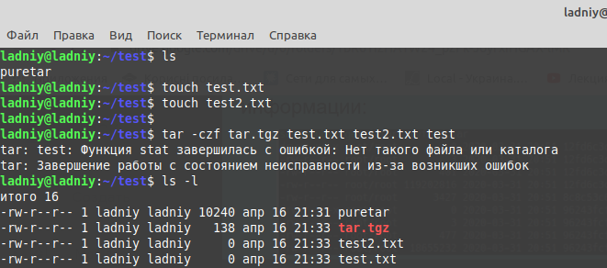

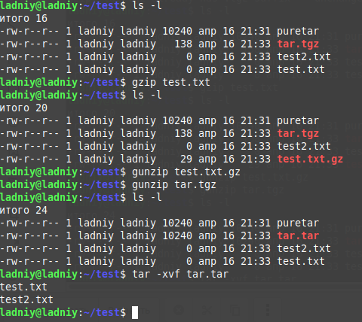

5. Look through man pages of the listed above commands.

*Done.*