EPAM University Programs

DevOps external course

Module 4 Linux & Bash Essentials

TASK 4.5

1. To discover files with active sticky bits, use the following version of the find command:

sudo find / -perm /6000 -type f -exec ls -ld {} \;>setuid.txt

Put into your report a fragment of setuid.txt file. Explain meaning of parameters of the above find command (hint: use find’s man page).

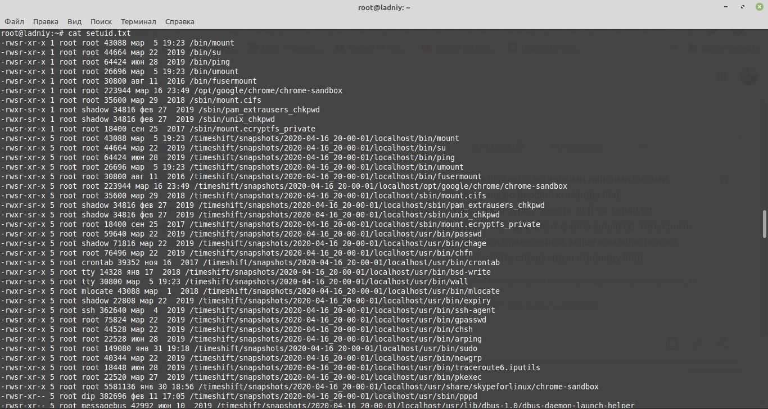

Find – *find file by filename*  
/ - *directory*

-perm /6000 - *find files with a permissions bits 6000 (with Suid 4*** and Sgid 2\*\*\**

-type f – *find only files*

ls -ld {} - *it means root home directory*

> setuid.txt – *import to file .txt*

2. Discovering soft and hard links.

Comment on results of these commands (place the output into your report):   
cd *– go to some directory ($cd ~ for home directory)*

mkdir test *– make directory name “test”*

cd test *– go to “test” directory*

touch test1.txt *– create .txt file*

echo “test1.txt” > test1.txt *– write to text to file*

ls -l . *- show long describe directory*

(a hard link)

ln test1.txt test2.txt *– create hard link for the file test1.txt*

ls -l . *- show long describe directory*

(pay attention to the number of links to test1.txt and test2.txt)

echo “test2.txt” > test2.txt *– write text to the link*

cat test1.txt test2.txt *– show text information both files*

rm test1.txt *– delete .txt file*

ls -l . *- show long describe directory*

(now a soft link)

ln -s test2.txt test3.txt *– create hard link for the file test2.txt*

ls -l . *- show long describe directory*

(pay attention to the number of links to the created files)

rm test2.txt; ls -l . - *delete .txt file and show long describe*

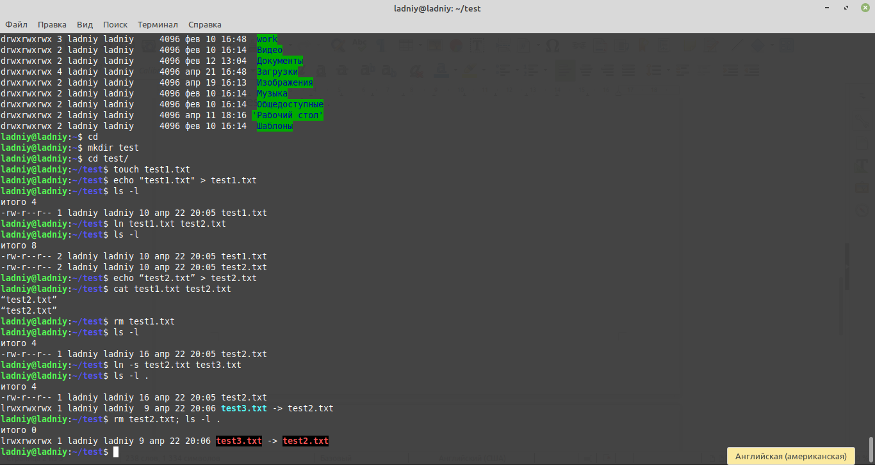

3. I/O redirect.

Execute these commands; comment on the output.

Mount – *show all hard devices like disc,usb and others*

blkid *– CLI utility to show attributes block devices*

mount | grep sda – *show all connected devices by filter “sda”*

dmesg | grep sda – *show discover which hard disks the kernel recognizes, you can search through the messages for the keyword “sda”*

sudo grep -R -e “root” /etc > root_entries.txt *– show words “root” in directory /etc and write to file “ root_entries.txt”*

(place only a reasonable fragment of root_entries.txt into your report)

