EPAM University Programs

DevOps external course

Module 4 Linux & Bash Essentials

TASK 4.6

1. User management. Here we suppose there are at least two users, namely, root and guest.   
(i) Create a new user user

groupadd user

useradd -g user -s /bin/bash -d /home/user -m user

passwd user

id user

ls -ld /home/user

(ii) Log in to the system as “user” (hint use su).

(ii) Edit /etc/passwd to prevent user user from logging in to the system.

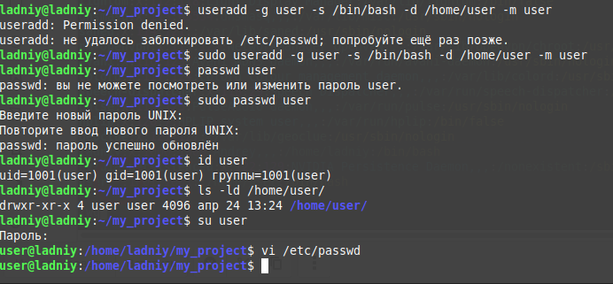



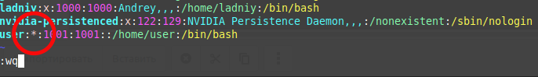

2. Content of /etc/passwd and /etc/group.

(i) Look through /etc/passwd and /etc/group (hint: use less or cat).

(ii) Get data from /etc/passwd and /etc/group about users: root, guest, user (hint: filter by grep).

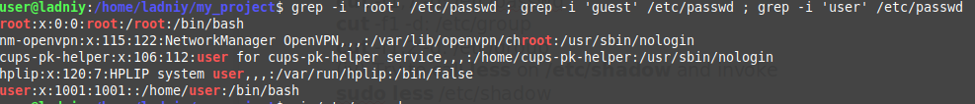

(iii)Parse /etc/passwd and /etc/group with cut.

cut -f1 -d: /etc/passwd

cut -f1,2 -d: /etc/passwd

cut -f1,7 -d: /etc/passwd

cut -f1 -d: /etc/group

cut -f1,2 -d: /etc/group

*DONE*

(iv) Try to call less on /etc/shadow and invoke

sudo less /etc/shadow

man -k shadow

man 5 shadow

Analyse content of /etc/shadow based on what you’ve found in man 5 shadow.

*DONE. Login name, encrypted password, date password change, age and other information.*

3. Dealing with chmod.

(i) An executable script. Open your favorite editor and put these lines into a file

#!/bin/bash

echo “Drugs are bad MKAY?”

Give name “script.sh” to the script and call to

chmod +x script.sh

Then you are ready to execute the script:

./script.sh

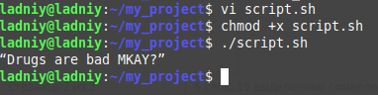

(ii) Suppose, you have logged in to the system as guest. Create directory “testDir” in the /tmp; put some file into testDir and prohibit user user from visiting this directory (i.e. “testDir”).

(iii) Test, if it possible to forbid an owner of some file to read to or write from this file.

