`Android Video Capture Tool

*Version 1.0*

Documentation and User Guide

**Table of Contents**

1) Setting Up Your Environment 2

1.1) Installing Java 2

1.2) Installing the Android SDK 2

2) Using the Android Video capture tool 3

2.1) Tool Description 3

2.2) Android VCT Usage Information 4

44444

# /Users/KevinMoran/Dropbox/Documents/My_Graduate_School_Work/SEMERU/Graphics_and_Logos/semeru-rounded.png/Users/KevinMoran/Dropbox/Documents/My_Graduate_School_Work/SEMERU/Graphics_and_Logos/wmseal.png1) Setting Up Your Environment

## 1.1) Installing Java

To run the Video Capture Tool (VCT) you will need to install Java and set up the proper path variables on your machine. We built the VCT using Java to help facilitate the tool working across different Operating Systems and computing environments. Installing Java is a relatively simple procedure, just follow one of the guides below if you need to install it.

Installation Guide for Windows: <http://docs.oracle.com/javase/7/docs/webnotes/install/windows/jdk-installation-windows.html>

Installation Guide for Mac: <http://docs.oracle.com/javase/7/docs/webnotes/install/mac/mac-jdk.html>

Installation Guide for Linux: <http://docs.oracle.com/javase/7/docs/webnotes/install/linux/linux-jdk.html>

## 1.2) Installing the Android SDK

To run the screenrecord tool which records the screen from an app currently running on an Android device, you must first install the most recent version of the Android SDK. This will allow our program to interface with a connected Android device or emulator connected to a PC or Mac. It is not necessary to install the full-fledged version of the SDK that includes Android Studio, but rather, you can simply download the SDK tools, and use the built-in installer to download the platform-tools. This process involves the following steps:

1. Download the Android SDK command line tools (See Picture below) from the following link, you will need to scroll down to the bottom of the page for the correct download: <https://developer.android.com/studio/index.html>

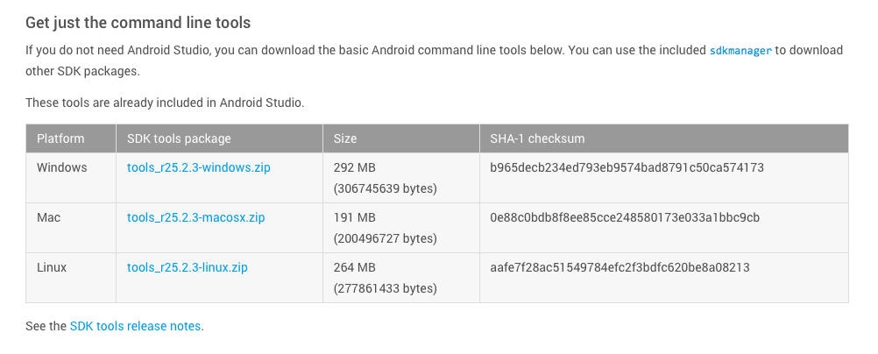

1. Unzip the file in the location of your choice. For convenience, it is probably best to place this in your home or user directory.
2. After you unzip the file, navigate to the tools folder and run the android (or android.bat) executable file to bring up the SDK Manager.
3. 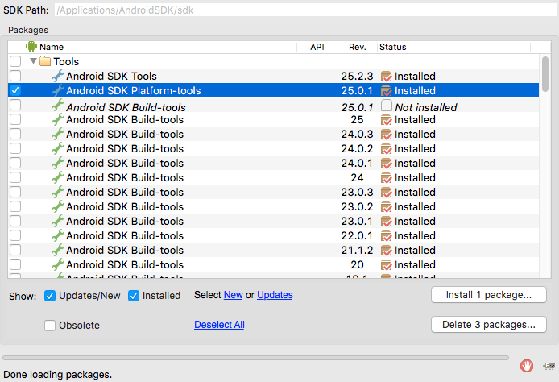After the Android SDK manager window opens, the box to download the Android SDK Platform tools, and click the “Install Packages” Button. See the red areas of the screenshot below for more detail:

# 2) Using the Android Video Capture Tool

## 

## 2.1) Tool Description

The Android Video Capture Tool allows for the screen capture of the current state of a target Android application screen. Additionally, VCT will capture the events performed by the user in a log file. The tool is self-contained within a jar file, but depends on the Android SDK to interface with a physical Android device or emulator. The executable jar file is called “VCT.jar”. To use this tool there are a few setup requirements:

1. Since you will be using a physical device it requires to have enabled the developer features and then enable USB debugging. This allows the phone to connect to a PC or Mac using the Android Debug Bridge (adb) which our program uses to interface with the device. Here is a link that describes the simple procedure to enable this: <https://goo.gl/CXei8H>
2. Next, connect the device to your computer using the provided USB cable.
3. Then install the application for which you would like to capture UI-information. Then launch the app and navigate to the screen for which you would like to capture data. That’s it! You are now ready to run the java program to capture the screen information.



## 2.2) Android VCT Usage Information

To use the VCT execute the following command in the console:

java –jar VCT.jar

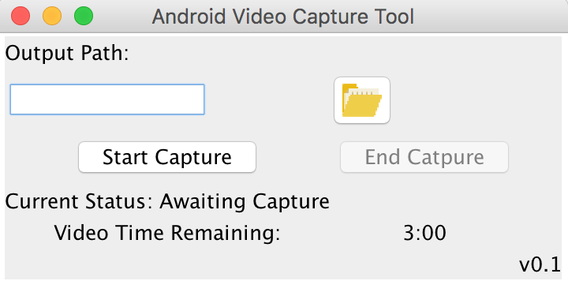A description of the program arguments are as follows:

Output Path: This is the full (not relative) file path for the output location of the video and the log generated by the program. This file path should end in a folder and the icon folder  can be used to select the folder manually. For example: /Users/KevinMoran/dev/app-1/video1

Start Capture: This is the button to Start Capturing recording the video and the inputs generated by the user.

End Capture: This is the button to stop the capture of the video and will transfer the files from the connected device to the output path.

Video Time Remaining: It shows the time limit for video capturing allowed by the Android SDK.