
Mestrado em Engenharia Informática – Cibersegurança e Administração de Sistemas.
Assignment 1
APRAU

1250515 Diogo
1220638 Marcelino
1131504 Joana Soares

28/10/2026
Instituto Superior de Engenharia do Porto
Contents
1 i
2 Introduction 2
3 Methodology 3
3.1 Wireshark 3
3.2 Analysis methodology 4
4 Conclusions 6
5 References 7

Abstract
The research employs exploratory data analysis and supervised learning algorithms on a 2,000 patients' cardiometabolic dataset given to Group 26. They include continuous target variable prediction (target_regression) and classification into one of the three diagnostic classes (target_class). Simple vs multiple linear regression; Logistic Regression and shrinkage LDA models that balance classes; holdout, cross-validation, leave-one-out and bootstrap methods; and L1 & L2-regularization-based feature selection are considered. Cross-validation on training only and 20% holdout stratification are used for evaluation.
For regression task, there is a very weak linear prediction signal since the chosen two features linear model gets holdout R² = 0.0037 and RMSE = 38.8743. Classification problem is significantly imbalanced: percentages of classes are 64.35%, 32.20% and 3.45%. LDA is better than Logistic Regression for macro-F1 in training, while for holdout Logistic Regression recognizes more samples from the small HT_HY class. L1-selector chooses 19 features out of 40 categorical ones, but its cross-validation macro-F1 is inferior to the macro-F1 of the full L2-regularized model.
Keywords: exploratory data analysis; linear regression; logistic regression; linear discriminant analysis; class imbalance; bootstrap; regularization; feature selection.

Introduction and research objectives
In this assignment, APRAU, we need to analyze the patient-level clinical and lifestyle variables with the help of several machine learning algorithms. There is a dataset consisting of demographic factors, anthropometric indices, laboratory tests, and behavioral variables along with two targets. In this study, we will be comparing the machine learning methods through an open and replicable experiment and will assess their generalization abilities [1].
There are four questions that we need to answer:
- What are the features and relations of the dataset of Group 26?
- Can one predictor or a combination of several predictors predict target_regression precisely?
- How does Logistic Regression perform in comparison to LDA in an imbalanced three-class problem, how the resampling impacts the stability of results?
- Can sparse regularizer decrease the complexity of the model and improve classification?
Class labels (DI, DI_HY, and HT_HY) and the units of measure of target_regression were reproduced as they were stated in the initial dataset; no conclusions about clinical meanings and measurements were made on our part.

Dataset and exploratory data analysis

Approach and data integrity
The initial exploration was carried out by investigating the dimensions of the dataset, the types of data, missing values, duplicated records, univariate distributions, and the proportion of classes for the diagnostic class. Descriptive statistics of mean, standard deviation, and quantiles were computed for numerical attributes, whereas descriptive statistics of counts were computed for categorical attributes. Linear relationships of the regression target were investigated through pearson correlations, while exploratory chi-square tests were carried out for classification patterns through class-conditioned boxplots.
Data property | Observed result
Records / columns | 2,000 / 35
Original predictors / targets | 33 / 2
Column types | 22 numeric (21 float, 1 integer); 13 text
Missing values / exact duplicates | 0 / 0
Regression target | Mean 138.192; SD 42.366; range 70–300

Diagnostic class imbalance
Class | Patients | Share
DI_HY | 1,287 | 64.35%
DI | 644 | 32.20%
HT_HY | 69 | 3.45%

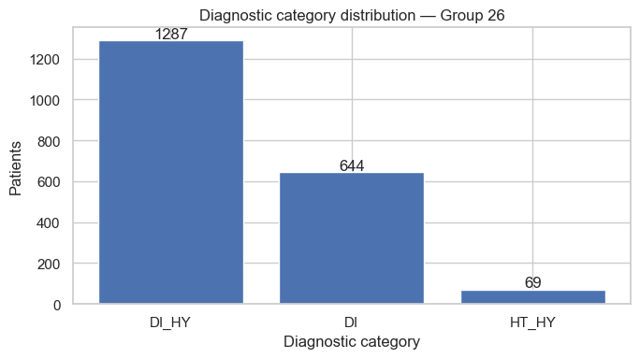
Figure 1. Diagnostic target frequencies in Group 26 (notebook cell 5).
Diagnostic classes are heavily unbalanced. A model that would always predict DI_HY class obtains 64.35% accuracy on the whole dataset without finding any instances of DI and HT_HY. For these reasons, we apply macro-F1, balanced accuracy, and recall for each class as the key metrics. In addition, HT_HY has a small number of samples, making hold-out estimation error-sensitive.

Numerical distributions and associations
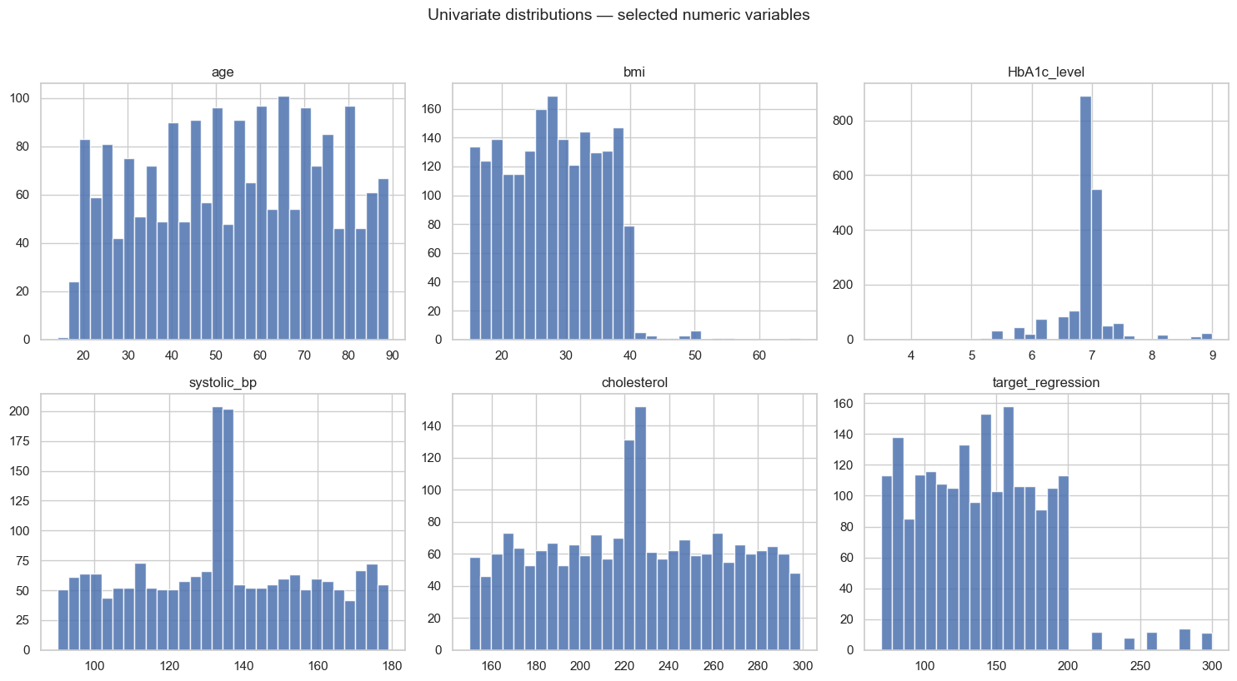
Figure 2. Selected numeric distributions, including the continuous response (notebook cell 7).
Mean age is 53.681 years (sd 20.139) and mean BMI is 27.891 (sd 7.429). Target_regression is characterized by a mean of 138.192 and sd of 42.366. The Pearson correlation of BMI with the target variable is highest (r = +0.0694); HbA1c comes in second place (r = +0.0620) and triglycerides (r = +0.0479) third. All the above correlations are weak linear relations, which means that even if the regression model fits the data well, it still may not explain much. Correlation does not imply causality.
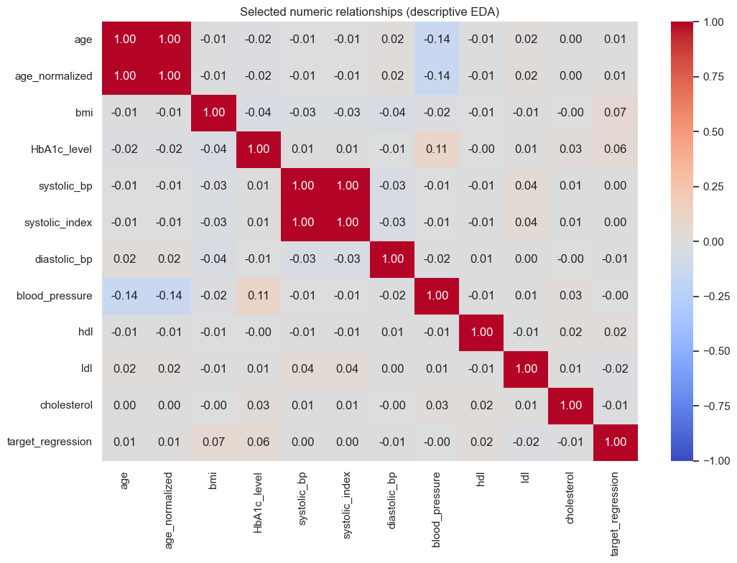
Figure 3. Correlations between selected numeric measurements and the regression target (notebook cell 8).
Chi-square associations of diagnosis revealed the following significant factors: low_hdl_cholesterol (p-value < 0.00001 from the rounded notebook table), smoking (p = 0.00019), sugar_consumption (p = 0.00484) and education_level (p = 0.01033). The mentioned p-values are unadjusted and are only indicative in terms of multiple comparisons, without implying any kind of advantage or relationship. In regard to mean HbA1c levels across the classes: 6.91 in DI, 6.95 in DI_HY, and 5.52 in HT_HY, the last one being less common.

Redundant and uninformative predictors
Variable “calcium_baseline” is a constant with a value of 9.42. The variable “systolic_index” is an exact copy of the variable “systolic_bp,” while the variable “age_normalized” is a perfect linear transformation of “age” (r = 1.0). We hence did away with these three variables and kept the original variables “age” and “systolic_bp.” There are 30 original input columns in the model matrix.

Experimental design and preprocessing
Splitting was performed only once, using fixed random seed 26 and stratification by target_class: 1,600 samples for training (80%), 400 samples for hold-out (20%). Class counts for training samples: DI_HY = 1,030, DI = 515, HT_HY = 55; class counts for test samples: DI_HY = 257, DI = 129, HT_HY = 14.
Both prediction tasks share the same patient split. However, none of the targets is used as a feature for the other task.
The preprocessing was incorporated in scikit-learn pipelines. Numerical features were median-imputed and standardized; categorical features were mode-imputed and one-hot encoded. The provided dataset does not have any missing values; however, imputation makes the pipeline reusable. Preprocessing fitting inside each validation fold prevents information leak.
Cross-validation on training was used for choosing a candidate approach; hold-out sample was used for descriptive evaluation only.
In the regression setting we present mean absolute error (MAE), root mean squared error (RMSE) and coefficient of determination (R²). Lower MAE/RMSE and higher R² correspond to better scores; test R² may be negative. In the classification setting we focus on macro-F1 (mean of class-wise F1), balanced accuracy (mean of class recall), accuracy and confusion matrices.

Simple linear regression

Approach
This project asks for a model that is based on just one feature and a process that searches for the best such feature [1]. For every possible numerical feature we constructed an OLS regression in isolation. The five-fold cross-validation on the training set evaluated each of these models, and the one with lowest mean RMSE on the validation sets was selected.

Results and interpretation
Predictor | 5-fold CV RMSE | 5-fold CV R²
bmi | 43.0517 | −0.0009
HbA1c_level | 43.0755 | −0.0021
crp_level | 43.1149 | −0.0037
hdl | 43.1162 | −0.0037

BMI ranked first, although all cross-validation R² values listed above are approximately zero or negative. The fitted regression equation, expressed on the original BMI scale, is:
predicted target_regression = 127.585 + 0.3926 × bmi
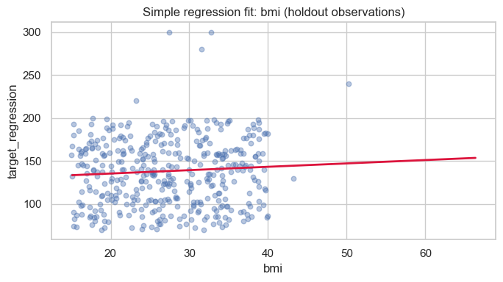
Figure 4. BMI-based simple linear fit and the independent test observations (notebook cell 16).
Holdout metric | BMI-only linear regression
MAE | 32.1912
RMSE | 38.8853
R² | 0.0032

With regard to the value of holdout R² being slightly positive, we see that it explains a bit less than 1% of variation relative to a constant prediction. The slope represents the estimated average relationship of 0.3926 target units for each BMI unit on the basis of a fitted linear model, not a causal relationship.

Multiple linear regression

Approach and feature-set comparison
In order to find out whether multiple clinical data would help in improving the prediction model’s accuracy, five different models were compared:
- the top 2, 4, and 8 most correlated with the training fold clinical features;
- the fixed set of nine variables;
- all 30 non-redundant predictors (including categorical encoding where needed).
The ranking was done within the validation/training folds to avoid leakage from feature selection.
Feature set | Variables | CV RMSE | CV R²
Top 2 numeric | 2 | 43.0421 | −0.0007
Top 4 numeric | 4 | 43.1368 | −0.0053
Clinical indicators | 9 | 43.1421 | −0.0057
Top 8 numeric | 8 | 43.1785 | −0.0076
All cleaned features | 30 | 43.3118 | −0.0142

The configuration selected utilized BMI and HbA1c level. The all-feature model performed worse overall in training cross-validation, suggesting the hypothesis that introducing more weak features increases estimation variance without increasing information.

Holdout regression comparison
Model | MAE | RMSE | R²
Training-mean reference | 32.2331 | 38.9979 | −0.0026
Simple: BMI | 32.1912 | 38.8853 | 0.0032
Multiple: BMI + HbA1c | 32.1896 | 38.8743 | 0.0037

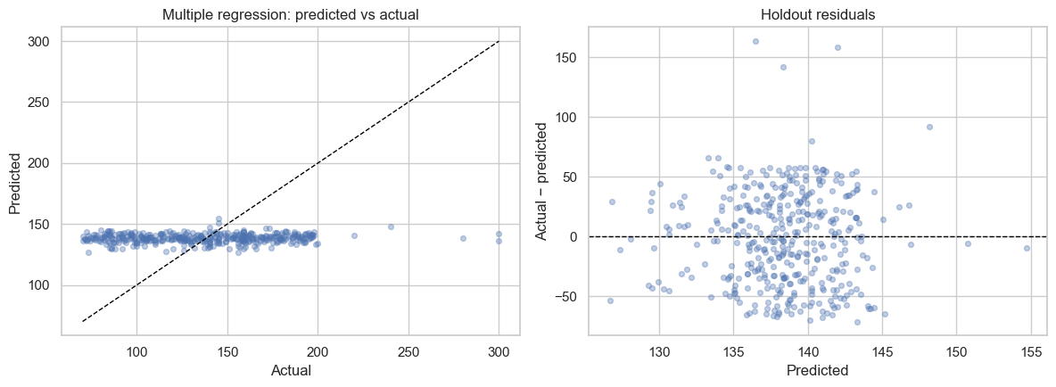
Figure 5. Predicted-versus-observed response and residuals for the selected multiple model (notebook cell 19).
The RMSE for the multiple model (38.8743) is the smallest compared to that for the simple model (38.8853) and training mean reference (38.9979); however, its difference with the other two is very minimal. The value of R² is still almost equal to zero at 0.0037. Therefore, based on the results of the experiment, the target is hard to be predicted linearly from the given characteristics.

Classification: Logistic Regression versus LDA

Approach
We explored the diagnosis prediction task of three classes through two linear classifiers and a majority-class baseline. The Logistic Regression classifier was trained with class weighting in order to combat the issue of fewer instances of the HT_HY class. LDA employed pooled covariance with automatic shrinkage in order to mitigate correlation among features and uses class priors by default, contrary to the weighted logistic classifier. The model was chosen based on five-fold cross-validation training and macro-F1 scoring.
Algorithm | 5-fold macro-F1 | SD | Bal. accuracy | Accuracy
LDA (shrinkage) | 0.5860 | 0.0292 | 0.6193 | 0.6612
Logistic Regression | 0.5768 | 0.0153 | 0.6382 | 0.5544
Majority baseline | 0.2611 | 0.0000 | 0.3333 | 0.6438

The LDA model outperformed Logistic Regression based on the pre-specified F1 metric criterion for training-CV by around 0.0092; however, the latter performed better in terms of balanced accuracy. Such a gap can be considered rather small compared to the variation between folds.

Independent holdout results
Algorithm | Accuracy | Balanced accuracy | Macro-F1
Logistic Regression | 0.5150 | 0.5406 | 0.5176
LDA (shrinkage) | 0.6450 | 0.5051 | 0.5130
Majority baseline | 0.6425 | 0.3333 | 0.2608

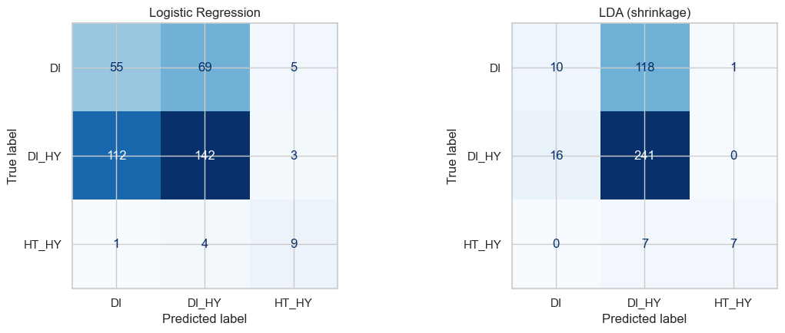
Figure 6. Three-class holdout confusion matrices (rows: true classes; columns: predictions; notebook cell 23).
True diagnosis | Logistic recall | LDA recall | Holdout support
DI | 0.426 | 0.078 | 129
DI_HY | 0.553 | 0.938 | 257
HT_HY | 0.643 | 0.500 | 14

LDA achieves 64.5% accuracy, just slightly beating out the 64.25% accuracy from majority baseline, due mostly to its ability to detect DI_HY with 0.938 recall whereas it detects only 7.8% of DI patients. Logistic Regression has lower accuracy (51.5%), although higher DI recall (42.6%) and HT_HY recall (64.3% compared to 50.0%). The latter is based on 9 out of 14 HT_HY patients for Logistic Regression versus 7 of 14 for LDA; two patients make a big difference for minority recall. As such, holdout macro F1 scores are similar (0.5176 versus 0.5130) and neither method has shown superior results from one test sample. The key thing here is that LDA is still the algorithm chosen by training macro-F1.

Resampling and variance analysis

Approach and measures
The homework task requires holdout, 5-fold CV, 10-fold CV, leave-one-out CV, and bootstrap, and variance analysis [1]. For the comparison of the two models inside the training set of 1,600 cases, the following methods were used: 15 stratified holdout tests with 25% validation; 5-fold and 10-fold stratified CV; 60 bootstraps based on the evaluation of OOB samples; and exact leave-one-out on stratified training subset of 400 cases. Each of these resamples performed a complete pipeline fit. The macro-F1 classification score metric was used in all cases.

Repeated assessment results
Model / procedure | Mean macro-F1 | Score SD | Score variance
Logistic · 5-fold CV | 0.57685 | 0.01530 | 0.00023
Logistic · 10-fold CV | 0.57597 | 0.05878 | 0.00346
Logistic · repeated holdout | 0.57270 | 0.02454 | 0.00060
Logistic · bootstrap OOB | 0.57404 | 0.02813 | 0.00079
LDA · 5-fold CV | 0.58598 | 0.02921 | 0.00085
LDA · 10-fold CV | 0.58440 | 0.03897 | 0.00152
LDA · repeated holdout | 0.58747 | 0.01855 | 0.00034
LDA · bootstrap OOB | 0.58245 | 0.02338 | 0.00055

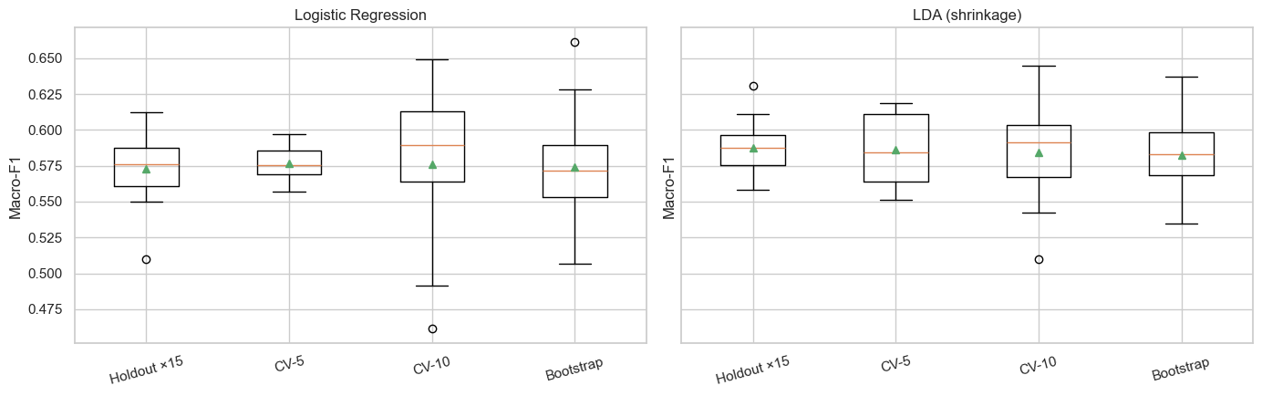
Figure 7. Distribution of macro-F1 scores across resampling procedures (notebook cell 30).
The minimum standard deviation of scores for Logistic Regression is obtained from five-fold CV (0.01530), while the maximum is from ten-fold CV (0.05878). The minimum and maximum standard deviations of LDA are from repeated holdout (0.01855) and ten-fold CV (0.03897) respectively. Therefore, increasing the number of folds does not automatically lead to the reduction of the standard deviation of fold scores; smaller validation folds can give more volatile metrics. This standard deviation measures the volatility of the estimated scores with respect to each experimental setup, but not an estimator of the variability of the prediction of the model.

LOOCV and bootstrap caveats
LOOCV on 400-case subset | Accuracy | Balanced accuracy | Pooled macro-F1
Logistic Regression | 0.5475 | 0.6327 | 0.6275
LDA (shrinkage) | 0.6075 | 0.5435 | 0.5544

Exactly LOOCV analysis was done on a stratified subset of 400 training observations: 400 fitted models per classifier. Prediction aggregation was required to compute macro-F1, as only one held-out observation cannot provide any statistically meaningful F1 score across three classes. It is not full dataset LOOCV analysis, and the obtained estimates are calculated on training samples of size 399, thus should not be considered comparable with the CV estimates on the whole dataset of size 1,600. It is an important difference between LOOCV and CV which needs to be highlighted during the oral examination.
The bootstrap experiment consisted of 60 draws of size 1,600 observations each. The number of out-of-bag observations per draw is approximately 588.4; all draws are valid and are used for both classifiers, as no draws contain missing classes. The mean values for the bootstrapped OOB are similar to the mean values from cross-validation; however, resampled datasets are not independent test samples.

Regularization and classification feature selection

Approach
The assignment defines Ridge and Lasso methods in the framework of classification feature selection [1]. Ridge and Lasso classifiers were chosen to be Logistic Regression with L2 penalty as the Ridge method, logistic regression with L1 penalty as one versus rest Lasso model, and logistic regression with L2 penalty applied after L1-based feature selection. The mentioned models represent classifiers' equivalents of L1/L2 norms in Ridge and Lasso regularization, rather than regular ridge and lasso regressions for continuous outcome variable. Model feature selector is fitted in the folds separately to prevent leakage.
There are still 30 predictors left after structural cleaning, but the process of one-hot encoding gives 40 predictors for model. Reduced model selection mask is applied to 40 predictors after encoding; it does not mean that there are only 19 original clinical predictors.

Validation and holdout results
Variant | CV macro-F1 | CV SD | Holdout macro-F1
All: Logistic L2 | 0.5768 | 0.0153 | 0.5176
All: OvR Logistic L1 | 0.5206 | 0.0263 | 0.5545
Reduced: L1 select + Logistic L2 | 0.5250 | 0.0311 | 0.5544

The all feature L2 classifier performed better than the other classifiers in the pre-specified five fold training CV selection stage (macro F1=0.5768). The selected model had lower score in this selection process (0.5250). It is important to note that both the L1 classifier and the selected model achieved higher macro F1 score in the test stage than the all feature L2 classifier. This is just an indication of variability of evaluations and not an excuse for changing the model based on test results.
Feature selection summary | Value
Full encoded predictor count | 40
Retained by sparse L1 selector | 19
Removed encoded predictor columns | 21
Nonzero encoded columns in all-feature OvR L1 model | 38 of 40

The chosen columns are: age, BMI, HbA1c, cholesterol, sleeping hours, triglycerides, blood pressure, diastolic blood pressure, alcohol consumption, HDL, alternate LDL, and eight indicator variables for categories (age group, smoking, stress, LDL flag, sugar consumption, education and occupation). Sparse models may increase interpretability, but variable selection can be unstable when there are correlated variables; choosing a variable does not prove causation.

Critical discussion and study limitations
The most striking result is not the winning model itself, but the contrast between two kinds of prediction tasks. The regression problem has almost no linear relationship between its output and input features: the maximum holdout R² is around 0.004, while the difference from the trivial baseline is negligible. In turn, classification problem has some hidden structure, but the significant imbalance calls for the usage of proper metrics and decision rules. LDA predicts correctly for the major class and poorly for DI, whereas logistic regression is more balanced in that regard, but makes much more errors on the major class.
Our protocol eliminates several usual errors: a common stratified holdout set, fold-local data processing, ranking of features on training data only and a baseline for each prediction task.
However, the following limitations affect the interpretation of the results:
• The minority class comprises 69 individuals in total and 14 in the final hold-out; the statistical sensitivity of minority recall to the class imbalance is dependent on very small numbers of cases.
• The selection of class_weight="balanced" for Logistic Regression as compared to empirical priors in LDA affects the nature of the class imbalance handling, thus limiting the pure algorithmic-only interpretation of the results.
• The resampling standard deviations are calculated for various numbers of samples and partitions; they cannot be considered to be estimates of variance and are therefore purely descriptive.
• LOOCV was done only on a subset of 400 training observations instead of all 2,000 or all 1,600 training records.
• L1/L2 Logistic Regression applies appropriate regularization for the categorical target variable; it does not use the objective function of the Ridge/Lasso regression.
• The data is in cross-sectional form. External independent validation was not carried out.
Future works include nested cross-validation to select the model and penalty, uncertainty intervals for macro-F1 score and recall for each class, investigation of other class prior assumptions, and other models besides linear ones. This is only a suggestion and was not an experiment performed in the uploaded notebook.

Conclusion
Our team (Group 26) has done the necessary explorations for exploratory, regression, classification, resampling and regularization for the provided dataset of patients. There is very low regression in the model with no linear dependency. The BMI and HbA1c is selected as the two-feature model and test R² is 0.0037. In three-class classification, training CV preferred shrinkage LDA by just a little bit on macro-F1 (0.5860 vs. 0.5768). However, the balanced Logistic Regression found more examples in the two rare classes during the holdout. Resampling indicated that the score dispersion varies depending on the model and procedure. Feature selection using L1 shrunk the encoded input from 40 to 19 columns without surpassing the whole L2 in training CV.
The takeaway here is to have clear validation rules prior to analyzing test data, taking into account class-wise cost and not only accuracy, and to be honest about predictions' limits. The outcomes here can be considered as a teaching example of machine learning comparison.

References
[1] Instituto Superior de Engenharia do Porto. (2026/2027). Trabalho_APRAU_2026_27_step1: Aprendizagem Automática assignment (version 1.0), Sections 2–6. Course handout.
[2] Gomes, E. F. (2026/2027). Linear Regression; Classification — Logistic Regression & Discriminant Analysis; Evaluation & Resampling; Linear Model Selection & Regularization. APRAU lecture slides, ISEP.
[3] James, G., Witten, D., Hastie, T., & Tibshirani, R. (2023). An Introduction to Statistical Learning: With Applications in Python. Springer. https://doi.org/10.1007/978-3-031-38747-0
[4] scikit-learn developers. (n.d.). scikit-learn user guide and API documentation. https://scikit-learn.org/stable/ (software version observed in notebook: 1.9.1).
[5] Group 26. (2026). APRAU_Group26.ipynb and dataset_grupo_26.csv. Executed analysis notebook and group-assigned dataset (primary sources for all report figures, tables and performance values).

Appendix A. Reproducibility and submission notes
Notebook: APRAU_Group26.ipynb. The uploaded notebook comprises 37 cells, which include 21 executed code cells and figures. Environment: Python 3.13.9 and scikit-learn 1.9.1. Seed: 26. Holdout experimental split: 80/20 stratified. All numerical results presented in this Word document were typed from the saved notebook results.

Methodology
This assignment has adopted a practical approach where there is a combination of network traffic analysis and security principles learned in SEGSI practical laboratories.
The first part involved analyzing the packets provided in order to know the systems in use, the protocols and operations carried out together with the security considerations. Each packet was analyzed individually in a consistent manner.
The second part was carried out practically through various lab exercises involving system security and access control. This was done in a controlled environment. Screenshots were taken during the process of carrying out the experiment and the configurations documented. In particular, the individual exercise involved discretionary access control lists (DACL) in Microsoft Active Directory.
The conclusions in the report are based on the observations drawn from the analysis of packets. Where the packet did not give enough information to draw a particular conclusion, it was avoided to make an assumption.

Wireshark
The first tool used to perform the network packet analysis was Wireshark. The program enabled examining the captured data on various protocol stack layers and studying individual packets.
For each capture file, the first stage of the analysis was done by performing an inspection of the packet list in order to find out what protocols were used, the source and destination addresses, the transport protocols, and ports. If necessary, the Wireshark filters were used to narrow down the traffic and study only that which relates to the chosen protocol.
The packet details pane was used to examine specific attributes of protocols. This stage is especially important for RADIUS analysis since attributes such as RADIUS Message Type, User-Name, Service-Type, NAS Information, and Microsoft-specific Vendor Attributes are studied.
For connection-oriented protocols, the communication was also studied in its entirety instead of only as packets. Where possible, the follow TCP stream feature of Wireshark was utilised to determine application-level transactions. This allowed the analysis of the authentication process and further FTP commands in the FTP capture.
A series of screenshots was taken using Wireshark to provide evidence in support of the findings of the report. However, the screenshots provided evidence related to the topic at hand and were not for all packets in the capture.

Analysis methodology
The same analysis methodology was used to study the packet captures. The aim of this procedure was to shift from the identification of the communication to its technical understanding and, ultimately, to security implications of that communication.
The following steps were done during the analysis:
1. Initial examination of the capture – The capture was reviewed to get information about its size, main protocols used and basic communication characteristics.
2. Identification of participants – The IP addresses, ports and system identifiers of both the source and destination hosts were reviewed to find out their roles (client, server, NAS and so forth).
3. Protocol identification – The main application and transport layer protocols were identified. Then, relevant protocol characteristics, messages, ports and communication methods were examined.
4. Reconstruction of the communication – Packets of the same communication were analyzed chronologically to understand what actions were performed. If needed, Wireshark stream analysis was used for analyzing full application-layer exchanges.
5. Collection of evidence – Relevant packets’ fields, commands, responses and other protocol parameters were identified. Screenshot samples were included in case they were directly related to the findings presented in the report.
6. Security analysis — The observable behavior was analyzed in terms of security by looking into various factors like authentication, authorization, confidentiality, information disclosure, encryption methods, privilege management and information about infrastructure being exposed.
7. Mitigation analysis — Each of the issues discovered was then subjected to an analysis of what could be done in order to mitigate the risks. This involved things like better forms of authentication, encryption of communication channel, network segmentation, principle of least privilege, better credential policies, etc. depending on the characteristics of each scenario.
Particular care has been taken not to confuse observable evidence with inference. For instance, in the FTP analysis, the evidence clearly shows how the authentication details could be recovered and that the credentials are accepted by the server. It also provides the names of the executables that have been transferred over FTP. However, the packet capture does not prove the maliciousness of those executables.
Similarly, the RADIUS capture was analyzed on the basis of the data available in the packets. In the capture, the username, NAS information, and MS-CHAP challenge-response data is exposed, although not the user’s password in plaintext form.
With respect to the practical access control task, the methodology for this task involved implementation of the necessary permissions in Microsoft Active Directory and testing of the resulting behavior through test accounts. DACLs were used to delegate particular administrative tasks to the Service Desk, HR and SysAdmin groups without granting unnecessary privileges. For the practical validation, aspects such as password management, modification of employee data and group membership were taken into consideration.
Also, the principle of least privilege, effective permissions, inheritance and potential security impact of the delegation of the relevant tasks were analyzed with respect to DACLs. Along with the implemented configuration, scalability, auditing, monitoring and access review were also taken into account.
All in all, the methodology described above was designed to ensure the reproducibility of the conclusions made within the assignment and their theoretical justification.

Conclusions
In conclusion, this assignment was an opportunity to use theoretical concepts of security in practical situations in relation to networking and system administration.

Using Wireshark, it was possible to study various types of network protocols, see how the systems operate and identify security problems, including the leaking of passwords, unsecured communication, and information leakage. It was also important to differentiate between what is observable and what may be considered a security problem.

Practical tasks showed that correct permissions management and administrative privileges play an important role. This issue was illustrated by the Active Directory tasks, in which access control and delegation allow assigning particular responsibilities without unnecessary access rights.

As a result, it became clear that the combination of secured protocols, adequate access control and monitoring are important for system and network security.

References
Technical sources accessed on 16 October 2026. The references explain concepts and tool interpretation; experimental results are documented in the laboratory figures.
[1] Microsoft. Kerberos authentication overview in Windows Server.
https://learn.microsoft.com/en-us/windows-server/security/kerberos/kerberos-authentication-overview
[2] Rowe, D. BadBlood. Project repository and documentation.
https://github.com/davidprowe/BadBlood
[3] SpecterOps. BloodHound Community Edition Custom Installation.
https://bloodhound.specterops.io/get-started/custom-installation
[4] Neo4j. Connect to a Neo4j DBMS. Neo4j Browser.
https://neo4j.com/docs/browser/legacy/operations/dbms-connection/
[5] SpecterOps. MemberOf. BloodHound Edges.
https://bloodhound.specterops.io/resources/edges/member-of
[6] SpecterOps. AdminTo. BloodHound Edges.
https://bloodhound.specterops.io/resources/edges/admin-to
[7] HackTricks. Active Directory Methodology.
https://book.hacktricks.wiki/es/windows-hardening/active-directory-methodology/index.html
Exercise source: Exercise 1 Attacks on Active Directory Kerberos, exercise sheet image. Figure sources: laboratory screenshots identified in their respective captions

