
Mestrado em Engenharia Informática – Cibersegurança e Administração de Sistemas.
Assignment 1 - Traffic Analysis
SEGSI

1260541 Luís Sá
1260513 André Ribeiro
1131504 Joana Soares

02/10/2026
Instituto Superior de Engenharia do Porto
Contents
1 Introduction 4
2 Methodology 5
2.1 Wireshark 5
2.2 Analysis methodology 5
3 Capture methodology 6
3.1 Capture nº. 5 6
3.1.1 Overview 6
3.1.2 Intervenients 6
3.1.3 Screenshot 1 7
3.1.4 Main Protocol 8
3.1.5 Performed Operations 8
3.1.5.1 Access-Request 8
3.1.5.2 Access-Accept 8
3.1.6 Screenshot 2 9
3.1.7 Communication Analysis 10
3.1.7.1 Communication Sequence 10
3.1.7.2 Relationship with authentication, authorization and accounting (AAA) 10
3.1.8 Security Analysis 11
3.1.8.1 Information Disclosure 11
3.1.8.2 MS-CHAP exposure 11
3.1.8.3 Legacy cryptographic mechanism 11
3.1.9 Mitigation 12
3.1.10 Conclusion 12
3.2 Capture nº.3 13
3.2.1 Overview 13
3.2.2 Intervenients 13
3.2.3 Main Protocol 14
3.2.4 Communication Analysis 14
3.2.5 Follow Stream Analysis 15
3.2.5.1 Authentication 15
3.2.5.2 Directory Listing 16
3.2.5.3 Transfer of logagent.exe 17
3.2.5.4 Transfer of mplayer2.exe 17
3.2.5.5 XPWD 17
3.2.6 Security Analysis 17
3.2.6.1 Vulnerability 1 - Plaintext credentials 17
3.2.6.2 Vulnerability 2 - Weak Password 18
3.2.6.3 Vulnerability 3 - Privileged account 18
3.2.6.4 Vulnerability 4 - File-transfer confidentiality 18
3.2.6.5 Vulnerability 5 - Service fingerprinting 18
3.2.7 Mitigation 18
3.2.8 Conclusion 19
3.3 Capture nº. 20
3.3.1 Overview 20
3.3.2 Intervenients 20
3.3.3 Main Protocol 20
3.3.4 Communication Analysis 20
3.3.5 Security Analysis 20
3.3.6 Mitigation 20
3.4 Capture nº. 20
3.4.1 Overview 20
3.4.2 Intervenients 20
3.4.3 Main Protocol 20
3.4.4 Communication Analysis 20
3.4.5 Security Analysis 20
3.4.6 Mitigation 20
4 Laboratory Exercise 1 20
5 Laboratory Exercise 2 20
6 Conclusions 20
7 References 22

Introduction

Methodology

Wireshark

Analysis methodology

Capture methodology

Capture nº. 5

Overview
In capture no.5, there is a short RADIUS authentication session involving two packets. This interaction takes place between the hosts 192.168.170.135 and 192.168.170.131 via UDP.
The first packet is a RADIUS Access-Request from 192.168.170.135 towards the RADIUS authentication service located at 192.168.170.131:1812. The second packet is an Access-Accept message from the server.
Property | Value
Number of packets | 2
Main protocol | RADIUS
Transport protocol | UDP
RADIUS Client/NAS | 192.168.170.135
RADIUS Server | 192.168.170.131
Server port | 1812/UDP
Authentication mechanism observed | MS-CHAP
User | bob
Result | Access-Accept

Intervenients
There are two participants to the captured communications:
RADIUS Client / NAS - 192.168.170.135
This participant starts the authentication exchange by sending packets with source UDP port 58157. The RADIUS Attributes reveal that Network Access Server is identified by NAS-IP-Address 192.168.170.135 and NAS-Identifier pfSense.home.arpa.
RADIUS Server – 192.168.170.131
This participant captures the authentication request on UDP port 1812 and replies with RADIUS Response packet.
Access-Request reveals the user who participates in the authentication procedure as bob.

Screenshot 1
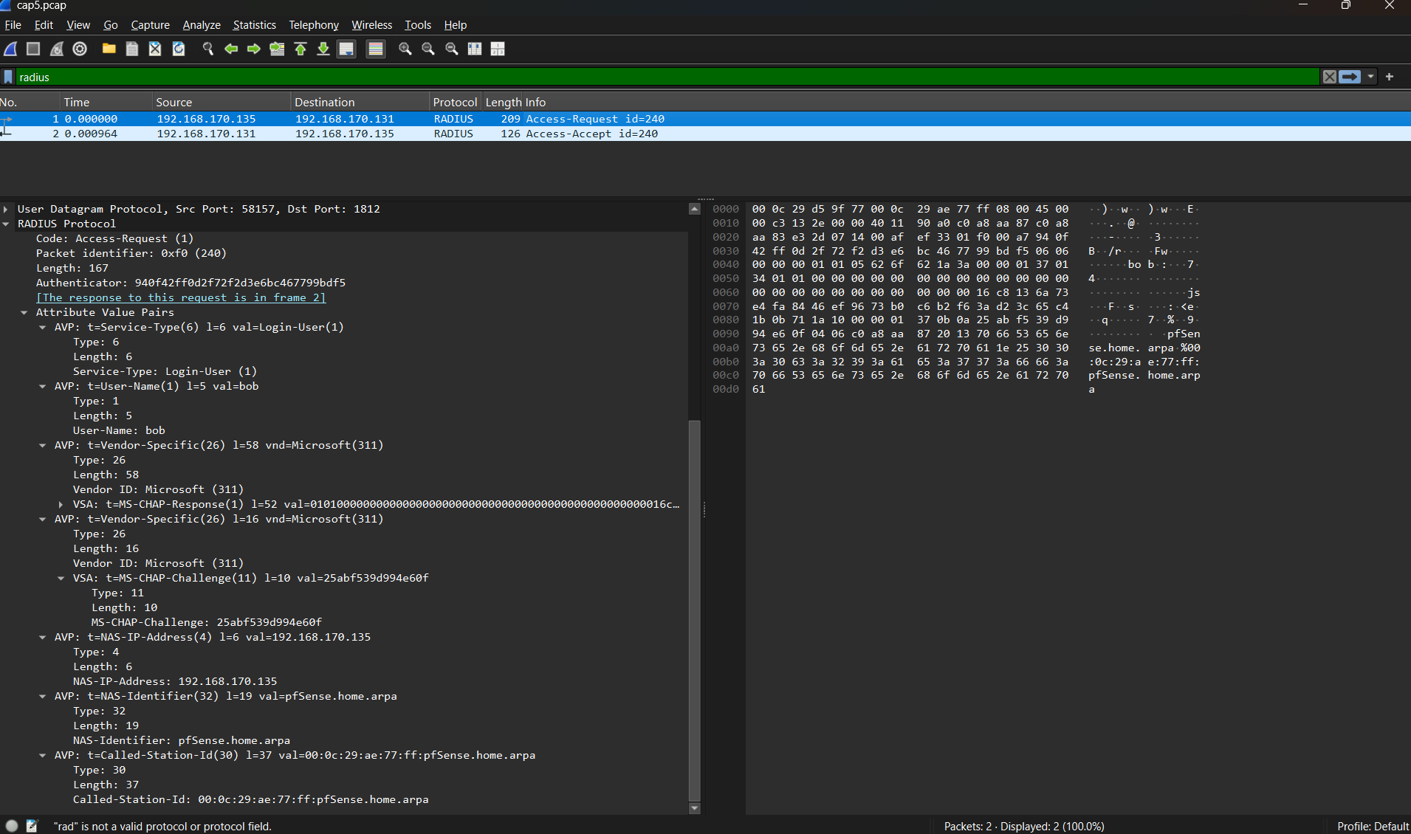
Figure 1 - RADIUS Access-Request sent by 192.168.170.135 to 192.168.170.131
Summary:
Packet 1: 192.168.170.135 → 192.168.170.131
RADIUS Protocol: Code: Access-Request (1)
Attribute Value Pairs:
Service-Type: Login-User
User-Name: bob
MS-CHAP-Response
MS-CHAP-Challenge
NAS-IP-Address: 192.168.170.135
NAS-Identifier: pfSense.home.arpa

Main Protocol
This capture consists mainly of the RADIUS protocol (Remote Authentication Dial-In User Service). In this exchange, the RADIUS protocol runs on UDP, where the RADIUS server gets the request at port 1812.
The RADIUS protocol is used to conduct an authentication and access control process. The access request contains user information and authentication method, and the server responds with Access-Accept.

Performed Operations

Access-Request
The communication is initiated by sending of the Access-Request from UDP port 58157 of the RADIUS client/NAS located at 192.168.170.135 to 192.168.170.131:1812.
The Access-Request carries the RADIUS Identifier 240 and consists of many attributes which describe the operation of authentication. The User-Name attribute states that the user is bob, and the Service-Type attribute takes the value Login-User.
Furthermore, there are MS-CHAP-Challenge and MS-CHAP-Response vendor-specific attributes from Microsoft which indicate that the MS-CHAP protocol is utilized for authentication. Information about the NAS includes its IP address 192.168.170.135 and NAS-Identifier pfSense.home.arpa, as well as the information about the Called-Station-Id 00:0c:29:ae:77:ff:pfSense.home.arpa.

Access-Accept
The RADIUS server operating at IP address 192.168.170.131 processes the request and sends back a response from UDP port 1812 to the original client port 58157.
The reply received by the client is an Access-Accept using the same RADIUS Identifier (240) as the original request. Wireshark explicitly links the reply to frame 1, showing a time difference of approximately 964 μs.
As the server sends out an Access-Accept message, it means that the authentication request for user bob has been accepted.
The reply includes several Microsoft specific attributes including MS-CHAP-MPPE-Keys encrypted, MS-MPPE-Encryption-Policy set to Encryption-Allowed and MS-MPPE-Encryption-Types set to RC4-40-128.

Screenshot 2
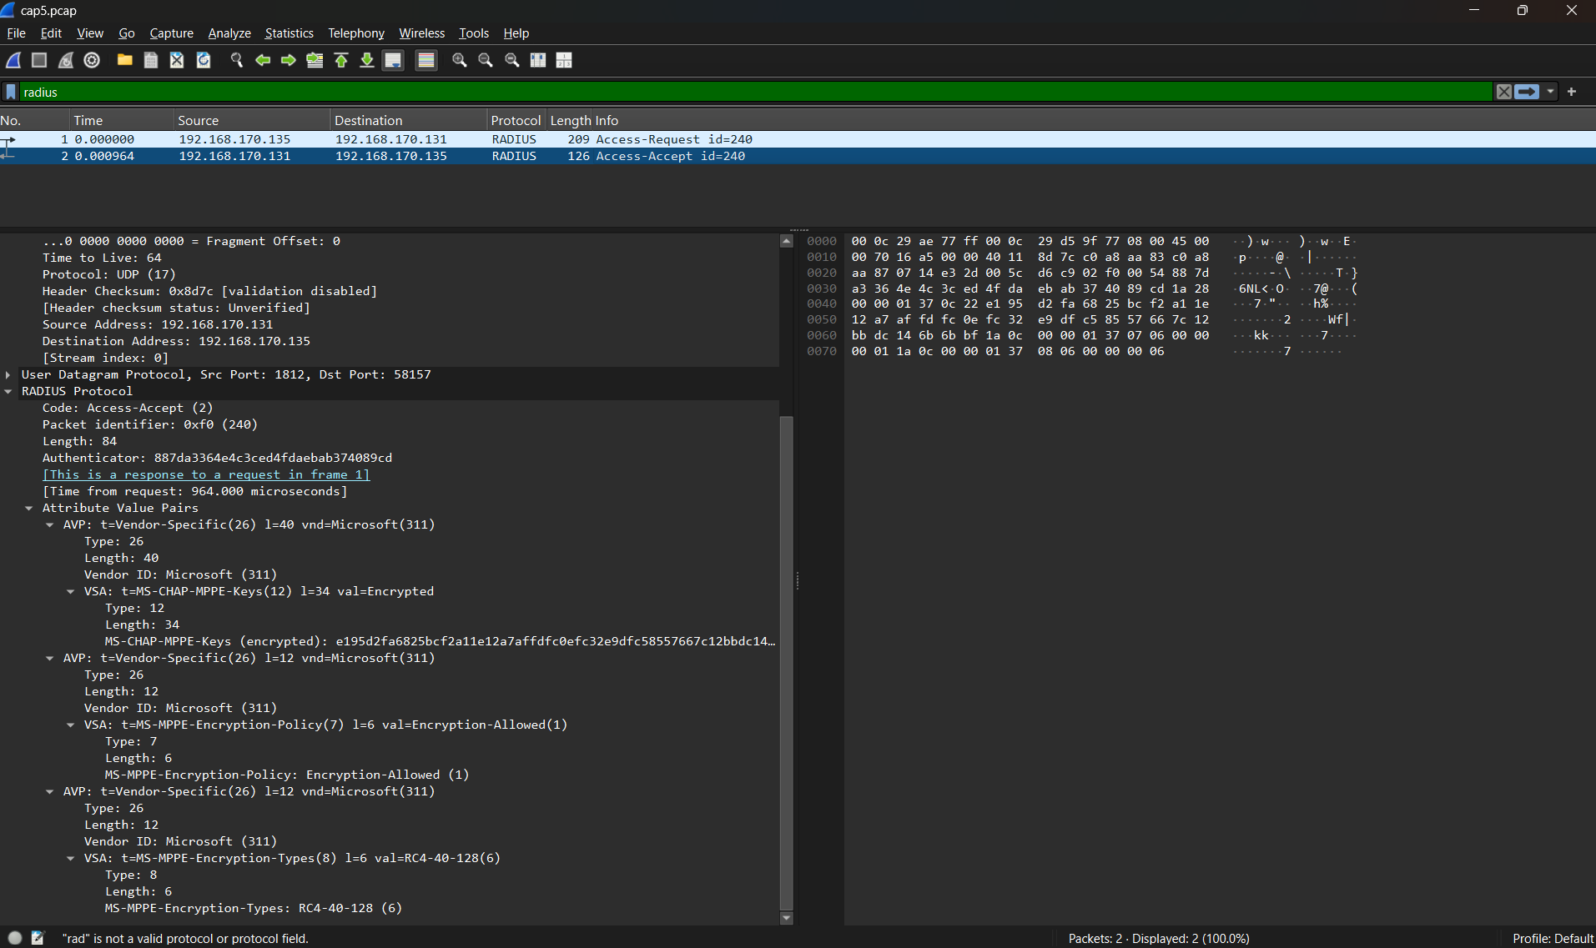
Figure 2 - RADIUS Access-Accept returned by 192.168.170.131
Summary:
RADIUS Protocol:
Code: Access-Accept (2)
Packet identifier: 0xf0 (240)
[This is a response to a request in frame 1]
[Time from request: 964.000 microseconds]
Attribute Value Pairs:
MS-CHAP-MPPE-Keys: encrypted
MS-MPPE-Encryption-Policy: Encryption-Allowed
MS-MPPE-Encryption-Types: RC4-40-128

Communication Analysis

Communication Sequence
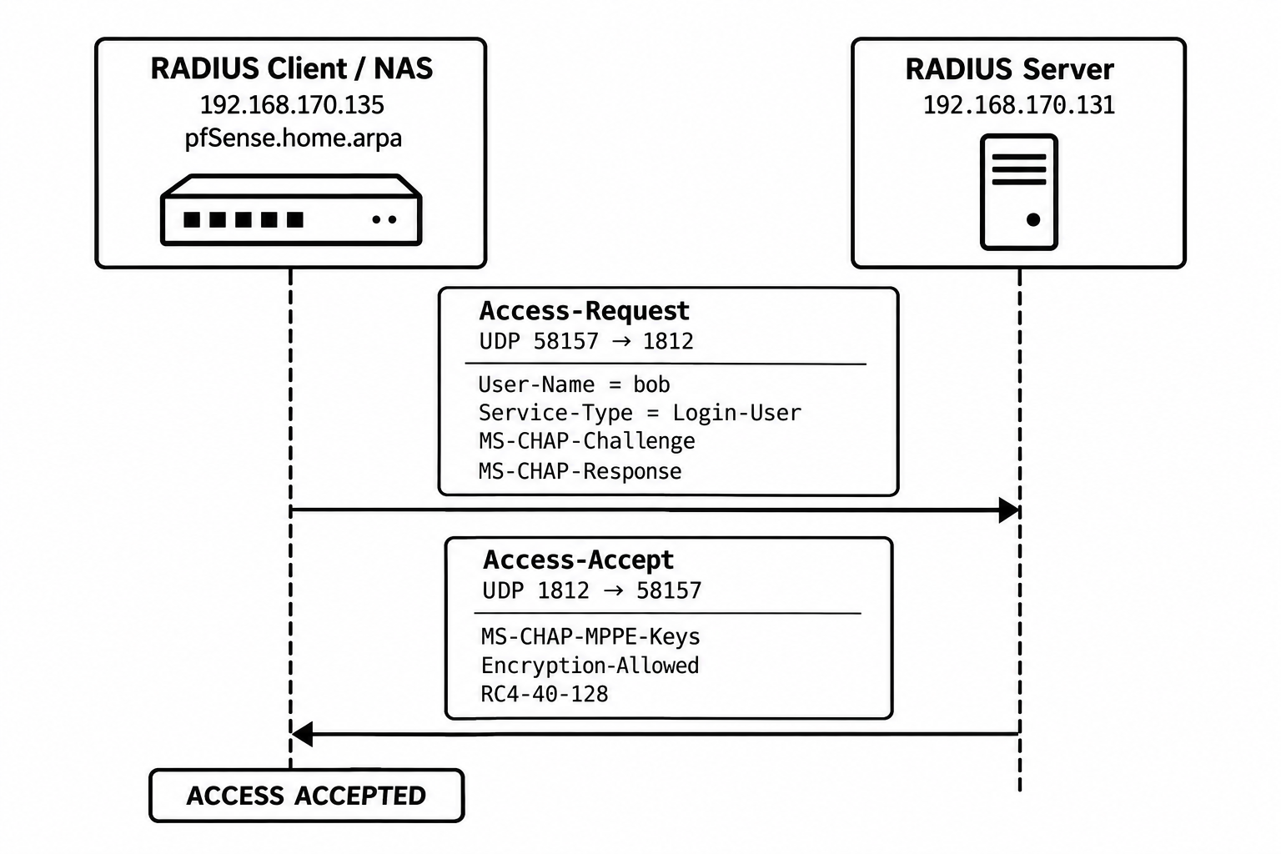
Figure 3 - Communication Sequence

Relationship with authentication, authorization and accounting (AAA)
This exchange can be linked with access control terms, such as identification, authentication, and authorization.
Identification can be seen with the help of the User-Name attribute, which tells us that the user is named bob.
Authentication can be seen in the MS-CHAP information provided in the Access-Request.
Access decision can be seen with the help of the Access-Accept response given by the RADIUS server, and it shows that the request has been accepted.
RADIUS may also be used for accounting purposes, but there is no accounting exchange in this capture.

Security Analysis

Information Disclosure

Evidence
In the Wireshark we obtain:
User-Name: bob
NAS-IP-Address: 192.168.170.135
NAS-Identifier: pfSense.home.arpa
Called-Station-Id: 00:0c:29:ae:77:ff:pfSense.home.arpa

Information Disclosure
Some of the metadata revealed from the intercepted RADIUS packets includes the username bob, the use of internal IP address scheme, the Network Access Server identifier pfSense.home.arpa and some data in the Called Station Id.
This information does not prove any disclosure of the plain-text password. But it reveals some information which may help an attacker in reconnaissance.

MS-CHAP exposure

Evidence
In the Wireshark we obtain:
MS-CHAP-Challenge
MS-CHAP-Response

MS-CHAP authentication information
Access Request makes the MS-CHAP challenge and response known to someone who intercepts the network traffic. The password is not available in plaintext in the capture. However, from this capture, it can be observed that the system uses MS-CHAP as an authentication mechanism and thus the security of the authentication method is open to scrutiny.
It is recommended to use a more secure authentication method and protect the authentication transport.

Legacy cryptographic mechanism

Evidence
In the Wireshark we obtain:
MS-MPPE-Encryption-Types: RC4-40-128

Legacy cryptographic configuration
The Access-Accept packet contains the attribute MS-MPPE-Encryption-Types, which has a value of RC4-40-128. This shows that the configuration included in the exchange supports RC4 MPPE encryption methods.
Legacy cryptography techniques need to be phased out wherever possible and replaced by current methods.

Mitigation
Security consideration | Evidence | Suggested mitigation
Exposure of authentication metadata | Username, NAS IP/identifier and station information are observable | Restrict access to the authentication network and protect the communication path
Exposure of MS-CHAP exchange information | Challenge and response observable | Prefer stronger authentication mechanisms where supported
Legacy cryptographic configuration | RC4-40-128 appears in MPPE encryption types | Replace legacy cryptographic mechanisms with currently supported alternatives
Exposure of AAA infrastructure | RADIUS client/server addresses and NAS information observable | Segment the AAA infrastructure and restrict communication to authorized RADIUS clients

Conclusion
Capture 5 shows a successful RADIUS authentication process from pfSense NAS located on 192.168.170.135 to the RADIUS server at 192.168.170.131.
The client initiates an Access-Request to authenticate the user bob through MS-CHAP related authentication attributes. The RADIUS server receives this request and returns an Access-Accept packet to show that the request was successfully authenticated.
In terms of security, we see metadata of both the authentication process and the underlying infrastructure. This includes the username, information about the NAS and MS-CHAP challenge/response pair. Moreover, the server claims that it is using RC4 based MPPE encryption algorithm. These observations show why AAA traffic should be protected against unauthorized access and usage of old authentication and cryptography techniques where better options exist.

Capture nº.3

Overview
Capture 3 shows an FTP session established between two systems in the local network. The FTP client in 192.168.2.101 creates a TCP connection to the FTP server in 192.168.2.100 running on port 21.
The client performs directory listing tasks and retrieves two executable files through the FTP session.
The current FTP session is a major security risk because the FTP control channel does not provide any protection against passive attacks. It is possible to derive the user ID and password from the network data.
Property | Observed value
Main protocol | FTP
Transport protocol | TCP
Client | 192.168.2.101
Server | 192.168.2.100
FTP control port | TCP/21
FTP data mode | Active
Username | administrator
Authentication result | Successful
Files retrieved | logagent.exe, mplayer2.exe

Intervenients
There are two primary hosts that engage in the communication process.
FTP Client – 192.168.2.101
This host establishes the TCP connection to the FTP server and then carries out the authentication, listing, and retrieval processes.
FTP Server – 192.168.2.100
This host accepts the connection on TCP port 21. The FTP banner for the service running on the host is colasoft_test_2 Microsoft FTP Service (Version 5.0).
The user taking part in the FTP authentication process is administrator.

Main Protocol
The application layer protocol that was seen in the capture is the File Transfer Protocol (FTP). FTP works on the Transmission Control Protocol (TCP).
In this case, the FTP control connection was made on TCP port 21, where the command and response exchange takes place. Meanwhile, other data connections are made for directory and file transfer.
Since PORT commands were used, the FTP session in this case runs on FTP active mode. This is because the client gives the server the information on which data connection to make.

Communication Analysis
Communication starts when 192.168.2.101 sends out the TCP connection request to 192.168.2.100:21. The TCP three-way handshake (SYN -> SYN/ACK -> ACK) process creates the connection prior to the FTP communication.
Upon creating the connection, the server identifies itself with the FTP 220 reply message:
220 colasoft_test_2 Microsoft FTP Service (Version 5.0).
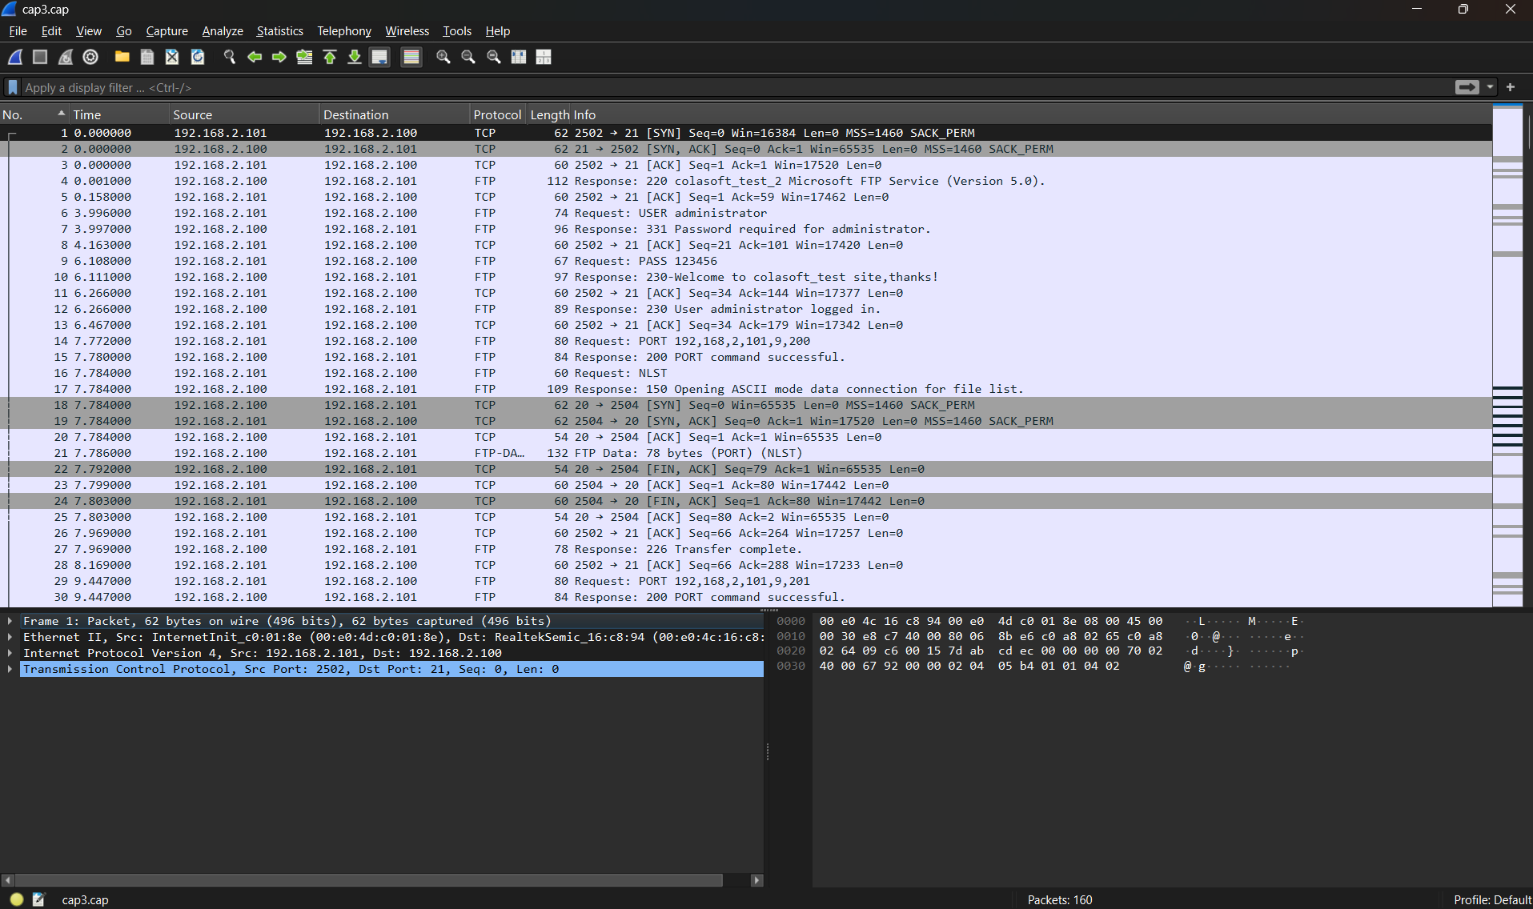
Figure 4 - Wireshark capture 3

Follow Stream Analysis

Authentication
Client starts authentication with:
USER administrator
Server gives the status code of 331 and asks for the password. Password is then provided by the client over the FTP control connection.
Server gives the status code of 230 and provides the message of “User administrator logged in”, showing that the authentication process was successful.
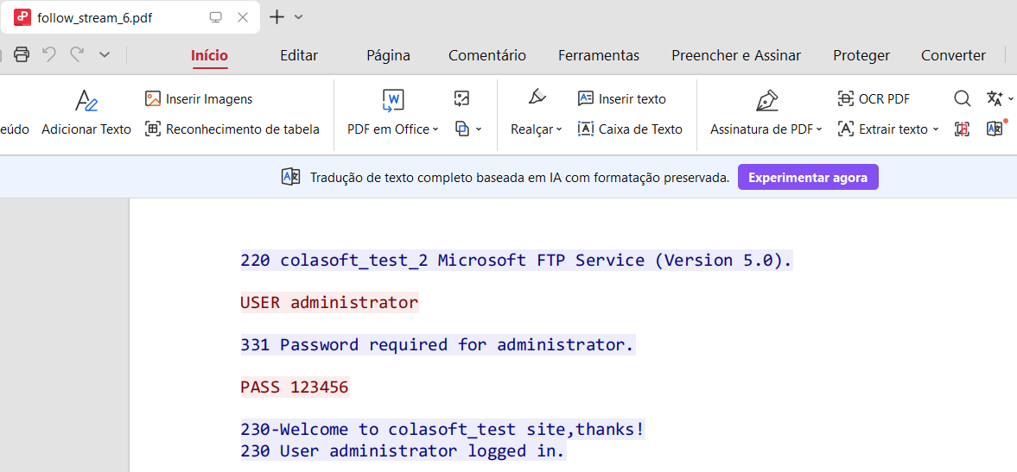
Figure 5 -FTP authentication reconstructed using Wireshark Follow TCP Stream

Directory Listing
Following authentication, the client asks for details regarding the files present on the FTP server.
NLST is used to ask for file names, whereas LIST is used to ask for more detailed file directory listing.
Prior to each data transfer, the client sends a PORT command. This reflects the use of active mode FTP.
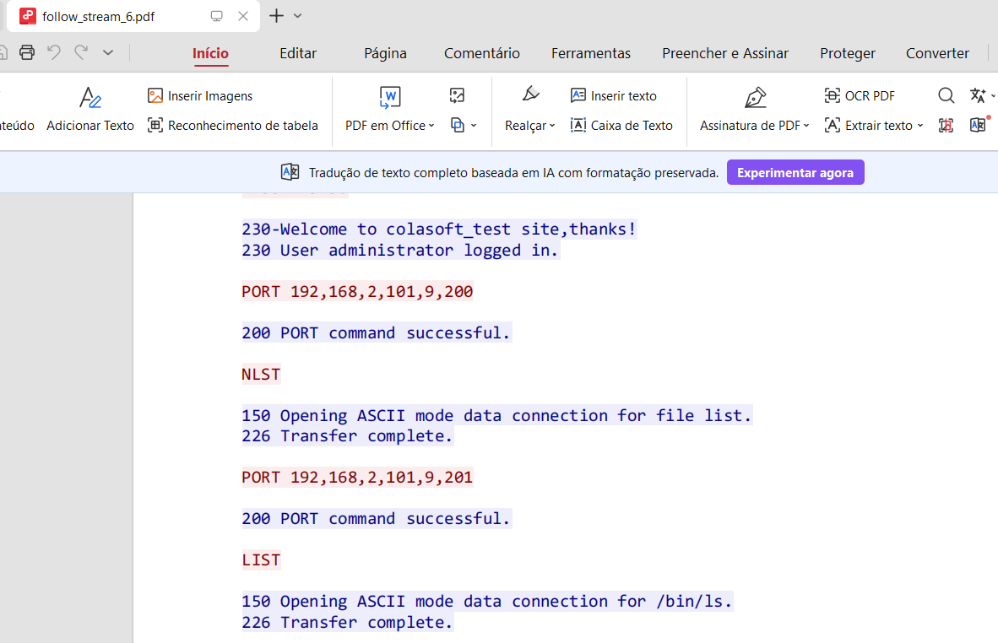
Figura 6 - FTP directory listing

Transfer of logagent.exe
The client then sends the command RETR logagent.exe, asking the server to transfer the file.
The server gives information about the size of the file, which is 65,296 bytes, and creates a data connection for the file. The process ends by returning FTP response 226.
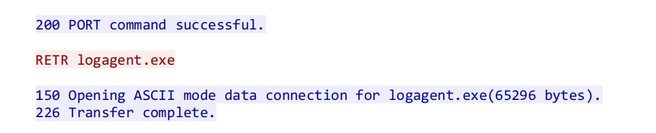
Figura 7 - FTP transfer logagent.exe

Transfer of mplayer2.exe
In a second request for file retrieval, the file requested is mplayer2.exe. The size of the file is 4,639 bytes, and the retrieval process ends with a 226 Transfer complete message.
While both transferred files end with the .exe extension, the mere packet capture alone does not provide any indication that they are harmful.
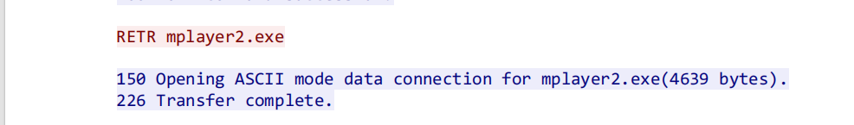
Figura 1 - FTP transfer mplayer2.exe

XPWD
XPWD command is sent by the client too. This command is met with 257 "/” is current directory from the server side as a reply.
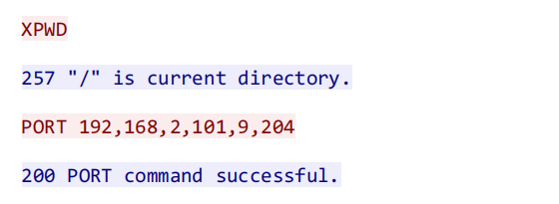

Security Analysis

Vulnerability 1 - Plaintext credentials
The primary problem of security which arises from this capture is the sending of authentication credentials on the FTP control connection in plaintext.
Wireshark's TCP stream shows that both the commands USER and PASS have been sent, and the following message 230 User Administrator logged in confirms that this was indeed an authentication attempt.
Therefore, if an attacker were able to passively sniff this traffic, he would be able to acquire the credentials without having to attack either end-point.

Vulnerability 2 - Weak Password
In addition to its transmission without any confidentiality measures in place, the observed password from the capture is based on an extremely simplistic numerical pattern. This kind of credential offers little protection against attempts at password guessing.
Stronger passwords and more advanced forms of authentication must be implemented.

Vulnerability 3 - Privileged account
The username “administrator” indicates a possible sensitive user; but capturing this username alone does not indicate the privileges assigned to this FTP user. Regardless of the privileges, the disclosure of valid user credentials is still a threat to security.

Vulnerability 4 - File-transfer confidentiality
Transport insecurity not only reveals the identity of the communicating processes but also reveals the identity of the files accessed by these processes. Here in this capture, it can be seen that the client accesses logagent.exe and mplayer2.exe.

Vulnerability 5 - Service fingerprinting
The FTP banner is indicative of the server implementation. The information obtained could be helpful to reconnaissance, since it allows the attacker to understand what technology is being exposed.

Mitigation
Security problem | Evidence from capture | Mitigation
Plaintext credentials | USER and PASS observable | Replace plain FTP with an encrypted file-transfer mechanism such as SFTP or appropriately configured FTPS
Weak authentication secret | Simple numeric password observed | Enforce stronger password policies and consider MFA where supported
Account credential exposure | Successful authentication visible | Apply least privilege and restrict accounts permitted to access file-transfer services
File-transfer metadata exposure | RETR logagent.exe, RETR mplayer2.exe visible | Encrypt the communication channel
Service information disclosure | FTP banner identifies Microsoft FTP Service | Reduce unnecessary banner disclosure where operationally appropriate
Unrestricted observation of FTP traffic | Complete session reconstructable | Network segmentation and access controls around management/file-transfer services

Conclusion
Capture 3 reflects a successful FTP session between the IP address 192.168.2.101 and the FTP server with an IP address 192.168.2.100. After creating the TCP control connection, the client logs into the server as the administrator, does directory listing and downloads the logagent.exe and mplayer2.exe files.
The main security problem illustrated by the capture is the lack of confidentiality protection on the FTP control channel. Authentication credentials can be recovered from the network packets, and then the server confirms their legitimacy. Information about the server software and files accessed is also available.
Thus, the capture illustrates the reasons why FTP is not an appropriate protocol for transmitting confidential information and credentials over unsecured networks. Encrypted file transfer methods, proper authentication measures, credential policy improvements and network access restrictions should be applied in order to mitigate this problem.

Capture nº.

Overview

Intervenients

Main Protocol

Communication Analysis

Security Analysis

Mitigation

Capture nº.

Overview

Intervenients

Main Protocol

Communication Analysis

Security Analysis

Mitigation

Laboratory Exercise 1

Laboratory Exercise 2

Conclusions

References

[1] | ISO, “ISO/IEC 27001:2022 Information security management systems.,” 2022. [Online]. Available: https://www.iso.org/isoiec-27001-information-security.html.
[2] | IT Governance, “ISO 27001 Overview,” 2022. [Online]. Available: https://www.itgovernance.co.uk/iso27001.

