Project

Requirement Report

Author: <Author name>

Revision: 0.1

|  |  |
| --- | --- |
| NA |  |
| NA | Date: April 11, 2018 |

**Revision History**

|  |  |  |  |
| --- | --- | --- | --- |
| **Revision** | **Date** | **Reason For Changes** | **Author** |
| 1.0 | Jan 02, 1990 | <Release> | <Author Name> |
| 0.1 | Jan 01, 1990 | <Initial draft> | <Author Name> |
|  |  |  |  |

**Table of Contents**

Microsoft Word users please click here and press F9 to create Table of Contents.

OpenOffice.org users please remove this text and select Insert Table of Content from menu.

**Table of Figures**

Microsoft Word users please click here and press F9 to create Table of Contents.

OpenOffice.org users please remove this text and select Insert Table of Content from menu.

**Executive Summary**

This section previews the main points of a report. The executive summary contains enough information for a reader to get familiarized with what is discussed in the full report without having to read it.

# Introduction

## Purpose

<This document provides requirements with their properties including requirement id, requirement name, requirement text and the dependencies.>

## Scope

<Provide a short description of the system being specified and its purpose, including relevant benefits, objectives, and goals.>

## Overview

<Describe what the document contains and explain how the document is organized>

# Your Requirements Project

## 1 Business requirements

### BR-22 Plan Database

### R2 Forum Database

The app must have a forum

#### R2.1 Access to users

##### BR-R2.1.1 Plants Database

The app must have a database of plants

**customNumberingData:**

Multi-levelɲɪɳtrueɲɪɳfalseɲɪɳBR-ɲɪɳɲɪɳ6ɲɪɳ_17_0_4beta_1b3a0482_1355297412593_609711_22854ɲɪɳ_11_5EAPbeta_be00301_1147873236436_846958_2313ɲɪɳ_11_5EAPbeta_be00301_1147873190330_159934_2220ɲɪɳtrue

###### BR-R2.1.1.1 Business requirement2

The system shall do term2

###### BR-R2.1.1.2 Business requirement3

The system shall do term2

###### BR-R2.1.1.3 Business requirement4

The system shall do term2

##### BR-R2.1.2 Plant Database

The app must have a database

#### R2.3 Write a new post

#### R2.4 Enter a post

## 2 Domain model

## 3 System requirements

### 3.1 Functional requirements

#### FR-1 Forum

The system shall do term1

**Derived:**

|  |  |
| --- | --- |
| -241635794.png | R2 Forum Database |

**Traced From:**

|  |  |
| --- | --- |
| -241635794.png | R2 Forum Database |

##### FR-1.1 Post

The system shall do term2

**Derived From:**

|  |  |
| --- | --- |
| -1715832788.png | BR-R2.1.1.1 Business requirement2 |

**Traced To:**

|  |  |
| --- | --- |
| -1715832788.png | BR-R2.1.1.1 Business requirement2 |

**Refines:**

|  |  |
| --- | --- |
| 919998030.png | Write a post |

###### FR-1.1.1 Read

**Refines:**

|  |  |
| --- | --- |
| 919998030.png | Read post |

###### FR-1.1.2 Comment

**Refines:**

|  |  |
| --- | --- |
| 919998030.png | Add a comment |

#### FR-10 Plant Database

**Derived:**

|  |  |
| --- | --- |
| -241635794.png | BR-22 Plan Database |

**Traced From:**

|  |  |
| --- | --- |
| -241635794.png | BR-22 Plan Database |

**Refines:**

|  |  |
| --- | --- |
| 919998030.png | Search plant |

#### FR-11 Access

**Refines:**

|  |  |
| --- | --- |
| 919998030.png | Log out |

|  |  |
| --- | --- |
| 919998030.png | Log In |

##### FR-11.1 Registered User

**Refines:**

|  |  |
| --- | --- |
| 919998030.png | Log In |

|  |  |
| --- | --- |
| 919998030.png | Sing up |

##### FR-11.2 Guest

**Refines:**

|  |  |
| --- | --- |
| 919998030.png | Continue as guest |

#### 3.1.1 Use cases

### 3.2 Non-functional requirements

## 4 Traceability

### 4.1 Coverage validation

# Appendix A: Diagram

## Add a comment

NA

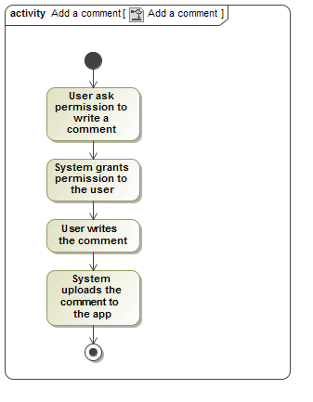

1. Add a comment

## Business requirement diagram

NA

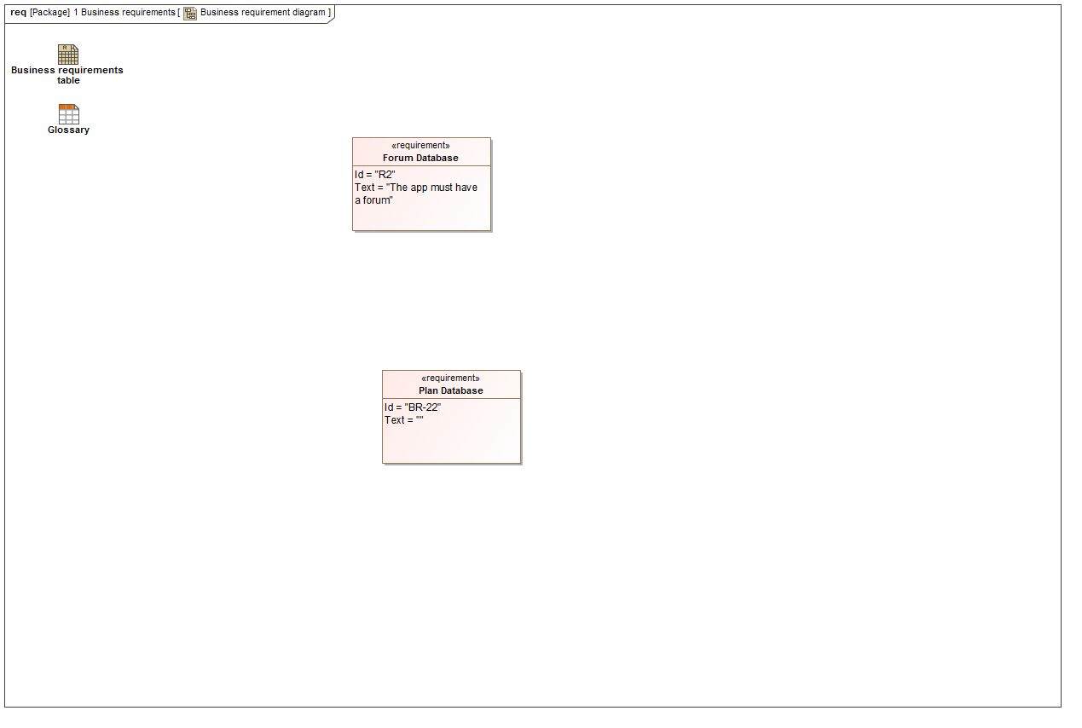

1. Business requirement diagram

## Business requirements table

NA

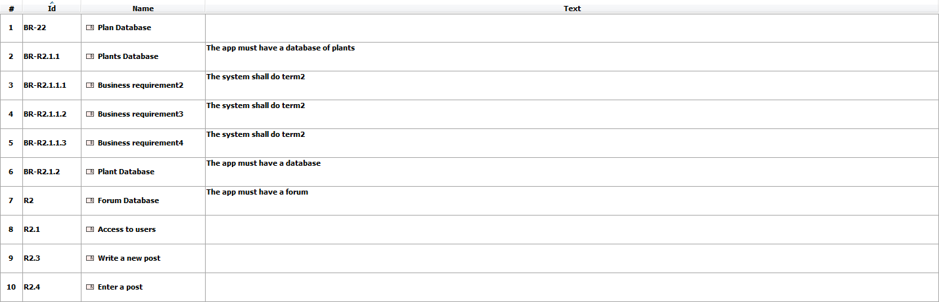

1. Business requirements table

## Continue as guest

NA

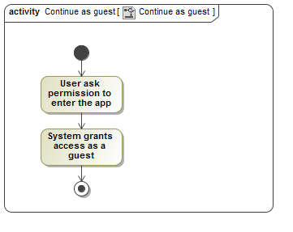

1. Continue as guest

## Derive FR and NFR from business requirements

NA

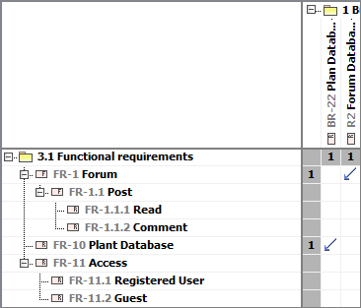

1. Derive FR and NFR from business requirements

## Domain model

NA

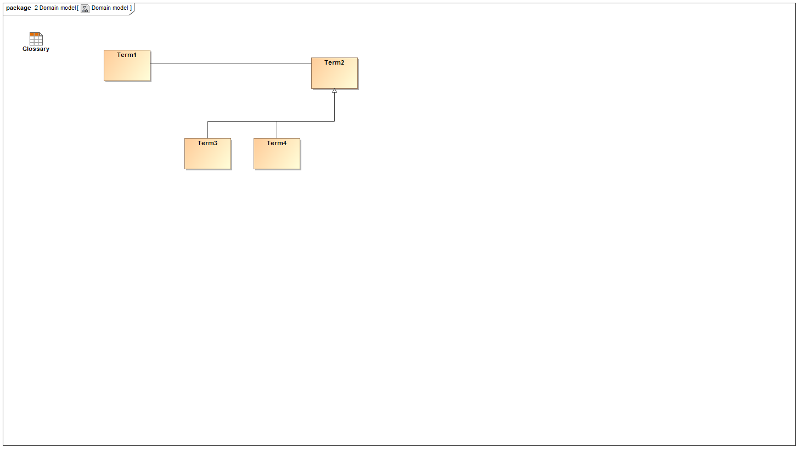

1. Domain model

## FR diagram

NA

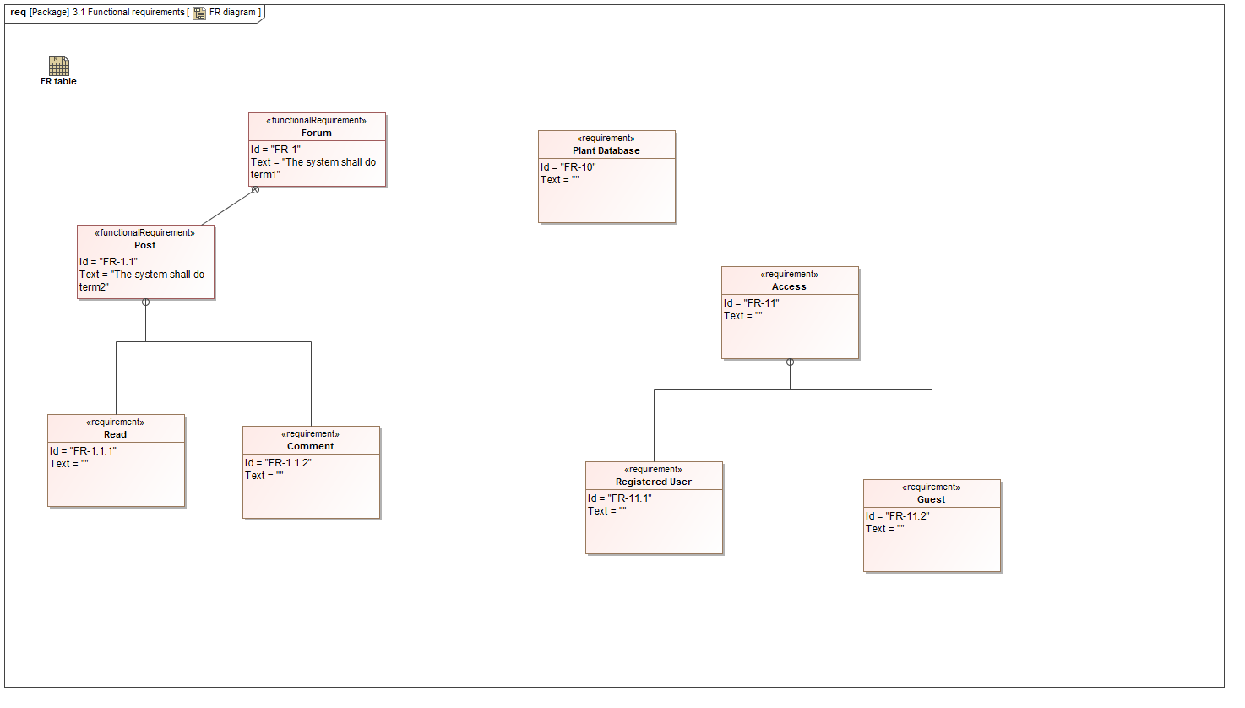

1. FR diagram

## FR table

NA



1. FR table

## Full traceability

NA

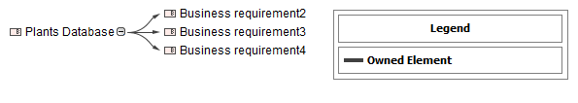

1. Full traceability

## Glossary

NA

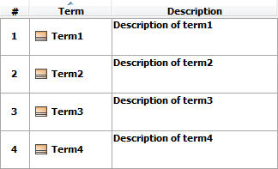

1. Glossary

## Intro

NA

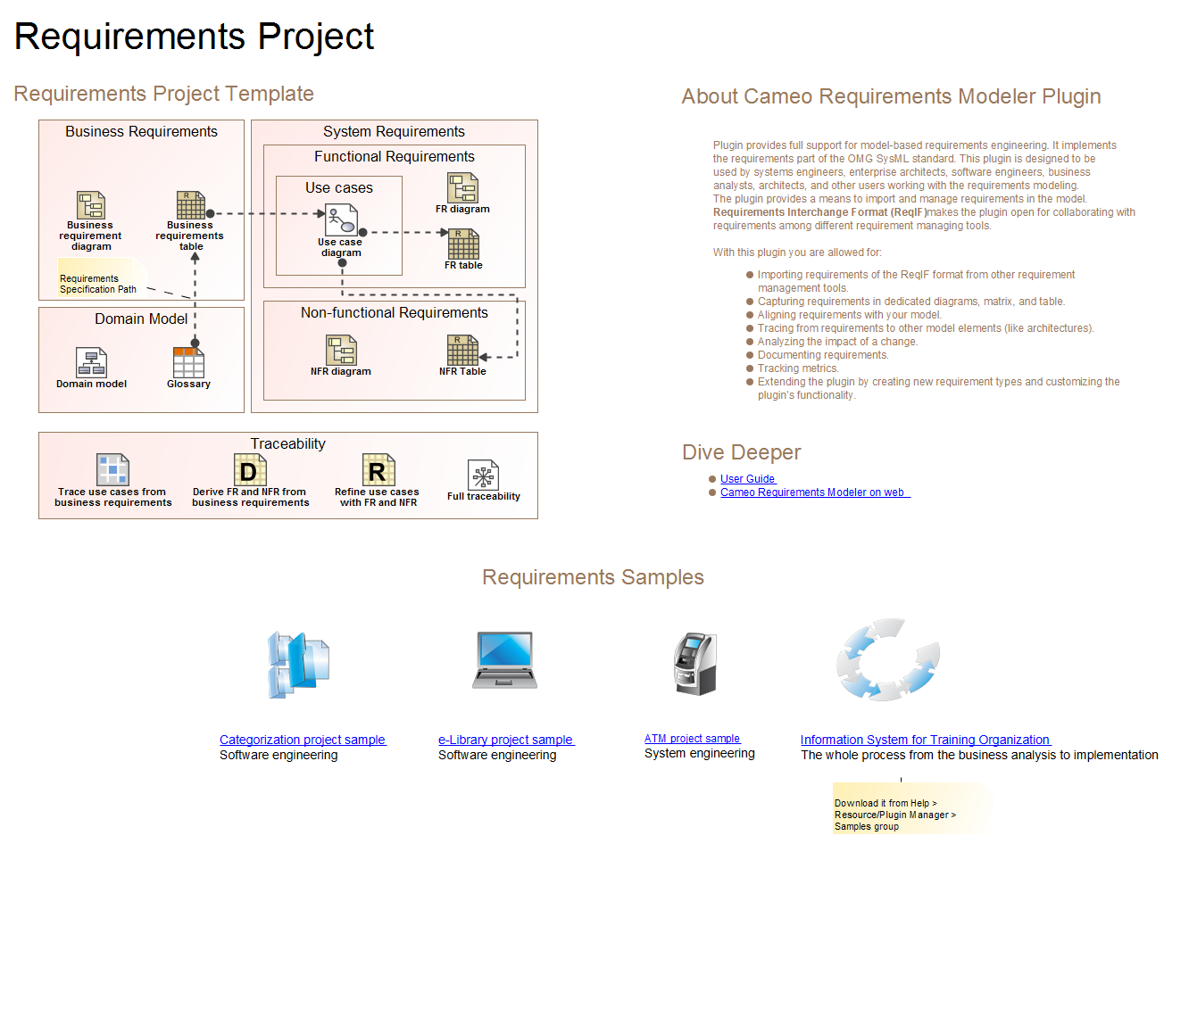

1. Intro

## Log In

NA

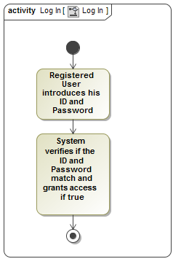

1. Log In

## Log out

NA

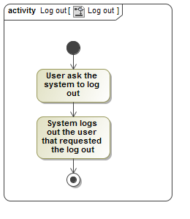

1. Log out

## NFR diagram

NA

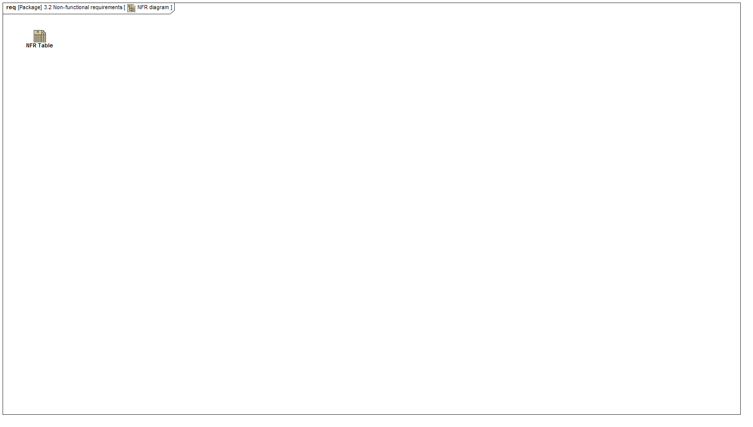

1. NFR diagram

## NFR Table

NA

1409611748.png

1. NFR Table

## Read post

NA

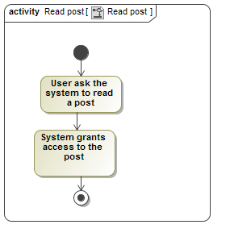

1. Read post

## Refine use cases with FR and NFR

NA

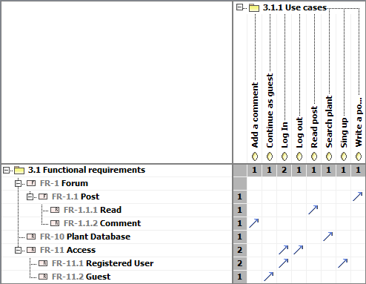

1. Refine use cases with FR and NFR

## Search plant

NA

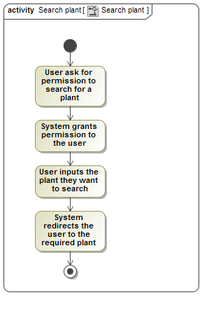

1. Search plant

## Sing up

NA

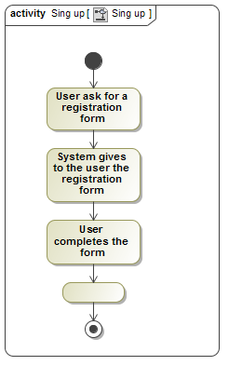

1. Sing up

## Trace use cases from business requirements

NA

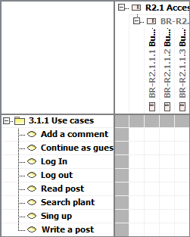

1. Trace use cases from business requirements

## Use case diagram

NA

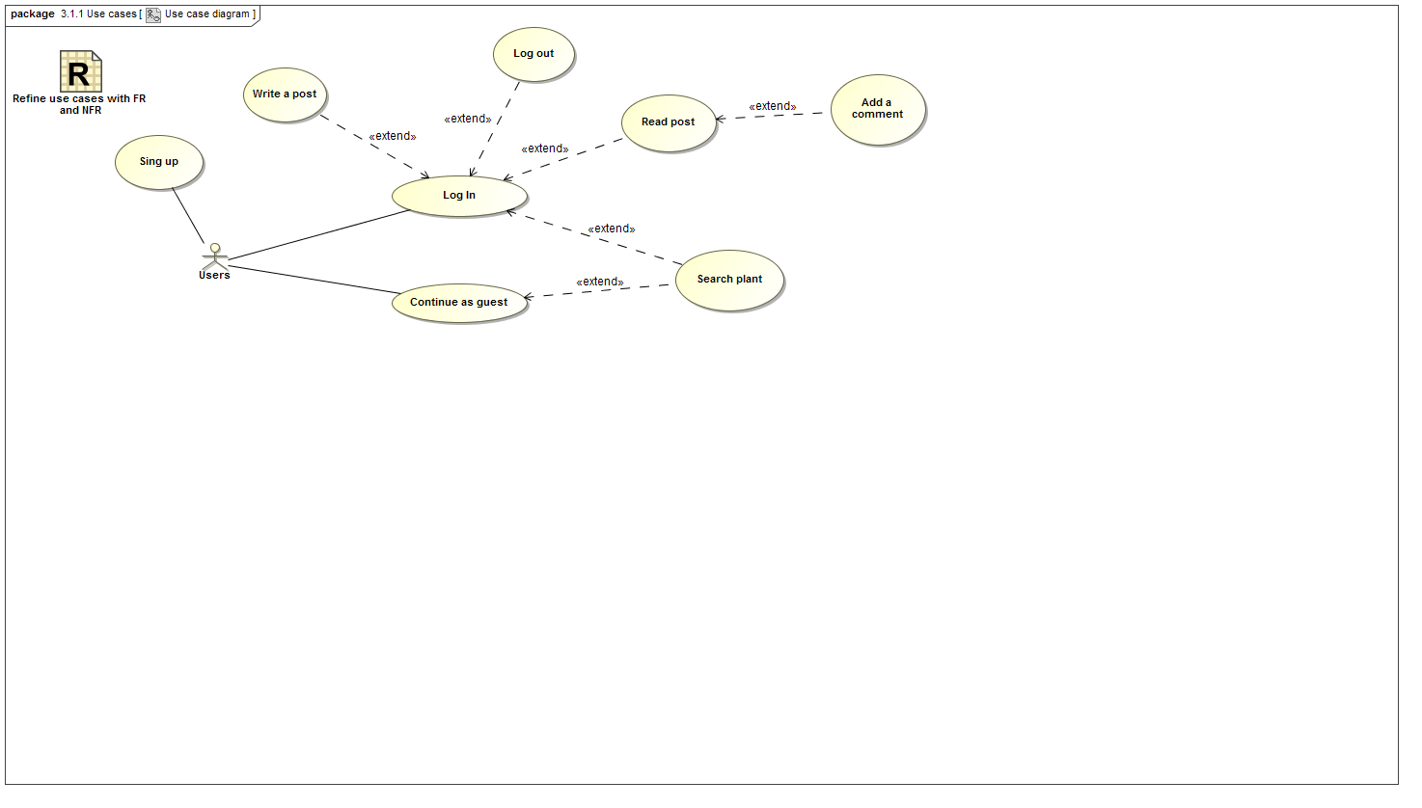

1. Use case diagram

## Write a post

NA

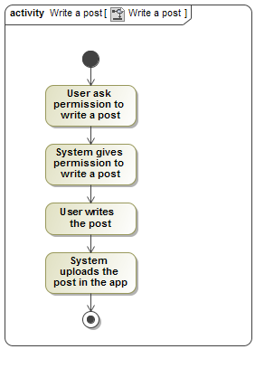

1. Write a post