## Snort 2 .9 . 3 预处理器开发步骤

1. 打开模板snort2.9.3.1/templates ,查看文件：sp_template.h和sp_template.c是开发预处理插件使用的模板，spp_template.h和spp_template.c是开发预处理器使用的模板。这里使用spp_template.h和spp_template.c。
2. 复制spp_template.h和spp_template.c重命名，得到新的插件

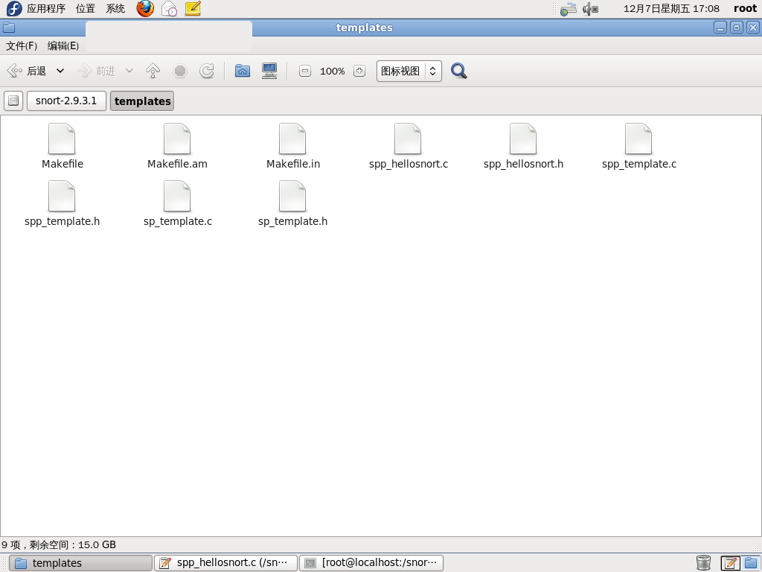

1. 复制spp_hellosnort.c 和spp_hellosnort.h 到snort2.9.3.1/src/preprocessors

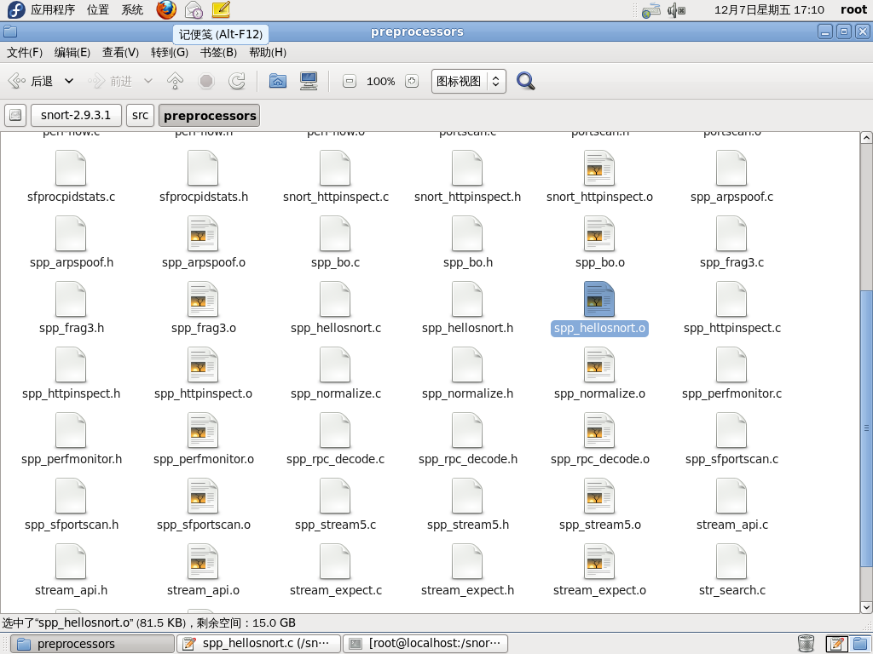

1. 修改plugbase.c 文件，将插件的头文件spp_hellosnort.h 包含到plugbase.c 中

如图（63、64行）

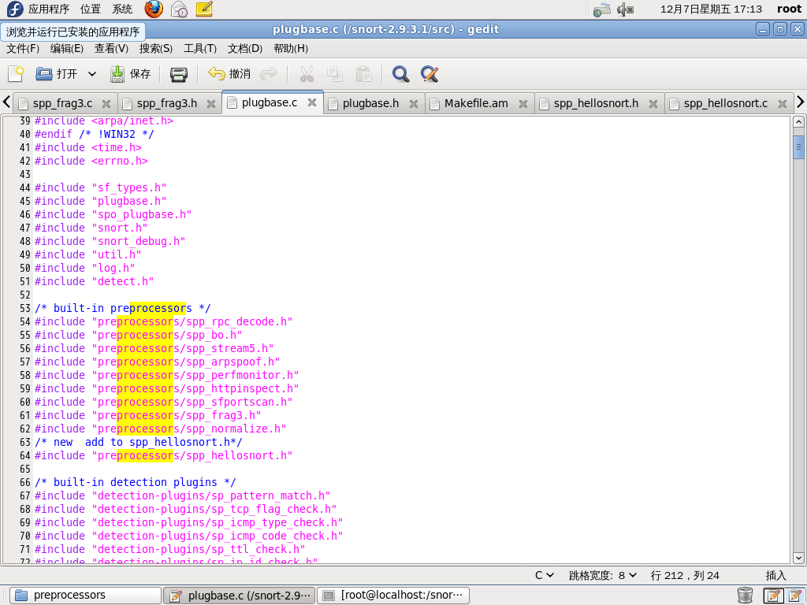

并且将插件的 SetupHelloSnort（）函数插入plugbase.c 的 RegisterPreprocessors()函数中

如图（672行）

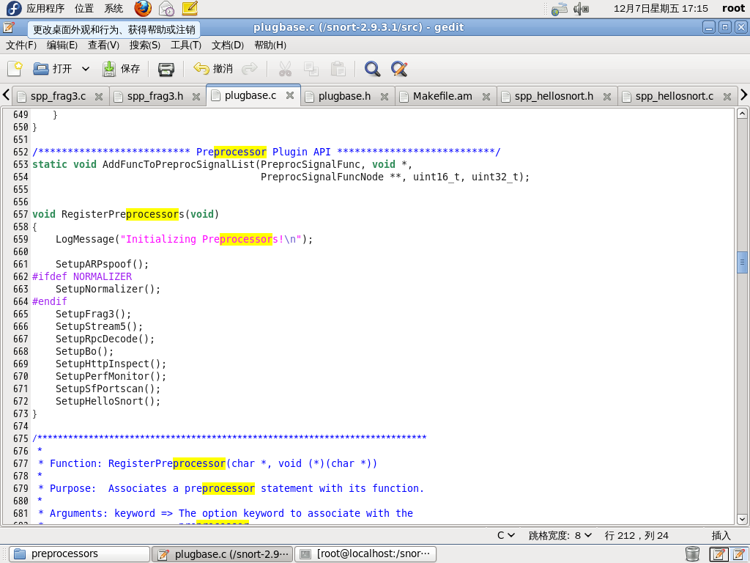

1. 修改spp_hellosnort.h文件，即定义初始化函数原形void SetupHelloSnort ();

如图（13行）

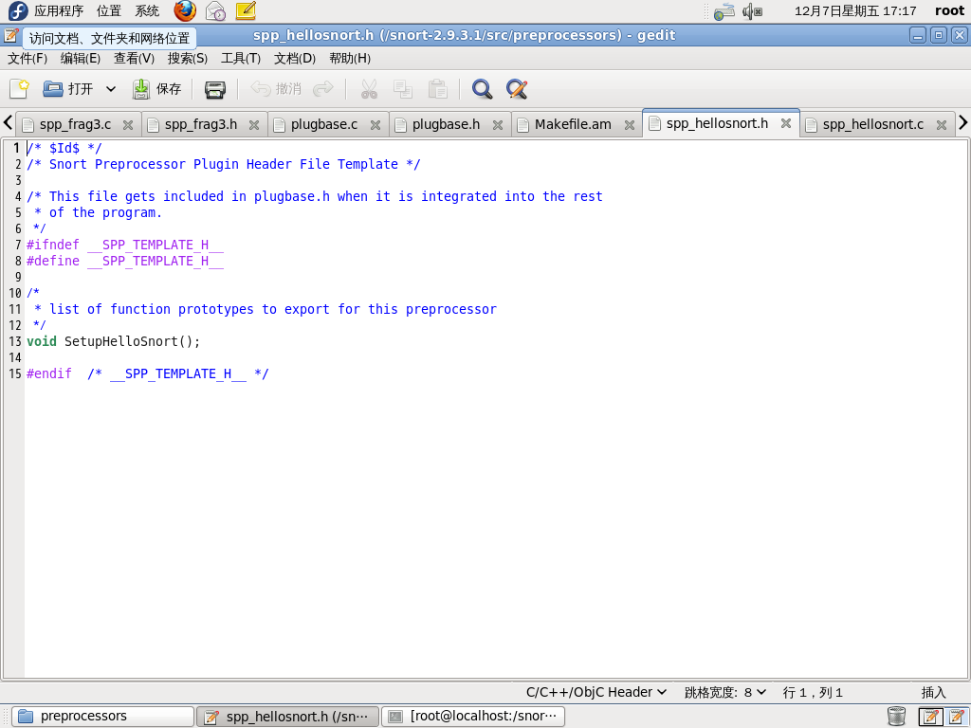

1. 修改spp_hellosnort.c文件。

需注意地方:

1、修改引用的头文件,删除#inlcude “spp_template.h”，增加#inlcude”spp_hellosnort.h”

2、增加#define PROTO_MASK 0x0001（添加函数到预处理器链表是用到）

3、AddFuncToPreprocList(HelloSnortFunct, PRIORITY_NETWORK, PP_HELLO_SNORT, PROTO_MASK);

此信息中的PRIORITY_NETWORK为源文件/src/ preprocids.h中引用（图80行）

此信息中的PP_HELLO_SNORT 需在源文件 /src/ preprocids.h中定义的最后添加

如图：添加#define PP_HELLO_SNORT 30（图72行）

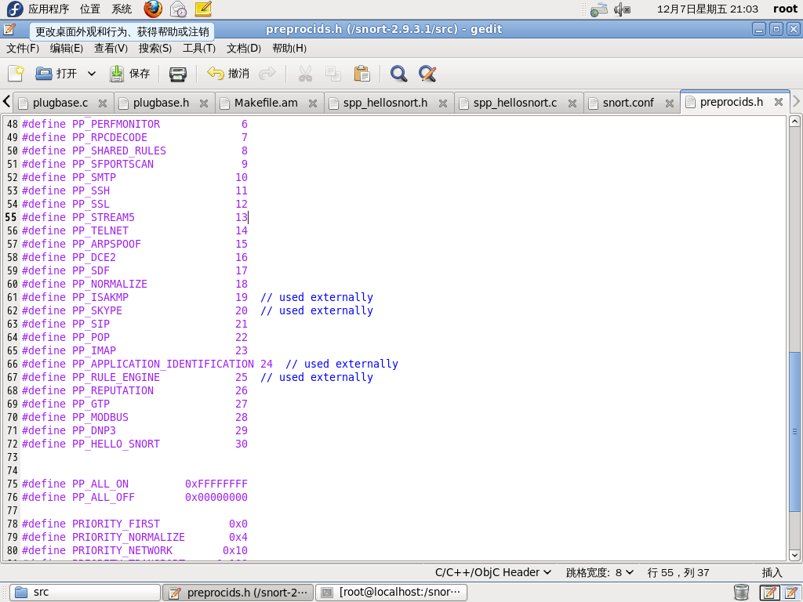

spp_hellosnort.c文件源码如下（只写出打印信息做调用参考，没有具体功能函数）：

/* $Id$ */

/* Snort Preprocessor Plugin Source File Template */

/*

* Purpose:

*

* Preprocessors perform some function *once* for *each* packet. This is

* different from detection plugins, which are accessed depending on the

* standard rules. When adding a plugin to the system, be sure to

* add the "Setup" function to the InitPreprocessors() function call in

* plugbase.c!

*

* Arguments:

*

* This is the list of arguements that the plugin can take at the

* "preprocessor" line in the rules file

*

* Effect:

*

* What the preprocessor does. Check out some of the default ones

* (e.g. spp_frag2) for a good example of this description.

*

* Comments:

*

* Any comments?

*

*/

#include <sys/types.h>

#include <stdlib.h>

#include <ctype.h>

#include <rpc/types.h>

#include "snort_debug.h"

/*

* If you're going to issue any alerts from this preproc you

* should include generators.h and event_wrapper.h

*/

#include "generators.h"

#include "event_wrapper.h"

#include "util.h"

#include "plugbase.h"

#include "parser.h"

/*

* put in other inculdes as necessary

*/

/*

* your preprocessor header file goes here if necessary, don't forget

* to include the header file in plugbase.h too!

*/

#include "spp_hellosnort.h"

#define PROTO_MASK 0x0001

/*

* define any needed data structs for things like configuration

*/

typedef struct _TemplateData

{

/* Your struct members here */

} TemplateData;

/*

* If you need to instantiate the preprocessor's

* data structure, do it here

*/

TemplateData SomeData;

/*

* function prototypes go here

*/

static void HelloSnortInit(char *);

static void ParseTemplateArgs(char *);

static void HelloSnortFunct(Packet *);

static void PreprocCleanExitFunction(int, void *);

static void PreprocRestartFunction(int, void *);

static void helloSnortreloadFuction(char *args);

/*

* Function: SetupTemplate()

*

* Purpose: Registers the preprocessor keyword and initialization

* function into the preprocessor list. This is the function that

* gets called from InitPreprocessors() in plugbase.c.

*

* Arguments: None.

*

* Returns: void function

*

*/

void SetupHelloSnort()

{

/*

* link the preprocessor keyword to the init function in

* the preproc list

*/

#ifndef SNORT_RELOAD

RegisterPreprocessor("Hello_Snort", HelloSnortInit);

#else

RegisterPreprocessor("Hello_Snort", HelloSnortInit,

helloSnortreloadFuction, NULL, NULL);

#endif

printf("now call the setupHelloSnort <><><><><><><><><><><><><><><><><><><><><><><><><><><><><><><><><><><><><>");

DEBUG_WRAP(DebugMessage(DEBUG_PLUGIN,"Preprocessor: HelloSnort is setup...\n"););

}

/*

* Function: TemplateInit(u_char *)

*

* Purpose: Calls the argument parsing function, performs final setup on data

* structs, links the preproc function into the function list.

*

* Arguments: args => ptr to argument string

*

* Returns: void function

*

*/

static void HelloSnortInit(char *args)

{

DEBUG_WRAP(DebugMessage(DEBUG_PLUGIN,"Preprocessor: HelloSnortInit Initialized\n"););

printf("HelloSnortInit ^^^^^^^^^^^^^^^^^^^^^^^^^^^^^^is setup");

/*

* parse the argument list from the rules file

*/

//ParseTemplateArgs(args);

/*

* perform any other initialization functions that are required here

*/

/*

* Set the preprocessor function into the function list

*/

//example: AddFuncToPreprocList(PreprocEvalFunc pp_eval_func, uint16_t priority,uint32_t preproc_id, uint32_t proto_mask)

AddFuncToPreprocList(HelloSnortFunct, PRIORITY_NETWORK, PP_HELLO_SNORT, PROTO_MASK);

// AddFuncToCleanExitList(PreprocCleanExitFunction, NULL);

// AddFuncToRestartList(PreprocRestartFunction, NULL);

}

/*

* Function: ParseTemplateArgs(char *)

*

* Purpose: Process the preprocessor arguements from the rules file and

* initialize the preprocessor's data struct. This function doesn't

* have to exist if it makes sense to parse the args in the init

* function.

*

* Arguments: args => argument list

*

* Returns: void function

*

*/

static void ParseTemplateArgs(char *args)

{

/* your parsing function goes here, check out the other spp files

for examples */

}

/*

* Function: PreprocFunction(Packet *)

*

* Purpose: Perform the preprocessor's intended function. This can be

* simple (statistics collection) or complex (IP defragmentation)

* as you like. Try not to destroy the performance of the whole

* system by trying to do too much....

*

* Arguments: p => pointer to the current packet data struct

*

* Returns: void function

*

*/

static void HelloSnortFunct(Packet *p)

{

/* your preproc function goes here.... */

/*

* if you need to issue an alert from your preprocessor, check out

* event_wrapper.h, there are some useful helper functions there

*/

printf("the HelloSnort`s Main function HelloSnortFunct is here^^^^^^^^^^^^^^^^^^^^^^^^^^^^^^^^^^^^^^^^");

}

/*

* Function: PreprocCleanExitFunction(int, void *)

*

* Purpose: This function gets called when Snort is exiting, if there's

* any cleanup that needs to be performed (e.g. closing files)

* it should be done here.

*

* Arguments: signal => the code of the signal that was issued to Snort

* data => any arguments or data structs linked to this

* functioin when it was registered, may be

* needed to properly exit

*

* Returns: void function

*/

static void PreprocCleanExitFunction(int signal, void *data)

{

/* clean exit code goes here */

}

static void helloSnortreloadFuction(char *args)

{

printf("call the reload hellosnort");

}

/*

* Function: PreprocRestartFunction(int, void *)

*

* Purpose: This function gets called when Snort is restarting on a SIGHUP,

* if there's any initialization or cleanup that needs to happen

* it should be done here.

*

* Arguments: signal => the code of the signal that was issued to Snort

* data => any arguments or data structs linked to this

* functioin when it was registered, may be

* needed to properly exit

*

* Returns: void function

*/

static void PreprocRestartFunction(int signal, void *foo)

{

/* restart code goes here */

}

1. 修改snort2.9.3.1/src/preprocessors/Makefile.am文件如下图添加信息（图31行）

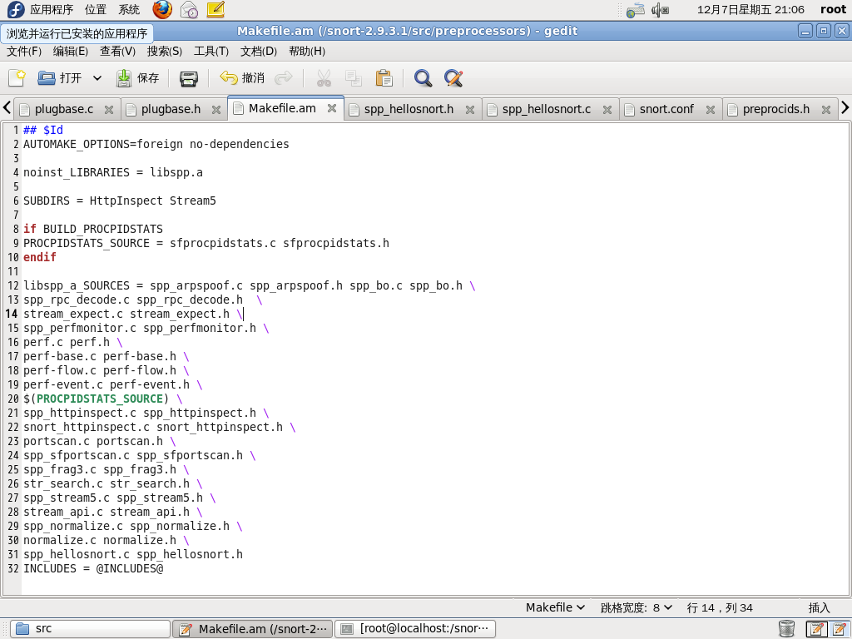

8、打开/etc/snort.conf

开启Hello_Snort（此关键字对应spp_helloSnort.c中setupHelloSnort函数中的RegisterPreprocessor("Hello_Snort", HelloSnortInit);注册的Hello_Snort预处理器

如图（271行）

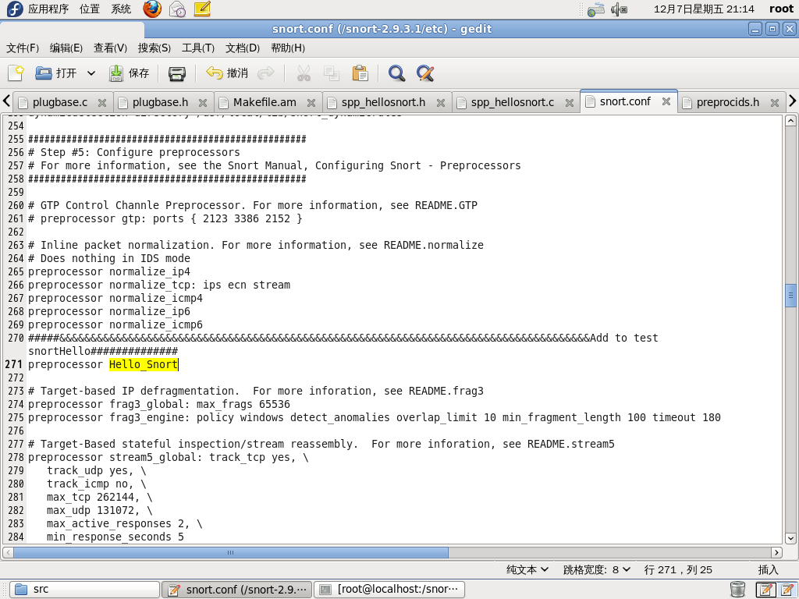

9、启动snortIDS模式启动插件的时候可以看到Hello_Snort预处理的启动过程中输入启动信息（spp_helloSnort.c中的输入打印信息）

如下图 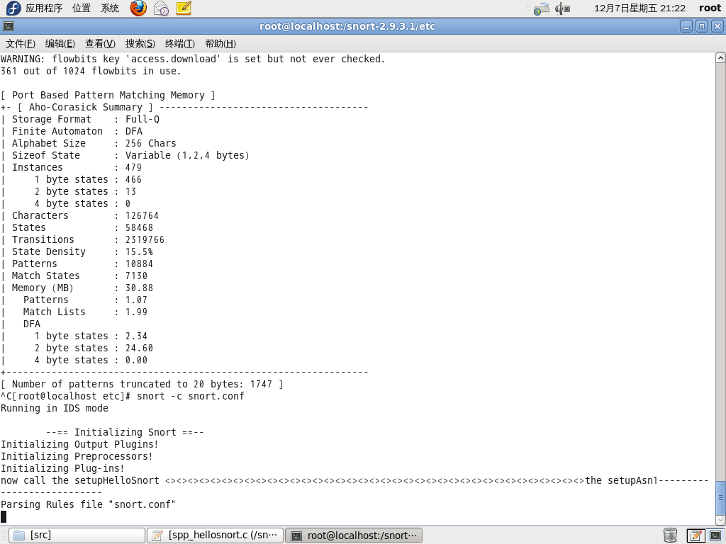

生成规则链表的时候的启动信息如下图：

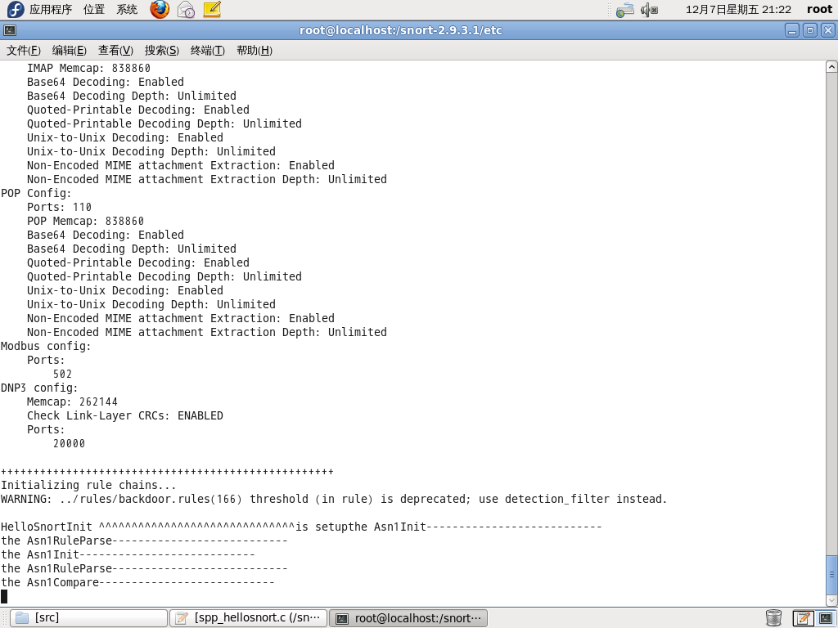

启动成功后每通过一个数据包，就会调用预处理插件并输出信息

如下图

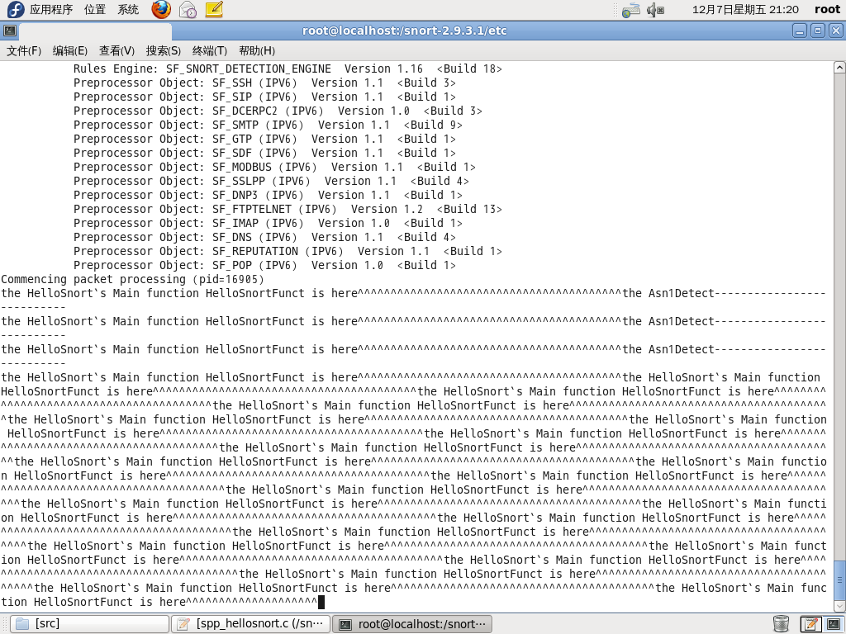

每Ping一次该主机，snort预处理器都会产生输入报文如下图：

