****

**2017 Formula Hybrid Electrical System Form (ESF)**

INTRODUCTION

The goal of the ESF is to ensure that vehicles are as safe as possible, and that they comply with the Formula-Hybrid completion rules. The ESF is divided seven main sections:

1 – Overview

2 – Cables, Fusing & Grounding

3 – Isolation & Insulation

4 – Electric Tractive System

5 – Accumulator System

6 – Safety Controls and Indicators

7 – GLV System

The *Cables and Fusing,* and *Insulation and Isolation* sections are at the beginning of the ESF as these are the areas where teams most often have trouble in complying with FH rules.

A clear, concise ESF will help you to build a better car. It will also help you to pass tech testing as most common tech problems can be addressed before the car reaches the track.

IMPORTANT INSTRUCTIONS AND REQUIREMENTS

1. Every part of this ESF must be filled with content. If a section is not relevant to your vehicle, mark it as “N/A” and describe briefly why not.
2. Please leave the written instructions in place and add your responses below them.
3. All figures and tables must be included. An ESF with incomplete tables or figures will be rejected.
4. The maximum length of a complete ESF is 100 pages.
5. Note that many fields ask for information that was submitted in your ESF-1. This information must be reentered – in some cases will be different than what was entered in ESF-1, which is OK.
6. When completed, this document must be converted to a pdf and submitted to: <http://formula-hybrid.com/uploads/>

Please submit any questions, corrections and suggestions for improvement to: <http://www.formula-hybrid.org/level2/support>

REVIEW PROCESS

Once submitted, your ESF will be reviewed by at least two FH reviewers. One will be the designated *primary reviewer* for your team.

Feedback on your ESF occurs through the Formula Hybrid upload system. You will receive emails via this system from your reviewers offering guidance and feedback. You will also submit revised versions of your ESF in this system. When you submit a revised ESF, please indicate the REVISION DATE AND LETTER (starting with Letter A) and which sections have been updated in the following table:

|  |  |
| --- | --- |
| REVISION DATE: |  |
| REVISION: (A, B, C, etc.) |  |
|  |  |
| Section | Revised (Yes / No) |
| 1 – Overview |  |
| 2 – Cables and Fusing |  |
| 3 – Insulation and Isolation |  |
| 4 – Electric Tractive System |  |
| 5 – Accumulator System |  |
| 6 – GLV System |  |
| 7 – Safety Controls and Indicators |  |
| 8 – Appendices / Datasheets |  |

TITLE PAGE

*Please include team logo, car picture, etc..*

|  |  |
| --- | --- |
| University Name: | Lafayette College |
| Team Name: | Lafayette Motorsports |
| Car Number: | 217 |

**Main Team Contact for ESF related questions:**

|  |  |
| --- | --- |
| Name: | Graham Thomas |
| e-mail: | thomasg@lafayette.edu |

**Table of Contents**

[TITLE PAGE iii](#_Toc442209092)

[I List of Figures vi](#_Toc442209093)

[II List of Tables vii](#_Toc442209094)

[III List of Abbreviations viii](#_Toc442209095)

[Section 1 Vehicle Overview 1](#_Toc442209096)

[Section 2 Cables, Fusing & Grounding 4](#_Toc442209097)

[2.1 Fusing & Overcurrent Protection 4](#_Toc442209098)

[2.2 Component Fusing 4](#_Toc442209099)

[2.3 System Wire Tables 5](#_Toc442209100)

[2.4 Grounding System 6](#_Toc442209101)

[2.5 Conductive Panel Grounding 6](#_Toc442209102)

[Section 3 Isolation & Insulation 7](#_Toc442209103)

[3.1 Separation of Tractive System and Grounded Low Voltage System 7](#_Toc442209104)

[3.2 Isolation & Insulation 8](#_Toc442209105)

[3.3 Conduit 9](#_Toc442209106)

[3.4 Shielded dual-insulated cable 9](#_Toc442209107)

[3.5 Firewall(s) 10](#_Toc442209108)

[Section 4 Electric Tractive System 11](#_Toc442209109)

[4.1 Motor(s) 11](#_Toc442209110)

[4.2 Motor Controller 11](#_Toc442209111)

[4.3 Tractive System Measurement Points (TSMP) 12](#_Toc442209112)

[4.4 Pre-Charge circuitry 12](#_Toc442209113)

[4.5 Discharge circuitry 13](#_Toc442209114)

[4.6 HV Disconnect (HVD) 14](#_Toc442209115)

[4.7 Accelerator Actuator / Throttle Position Sensor 14](#_Toc442209116)

[4.8 Accelerator / throttle position encoder error check 14](#_Toc442209117)

[Section 5 Accumulator System 15](#_Toc442209118)

[5.1 Accumulator Pack 15](#_Toc442209119)

[5.2 Cell description 16](#_Toc442209120)

[5.3 Cell configuration 16](#_Toc442209121)

[5.4 Segment Maintenance Disconnect 16](#_Toc442209122)

[5.5 Lithium-Ion Pouch Cells 17](#_Toc442209123)

[5.6 Cell temperature monitoring 17](#_Toc442209124)

[5.7 Accumulator Isolation Relays (AIR) 18](#_Toc442209125)

[5.8 Accumulator Management System (AMS) 18](#_Toc442209126)

[5.9 Accumulator wiring, cables, current calculations 19](#_Toc442209127)

[5.10 Accumulator indicator 19](#_Toc442209128)

[5.11 Charging 19](#_Toc442209129)

[5.12 Accumulator Container/Housing 20](#_Toc442209130)

[Section 6 Safety Controls and Indicators 21](#_Toc442209131)

[6.1 Shutdown Circuit 21](#_Toc442209132)

[6.2 IMD 22](#_Toc442209133)

[6.3 Reset / Latching for IMD and AMS 22](#_Toc442209134)

[6.4 Shutdown System Interlocks 22](#_Toc442209135)

[6.5 Tractive System Energized Light (TSEL) 22](#_Toc442209136)

[6.6 Tractive System Voltage Present light (TSVP) 23](#_Toc442209137)

[6.7 Ready-To-Drive-Sound (RTDS) 23](#_Toc442209138)

[Section 7 GLV System 24](#_Toc442209139)

[7.1 GLV System Data 24](#_Toc442209140)

[Section 8 Appendices 25](#_Toc442209141)

# List of Figures

[Figure 1 - Electrical System Block Diagram 2](#_Toc442209142)

[Figure 2 - Drawings showing the vehicle from the front, top, and side 2](#_Toc442209143)

[Figure 3 - Locations of all major TS components 2](#_Toc442209144)

[Figure 4 - TSV Wiring Schematic 3](#_Toc442209145)

[Figure 5 - TS and GLV separation 7](#_Toc442209146)

[Figure 6 - Team Designed PCB Layout 8](#_Toc442209147)

[Figure 7 – Safety Shutdown Circuit Schematic 21](#_Toc442209148)

[Figure 8 – Location of Shutdown Circuit Components 22](#_Toc442209149)

*Must be hyperlinked!*

# List of Tables

[Table 1- General Electrical System Parameters 3](#_Toc442209150)

[Table 2 - Fuse Table 4](#_Toc442209151)

[Table 3 - Component Fuse Ratings 4](#_Toc442209152)

[Table 4 - System Wire Table 5](#_Toc442209153)

[Table 5 - PCB Spacings 7](#_Toc442209154)

[Table 6 – List of Containers with TS and GLV wiring 8](#_Toc442209155)

[Table 7- Insulating Materials 9](#_Toc442209156)

[Table 8 - Conduit Data 9](#_Toc442209157)

[Table 9 - Shielded Dual Insulated Cable Data 9](#_Toc442209158)

[Table 10 - Motor Data 11](#_Toc442209159)

[Table 11 - Motor Controller Data 12](#_Toc442209160)

[Table 12 – TSMP Resistor Data 12](#_Toc442209161)

[Table 13 - Data for the pre-charge resistor 13](#_Toc442209162)

[Table 14 - Data of the pre-charge relay 13](#_Toc442209163)

[Table 15 - Data of the discharge circuit. 14](#_Toc442209164)

[Table 16 - Throttle Position encoder data 14](#_Toc442209165)

[Table 17 - Main accumulator parameters 15](#_Toc442209166)

[Table 18 - Main cell specification 16](#_Toc442209167)

[Table 19 - SMD Data 17](#_Toc442209168)

[Table 20 - Cell Temperature Monitoring 18](#_Toc442209169)

[Table 21 AIR data 18](#_Toc442209170)

[Table 22 - AMS Data 18](#_Toc442209171)

[Table 23 - Charger data 19](#_Toc442209172)

[Table 24 - Switches& devices in the shutdown circuit 21](#_Toc442209173)

[Table 25 - Shutdown circuit Current Draw 22](#_Toc442209174)

[Table 26 Parameters of the IMD 22](#_Toc442209175)

[Table 27- GLV System Data 24](#_Toc442209176)

*Must be hyperlinked*!

# List of Abbreviations

AIR Accumulator Isolation Relay

AMS Accumulator Management System

FH Rules Formula Hybrid Rule

GLV Grounded Low-Voltage

IMD Insulation Monitoring Device

SMD Segment Maintenance Disconnect

TS Tractive System

TSEL Tractive System Energized Light

TSMP Tractive System Measurement Point

TSV Tractive System Voltage

TSVP Tractive System Voltage Present

*(Add more as needed)*

# Vehicle Overview

Person primarily responsible for this section:

|  |  |
| --- | --- |
| Name: | Graham Thomas |
| e-mail: | thomasg@lafayette.edu |

Check the appropriate boxes:

**Vehicle is**

New (built on an entirely new frame)

New, but built on a pre-existing frame (FSAE, FS, FH-HIP, FH electric-only, etc.)

Updated from a previous year vehicle

**Architecture**

Hybrid

Series

Parallel

Hybrid in Progress (HIP)

Electric-only

**Drive**

Front wheel

Rear wheel

All-wheel

**Regenerative braking**

Front wheels

Rear wheels

All wheels

None

NARRATIVE OVERVIEW

*Provide a brief, concise description of the vehicles main electrical systems including tractive system, accumulator, hybrid type (series or parallel) and method of mechanical coupling to wheels. Describe any innovative or unusual aspects of the design.*

Include the following figures:

* **Figure 1** – an electrical system block diagram showing all major parts associated with the tractive-system. (Not detailed wiring).
* **Figure 2** – Drawings or photographs showing the vehicle from the front, top, and side
* **Figure 3** – A wiring diagram superimposed on a top view of the vehicle showing the locations of all major TS components and the routing of TS wiring.
* **Figure 4** -- Include a complete TSV wiring schematic per FH Rule EV13.2.1showing connections between all TS components. This should include accumulator cells, AIRs, SMDs, motor controller, motor, pre-charge and discharge circuits, AMD, IMD, charging port and any other TS connections. **NOTE:** Figure 4 is the most important diagram in the ESF

Macintosh HD:Users:Greg:Downloads:simplified_system_block_diagram.pdf

Figure 1 - Electrical System Block Diagram



Figure 2 - Drawings showing the vehicle from the front, top, and side

Replace with your own diagram or figure


Figure 3 - Locations of all major TS components

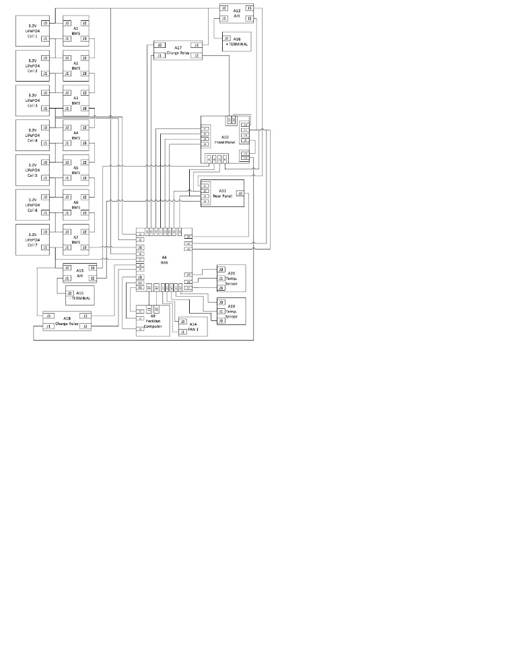

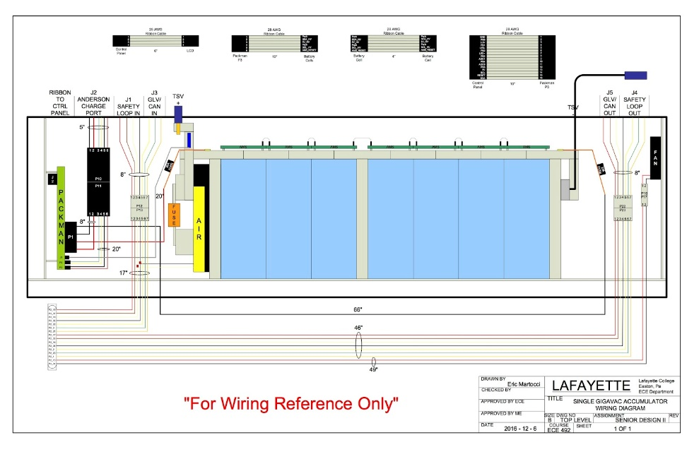

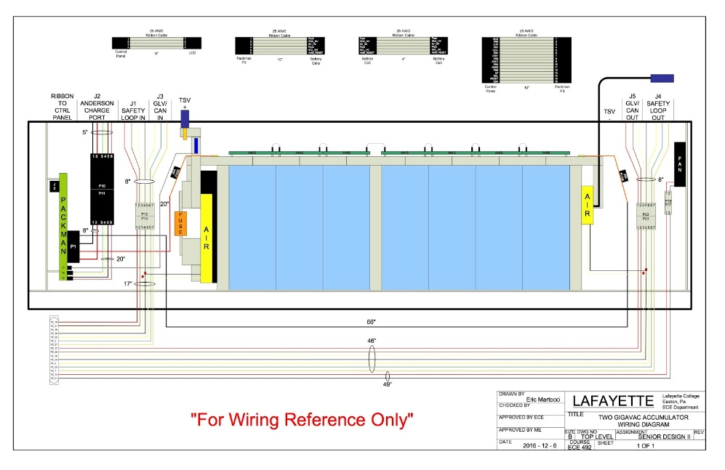

Figure 4 - TSV Wiring Schematic

Fill in the following table:

|  |  |
| --- | --- |
| Item | Data |
| Nominal Tractive System Voltage (TSV) | 89.6VDC |
| Max. TSV (typically this is during charging) | 106.4 VDC |
| Control System voltage (GLV) | 24 VDC |
| Total Accumulator capacity (Wh)[[1]](#footnote-1) | 5.375 kWh |
| Accumulator type (Lead-acid, Li-Ion, NiMH, Ultracap..) | LiFeMnPO4 |
| Number of electric motors, total | 1 |
| Are wheel motors used? | Yes /  No |

Table 1- General Electrical System Parameters

# Cables, Fusing & Grounding

Person primarily responsible for this section:

|  |  |
| --- | --- |
| Name: |  |
| e-mail: |  |

## Fusing & Overcurrent Protection

*List TS and GLV fuse (or circuit breaker) data, and where used*

|  |  |  |  |  |  |
| --- | --- | --- | --- | --- | --- |
| Mfg. | Fuse Part Number | Cont. Rating (A) | DC Voltage Rating | DC Interrupt Rating (A) | Where Used |
| Mersen/Ferraz Shawmut | A3T200 | 200 A | 160 V | 50,000 AIC | Accumulator container; between the positive input terminal of the first cell and the AIRS. |
| Mersen/Ferraz Shawmut | 32031T | 200 A | 300 V | Can’t find on datasheet | Accumulator container - Tractive system high voltage fuse holder. |
| Littelfuse | 0287005.PXCN | 5 A | 32 V | 1 kA at 32 VDC | PacMAN board; separates the incoming high voltage from the accumulator from the 5V in the high voltage section of the PacMAN board. |
| Littelfuse | 0287025.PXCN | 25 A | 32 V | 1kA @ 32 VDC | Accumulator container; one between positive input terminal of the first cell and PacMAN board. One between the negative input terminal of the last cell and the PacMAN board. |
| Qualtek | QLB-103-11B3N-3BA | 10A | 32 | 10A | Safety Loop and GLV power |

Table 2 - Fuse Table

## Component Fusing

*List major components (e.g., motor controller, dc-dc converter) and data sheet max fuse rating. Ensure that the rating of the fuse used is less than the maximum value for the component*

|  |  |  |  |  |
| --- | --- | --- | --- | --- |
| Component | Fuse Part Number | Max Fuse Rating A | Installed Fuse Rating A | Notes |
| DC-DC Converter (Murata Power Solutions, NCS6S1205C) | 0287005.PXCN (LittelFuse) | 5 A | 5A | On PacMAN board. |
| Microcontroller (Microchip Technology, AT90CAN128-16AUR) | 0287005.PXCN (LittelFuse) | 200mA | 5A | On PacMAN board. |
| AMS - PacMAN board | 0287025.PXCN  (LittelFuse) | 25A | 25A | In accumulator container; two fuses from positive input terminal of the first cell and the negative input terminal of the last cell both to the PacMAN board. |
| DC-DC | VYC30W-Q24-S12 | 2.5A | 2.5A |  |
| DC-DC | VYB20W-Q24-S5 | 4A | 4A |  |
|  |  |  |  |  |
|  |  |  |  |  |

Table 3 - Component Fuse Ratings

## System Wire Tables

*List wires and cables used in the Tractive System and the GLV system - wires protected by a fuse of 1 A or less may be omitted.*

*Cable capacity is the value from FH Rules* ***Appendix E*** *(Wire Current Capacity). A revised version of* ***Appendix E*** *that includes metric wire sizes is available at the FH web site. Show available fault current and how calculated. Available fault current can be calculated from*

|  |  |  |  |  |  |  |  |  |  |  |  |
| --- | --- | --- | --- | --- | --- | --- | --- | --- | --- | --- | --- |
| Mfg. | Part Number | Size AWG / mm2 | Insul-ation Type | Voltage Rating | Temp. Rating C | Cable Capacity A | Fuse Part # | Fuse Cont. A | Fuse Interr-upting Rating Adc | Avail. Fault Current A | Where Used & How fault current is calculated |
| CCI | 10416 | 00 | EPDM | 600 V | -50 to 105 | 400 A | - | - | - | - | Input into container 1 |
| CCI | 10416 | 00 | EPDM | 600 V | -50 to 105 | 400 A | - | - | - | - | Between containers 1 and 2 |
| CCI | 10416 | 00 | EPDM | 600 V | -50 to 105 | 400 A | - | - | - | - | Between containers 2 and 3 |
| CCI | 10416 | 00 | EPDM | 600 V | -50 to 105 | 400 A | - | - | - | - | Between containers 2 and 3 |
| CCI | 10416 | 00 | EPDM | 600 V | -50 to 105 | 400 A | - | - | - | - | Between containers 3 and 4 |
| CCI | 10416 | 00 | EPDM | 600 V | -50 to 105 | 400 A | - | - | - | - | Between containers 4 and output |

Table 4 - System Wire Table

## Grounding System

*Describe how you keep the resistances between accessible components below the required levels as defined in FH Rules* ***EV8.1****. If wire is used for ground bonding, state the AWG or mm2 of the wire*

To ensure that we will have proper grounding to the chassis, we will be using 12AWG wire for distributing the chassis ground.

## Conductive Panel Grounding

*If carbon fiber or coated conductive panels are used in your design, describe the fabrication methods used to ensure point to point resistances that comply with* ***EV8.1.2****. Describe results of measurements made per* ***EV8.1.5****.*

We are not using any carbon fiber or coated conductive panels on our vehicle.

# Isolation & Insulation

Person primarily responsible for this section:

|  |  |
| --- | --- |
| Name: |  |
| e-mail: |  |

## Separation of Tractive System and Grounded Low Voltage System

*Describe how the TS and GLV systems are physically separated (****EV5.3****). Add CAD drawings or photographs of how TS and GLV are segregated in key areas of the electrical system.*



Figure 5 - TS and GLV separation

*List all electrical circuit boards designed by team that contain TS and GLV voltage in the following table.*

|  |  |  |  |  |
| --- | --- | --- | --- | --- |
| Device / PCB | TS Voltage Present (V) | Minimum Spacing mm | Thru Air of Over Surface | Notes |
| Student Design | 96 | 6.4 | Over Surface |  |
|  |  |  |  |  |
|  |  |  |  |  |
|  |  |  |  |  |
|  |  |  |  |  |
|  |  |  |  |  |
|  |  |  |  |  |

Table 5 - PCB Spacings

*Add a figure (board layout drawing) for each team-designed PCB showing that spacings comply with* ***EV5.5.***



Figure 6 - Team Designed PCB Layout

*List all purchased components with both TS and GLV connections (at min motor controller and AMS)*

Our AMS boards are powered from the TSV system so they do not have a GLV connection. To ensure isolation there is a DC to DC converter between the cell and the AMS board.

|  |  |  |  |
| --- | --- | --- | --- |
| Component | Isolation Method | Link to Document Describing Isolation | Notes |
| Bender ISOMETER IR155-3203 | Galvanic Isolation | [http://www.bender-es.com/fileadmin/products/doc/IR155-32xx-V004\_D00115\_D\_XXEN.pdfhttp://www.bender-es.com/fileadmin/products/doc/IR155-32xx-V004\_D00115\_D\_XXEN.pdf](http://www.bender-es.com/fileadmin/products/doc/IR155-32xx-V004_D00115_D_XXEN.pdf)  <http://www.bender-es.com/fileadmin/products/doc/IR155-32xx-V004_D00115_D_XXEN.pdf> | Recommended by rules. |
|  |  |  |  |
|  |  |  |  |
|  |  |  |  |
|  |  |  |  |
|  |  |  |  |
|  |  |  |  |

## Isolation & Insulation

*Provide a list of containers that have TS and GLV wiring in them. If a barrier is used rather than spacing, identify barrier material used (reference Table 7- Insulating Materials).*

|  |  |  |  |  |  |
| --- | --- | --- | --- | --- | --- |
| Container Name | Segregation by Spacing (Y or N) | How is Spacing maintained | Actual Measured Spacing mm | Alt – Barrier Material P/N | Notes |
| Accumulator Container | Y | Containers being bolted down | ? | N/A | Can bus isolation description. |
| Accumulator Container | N | Isolators | N/A | N/A | Safety Loop Isolation, Galvanically isolated |
| TSI System Box | Y | PCB Designed with spacing guidelines. All wires entering/exiting box will be fastened to structure of box. |  | N/A |  |
|  |  |  |  |  |  |
|  |  |  |  |  |  |
|  |  |  |  |  |  |
|  |  |  |  |  |  |

Table 6 – List of Containers with TS and GLV wiring

*List all insulating barrier materials used to meet the requirements of* ***EV2.4*** *or* ***EV5.4***

|  |  |  |  |  |
| --- | --- | --- | --- | --- |
| Insulating Material / Part Number | UL Recog-nized ? | Rated Temper-ature ºC | Thickness mm | Notes |
|  |  |  |  |  |
|  |  |  |  |  |
|  |  |  |  |  |
|  |  |  |  |  |
|  |  |  |  |  |
|  |  |  |  |  |
|  |  |  |  |  |

Table 7- Insulating Materials

## Conduit

*List different types of conduit used in the design. Specify location and if manufacturer’s standard fittings are used. Note Virtual Accumulator Housing FH Rules* ***EV2.12*** *requires METALLIC type LFMC.*

*Describe how the conduit is anchored if standard fittings are not used.*

|  |  |  |  |  |  |
| --- | --- | --- | --- | --- | --- |
| Conduit Type | MFR | Part Number | Diameter  Inch or mm | Standard Fittings  (Y or N) | Location / Use |
|  |  |  |  |  |  |
|  |  |  |  |  |  |
|  |  |  |  |  |  |

Table 8 - Conduit Data

*Is all conduit contained within the vehicle Surface Envelope per* ***EV3.1.6****? (****Y or N****).*

*Does all conduit comply with* ***EV3.2****? (****Y or N****).*

## Shielded dual-insulated cable

*If Shielded, dual-insulated cable per EV3.2.5 used in the vehicle, provide specifications and where used:*

None are being used. All TSV cables will be located inside conduits.

|  |  |  |  |  |
| --- | --- | --- | --- | --- |
| MFR | Part Number | Cross Section mm2 | Shield grounded at both ends (Y or N) | Location / Use |
|  |  |  |  |  |
|  |  |  |  |  |

Table 9 - Shielded Dual Insulated Cable Data

## Firewall(s)

## Description/materials

*Describe the concept, layer structure and the materials used for the firewalls. Describe how all firewall requirements in FH Rules* ***T4.5*** *are satisfied. Show how the low resistance connection to chassis ground is achieved.*

#### Position in car

*Provide CAD-rendering or photographs showing the location of the firewall(s).*

# Electric Tractive System

Person primarily responsible for this section:

|  |  |
| --- | --- |
| Name: |  |
| e-mail: |  |

## Motor(s)

*Describe the motor(s) used and reason for this particular choice. Add additional tables if multiple motor types are used*

|  |  |
| --- | --- |
| Manufacturer and Model: |  |
| Motor type (PM, Induction, DC Brush) |  |
| Number of motors of this type used |  |
| Nominal motor voltage (Vrms l-l or Vdc) |  |
| Nominal / Peak motor current (A or A/phase) | Nom: / Peak: |
| Nominal / Peak motor power | Nom: / Peak: |
| Motor wiring – conductor size and type |  |

Table 10 - Motor Data

*Provide calculations for currents and voltages. State how this relates to the choice of cables and connectors used.*

## Motor Controller

*Describe the motor controller(s) used and reason for this particular choice. Add additional tables if multiple motor controller types are used.*

|  |  |
| --- | --- |
| Manufacturer and Model: |  |
| Number of controllers of this type used: |  |
| Maximum Input voltage: |  |
| Nominal Input Current (A) |  |
| Max Input Fuse (A) per Mfr. |  |
| Output voltage (Vac l-l or Vdc) |  |
| Isolation voltage rating between GLV (power supply or control inputs) and TS connections |  |
| Is the accelerator galvanically isolated from the Tractive System per **EV3.5 & EV5**? | Yes /  No |

Table 11 - Motor Controller Data

*If the answer to the last question is NO, how to you intend to comply with* ***EV3.5*** *(an external isolator is acceptable).*

*Provide calculations for currents and voltages. State how this relates to the choice of cables and connectors used.*

## Tractive System Measurement Points (TSMP)

*The TSMP must comply with FH Rule* ***EV10.3****. Describe the TSMP housing and location. Describe TSMP electrical connection point.*

|  |  |
| --- | --- |
| TSMP Output Protection Resistor Value | 10 kΩ |
| Resistor Voltage Rating | 460 V |
| Resistor Power Rating | 5 W |

Table 12 – TSMP Resistor Data

## Pre-Charge circuitry

*Describe your design for the pre-charge circuitry. Describe wiring, connectors and cables used.*

* *Include a schematic of the pre-charge circuit*
* *Include a plot of calculated TS Voltage vs. time*
* *Include a plot of calculated Current vs. time*
* *Include a plot of resistor power vs time.*

*Provide the following information:*

|  |  |
| --- | --- |
| Resistor Type: |  |
| Resistance: | Ω |
| Continuous power rating: | W |
| Overload power rating: | W for sec |
| Voltage rating: | V |

Table 13 - Data for the pre-charge resistor

|  |  |
| --- | --- |
| Relay MFR & Type: |  |
| Contact arrangement (e.g. SPDT) |  |
| Continuous DC contact current (A): | A |
| Contact voltage rating (Vdc). | V |

Table 14 - Data of the pre-charge relay

## Discharge circuitry

*Describe your concept for the discharge circuitry. Describe wiring, connectors and cables used.*

* *Include a schematic of the pre-charge circuit*
* *Include a plot of calculated TS Voltage vs. time*
* *Include a plot of calculated “Discharge current” vs. time*
* *Include a plot of resistor power vs time.*

*Provide the following information:*

|  |  |
| --- | --- |
| Resistor Type: |  |
| Resistance: | Ω |
| Continuous power rating: | W |
| Overload power rating: | W for \_\_\_\_\_ sec |
| Voltage rating: | V |
| Maximum expected current: | A |
| Average current: | A |

Table 15 - Data of the discharge circuit.

## HV Disconnect (HVD)

*Describe your design for the HVD and how it is operated, wiring, and location. Describe how your design meets all requirements for* ***EV2.9.***

## Accelerator Actuator / Throttle Position Sensor

*Describe the accelerator actuator and throttle position sensor(s) used, describe additional circuitry used to check or condition the signal going to the motor controller. Describe wiring, cables and connectors used. Provide schematics and a description of the method of operation of any team-built signal conditioning electronics. Explain how your design meets all of the requirements of FH Rules* ***IC1.6*** *and* ***EV3.5.***

The position sensors we are using are two 5K piston potentiometers. They will be offset by 5 volts and mounted next to each other so the pedal will compress them evenly under normal use. The outputs from the potentiometers used for throttle position are first passed through window comparators that will ensure there is not open or short circuit. The unbiased signals will then be passed through a differential op-amp and compared against a 0.5 volt signal to determine their plausibility to each other. If all of these tests pass, one of the potentiometer signals will be fed to the throttle input of the motor controller.

|  |  |
| --- | --- |
| Actuator / Encoder manufacturer and model: | ? |
| Encoder principle (e.g.Potentiometer): | Potentiometer |
| Output: | 5V range of signals (max 5-10V) |
| Is motor controller accelerator signal isolated from TSV? | ☒Yes / ☐ No |
| If no, how will you satisfy rule **EV3.5**? |  |

Table 16 - Throttle Position encoder data

## Accelerator / throttle position encoder error check

*Describe how the system reacts if an error (e.g. short circuit or open circuit or equivalent) is detected. Describe circuitry used to check or condition the signal going to the motor controller. Describe how failures (e.g. Implausibility, short circuit, open circuit etc.) are detected and how the system reacts if an error is detected. State how you comply with* ***EV3.5.4.***

If either a short or open circuit occurs, the signal closing a power MOSFET switch is opened preventing voltage from reaching the motor controller throttle input. If there is an implausibility detected by a differential op-amp circuit fed into a window comparator, the same situation will occur as a short or open circuit where voltage to the motor controller throttle input is driven to zero.

# Accumulator System

Person primarily responsible for this section:

|  |  |
| --- | --- |
| Name: |  |
| e-mail: |  |

## Accumulator Pack

*Provide a narrative design of the accumulator system and complete the following table.*

|  |  |
| --- | --- |
| Maximum Voltage (during charging): | 26.6 VDC |
| Nominal Voltage: | 22.4 VDC |
| Total number of cells: | 28 |
| Cell arrangement (x in series / y in parallel): | 28 in series |
| Are packs commercial or team constructed? | Commercial /  Team |
| Total Capacity (per FH Rules **Appendix A[[2]](#footnote-2)**): | 4.3 kWh |
| Maximum Segment Capacity | 1.5 MJ |
| Number of Accumulator Segments | 4 |

Table 17 - Main accumulator parameters

Cp = (I^k)\*t = (3^1.05)\*0.5  = 63.4 AH

63.4 = (I^1.05)\*0.5

I = 100.686 (half hour discharge)

2C = 50.3 AH

*Describe how pack capacity is calculated. Provide calculation at 2C (0.5 hour) rate? How is capacity derived from manufacturer’s data? If so, include discharge data or graph here. Include Peukert calculation if used (See FH Rules* ***Appendix A****)*

*Show your segment energy calculations. The segment energy is calculated as*

(The 80% factor is not applied for this calculation.)

## Cell description

*Describe the cell type used and the chemistry and complete the following table.*

|  |  |
| --- | --- |
| Cell Manufacturer and Model | AA Portable Power Corp, LFP-G60 |
| Cell type (prismatic, cylindrical, pouch, etc.) | Prismatic |
| Are these pouch cells | ☐Yes / ☒ No |
| Cell nominal capacity at 2C (0.5 hour) rate: | 50.3 AH |
| Data sheet nominal capacity | 60 Ah at 20 hour rate |
| Maximum Voltage (during charging): | 3.9 V |
| Nominal Voltage (data sheet value): | 3.2 V |
| Minimum Voltage (AMS setting): | 2.0V |
| Maximum Cell Temperature (charging - AMS setting) | 60 C |
| Maximum Cell Temperature (discharging - AMS setting) | 60 C |
| Cell chemistry: | LiFeMnPO4 in prismatic case |

Table 18 - Main cell specification

Cp = (I^k)\*t = (3^1.05)\*0.5  = 63.4 AH

63.4 = (I^1.05)\*0.5

I = 100.686 (half hour discharge)

2C = 50.3 AH

*IMPORTANT: Show your calculations here for 2C nominal AH capacity if the data sheet uses a different discharge rate. Refer to FH rules* ***Appendix A***

## Cell configuration

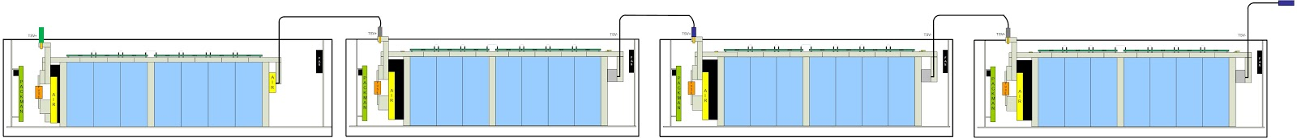

In each accumulator segment, seven cells are placed in series. Each segment is within an accumulator container. There are four containers, each of which is placed in series. In total, seven cells in four containers are all in series.

*Does the accumulator combine individual cells in parallel without cell fuses?* Yes /  No

*If Yes, explain how* ***EV2.6*** *is satisfied.*

## Segment Maintenance Disconnect

*Describe segment maintenance disconnect (SMD) device, locations, ratings etc.*

|  |  |
| --- | --- |
| Is HVD used as an SMD? | Yes /  No |
| Number of SMD Devices / Number of Segments | [10] / [4] |
| SMD MFR and Model | ITT Cannon, NLS-3-GY-S120-M40A and NPS-N-BL-T4  Gigavac, GX14CB |
| SMD Rated Voltage (if applicable) | 3kV  24 V |
| SMD Rated Current (if applicable) | 400 A  350 A |
| Segment Energy (6 MJ max[[3]](#footnote-3)) | 6 MJ |
| Segment Energy Discharge Rate (Ref FH Rules **Appendix A**) | 10 C |

Table 19 - SMD Data

## Lithium-Ion Pouch Cells

*The vehicle accumulator uses individual pouch cells.* Yes  No

Note that designing an accumulator system utilizing pouch cells is a substantial engineering undertaking which may be avoided by using prismatic or cylindrical cells.

*If your team has designed your accumulator system using individual Lithium-Ion pouch cells, include drawings, photographs and calculations demonstrating compliance with all sections of rule* ***EV11.*** *If your system has been issued a variance to* ***EV11*** *by the Formula Hybrid rules committee, include the required documentation from the cell manufacturer.*

## Cell temperature monitoring

Each cell within each accumulator segment is monitored by an AMS board. Each AMS board contains a linear active thermistor (MCP9700, Microchip) that measures the temperature of each cell. The AMS boards communicate this information via I2C to the PacMAN board within their respective accumulator containers, which determines if any cell has exceeded 60oC. If this is the case, a fault case is asserted and the safety loop is opened.

|  |  |
| --- | --- |
| Number of Cells with Temperature Monitoring (#1) | 28 |
| Total Number of Cells (#2) | 28 |
| Percentage Monitored (#1 / #2) | 100% |
| Percentage Required by FH Rules **Table 11** | 30% |
| If each sensor monitors multiple cells, state how many: | N/A |

Table 20 - Cell Temperature Monitoring

## Accumulator Isolation Relays (AIR)

Within the accumulator system, we utilize five AIRs. Our design places the four accumulator containers in series. The first in this series contains two AIRs. The three subsequent containers contain one AIR; we justify this design decision as the one AIR sufficiently separates each HV segment from each other.

|  |  |
| --- | --- |
| MFR & Model | Gigavac GX14CB |
| Contact arraignment: | Single Pole Single Throw Normally Open |
| Continuous DC current rating: | 350 A |
| Overload DC current rating: | 1000 A for 85 sec |
| Maximum operation voltage: | 32 VDC |
| Nominal coil voltage: | 24 VDC |
| Normal Load switching: | Make and break up to 600 A |

Table 21 AIR data

## Accumulator Management System (AMS)

The AMS within each accumulator consists of one PacMAN board and seven AMS boards. The PacMAN board is comprised of a microcontroller (Microchip Technology, AT90CAN128-16AUR) which monitors overall pack current and voltage directly and receives individual cell information from the AMS boards. Each AMS board monitors a single cell for temperature and voltage and communicates this to the PacMAN via I2C. If the PacMAN detects a fault, defined as cell temperature exceeding 60°C, cell voltage exceeding 4 V, accumulator segment voltage exceeds 26 V, or an AMS board is unresponsive, the PacMAN board opens the safety loop relay. Accumulator voltage is only present when the safety loop is closed.

PacMAN also keeps track of accumulator state, state of charge, and the state of the safety loop relay on PacMAN. All of these data are regularly sent via CAN frames to the VSCADA computer. The microcontroller communicates on the CAN bus through a Microchip MCP2551 CAN interface IC. This information is also displayed on the top of each accumulator container through the control panel. Managed by PacMAN, this LCD will be able to display pack voltage, pack current, cell voltage, cell temperature, state of charge, cell balancing state, charging state, charging history, discharge history and safety loop state. It will also have functionalities of going into sleep mode and choosing calibration factors where they are necessary.

When either the charging or low current output port (Anderson Power connector on the control panel that is limited to 20 A and 30 V), are in use, a relay on the PacMan computer closes allowing access to the positive and negative terminal of the accumulator. These connections are fused at the terminals with 25A blade fuses. Current flowing through the charge relay also flows through a 1 mOhm current sensing resistor that is monitored via a Kelvin connection by a Texas Instruments INA 226 current monitor. This IC also allows voltage sensing for the full accumulator voltage.

While charging, the voltage of each cell is monitored by the AMS boards, and communicated to PacMAN via I2C. A cell will be placed in bypass mode when its voltage reaches 3.6 V, allowing other cells to continue to charge without overcharging. This is accomplished allowing some current to pass through a resistor attached to a heat sink instead of the cell. A 5V fan is allowed to run at all times while charging to maintain the ambient temperature inside the accumulator. Once any cell reaches 3.9 V, charging is considered complete. Both bypassing and completion of a charge cycle trigger an entry in a charge history stored on the microcontroller. This data will be accessible in debug via USB, and an abbreviated history is available on the control panel LCD.

|  |  |
| --- | --- |
| AMS MFR and Model | Manufactured/Designed in House |
| Number of AMSs | 4 |
| Upper cell voltage trip | 4 V |
| Lower cell voltage trip | 2 V |
| Temperature trip | 60°C |

Table 22 - AMS Data

## Accumulator wiring, cables, current calculations

We expect no AC voltage. For an accumulator container we expect a thevenin voltage of 23.6 V with 14 mOhm thevenin resistance at 100% state of charge. With a fully charged accumulator container, we expect roughly 24 V with seven cells charged to 3.4 V. With a fully charged accumulator system we expect 96 V. From experimentation, it takes 53 minutes for full discharge for a single accumulator container. The low current output draws 20 A. Each cell has 60A-h.

Through a motor and controller characterization, the maximum RPM is 4500 RPM with a maximum possible torque of 92 ft-lbs. The maximum efficiency motor speed in the fully integrated car is 2500 RPM with steady state torque estimate of 15 ft-lbs based upon a constant power experiment showing the maximum efficiency for the motor reached at and above 2500 RPM. At this maximum efficiency, the motor will draw 71 A from the accumulator. This means the battery will dissipate from this analysis in 51 minutes or 0.85 hours.

The DC current from the accumulator is measured utilizing a current sensor from each accumulator container.

For the rate of charge and discharge of an accumulator container, assuming the slowest possible discharge current for an accumulator at 20A, the actual current is expected to be within the range of 20.366 and 19.634A. Given an accumulator capacity of 60 A­h, the capacity in Coulombs is equal to 216000. At 20 Coulombs per second, the pack will discharge in 10800 seconds, meaning a discharge rate of 1% every 108 seconds. For 20.366 and 19.634 A, the pack discharges 1.018% or 0.982% every 108 seconds respectively. .018 multiplied by 100 to account for the possible accumulation of error gives a confidence interval of +/­ 1.8% ​between the measured and expected values for state of charge.

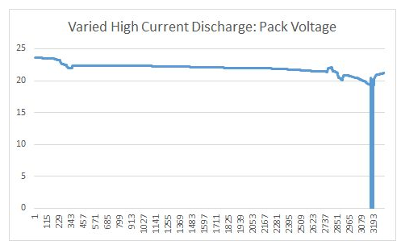

## Accumulator indicator

LCD display, controls and indicators are going to be provided on top of the pack.

As illustrated below, controls of the pack are four pushbuttons and an indicator is the red led. Four push buttons are integrated the LCD display. One is for navigating up through the options, one is for navigating down through the options, one is for choosing/selecting and one is for reset. The red LED is an indicator for when AIRs are closed (when the pack is alive).

Managed by the PacMAN board, the LCD will be able to display pack voltage, pack current, cell voltage, cell temperature, state of charge, cell balancing state, charging state, charging history, discharge history and safety loop state. It will also have functionalities of going into sleep mode and choosing calibration factors where they are necessary.

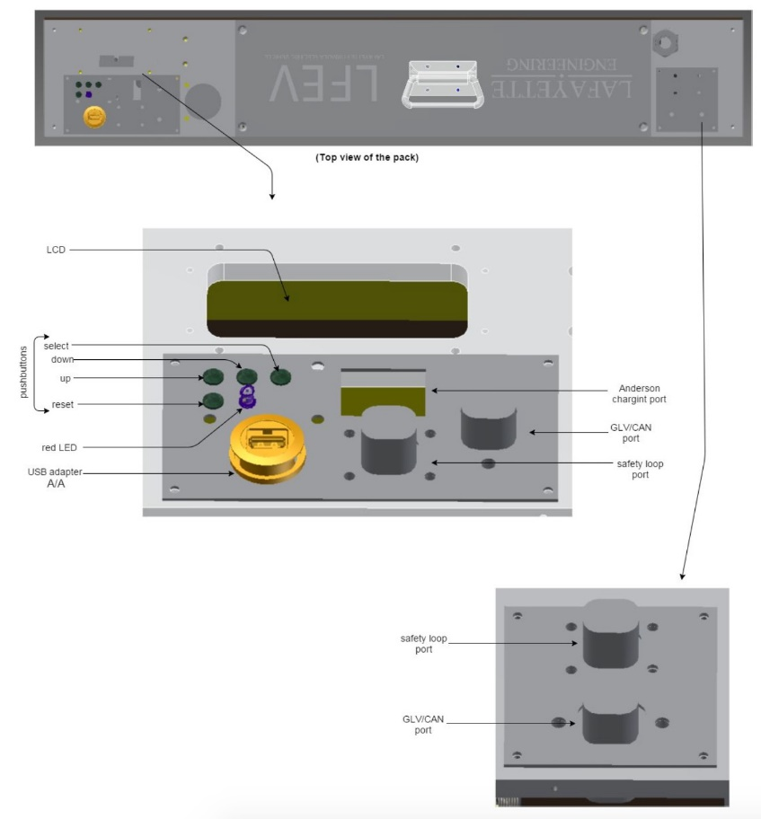

## Charging

This design utilizes coulomb counting, integrating the current flowing through the current sensing resistor to determine the increase in state of charge due to charging as well as the decrease in state of charge due to low current output and the operation of the PacMan computer.

To monitor current flowing through the high current output, a Ametes BBM­01 current sensor is attached to the 0.5 in by 1 in aluminum bar wire that attaches the negative accumulator terminal to the negative terminal of battery of cells. This sensor provides a differential voltage output that is available to the microcontroller over I2C through a Texas Instruments ADS1115 analog to digital converter.

While charging, the voltage of each cell is monitored by the AMS boards, and communicated to PacMAN via I2C. A cell will be placed in bypass mode when its voltage reaches 3.6 V, allowing other cells to continue to charge without overcharging. This is accomplished allowing some current to pass through a resistor attached to a heat sink instead of the cell. A 5V fan is allowed to run at all times while charging to maintain the ambient temperature inside the accumulator. Once any cell reaches 3.9 V, charging is considered complete. This allows for plug-and-forget charging. Both bypassing and completion of a charge cycle trigger an entry in a charge history stored on the microcontroller. This data will be accessible in debug via USB, and an abbreviated history is available on the LCD.

|  |  |
| --- | --- |
| Charger Manufacturer and model: | MPJA 9604PS |
| Maximum charging power: | 0.3 kW |
| Isolation | Yes /  No |
| UL Certification (If “no”, fill in the line below) | Yes /  No |
| Do you have a waiver from the FH rules committee? | Yes /  No |
| Maximum charging voltage: | 30 V |
| Maximum charging current: | 10 A |
| Interface with accumulator (e.g. CAN, relay etc) | Anderson Charging Port |
| Input voltage: | 110 VAC single phase |
| Input current: | Not on data sheet |

Table 23 - Charger data

## Accumulator Container/Housing

The accumulator container will be made of 1/16” steel sheet/plate and each (2) will contain 2 battery packs. The container will have a latching cover that can be removed so that the accumulators can be removed from the vehicle. The cover will also have cutouts so that the high voltage 2/0 wires can go from pack to pack. The wires are connected to the poles of the accumulators and are encased in an insulated casing. That entire accumulator container will go in the side pods on the car, the area designated for the storage of the packs. There will also be cutouts for small amounts of air to help cool the accumulators, although the cells don’t end up reaching that high of a temperature during discharge. There will also be through-holes for the mounting method for the battery packs and accumulator containers.

Requirements for V-0

1. The specimens may not burn with flaming combustion for more than 10 seconds after either application of the test flame.
2. The total flaming combustion time may not exceed 50 seconds for the 10 flame applications for each set of 5 specimens.
3. The specimens may not burn with flaming or glowing combustion up to the holding clamp.
4. The specimens may not drip flaming particles that ignite the dry absorbent surgical cotton located 300 mm below the test specimen.
5. The specimens may not have glowing combustion that persists for more than 30 seconds after the second removal of the test flame.

1/16” steel sheet/plate will fulfill the requirements above

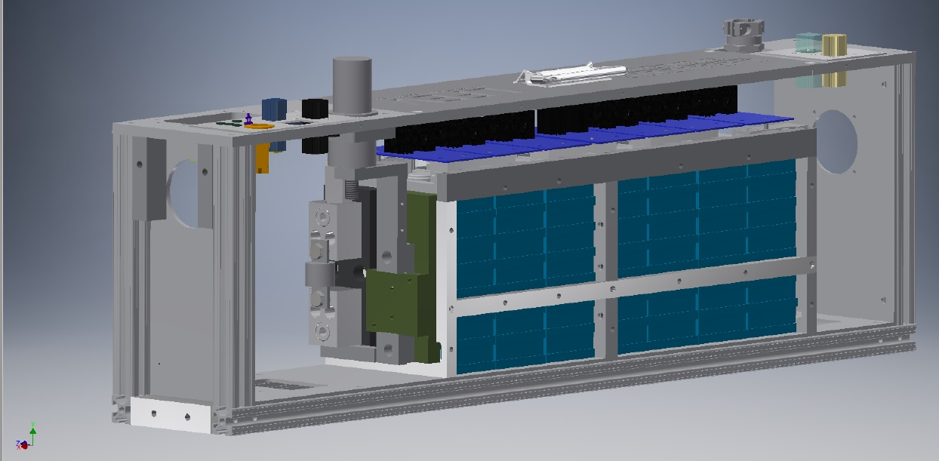

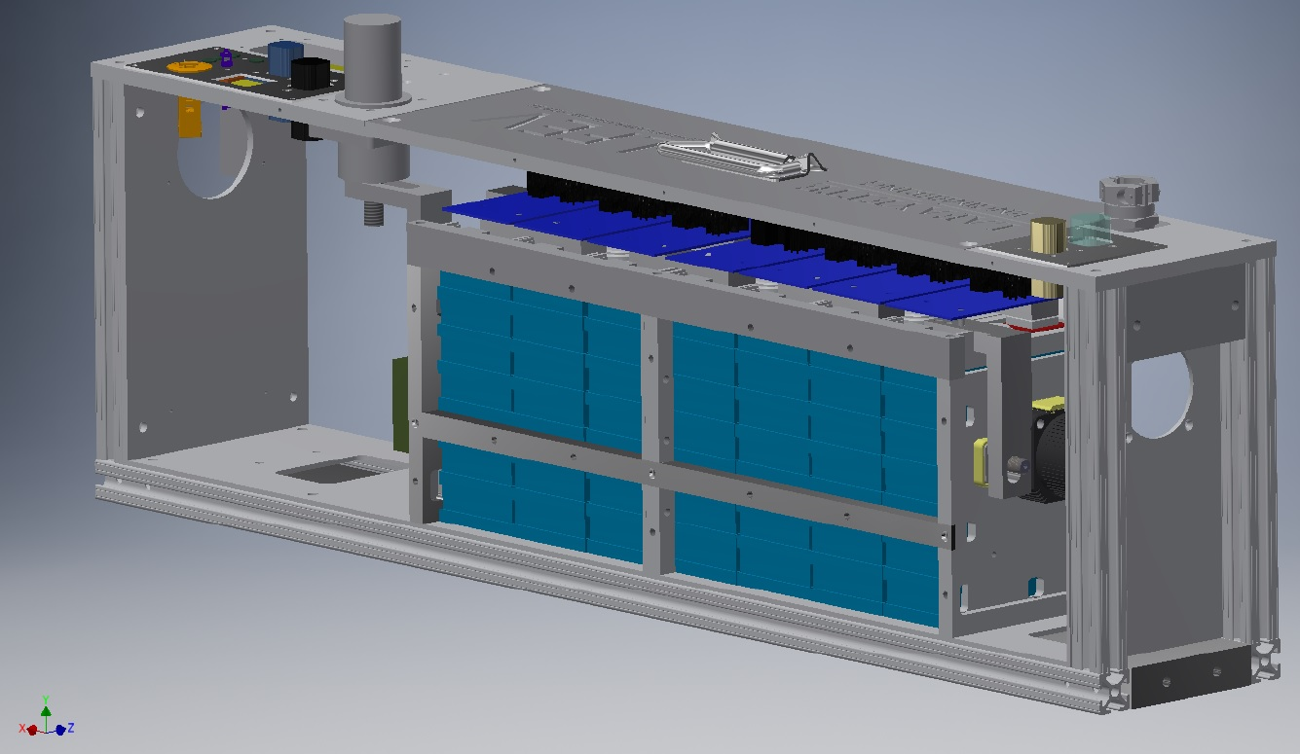

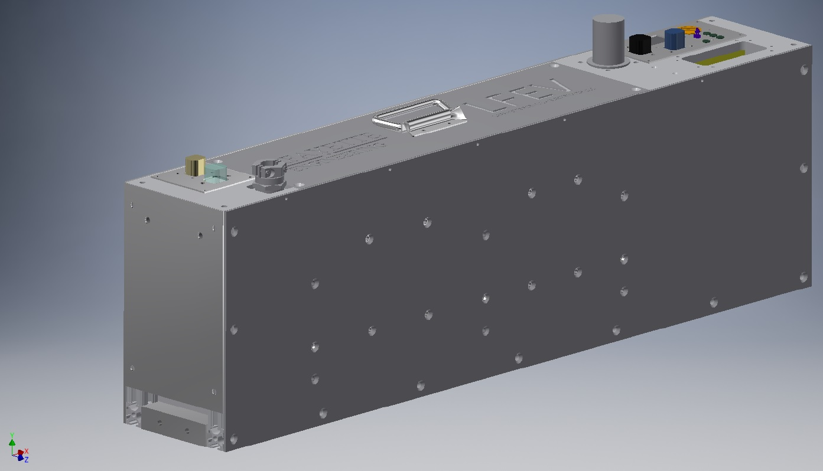

# Safety Controls and Indicators

## Shutdown Circuit

*Include a schematic of the shutdown circuit for your vehicle including all major components in the loop*

*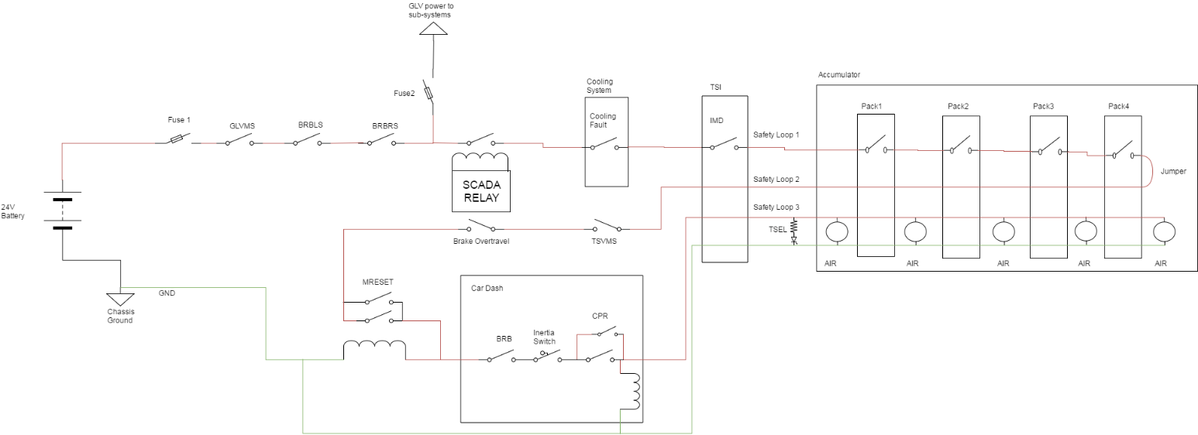*

Figure 7 – Safety Shutdown Circuit Schematic

*Describe the method of operation of your shutdown circuit, including the master switches, shut down buttons, brake over-travel switch, etc. Also complete the following table*

Master switches and BRB’s shut down entire system. SCADA monitoring, Cooling, AMS and IMD systems have the ability to shut down AIR’s in TSV. Then post AMS the Brake overtravel switch and TSV master switch shut down the AIR’s outside cockpit. The only Driver resettable switches are the BRB, inertia switch and CPR located directly before the AIR’s.

|  |  |
| --- | --- |
| **Part** | **Function  (Momentary, Normally Open or Normally Closed)** |
| Main Switch (for control and tractive-system; CSMS, TSMS) | Normally Closed |
| Brake over-travel switch (BOTS) | Push pull switch that will be pressed when the brake lines do not create enough pressure to stop the pedal. This will stop voltage from reaching the motor controller throttle input. Normally Closed. |
| Shutdown buttons (BRB) | Normally Closed |
| Insulation Monitoring Device (IMD) | Bender ISOMETER IR155-3203. Operating with normal specs stated on the datasheet. OKHS will be used for monitoring ground faults. Normally outputs digital HIGH. |
| Battery Management System (AMS) | Normally Closed |
| Cooling system | Normally Closed |
| Scada Relay | Normally Open |
| Crash Protection Reset(CPR) | Normally Open |
| Master Reset | Normally Open |
| Interlocks (if used) | None |

Table 24 - Switches& devices in the shutdown circuit

Each accumulator container houses one AIR between the HV positive input terminal of each container and the Mersen/Ferraz Shawmut A3T200 fuse, which then connects to the positive terminal of the first cell in the accumulator segment. Thus, simply, the AIR is in series with the HV input, fuse, and first cell. This AIR in each accumulator container is then connected to the PacMAN board and out the CAN output of the container. Only the first accumulator container in the series contains a second AIR which connects between the minus terminal of the last cell in series in the accumulator segment and the HV negative output terminal of the accumulator container.

If the PacMAN detects a fault, defined as cell temperature exceeding 60°C, cell voltage exceeding 4 V, accumulator segment voltage exceeds 26 V, or an AMS board is unresponsive, the PacMAN board opens the AIR. Accumulator voltage is only present when the safety loop is closed. Externally, the AIR can be opened or closed via the CAN connectors on each container from the safety loop.

|  |  |
| --- | --- |
| Total Number of AIRs: | 5 |
| Coil holding current per AIR: | 350 A |
| Current drawn by other components wired in parallel with the AIRs. | 0 A |
| Total current: | 350 A |

Table 25 - Shutdown circuit Current Draw

*Provide CAD-renderings showing the shutdown circuit parts. Mark the parts in the renderings*



Figure 8 – Location of Shutdown Circuit Components

## IMD

*Describe the IMD used and use a table for the common operation parameters, like supply voltage, temperature, etc. Describe how the IMD indicator light is wired. Complete the following table.*

|  |  |
| --- | --- |
| MFR / Model | Bender ISOMETER IR155-3203 |
| Set response value: | 100 kΩ (1 kΩ/Volt) |

Table 26 Parameters of the IMD

*Describe IMD wiring with schematics.*

## Reset / Latching for IMD and AMS

*Describe the functioning and circuitry of the latching/reset system for a tripped IMD or AMS. Describe wiring, provide schematics.*

The IMD tripped circuit will open a relay that is use to complete the safety loop. When the OKHS signal is not producing the normal 24V during safe usage, the relay will open and the override button that is not driver resettable will need to be pushed in order to close this relay again. Schematics for this can be found in the GLV safety loop.

When AMS or IMD breaks the safety loop two reset buttons must be pushed to reengage the AIR’s. The Master reset on the outside of the car and the CPR in the cockpit of the car. Both are latching buttons. By pressing the reset it shorts the second switch and provides current through the inductor closing the bottom switch.

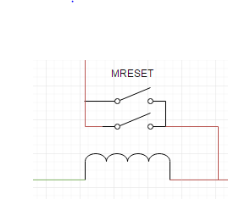

## Shutdown System Interlocks

*(If used) describe the functioning and circuitry of the Shutdown System Interlocks. Describe wiring, provide schematics.*

N/A

## Tractive System Energized Light (TSEL)

*Describe the tractive system energized light components and method of operation. Describe location and wiring, provide schematics. See* ***EV9.1.***

## Tractive System Voltage Present light (TSVP)

*Describe the tractive system voltage present light components and method of operation. Describe location and wiring, provide schematics. See* ***EV9.3***

The TSEL will be controlled from a voltage monitoring device that can handle the TS voltage that we are applying to it. The LTC2965 allows for a user defined threshold voltage, in our case 32 volts, and output a logic HIGH. This will then be passed through an opto-isolator to the low voltage side and will power two 12 volt trailer clearance lamps found from www.superbrightleds.com - part number M9-x4.

## Ready-To-Drive-Sound (RTDS)

*Describe your design for the RTDS system. See* ***EV9.2.***

The ready to drive sound will activate when the drive button is pressed assuming the correct startup sequence has been met up to that point. This information will be made available to us by the VSCADA system over CAN bus. If all conditions are met when the button is pressed, the microcontroller used in the TSI system will drive a sound maker similar to the provided sound clips for 2 seconds.

# GLV System

Person primarily responsible for this section:

|  |  |
| --- | --- |
| Name: |  |
| e-mail: |  |

## GLV System Data

*Provide a brief description of the GLV system and complete the following table*

The GLV system is comprised of the 24V LiFePo4 battery, vehicle computer interface(VCI), the vehicle user interface(VUI) and the safety loop. The battery provides 24V to all sub-systems. The VCI provides hardware for VSCADA interfacing. The VUI is the driver interface including buttons and dashboard display screen. The safety loop assures all systems are functioning properly before opening airs and allowing HV from the accumulators.

|  |  |
| --- | --- |
| GLV System Voltage | 24 V |
| GLV Main Fuse Rating | 40 A(BMS) |
| Is a Li-Ion GLV battery used? | Yes /  No |
| If Yes, is a firewall provided per **T4.5.1**? | Yes /  No |
| Is a dc-dc converter used from TSV? | Yes /  No |
| Is the GLV system grounded to chassis? | Yes /  No |
| Does the design comply with **EV4**? | Yes /  No |

Table 27- GLV System Data

# Appendices

Include only highly-relevant data. A link to a web document in the ESF text is often more convenient for the reviewer.

The specification section of the accumulator data sheet, and sections used for determining accumulator capacity (FH Rules **Appendix A**) should be included here.

1. Calculate accumulator capacity per 2017 FH Rules Appendix A. Be sure to use the 2C (0.5 hour) discharge rate for the Ah value. [↑](#footnote-ref-1)
2. This includes an 80% derating for available traction energy [↑](#footnote-ref-2)
3. Note Segment energy = rated AH x nominal voltage. The 80% derating is NOT applied for this calculation. [↑](#footnote-ref-3)