**Lafayette College: Electrical and Computer Engineering**

08

**Fall**

Accumulator Simulated Load Experiment: EXP-01

Greg Flynn

This document contains information about how to set up an experiment to simulate the operation of the accumulator. A simulated load is used for this acquisition. Both one pack and all four in series are documented here.

Table of Contents

Desired objectives 3

Required Hardware 3

Required Software 3

Hardware Setup 4

Software Setup 6

Data 6

Desired data 6

Thévenin Voltage 6

Temperature 6

Appendix A: Wiring requirements 7

# Desired objectives

This experiment should characterize how the packs perform safely. To achieve this the packs will discharge into a simulated load. This will be done in two steps. The first experiment will verify that an individual pack can deliver the expected current. The second experiment will ensure that all of the packs can work together to ensure that the correct current can be driven into the load at the right voltage.

The nominal voltage of 4 packs in series is 89.6VDC. For one pack it is 22.4V. The maximum current that the packs will be asked to draw is 200A. The maximum anticipated voltage is 106.4VDC. The experiments are designed to ensure that no more than 200 A will be drawn in any circumstance.

To run these test a safety plan must have already been agreed and accepted by the ECE Director of Laboratories.

# Required Hardware

* 4 Packs in series
* Simulated load
* Basic GLV safety loop
* PPE per safety plan
* Danger zone per safety plan
* Cables as specified in Appendix A
* Temperature Probe
* Multimeter

# Required Software

None

# Hardware Setup

## Single pack

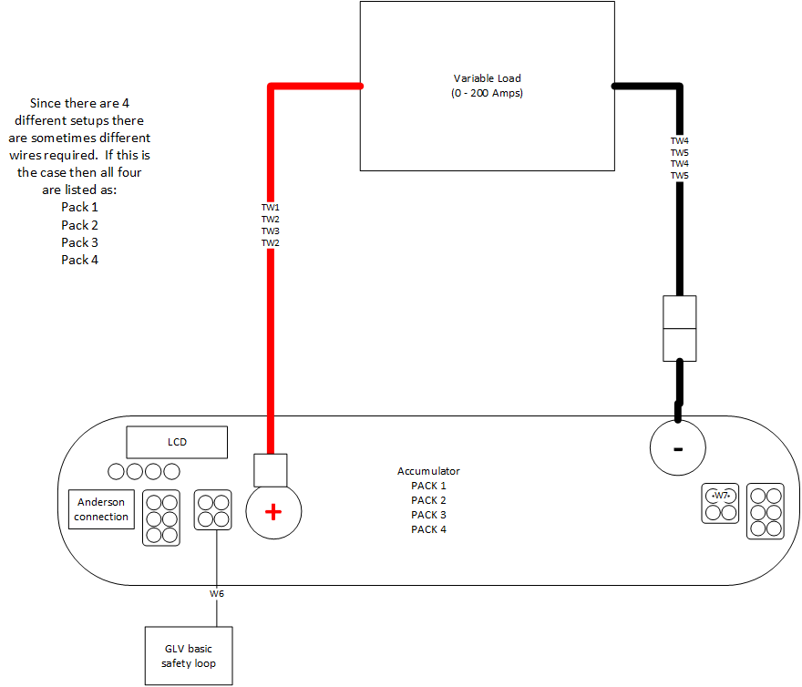

Figure 1 Single pack connections

## Full accumulator setup

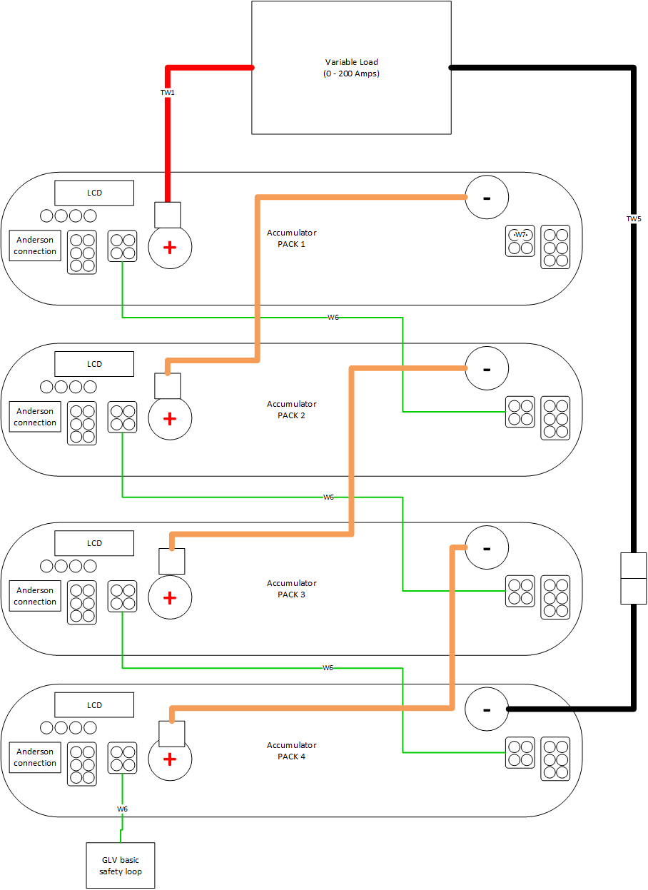

Figure 2 Full 4 cell test

# Software Setup

N/A

# Data

Perform full stress test and ramp the desired current up to 200 Amps.

## Desired data

It is desired to get for both the single pack and the chain of packs:

* Thévenin voltage
* Temperature of cells

## Thévenin Voltage

Check all packs individually from 0 Amps to 200 Amps to be able to characterize the Thévenin equivalent. Add more rows as appropriate. Pay careful attention to measuring the voltage away from the cells, a correction factor may be needed to deal with voltage loss.

|  |  |  |
| --- | --- | --- |
| Pack | Current | Voltage at load |
|  |  |  |
|  |  |  |
|  |  |  |
|  |  |  |

Check chain of packs from 0 Amps to 200 Amps.

|  |  |
| --- | --- |
| Current | Voltage at load |
|  |  |
|  |  |
|  |  |
|  |  |

## Temperature

While testing ensure that no part of the pack gets 40C above ambient temperature.

___________________________________________ ____________________ ____________________

Witness/examiner signature Date Pass/Fail

# C:\Users\flynng\Desktop\Important-Paperwork\Experiments\EXP-01\Test wires.pngAppendix A: Wiring requirements

|  |  |  |
| --- | --- | --- |
| Cable | What packs use it | Total count for full test |
| W6 | 1,2,3,4 | 4 |
| W7 | 1,2,3,4 | 1 |
| TW1 | 1 | 1 |
| TW2 | 2,4 | 2 |
| TW3 | 3 | 1 |
| TW4 | 1,3 | 2 |
| TW5 | 2,4 | 2 |