**Lafayette College: Electrical and Computer Engineering**

08

**Fall**

Tractive System Interface Verification: QA-TSI-01

Greg Flynn

This document contains information about how to verify the electrical connections inside the TSI box.

Table of Contents

Desired objectives 3

Required Hardware 3

Required Software 3

Hardware Setup 4

TSI box 4

Software Setup 5

Test 5

Desired data 5

Appendix A: Wiring requirements 6

Appendix B: Measurement location images 7

# Desired objectives

This test verifies all high voltage mechanical connections in the TSI circuit are electrically connected.

# Required Hardware

* TSI box
* Cables to
* Simulated load
* PPE per safety plan
* Danger zone per safety plan
* Current probe

# Required Software

None

# Hardware Setup

## TSI box

* Short W11 together so that HV+ is connected to HV-. Use a bolt for this
* Connect HV+ and HV- to a power supply that can be current limited.

# Software Setup

N/A

# Test

Suggestion: Run test at 20A.

## Desired data

It is desired to get the resistance between all connections. Use the picture in Appendix A.

Fill out attached excel document the box. All resistances should be at least under 100uOhms. Ideally they should be under 10uOhms.

___________________________________________ ____________________ ____________________

Witness/examiner signature Date Pass/Fail

# Appendix A: Wiring requirements

|  |  |
| --- | --- |
| Cable | Total count for full test |
| W12 | 1 |
| W13 | 1 |

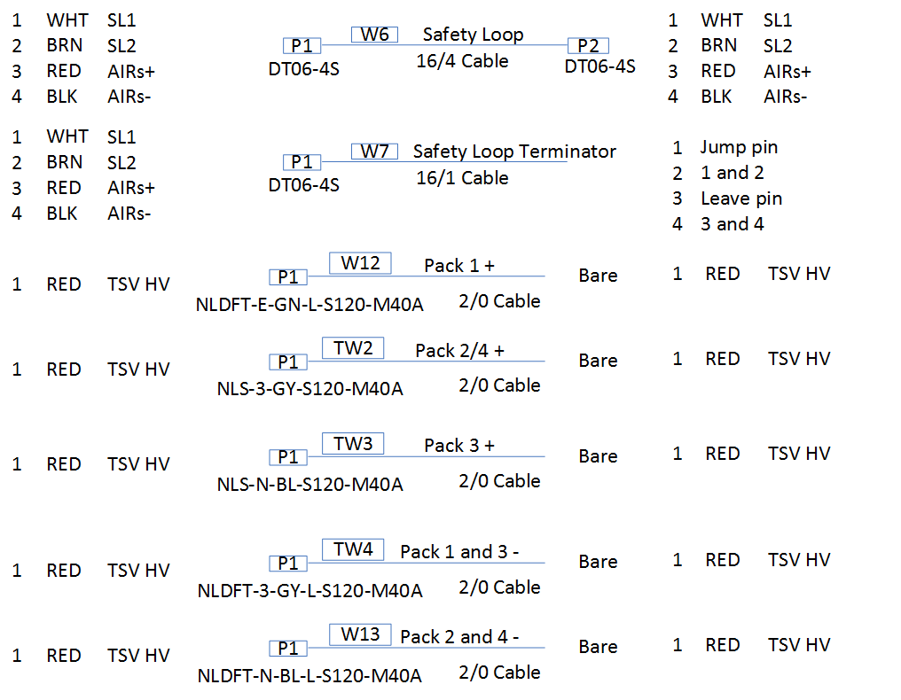

# Appendix B: Measurement location images

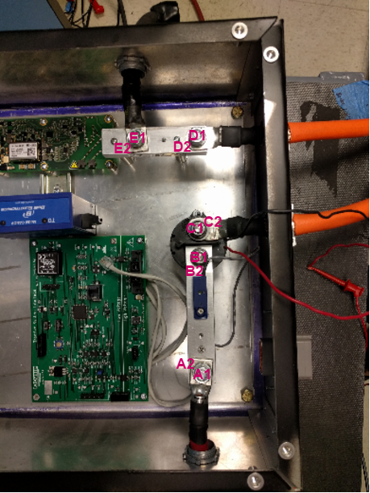

Figure 1 Top of TSI box