**Lafayette College: Electrical and Computer Engineering**

08

**Fall**

Accumulator Verification: QA-TSV-01

Greg Flynn

This document contains information about how to verify the electrical connections inside the pack.

Table of Contents

Desired objectives 3

Required Hardware 3

Required Software 3

Hardware Setup 4

Single pack 4

Software Setup 5

Test 5

Desired data 5

Appendix A: Wiring requirements 6

Appendix B: Measurement location images 7

# Desired objectives

This test verifies all mechanical connections in the TSV circuit are electrically connected.

# Required Hardware

* 1 Pack
* Simulated load
* Basic GLV safety loop
* PPE per safety plan
* Danger zone per safety plan
* Cables as specified in Appendix A
* Multi-meter
* Current probe

# Required Software

None

# Hardware Setup

## Single pack

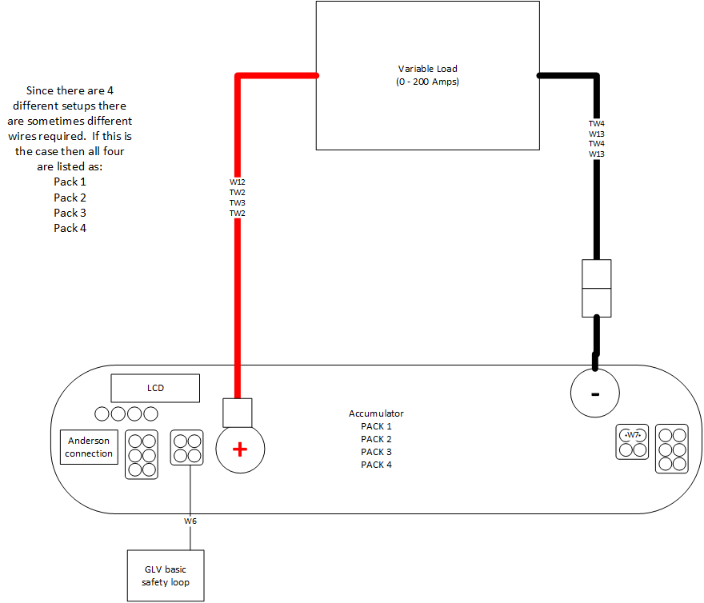

Figure Single pack connections

# Software Setup

N/A

# Test

Suggestion: Run test at 20A.

## Desired data

It is desired to get the resistance between all connections. Use the picture in Appendix B. Note that in figure five pack one has an air between X1 and X2.

Fill out attached excel document for each pack in a new sheet.

___________________________________________ ____________________ ____________________

Witness/examiner signature Date Pass/Fail

# Appendix A: Wiring requirements

|  |  |  |
| --- | --- | --- |
| Cable | What packs use it | Total count for full test |
| W6 | 1,2,3,4 | 4 |
| W7 | 1,2,3,4 | 1 |
| W12 | 1 | 1 |
| TW2 | 2,4 | 1 |
| TW3 | 3 | 1 |
| TW4 | 1,3 | 1 |
| W13 | 2,4 | 1 |

Appendix B: Measurement location images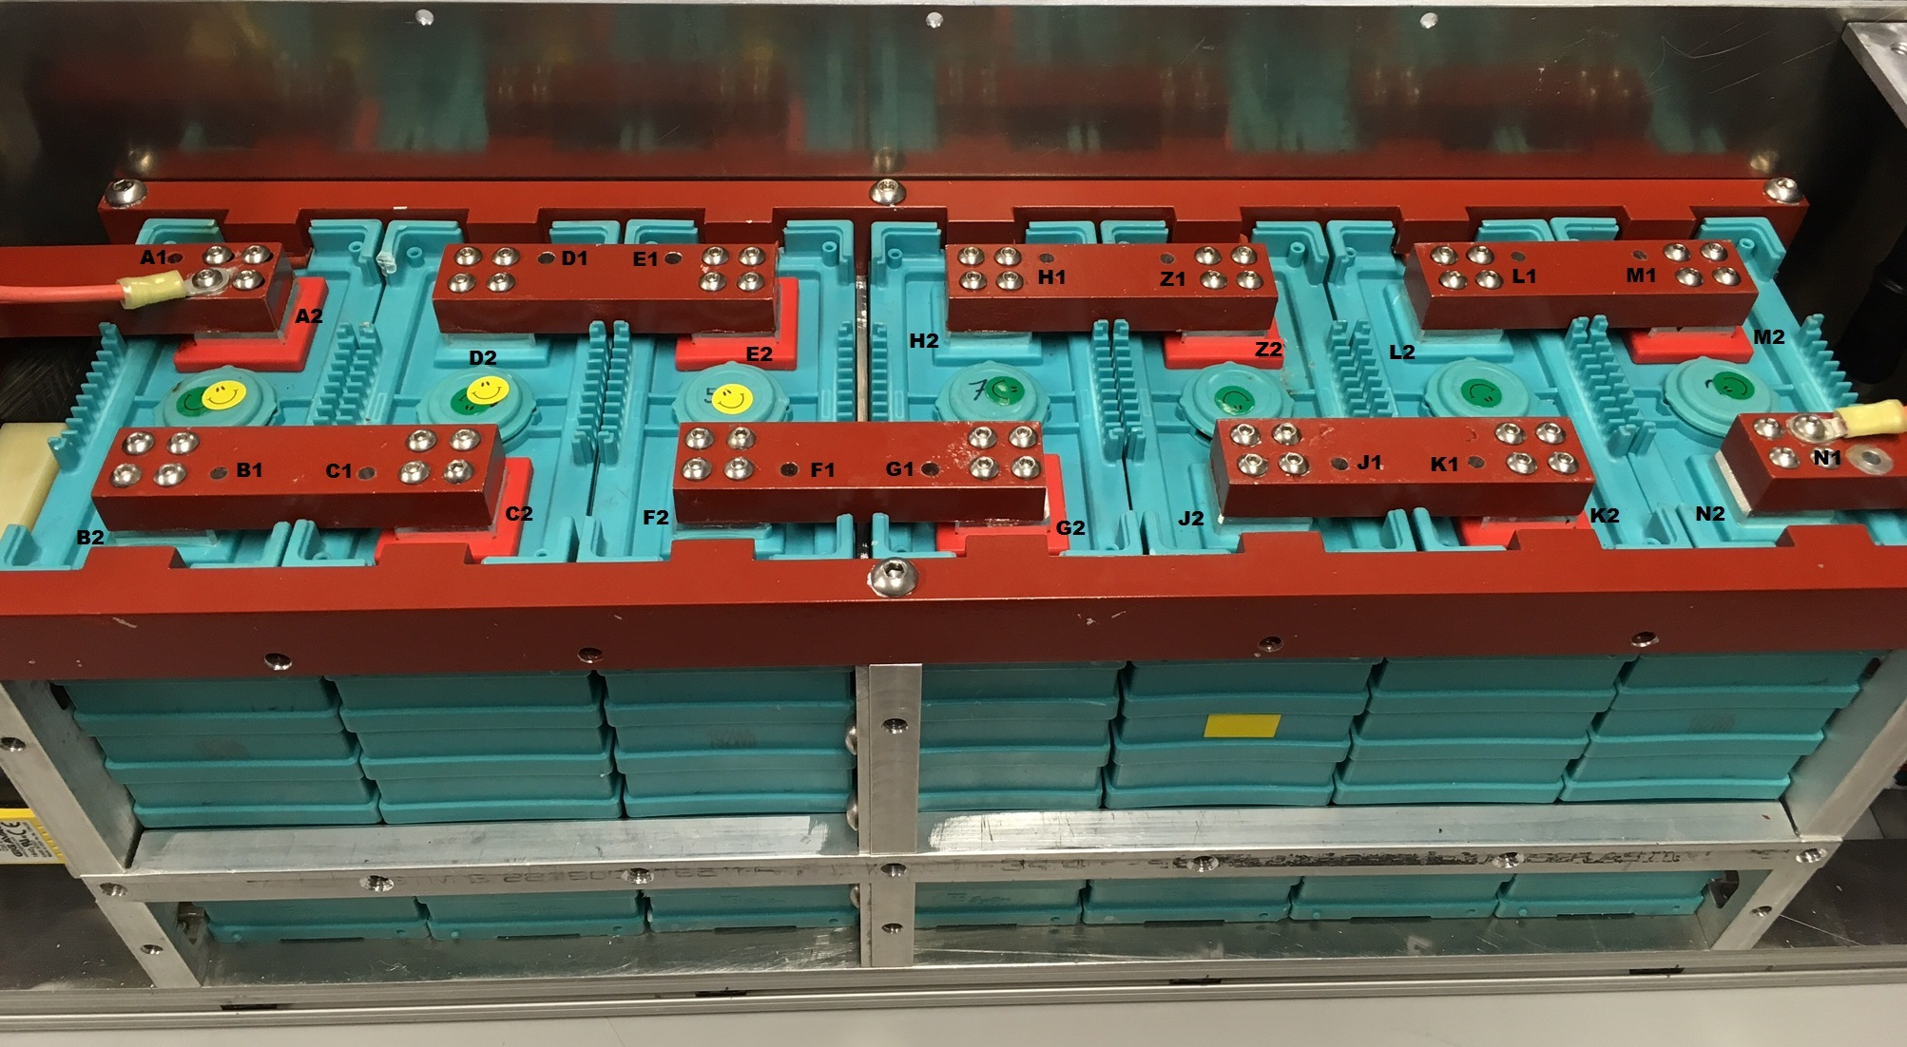

Figure Top of cells

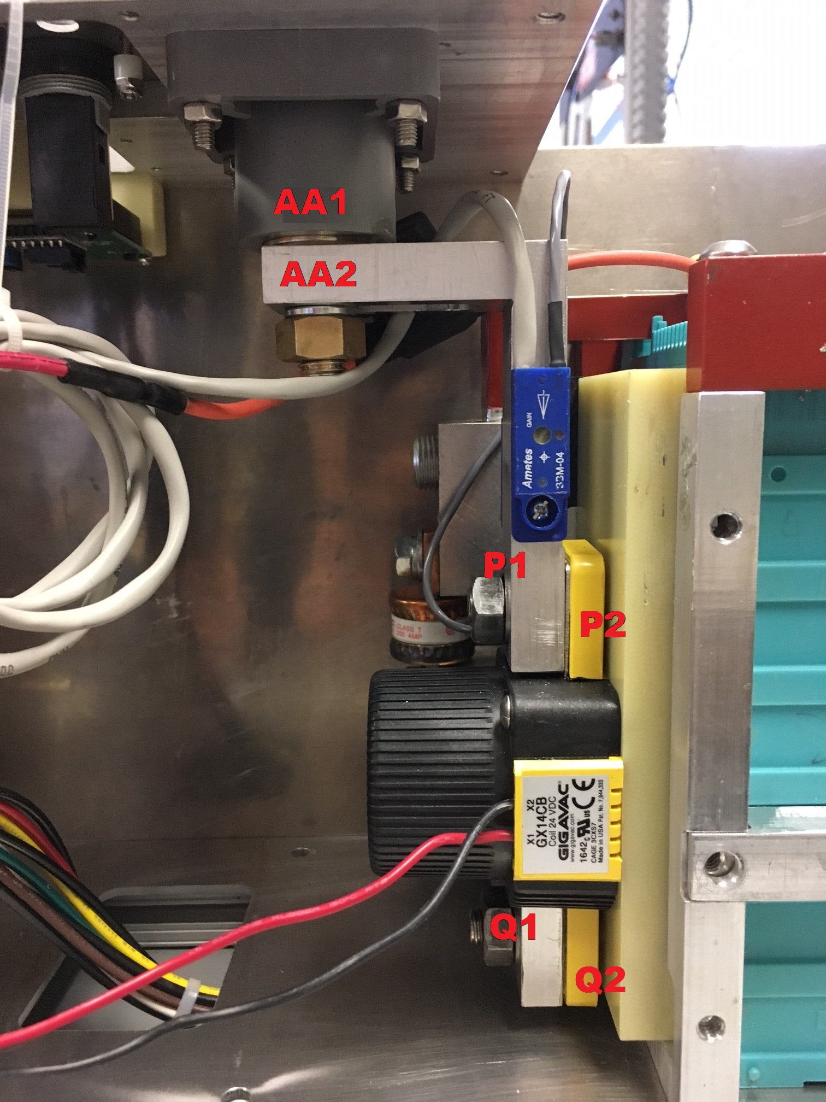

Figure Positive connections front

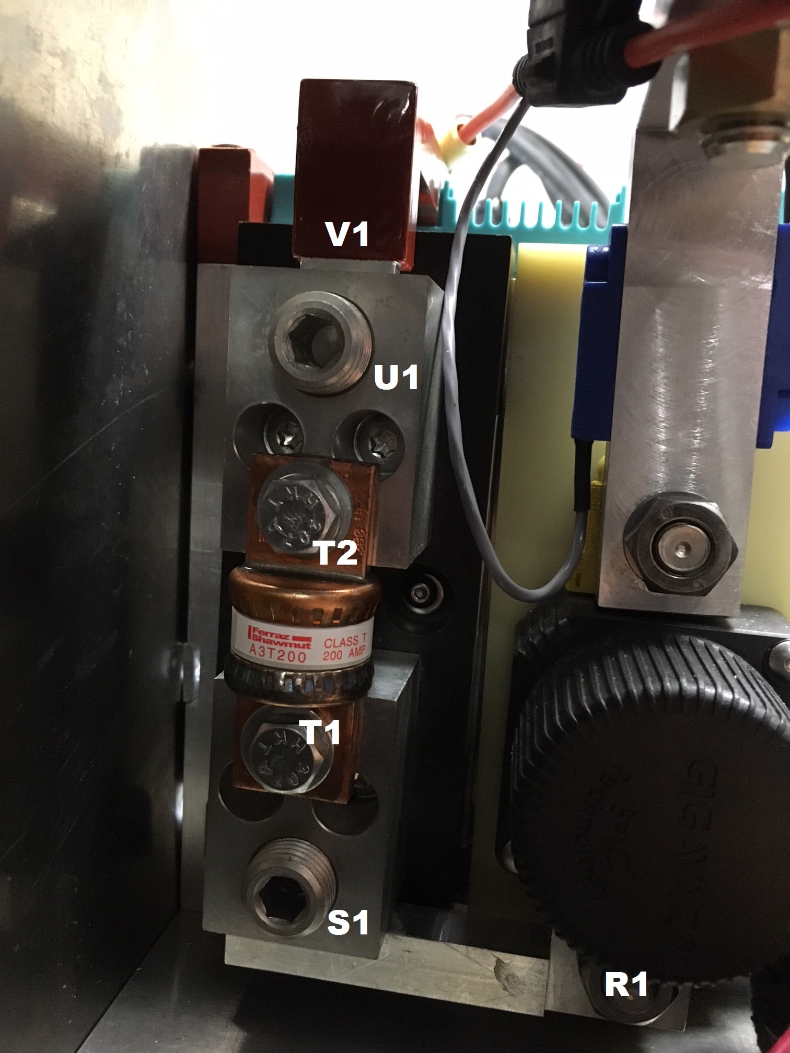

Figure Positive terminal side

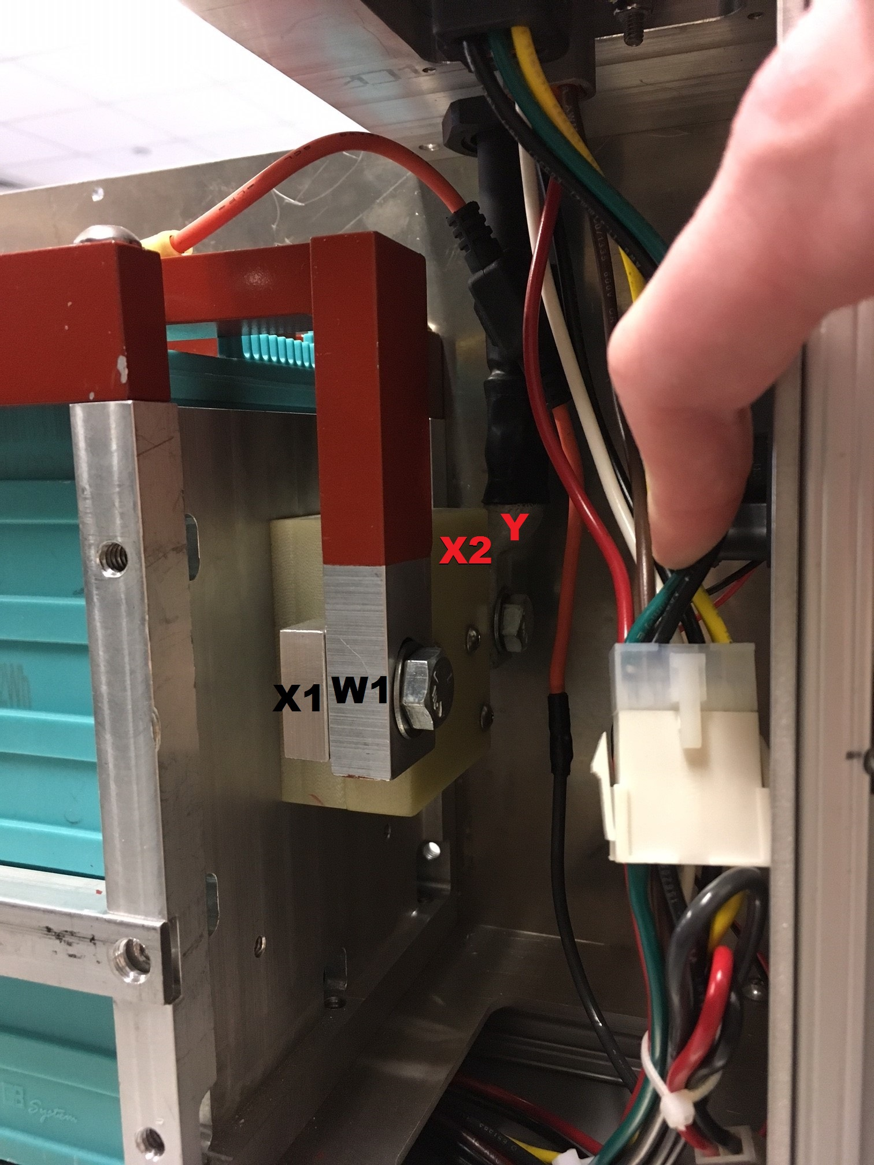

Figure Negative connection side