Lafayette Formula Electric Vehicle

ECE492  Spring 2017

Tractive Sysytem Interface interconnectivity document

Table of Contents

Table of Contents 1

Overview 2

internal interconnect 2

Wiring diagram 3

Ribbon cable pinouts 4

Overview 4

20-pin ribbon cable 4

14-pin ribbon cable 5

# Overview

The purpose of this document is to provide wiring and interconnect information about the Tractive System Interface box. This document specifically regards the interconnect information for the components within the TSI box. All of the images included below are provided in .pdf and original form in the zip folder located here: <http://sites.lafayette.edu/ece492-sp17/subsystems/tsi/>

For information about TSI and these subsystems, see the User Manual and Maintenance Manual, both of which can be accessed here: <http://sites.lafayette.edu/ece492-sp17/subsystems/tsi/>

# internal interconnect

For information on the external interconnect and cabling, refer to the Overall System Diagram v1.2 which can be found here:

<https://sites.lafayette.edu/ece492-sp17/files/2017/02/Car_v1.2.pdf>

# Wiring diagram

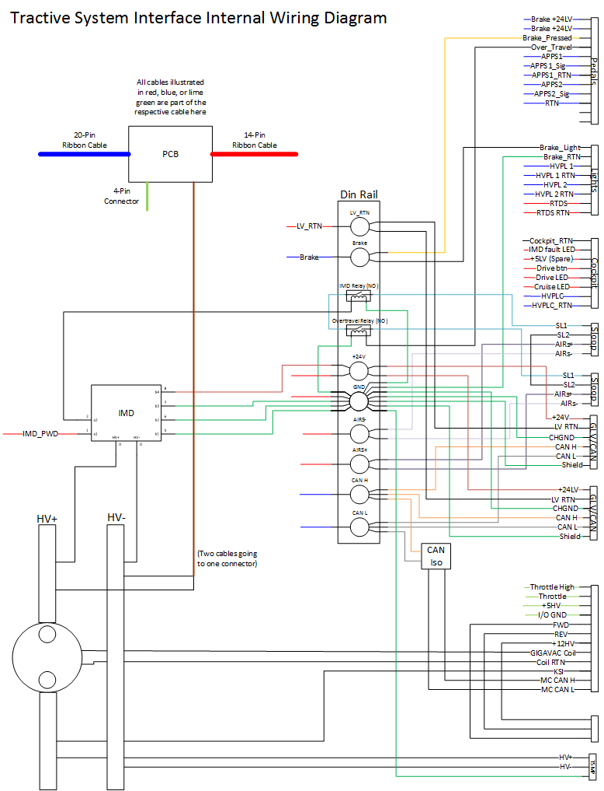

# Ribbon cable pinouts

## Overview

This section contains information relating to the pinouts for the two ribbon cables used in the TSI box. For both ribbon cables, pin 1 is a brown cable at the bottom of the ribbon.

## 20-pin ribbon cable

|  |  |  |  |  |
| --- | --- | --- | --- | --- |
| Pin Number | Name | Color | Going to | Wire |
| 20 | Brake_24 | Black | 1.1 | W24 |
| 19 | Brake_24 | White | 1.2 | W24 |
| 18 | BOT | Grey | BOT din |  |
| 17 | APPS2 | Purple | 1.9 | W24 |
| 16 | BP | Blue | Brake Din |  |
| 15 | APPS1 | Green | 1.6 | W24 |
| 14 | NC | Yellow |  |  |
| 13 | RTN_GLV | Orange | 1.10 | W24 |
| 12 | HVPL_Cock_RTN | Red | 3.8 | W25 |
| 11 | APPS1_RTN | Brown | 1.7 | W24 |
| 10 | HVPL_2_RTN | Black | 2.4 | W23 |
| 9 | APPS2_5 | White | 1.8 | W24 |
| 8 | HVPL_1_RTN | Grey | 2.6 | W23 |
| 7 | APPS1_10 | Purple | 1.5 | W24 |
| 6 | HVPL_Cock | Blue | 3.6 | W25 |
| 5 | NC | Green |  |  |
| 4 | HVPL_2 | Yellow | 2.3 | W23 |
| 3 | CAN_L | Orange | Can L Din |  |
| 2 | HVPL_1 | Red | 2.5 | W23 |
| 1 | CAN_H | Brown | Can H Din |  |

## 14-pin ribbon cable

|  |  |  |  |  |
| --- | --- | --- | --- | --- |
| Pin Number | Name | Color | Going to | Wire |
| 14 | RTDS_RTN | Yellow | 2.8 |  |
| 13 | IMD_PWM | Orange | IMD PWM |  |
| 12 | RTDS | Red | 2.7 | W23 |
| 11 | IMD_Status | Brown | IMD |  |
| 10 | Drive_LED | Black | 3.5 | W25 |
| 9 | AIRs- | White | AIRs- Din |  |
| 8 | Drive_BTN | Grey | 3.4 | W25 |
| 7 | AIRs+ | Purple | AIRSs+ Din |  |
| 6 | Drive_BTN_+5 | Blue | 3.3 | W25 |
| 5 | 24LV | Green | 24LV Din |  |
| 4 | IMD_Fault_LED | Yellow | 3.2 | W25 |
| 3 | LV_RTN | Orange | LV_RTN Din |  |
| 2 | CC_LED | Red | 3.7 | W25 |
| 1 | CHGND | Brown | GND Din |  |