**Habilin: A Quest to Uncover the Rich Heritage of Philippine Heroes in 2D Mobile Game**

Jastine M. Zaplan

Bulacan State University

Bulacan, Philippines

+63 916 998 1016

reniel.bernardino.a@bulsu.edu.ph

Marcus Frederick G. Sanchez Bulacan State University

Bulacan, Philippines

+63 997 550 8625

vinceallen.calimon.a@bulsu.edu.ph

Jomar Kenneth T. Navarro Bulacan State University

Bulacan, Philippines

+63 956 775 9184

hernando.albajr.o@bulsu.edu.ph

John Emmanuel M. Barleta Bulacan State University

Bulacan, Philippines

+63 995 947 6804

johnmarkmorada0@gmail.com

Christian David N. Castro

Bulacan State University

Bulacan, Philippines

+63 935 512 2204

arjay.cabanela.d@bulsu.edu.ph

Ayra Jhoy N. Villamor

Samparada

Bulacan State University

Bulacan, Philippines

+63 961 261 9753

jhenlmervincent.samparada.l@bulsu.e du.ph

**ABSTRACT**

The 2D mobile game "Habilin: A Quest to Uncover the Rich Heritage of Philippine Heroes" was developed to gamify the history of the Philippines, providing an enjoyable and adaptive learning experience for a diverse audience interested in Philippine history, tradition, and culture. As an educational tool, the game aims to integrate relaxation and enjoyment harmoniously with social interaction, striving to mitigate potential risks such as addiction while delivering tangible learning outcomes and social benefits. Employing Agile methodology during development, the researchers utilized Data Flow Diagrams and Entity Relationship Diagrams to visually represent the complexities of data flow and relationships within the game's database. Assessing the system's acceptability based on ISO/IEC Software Quality Standards and utilizing the MEEGA+ questionnaire for respondents, the results revealed an overall mean of 4.29, categorizing the system as "Very Acceptable." This classification underscores the positive reception from both clients and experts, affirming the game's effectiveness in imparting knowledge about Philippine history.

**Keywords**

2D Mobile Game; gamify; Philippine history; tradition; culture.

**1. INTRODUCTION**

Gamification involves incorporating game elements such as competition and rewards into non-game contexts to enhance engagement and motivation. This strategy applies principles from game design to various activities, utilizing features like points, badges, and challenges to make them more enjoyable and encourage desired behaviors. Gamification finds widespread application in fields like education, marketing, and training, enhancing user participation and satisfaction [1]. This study's specific aim is to develop a 2D mobile game that is both learnable and suitable for players interested in acquiring knowledge about the history of the Philippines.

In the past, both gamification and gaming were often viewed negatively, considered as potential bad habits. However, with the rapid advancements in technology, games now offer educational benefits, a phenomenon referred to as gamification. According to student reports [2], gamification contributes to educational advancement. The creation of a 2D mobile game aims to assist individuals having difficulty learning about the history of the Philippines. The study revealed that students using the mobile game achieved notably better results in knowledge exams compared to those who were taught the same material using traditional methods [3].

The effective implementation of gamification in history education relied on the successful integration of educational content and game mechanics. While game-based learning showed promise in improving student motivation and engagement, it was essential to maintain a harmonious interaction between the game's mechanics and educational objectives. The instructional material's presentation needed to foster the development of critical thinking skills and align with the curriculum's goals. Moreover, the design of game mechanics aimed to enhance the educational content without compromising its quality and rigor. Therefore, educators had to carefully analyze and strategize the integration of educational material and game dynamics to ensure the effectiveness of the game-based learning approach. Consequently, the success of gamification in history education was heavily contingent on the skillful integration of educational content and game mechanics. With these considerations in mind, the researchers aimed to demonstrate the positive benefits of gamification for users.

**1.1 Project Objectives**

This research aimed to develop a culturally and historically relevant 2D mobile game for teaching Philippine history effectively. Specific objectives included (1) designing game elements that accurately portrayed national heroes, (2) incorporating cultural nuances, and creating (3) an immersive gaming experience with exploration, combat, power-ups, puzzle elements, and more. (4) Technical features encompassed character selection, progress tracking, educational content, and various game modes. (5) Evaluation using the MEEGA+ framework focused on usability and player experience parameters, such as aesthetics, learnability, operability, accessibility, user error protection, confidence, challenge, satisfaction, social interaction, fun, focused attention, relevance, and perceived learning. The study's comprehensive approach sought to not only convey historical content accurately but also ensure an engaging and user-friendly game, evaluated by stakeholders and experts for continual refinement.

**2. LITERATURE REVIEW**

**2.1 2D Mobile Game**

Since the inception of mobile gaming, significant improvements have been observed in the realm of 2D mobile games. As noted by Bramble, [4] these games typically showcase sprite graphics and flat design, with movement restricted to up, down, left, and/or right directions. Despite their relative simplicity compared to 3D counterparts, 2D games are favored for their accessibility and user-friendly nature. Advancements in mobile technology have empowered developers to craft more intricate and captivating 2D games, approaching the quality of console and PC equivalents [4]. According to Ariffin and Shukri [5], mobile devices have become the primary platform for gaming, offering a versatile learning environment. Successful development of engaging mobile games requires careful consideration of elements like game mechanics, level design, and user interface [6]. Design, encompassing visual and aesthetic components, is crucial for enhancing player engagement and enjoyment, contributing to increased retention [7]. Mechanics, including rules and systems like the physics engine and AI, play a key role in player immersion and enjoyment [8]. Well-designed mechanics create a sense of challenge and reward, maintaining player engagement. Gameplay, representing player actions, significantly influences enjoyment and retention, with players favoring balanced complexity [9]. Emphasizing the importance of design, gameplay, and mechanics in 2D mobile games is essential for creating a captivating player experience. This involves ensuring an attractive visual design, providing gameplay that is both challenging and accessible, and establishing clear mechanics. These factors collectively contribute to enhancing player satisfaction and retention.

**2.1 Gamification as a Tool for Education and Progressive Learning**

Gamification is the application of game-playing elements to non-game environments, recognized in the early 2000s but widely popularized in 2010 across various industries. This approach has led to the creation of numerous gamified applications in fields like productivity, finance, health, education, sustainability, and media [10]. Saleem et al., [11] highlight gamification's contemporary role in improving blended education and dynamic learning, with a surge in its use in e-learning due to practicality and enjoyment [12]. Ke et al., [13] found a 16% increase in student performance through gamification compared to traditional instruction, attributing it to heightened motivation and engagement, while the use of gamified elements like points and leaderboards fosters social interaction and collaboration [14].

**3. METHOD AND DESIGN**

**3.1 Research Design**

This research utilized both descriptive and developmental research methods to examine Filipinos' knowledge of Philippine history. The descriptive approach allowed the researchers to explore problems, gather information, and propose solutions through observation, interviews, and surveys. Concurrently, the developmental method was applied to create a 2D mobile game focused on history, assessed using the MEEGA+ model to ensure high quality and alignment with intended standards.

**3.2 Project Development**

The researchers developed the system by following the phases of the Software Development Life Cycle, integrating the Agile Software Development Strategy. Agile Development Methodology, a practice in software application development that emphasizes continuous improvement and testing, was employed to yield the required results, allowing the researchers to revisit previous steps for necessary adjustments.

3.2.1 Plan

The researchers gathered data on the current living conditions of Filipinos, assessing their awareness of the culture and heroes of the Philippines through observations and literature research. Employing the MEEGA+ model and a standardized questionnaire, they analyzed the information to identify essential features for the History-Based Game, ensuring its quality and alignment with intended standards.

3.2.2 Design

Initiating the design phase for the History-Based Game, the researchers utilized a Data Flow Diagram (DFD) to outline the processes following the planning phase. Subsequently, an Entity Relationship Diagram (ERD) was devised after formulating the DFD for the game. To further illustrate the algorithm essential for the game, the researchers employed a Flowchart.

3.2.3 Develop

Following the design phase, the researchers developed the History-Based Game, implementing all the features they had constructed. Various developmental tools, including Unity as the development platform and C# as the programming language within Visual Studio as the Integrated Development Environment (IDE), were employed. The system's database was established using Realtime Database in Firebase.

3.2.4 Deploy

Following the development of the History-Based Game, the researchers conducted an evaluation using the Method for the Evaluation of Educational Games for Computing Education (MEEGA+). The response format utilized a 5-point Likert scale, ranging from "strongly disagree" to "strongly agree."

3.2.5 Review

Upon testing and deploying the game, the researchers identified and addressed errors detected during testing, ensuring the resolution of potential issues before the game's launch.

3.2.6 Launch

Launch. This phase follows thoughtful planning, development, and ongoing iterations, leading to the researchers' readiness to introduce the game to the public. Embracing an incremental and iterative approach, the researchers can swiftly respond to feedback and implement necessary changes post-launch.

**3.3 Research Instrument**

This study draws upon the MEEGA (Model for the Evaluation of Educational Games), crafted by (Petri et al., 2018), as its primary source. The evaluation derived from MEEGA was transformed into a survey questionnaire, which underwent analysis and validation by an expert panel consisting of Beecham, Hall, Britton, Cotte, & Rainer (2005). The survey questionnaire incorporated both closed- and open-ended questions. Open-ended questions enable comprehensive responses, addressing diverse elements, while closed-ended questions present predetermined answer options, facilitating efficient data collection for rapid surveys (Indeed Career Guide, 2023). The selection between these question types of hinges on the requirement for specific feedback or a more structured approach.

**3.3 Data Gathering Procedure**

In executing the data collection process, the team utilized Google Forms to distribute the questionnaire, involving respondents in completing survey questionnaires through this online platform. Apart from surveys, the team leveraged interviews to ensure a comprehensive understanding of the subject matter, especially engaging historians to validate the historical accuracy and narrative flow of the story or game. These varied approaches ensured a thorough comprehension, contributing to a more detailed dataset and subtle insights. The tools used, including Google Forms, played a crucial role in ensuring an efficient and well-organized data gathering process, allowing the team to streamline procedures and collect responses from a broad audience.

**3.5 Population and Sample of the Study**

The distribution of respondents presents a varied group, ensuring a comprehensive viewpoint for the study. The breakdown includes 5 IT experts, 1 historian, 4 history teachers, 10 CICT students (College of Information and Communication Technology), and 20 high school/elementary students. This diverse representation ensures that insights from IT professionals, historians, educators, college students, and younger learners are considered, promoting a well-rounded and inclusive approach to the research. The overall respondent count is 40, providing a significant sample size for a thorough examination of the study.

**3.6 Statistical Treatment**

The researchers employed a Five-point Likert scale to interpret the results of the system evaluation conducted with the study participants. Each rating on the scale is associated with a descriptive label and a weighted mean. Respondents provided their feedback using a scale ranging from 1 to 5, where 1 signifies "Not Acceptable" and 5 corresponds to "Extremely Acceptable." This scale was also utilized to assess the overall acceptability of the system.

**4. RESULTS AND DISCUSSION**

**4.1**

**5. CONCLUSIONS**

**Figure 1. Save & Load, Cloud Save Menu**

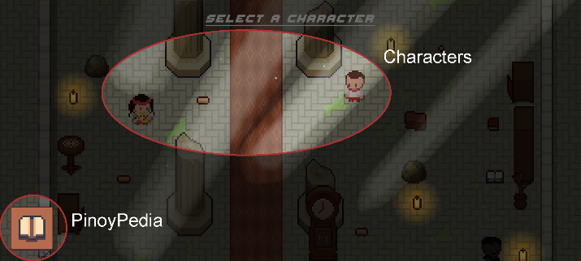

**Figure 2. Character Selection & PinoyPedia**

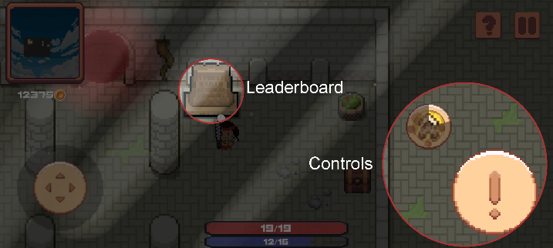

**Figure 3. In Game Controls & Leaderboards**

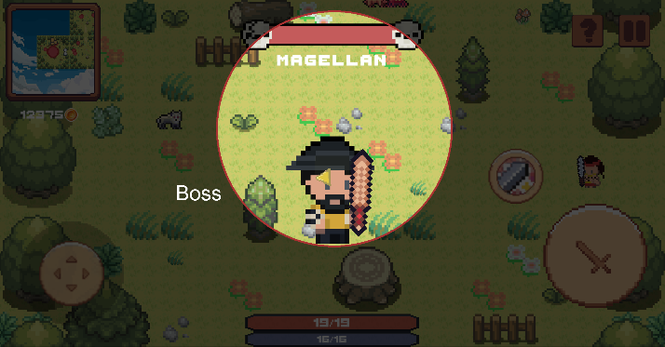

**Figure 4. Hack n’ Slash & Boss**

Following data analysis, the study revealed that players endorsed the effectiveness of gamification, offering valuable insights for enhancing the 2D mobile game's educational and entertainment aspects. The game adeptly incorporates cultural elements and educational gameplay, earning high praise from players and effectively portraying historical figures. Collaboration with historians contributed to a comprehensive understanding of Philippine history, enriching the game's development. The game boasts feature such as exploration (1), hack-and-slash combat with powerful bosses (5), diverse power-ups, and strategic depth in gameplay (4). The intelligence system dynamically adjusts complexity, ensuring a challenging and engaging journey (9). A leaderboard based on stars introduces multiplayer competition (10). Key features include character selection (11), progress tracking (12), educational content, including PinoyPedia and trivia questions (13), and save/load functionality (14). The game offers settings for volume, language, and account binding (15, 16, 17), providing a customizable and user-friendly experience through Firebase integration (17). Enjoyable different game modes include story mode and endless mode (18). Players expressed consistent satisfaction through the MEEGA+ questionnaire (19), confirming the game's success in delivering a pleasurable and positively impactful experience.

**6. RECOMMENDATIONS**

The researchers provide valuable insights for future studies in Information Technology by suggesting key recommendations. Expanding the 2D mobile game with additional characters inspired by Philippine historical figures and a broader range of events is proposed, aiming to enrich the gaming experience and enhance its educational value. Additionally, the integration of extra mini games aligned with Philippine history, traditions, and culture is recommended to provide interactive elements and explore the nation's rich heritage within the game. To enhance social interaction among players, a combination of collaborative and competitive components, including a multiplayer element, is advocated. Furthermore, the development of a cross-platform solution for both desktop and mobile environments is emphasized to maximize accessibility. Lastly, creating an open API system is suggested to facilitate researchers' contributions of verified historical data, promoting collaboration, and ensuring the continuous accuracy and relevance of the game.

**7. RESEARCH IMPLICATIONS**

This study aimed to develop a 2D mobile game that effectively portrayed the history of the Philippines within the cultural and historical context of the nation. The proposed system held potential benefits for various stakeholders: Players could engage in an immersive and interactive learning experience, gaining a deeper understanding of national heroes and historical significance. Historians could utilize the game for more interactive exploration and engagement with historical events, while teachers could enhance their lessons with a practical and engaging educational tool. Game developers stood to gain positive exposure and recognition, establishing expertise in the field. Additionally, the game could serve as a novel platform for researchers to gather data on historical topics and engage a wider audience, contributing to the broader academic discourse on Philippine history.

**8. ACKNOWLEDGEMENTS**

No internal or external financial sources were utilized in this research. The researchers express sincere gratitude to Professor Xiao Chua and PHACTO for their invaluable guidance and support throughout the study. Professor Xiao Chua's expertise played a crucial role in shaping the research, while PHACTO's support significantly enriched the process. The researchers also appreciate the contributions of participants and all individuals involved in the study. Thanks, extend to friends, family, and others for their understanding and encouragement during the research journey.

**9. REFERENCES**