# **Overview**

**This file is a specification of the model created by UML definition**

# **Package List**

|  |  |
| --- | --- |
| **Full Name** | **Summary** |
| [Root] |  |

# **[Root] Package**



## **UseCase List**

|  |  |
| --- | --- |
| **Name** | **Summary** |
| Pesquisar Produto |  |

## **Classifier List**

|  |  |  |
| --- | --- | --- |
| **Name** | **Type** | **Summary** |
| HTML | Actor |  |
| Usuário | Actor |  |

## **Diagram**

### **RF002_PesquisarProdutos[UseCase Diagram]**

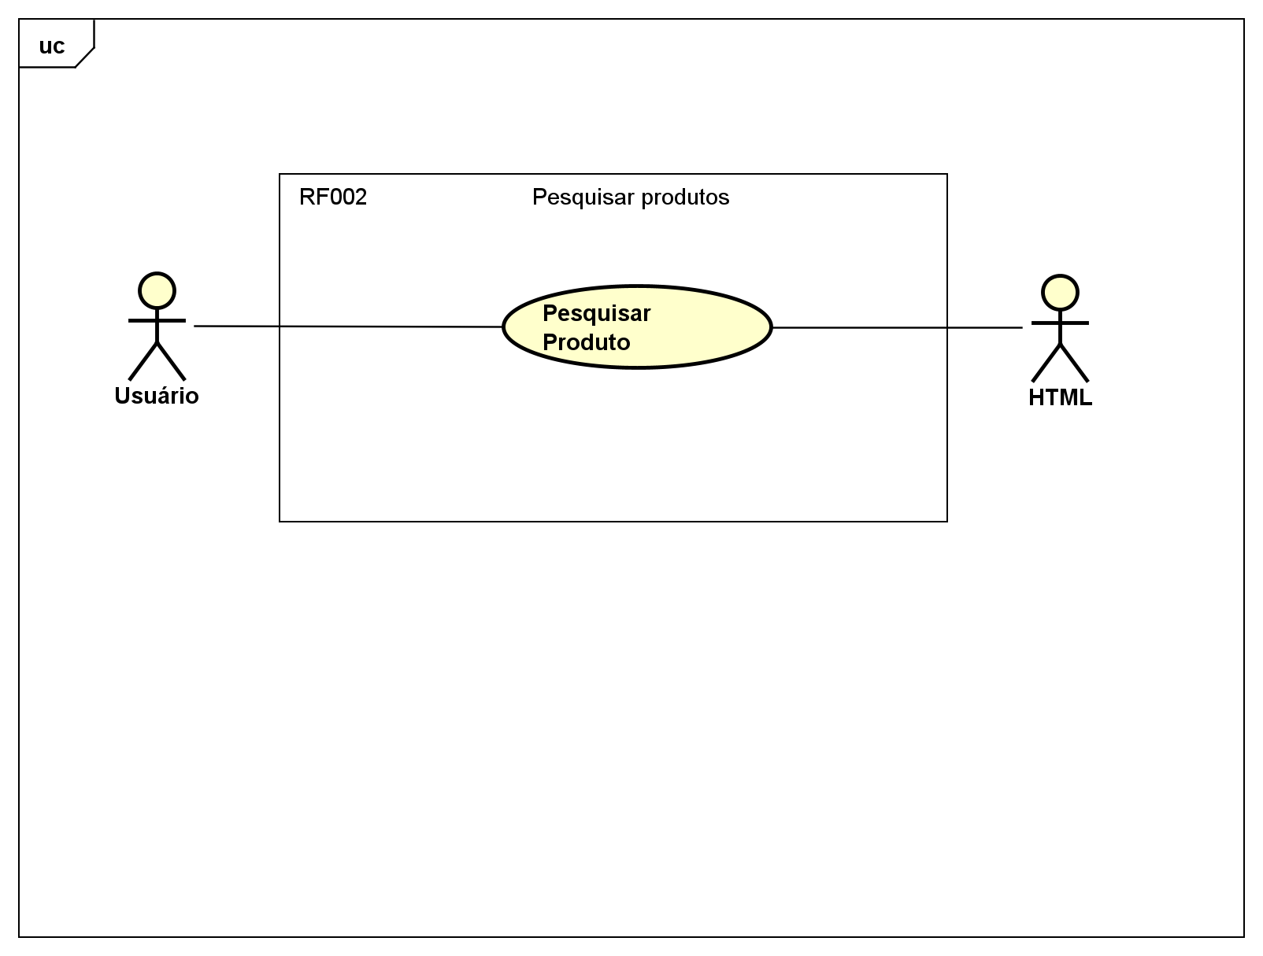

figure 1 : RF002_PesquisarProdutos[UseCase Diagram]

#### **Definition**

**Caso de Uso**

**RF002 Pesquisar Produtos**

## **UseCase**

### **Pesquisar Produto [UseCase]**



#### **Namespace**

**[Root]**

#### **UseCase Description**

|  |  |
| --- | --- |
| **Template** | Astah Original |
| **UseCase** | Pesquisar Produto |
| **Summary** |  |
| **Actor** | Usuário,  HTML |
| **Precondition** |  |
| **Postcondition** |  |
| **Base Sequence** |  |
| **Branch Sequence** |  |
| **Exception Sequence** |  |
| **Sub UseCase** |  |
| **Note** |  |

## **Class**

### **HTML [Actor]**



#### **Declaration**

**public class HTML**

#### **Namespace**

**[Root]**

#### **Stereotype**

**<<actor>>**

#### **Relation (From Source To Target)**

|  |  |  |  |
| --- | --- | --- | --- |
| **Name** | **Type** | **Target** | **Summary** |
|  | Association | Pesquisar Produto |  |

### **Usuário [Actor]**



#### **Declaration**

**public class Usuário**

#### **Namespace**

**[Root]**

#### **Stereotype**

**<<actor>>**

#### **Relation (From Source To Target)**

|  |  |  |  |
| --- | --- | --- | --- |
| **Name** | **Type** | **Target** | **Summary** |
|  | Association | Pesquisar Produto |  |