# **Overview**

**This file is a specification of the model created by UML definition**

# **Package List**

|  |  |
| --- | --- |
| **Full Name** | **Summary** |
| [Root] |  |

# **[Root] Package**



## **UseCase List**

|  |  |
| --- | --- |
| **Name** | **Summary** |
| Carrinho de compras |  |
| Produtos em oferta |  |
| Página de Ofertas |  |
| Página de oferta |  |

## **Classifier List**

|  |  |  |
| --- | --- | --- |
| **Name** | **Type** | **Summary** |
| Gerente | Actor |  |
| HTML | Actor |  |
| PF | Actor |  |
| PJ | Actor |  |
| usuário | Actor |  |

## **Diagram**

### **RF003_PaginadeOfertas[UseCase Diagram]**

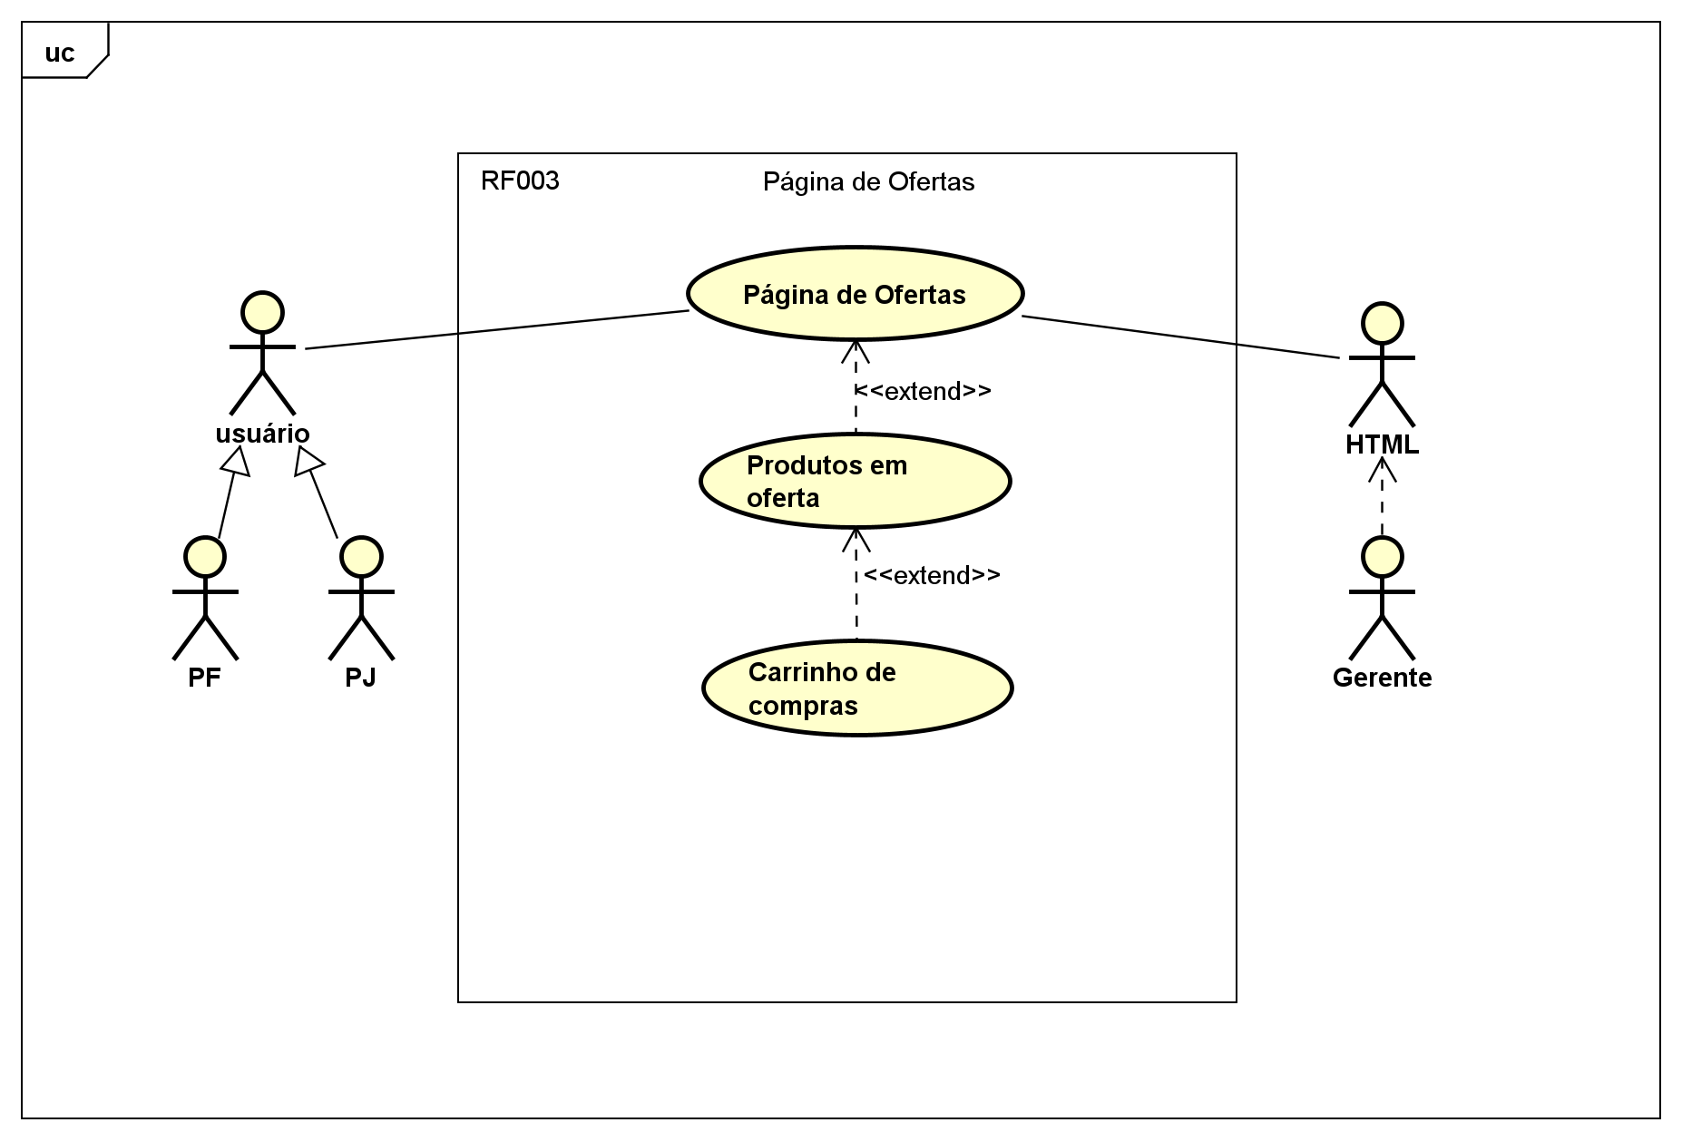

figure 1 : RF003_PaginadeOfertas[UseCase Diagram]

## **UseCase**

### **Carrinho de compras [UseCase]**



#### **Namespace**

**[Root]**

#### **Relation (From Source To Target)**

|  |  |  |  |
| --- | --- | --- | --- |
| **Name** | **Type** | **Target** | **Summary** |
|  | Extend | Produtos em oferta |  |

#### **UseCase Description**

|  |  |
| --- | --- |
| **Template** | Astah Original |
| **UseCase** | Carrinho de compras |
| **Summary** |  |
| **Actor** |  |
| **Precondition** |  |
| **Postcondition** |  |
| **Base Sequence** |  |
| **Branch Sequence** |  |
| **Exception Sequence** |  |
| **Sub UseCase** |  |
| **Note** |  |

### **Produtos em oferta [UseCase]**



#### **Namespace**

**[Root]**

#### **Relation (From Source To Target)**

|  |  |  |  |
| --- | --- | --- | --- |
| **Name** | **Type** | **Target** | **Summary** |
|  | Extend | Página de Ofertas |  |

#### **UseCase Description**

|  |  |
| --- | --- |
| **Template** | Astah Original |
| **UseCase** | Produtos em oferta |
| **Summary** |  |
| **Actor** |  |
| **Precondition** |  |
| **Postcondition** |  |
| **Base Sequence** |  |
| **Branch Sequence** |  |
| **Exception Sequence** |  |
| **Sub UseCase** |  |
| **Note** |  |

### **Página de Ofertas [UseCase]**



#### **Namespace**

**[Root]**

#### **UseCase Description**

|  |  |
| --- | --- |
| **Template** | Astah Original |
| **UseCase** | Página de Ofertas |
| **Summary** |  |
| **Actor** | usuário,  HTML |
| **Precondition** |  |
| **Postcondition** |  |
| **Base Sequence** |  |
| **Branch Sequence** |  |
| **Exception Sequence** |  |
| **Sub UseCase** |  |
| **Note** |  |

### **Página de oferta [BusinessUseCase]**



#### **Namespace**

**[Root]**

#### **Stereotype**

**<<business>>**

#### **UseCase Description**

|  |  |
| --- | --- |
| **Template** | Astah Original |
| **UseCase** | [business]Página de oferta |
| **Summary** |  |
| **Actor** |  |
| **Precondition** |  |
| **Postcondition** |  |
| **Base Sequence** |  |
| **Branch Sequence** |  |
| **Exception Sequence** |  |
| **Sub UseCase** |  |
| **Note** |  |

## **Class**

### **Gerente [Actor]**



#### **Declaration**

**public class Gerente**

#### **Namespace**

**[Root]**

#### **Stereotype**

**<<actor>>**

#### **Relation (From Source To Target)**

|  |  |  |  |
| --- | --- | --- | --- |
| **Name** | **Type** | **Target** | **Summary** |
|  | Dependency | HTML |  |

### **HTML [Actor]**



#### **Declaration**

**public class HTML**

#### **Namespace**

**[Root]**

#### **Stereotype**

**<<actor>>**

#### **Relation (From Source To Target)**

|  |  |  |  |
| --- | --- | --- | --- |
| **Name** | **Type** | **Target** | **Summary** |
|  | Association | Página de Ofertas |  |

### **PF [Actor]**



#### **Declaration**

**public class PF**

**extends usuário**

#### **Namespace**

**[Root]**

#### **Stereotype**

**<<actor>>**

#### **Relation (From Source To Target)**

|  |  |  |  |
| --- | --- | --- | --- |
| **Name** | **Type** | **Target** | **Summary** |
|  | Generalization | usuário |  |

### **PJ [Actor]**



#### **Declaration**

**public class PJ**

**extends usuário**

#### **Namespace**

**[Root]**

#### **Stereotype**

**<<actor>>**

#### **Relation (From Source To Target)**

|  |  |  |  |
| --- | --- | --- | --- |
| **Name** | **Type** | **Target** | **Summary** |
|  | Generalization | usuário |  |

### **usuário [Actor]**



#### **Declaration**

**public class usuário**

#### **Namespace**

**[Root]**

#### **Stereotype**

**<<actor>>**

#### **Relation (From Source To Target)**

|  |  |  |  |
| --- | --- | --- | --- |
| **Name** | **Type** | **Target** | **Summary** |
|  | Association | Página de Ofertas |  |