Sign In Page (Ben Cikes):

This is a simple sign in page where existing users can login to their account, it has text entries for email and password as well as an obvious button to submit these field and login. In addition there is a button a user who may not have an account to move directly to the registration page, or if they have forgotton their account login details begin the process of recovering them.

Registration Page (Ben Cikes):

This is a simple Registration page with text inputs for Username, email and password in addition to a confirmation text entry for the password, in addition the text entered into the field will be asterisks unless the Eye button is clicked to reveal it, finally there is an obvious register button, and a quick link to the login page if the user already has an account.

Oliver Scully (Dashboard Page)

Browsing Page (Ben Cikes):

This will be the layout of a page whenever a user is using the search engine it has a text entry for entering search queries. A URL bar is positioned at the top of the page as well as buttons for returning to previous pages or reloading them as required in addition there is a home button to return the user to their dashboard and a user icon on the left for the user to access various user settings. In addition, it includes the functionality of allowing a user to have multiple tabs open at a time.

Usage reports page (Dom Cutajar):

The usage reports page allows the user to view a graph showing how long they have spent on each category (productivity, socials, etc). The dropdown menus below allow the user to filter the time (past day, week, all time, etc) and categories to be shown in the graph. If the user filters to a specific category, the pie chart will then show individual websites.

History page (Dom Cutajar):

The history page allows the user to see all of the sites they have visited recently. The search bar allows the user to filter the results, and the dropdown menus below allow the user to filter the time (past day, week, all time, etc) and categories to be shown in the list.

Account Settings (Joshua Keenan)

This page is part of the settings page group. This particular page is the account settings which allow the user to modify their login credentials and account information. It also allows functionality to log out of the account. Navigating the setting page group is done through the left-hand side bar which highlights the current page being displayed.

Joshua Keenan (Focus Mode)

This page is part of the settings page group. This page provides the user the functionality to set presets for browsing restrictions and categories. For each restriction profile, users would be able to select which browsers can and can’t be visited through the whitelist and blocklist. Additional rules can also be implemented such as time restrictions or notification systems. The page allows for creation and switching between focus profile modifications.

Limit settings pop-up page (Luis Torres)

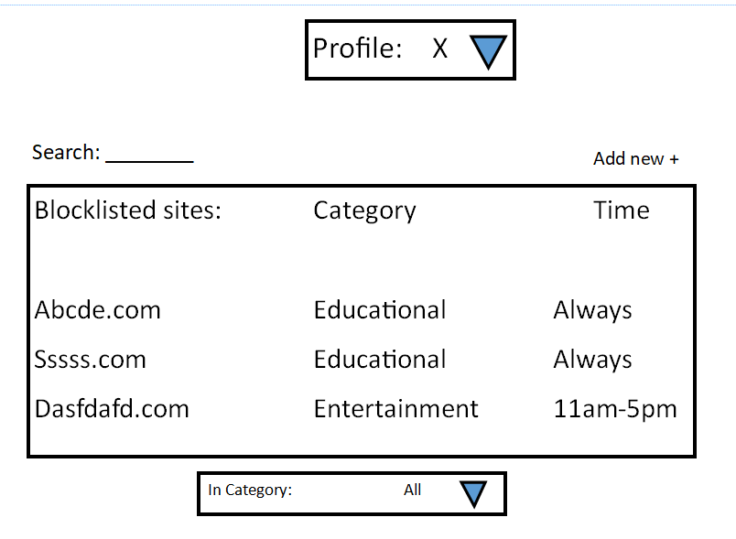

This page is for user to view and configure limit settings they have made, the user can view the websites based on category using the dropdown menu, the user can choose the profile they are viewing the limitations for with the dropdown above, as different profiles would have different limitations set. The time limitations are set in the profile settings in a separate part of the application but can be viewed here. The user may also search for a specific website. By clicking on the website they access the editing window for that website, where they can change the category or delete it From their list.

(Luis Torres)

They are also able to add new sites via the “add new” button, opening the below page. A dropdown will allow the user to set a category, the application may also try to predict the category based on the domain.

(Luis Torres)

