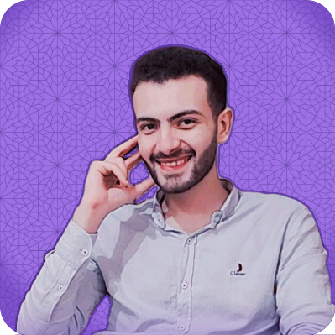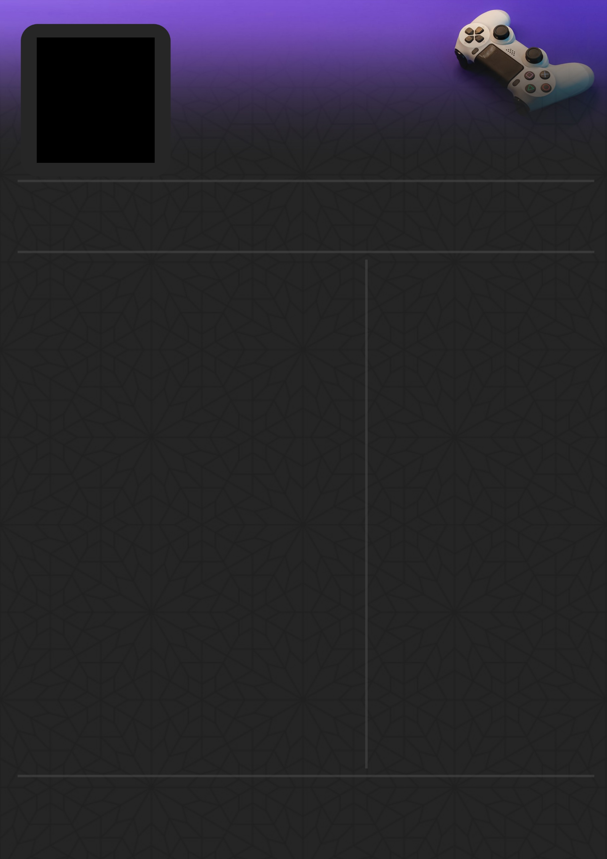

**Experiences:**

1. (2017- now) solo developer at Lagg game studio (self-employee) [LAgg - itch.io](https://ahmedmostafa.itch.io/)
2. (2021) – hyper casual game for [Voodoo](https://www.voodoo.io/) that not published [Demo video](https://www.youtube.com/watch?v=kDg-7SNnAI8)
3. (2021) – worked in [Wolves interactive](https://play.google.com/store/apps/dev?id=4753128145277262392&hl=en&gl=US) to complete jam project (freelancer) [Project](https://ahmedmostafa.itch.io/bubbles) [Source Code](https://github.com/LaggStudio/Bubble)
4. (2021 - 2022) Worked in [Wolves interactive](https://play.google.com/store/apps/dev?id=4753128145277262392&hl=en&gl=US) (full time)

* Worked on hyper casual game that released on mobile platform called ([Tomp](https://play.google.com/store/apps/details?id=com.wolvesinteractive.tomp&hl=en&gl=US))
* My role was to create all the game (code – system and design – some Art -VFX)
* Worked on 2D Battle Royal Game that will be released next year called (Twins Battle)
* My role was to create the (Networking, systems and UX & UI design, all the code) of the game.

1. (2022 – Now) Working as lead unity developer at [Genesis creations](https://www.genesiscreations.co/) (full time)

* Worked on VR and real-life scenarios simulations (car simulations, medical proceguers)

**Game Jams:**

1. 2022 – [AN Game jam](https://angamesstudio.com/) ([paintball fight](https://ahmedmostafa.itch.io/paintballfight)) 3th – made in 3 days.
2. 2021 - [6wrni game jam 3](https://www.youtube.com/channel/UCu1AOFVJx5nvhGbo8EmAKHg) ([struggle](https://ahmedmostafa.itch.io/struggle)) 1th – made in 3 days.
3. 2021 - [tafra game jam](https://www.tafragames.com/) ([souls](https://ahmedmostafa.itch.io/souls)) ownable mention – made in 3 days.
4. 2021 - [6wrni game jam 2](https://www.youtube.com/channel/UCu1AOFVJx5nvhGbo8EmAKHg) ([Tick Taco](https://ahmedmostafa.itch.io/tick-taco)) 3th – made in 3 days.
5. 2020 - [Blackthornprod game jam](https://www.youtube.com/channel/UC9Z1XWw1kmnvOOFsj6Bzy2g/videos?view_as=subscriber) ([Less is More](https://ahmedmostafa.itch.io/less-is-more)) – made in 7 days.
6. 2020 - [Game zanga 10 jam](https://itch.io/jam/gamezanga10) ([kabreet](https://ahmedmostafa.itch.io/kabreet)) 3th – made in 3 days.
7. 2020 - [palestinian game gam](https://itch.io/jam/pgj1/rate/908780) ([Aml](https://ahmedmostafa.itch.io/aml)) 1th mentioned in [Aljazeera News](https://www.aljazeera.net/news/alquds/2021/2/18/%D9%85%D8%B3%D8%A7%D8%A8%D9%82%D8%A9-%D8%A3%D9%84%D8%B9%D8%A7%D8%A8-%D8%A7%D9%84%D9%83%D8%AA%D8%B1%D9%88%D9%86%D9%8A%D8%A9-%D8%AA%D8%B1%D9%83%D9%8A%D8%A9-%D9%84%D9%84%D8%AA%D8%B9%D8%B1%D9%8A%D9%81) –made in 3 days.

**Education:**

* **Undergraduate student physics and computer science Al-Azhar University**

**Languages:**

* English (fluent)
* Arabic (fluent)

**Things I Like:**

* **Reading**
* **Gaming**
* **Football**

**Skills:**

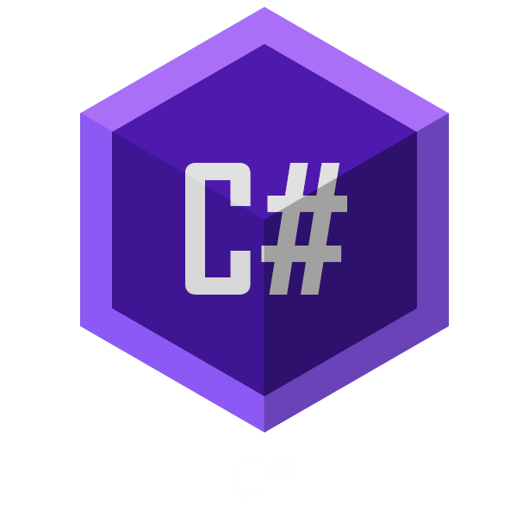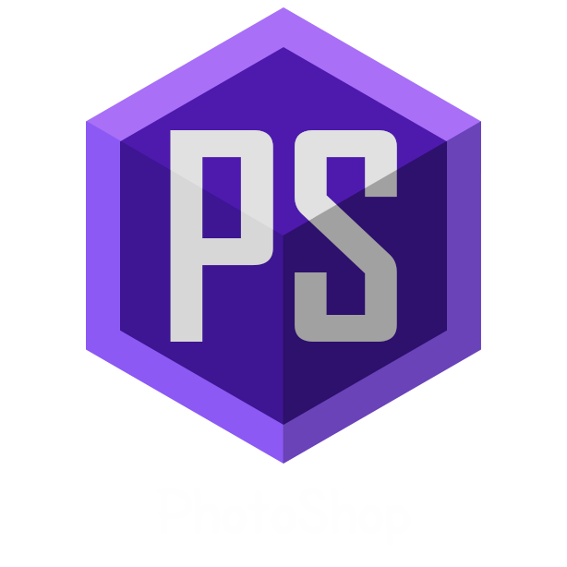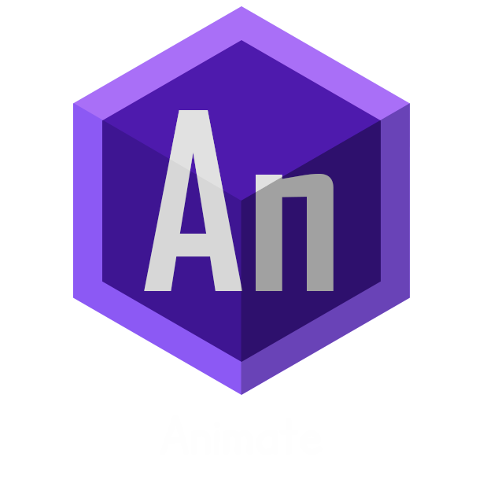

Love making games, hope one day I can express my voice throw my games to the world.

Phone: +201027748381

Unity Game Developer and Designer

[](https://twitter.com/moristanguy) [](mailto:laggindiegamestudio@gmail.com) [](https://ahmedmostafa.itch.io/) [](https://www.linkedin.com/in/ahmed-mostafa-299bb7215/)

Ahmed Mostafa Shaban