In this project, you will construct a BST with the keys that are in the given input file. The BST has the following properties:
- its nodes are distributed over 3⎣log₄ n⎦ depth levels;
- it provides the best possible total access time.
You will develop an algorithm that reads the keys from input.txt file and inserts the keys to the BST with the properties as defined above. After constructing the BST, your program will print the depth level of the BST, and the number of nodes in each depth level. Next any key may be searched for in the BST. If the key is in the BST, the program's output will be the depth level and the distance to the leftmost node, otherwise the output will be the following message: “The key is not in the tree.”
- The BST should have at least 16 nonnegative and non-replicated keys, you have to control the input file, if input file contains less and/or negative keys then the program produces an error message.
- The name of the input file must be “input.txt” and it should be at the same directory with your source code. (I won’t check the path and the name of your input file. When I run your program if the path or source file is not found, I will not evaluate your code.)
- The input file contains strictly positive (i.e., excluding 0) integers separated with space in a line. An example follows:
  - 10 5 3 25 70 97 115 2 65 69 32 152 1 21 49 8 12 78
- Do not use another header file or do not separate your functions into different source files. There will be only one source file.

Example Run:
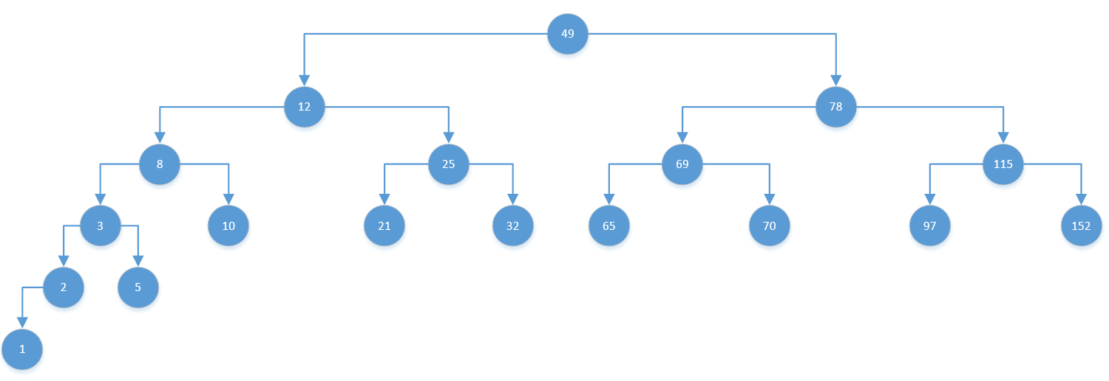
Output:
Depth level of BST is 6
Depth level 0 →1
Depth level 1 →2
Depth level 2 →4
Depth level 3 →8
Depth level 4 →2
Depth level 5 →1
Key value to be searched (Enter 0 to exit) : 32
At Depth level 3, 4th element
Key value to be searched (Enter 0 to exit) : 152
At Depth level 3, 8th element
Key value to be searched (Enter 0 to exit) : 78
At Depth level 1, 2nd element
Key value to be searched (Enter 0 to exit) : 4
4 is not found in BST
Key value to be searched (Enter 0 to exit) : 0
Exit

