
CLOUD DEVELOPMENT
PROJECT
Task Management System


Version 2.0
20241210111  20241481780  20241041475  20241042354  20241040798 | عبدالرحمن رمضان حسين  احمد سامي سعد رزق  محمد احمد جلال الدين  اكرم يوسف ابراهيم احمد  مؤمن محمد بدوي
MEGATOWN
May 8, 2026

Table of Contents
- Project Overview ............................................... Page 2
- Project Objectives ........................................ Page 2
- System Architecture .................................... Page 3
- Features ........................................................... Page 3
- Technologies Used ......................................... Page 3
- Functional Requirements ................................. Page 4
- Cloud & Deployment Design .............................. Page 4
  - Local Deployment .............................. Page 4
  - AWS Deployment Plan ....................... Page 5
  - AWS Services Used ............................. Page 5

Project Overview

Purpose

This project is a simple cloud-based Todo Application that allows users to manage tasks efficiently. Users can create, view, update, and delete tasks through a web interface.

The system is designed as a full-stack application and demonstrates key cloud development concepts such as containerization, service separation, and cloud deployment readiness.

The project is built using:

React (Frontend)

Node.js + Express (Backend API)

MySQL (Database)

Docker & Docker Compose (Containerization)

Project Objectives

The main objectives of this project are:

Develop a functional CRUD-based web application

Implement a full-stack architecture

Use Docker for containerization

Understand multi-container systems

Prepare the system for AWS deployment

Demonstrate basic cloud computing principles

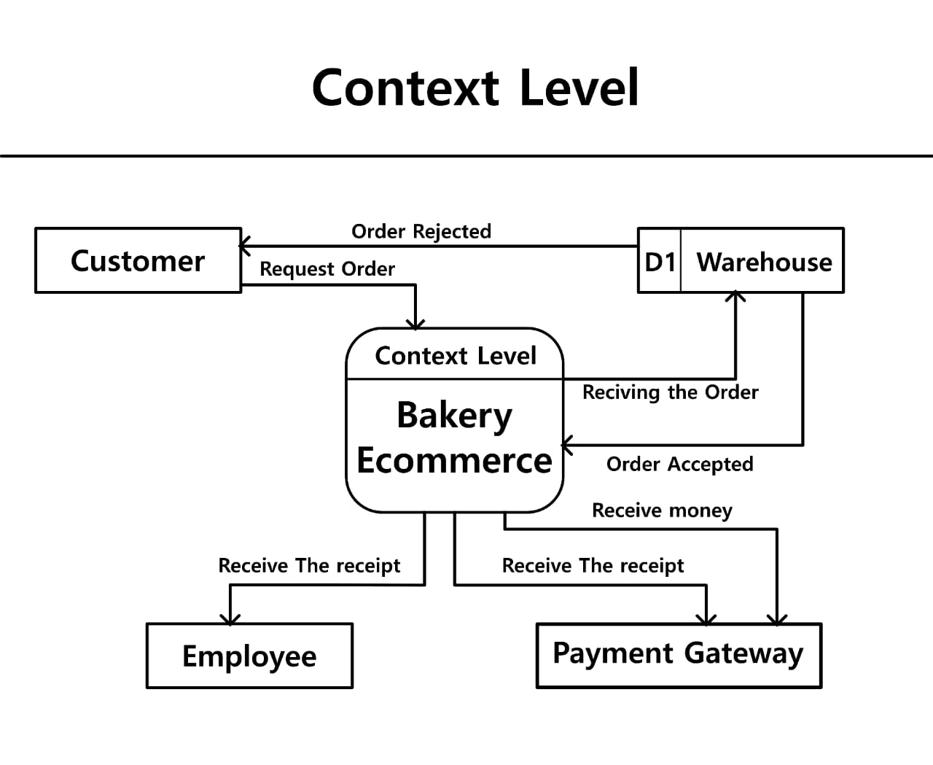

System Architecture

The application follows a simple layered architecture:

User Browser → React Frontend → Node.js / Express Backend API → MySQL Database

Each component is containerized and communicates through Docker networking.

4. Features

The application supports the following features:

Create new tasks

View all tasks

Update existing tasks

Delete tasks

Persistent data storage using MySQL

Containerized execution environment

5. Technologies Used

Layer | Technology
Frontend | React
Backend | Node.js, Express
Database | MySQL
Containerization | Docker, Docker Compose
Cloud Platform | AWS EC2 (deployment target)

6. Functional Requirements

Requirement | Status
User interface | Completed
Backend API | Completed
Database integration | Completed
CRUD operations | Completed
Docker support | Completed
Multi-service architecture | Completed

7. Cloud & Deployment Design
7.1 Local Deployment

The application can be run locally using Docker Compose:

“docker compose up --build”

This starts:

Frontend service

Backend service

MySQL database

7.2 AWS Deployment Plan

The application is designed to be deployed on Amazon EC2.

Deployment Steps:

Launch an Ubuntu EC2 instance

Install Docker and Docker Compose

Clone the repository

Run the application using Docker Compose

Configure security groups (open required ports)

Access application via public IP

Example access:

http://localhost:8080

7.3 AWS Services Used

Service | Purpose
Amazon EC2 | Hosting the application
Security Groups | Network access control

8. Containerization

The system uses Docker to ensure consistency across environments.

Containers Used:

Frontend/Backend application container

MySQL database container

Docker Files:

Dockerfile

compose.yaml

Docker Compose manages service orchestration and networking.

9. Database Design

The application uses MySQL to store tasks.

Example Table: Todos
Field | Type
id | Integer (Primary Key)
title | String
completed | Boolean

10. Scalability & Reliability

Scalability:

Container-based architecture allows horizontal scaling

Services can be replicated in cloud environments like AWS ECS

Reliability:

Persistent database ensures data is not lost

Separation of services improves fault isolation

11. Error Handling & Logging

The system includes basic error handling:

API request validation

Database connection error handling

Server-side error responses

Logging is handled using:

Console logs

Docker container logs

12. Security Considerations

Basic security practices include:

Separation of frontend and backend services

Use of environment variables for configuration

Controlled database access via internal Docker network

Future improvements may include authentication and HTTPS.

13. Challenges Faced

Understanding multi-container Docker setup

Connecting backend with database through containers

Preparing application for cloud deployment structure

Managing environment configuration across services

14. Future Improvements

Possible enhancements include:

User authentication (login/register)

AWS RDS integration instead of local MySQL

CI/CD pipeline using GitHub Actions

Load balancing using AWS services

HTTPS with domain name

Monitoring using AWS CloudWatch

15. Conclusion

This project demonstrates the development of a full-stack containerized Todo application. It integrates frontend, backend, and database services using Docker and is structured to be deployable on AWS EC2.

The project fulfills the core requirements of cloud application development by combining:

Web development

Containerization

Database integration

Cloud deployment planning

