MPC-MAP Assignment No. 4 - Report

Author: Tomáš Špelda

Date: 20. 04. 2026

Task 1
Loaded the outdoor_1 map. The trajectory is defined by a spline-based function from start to finish with few control points.

The GNSS covariance matrix was initialized using historical GNSS data.
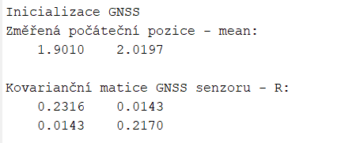

Task 2
In the prediction step, the nonlinear motion model was implemented.
G = [1,0,-v*dt*sin(θ); 0,1,v*dt*cos(θ); 0,0,1];

In the correction step, Linear KF is used.

Task 3

I tested three different values of the R matrix:
  - – Works well. Good balance between the model and GNSS; smooth and accurate trajectory.
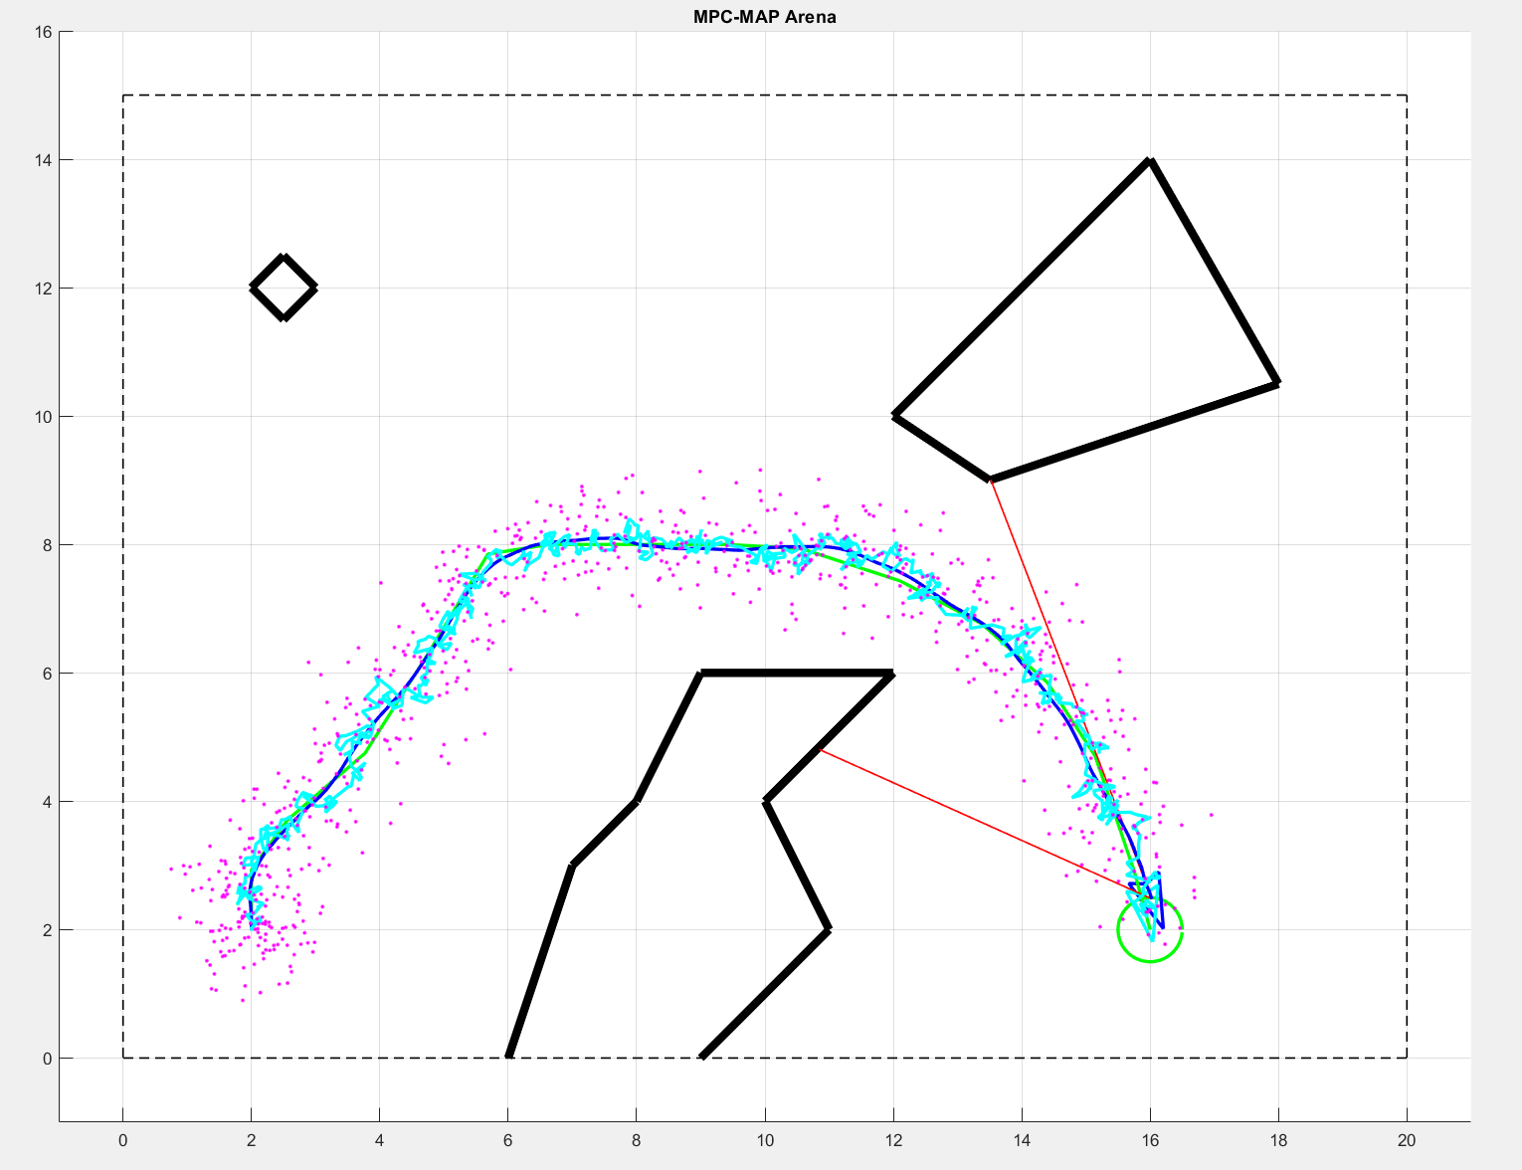
0.0001 – Too small. Overtrusts the model, ignores GNSS; smooth but drifts over time. But also works
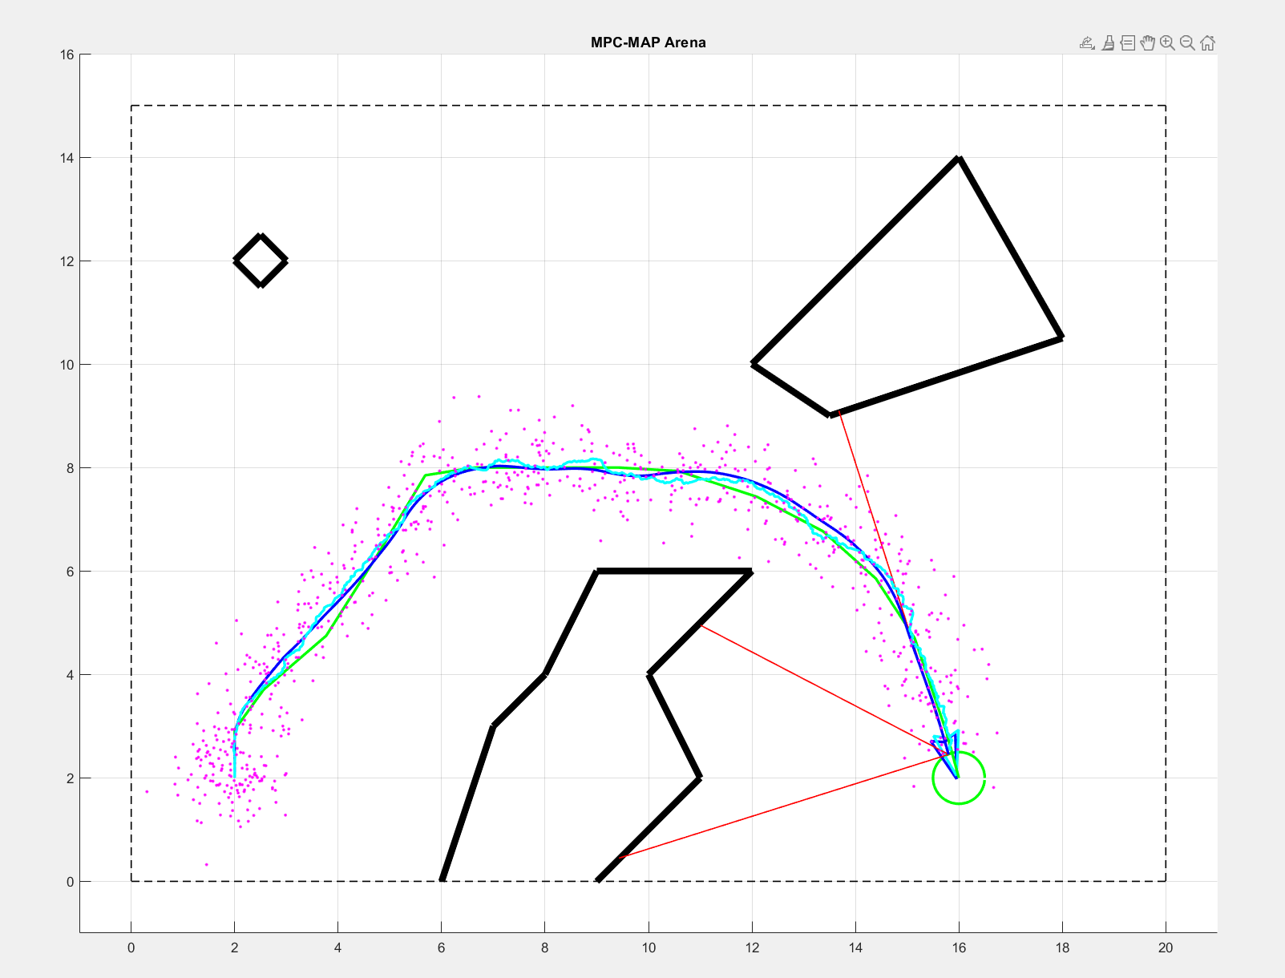
1.0 – Too large. Overtrusts GNSS; trajectory is noisy and erratic.

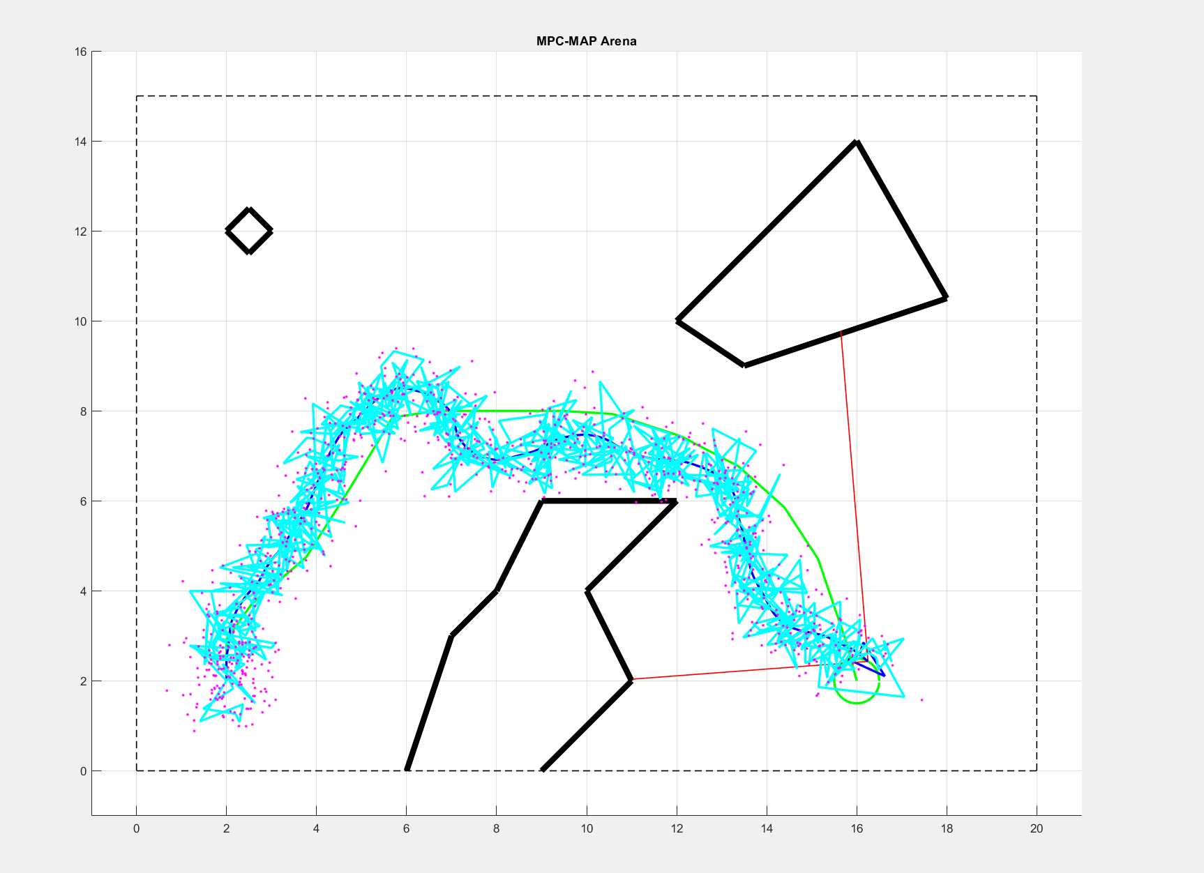

Task 4
Start of simulation: 100 measurements were taken and averaged, so the X and Y position are quite reliable. The rotation is unknown, so the initial angle is set to 0° with low confidence. After a few iterations, once the robot starts moving, the rotation is gradually estimated.

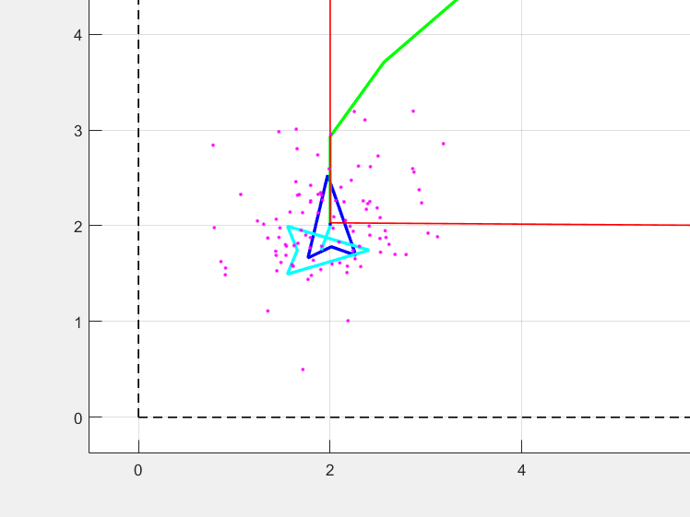

End of simulation:
