MPC-MAP Assignment No. 5 - Report

Author: Tomáš Špelda

Date: 20. 04. 2026

Task 1
Algorithm
- A* algorithm was write
- World coordinates are converted to grid index
- Start and goal are mapped to grid cells
Core
- Uses a priority queue to explore lowest-cost nodes first
- Uses Euclidean distance
- Explores 8 directions (cost 1 straight, sqrt(2) diagonal)
- Reconstructs the path and converts it back to world coordinates

Find path but ignores obstacles.
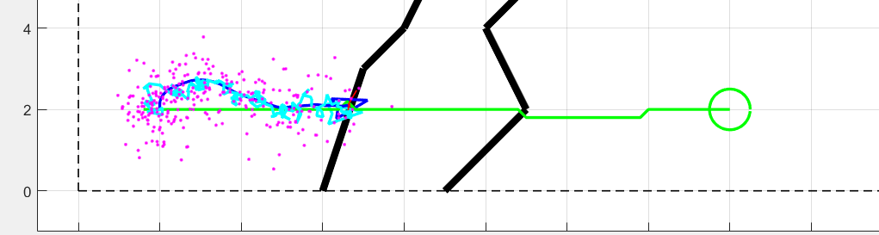

Task 2
An iterative smoothing method was used to refine the raw A* path and improve the trajectory.
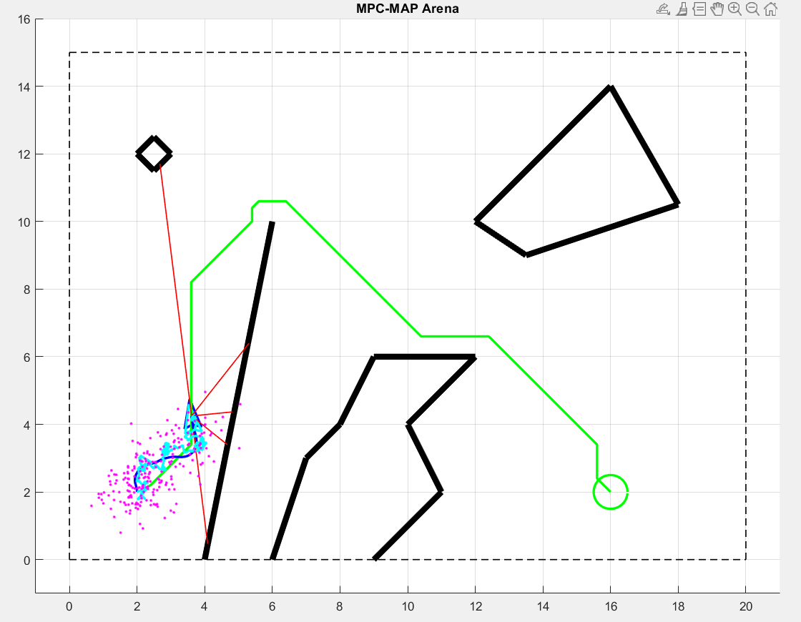

Task 3

A smoothing process was applied iteratively to the A* path to make the trajectory smoother and cleaner.
