MPC-MAP Assignment No. 3 - Report

Author: Tomáš Špelda

Date: 13. 04. 2026

Task 1
The Predict_pose function takes the particle's position and, based on its angular velocity, calculates the particle's new position. It also adds noise to it.
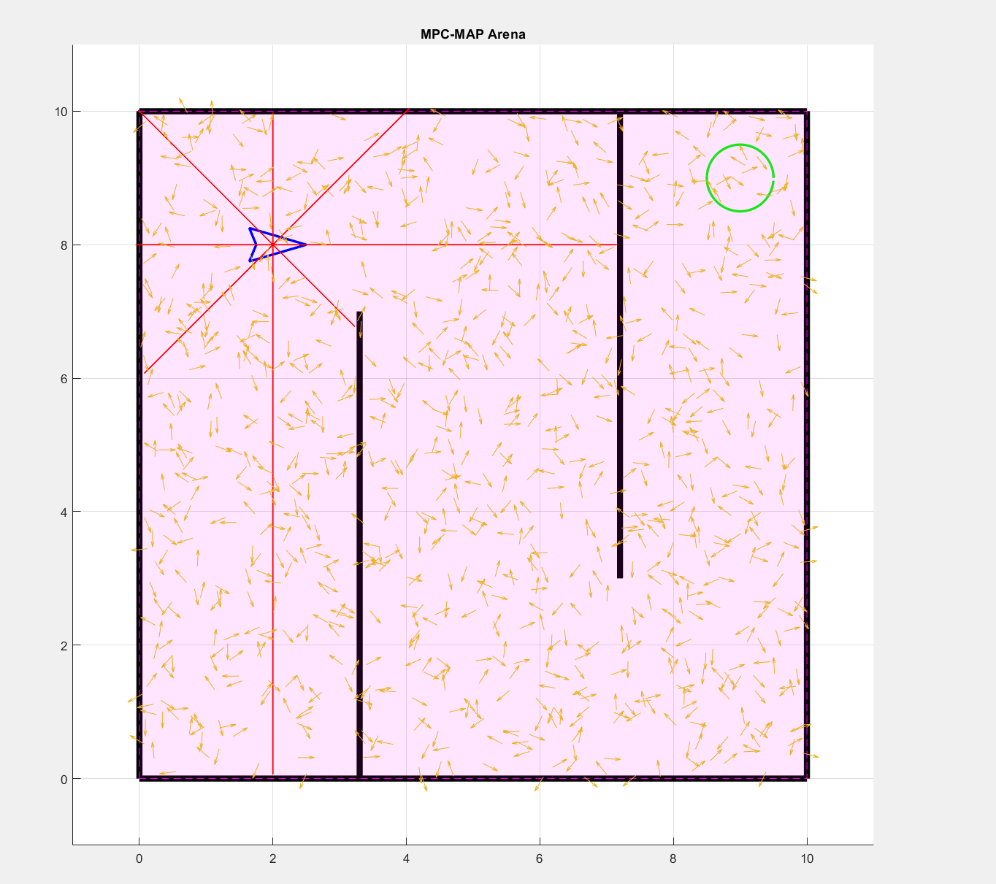
The Predict_pose function takes the particle's position and, based on its angular velocity, calculates the particle's new position. It also adds noise to it.

Task 2
For each LIDAR beam, the total angle is calculated by adding the particle’s orientation to the beam’s relative angle.
The `ray_cast` function is used to find intersections between the beam and the walls.
For each intersection, the Euclidean distance is calculated and the minimum distance is stored.
If no intersections are found, the distance is set to inf.

An estimated LIDAR measurement is calculated for each particle.
The estimated measurements are compared with the actual measurements using a Gaussian probability function. The sigma value was set to 1. Using a lower sigma value caused the particles to converge too quickly.

Particle measurements that are closer to the actual measurements are assigned a higher weight. The weights are then normalized.

Task 3

Resampling is performed using low-variance resampling. Noise is added to the resampled particles.

Task 4
Start of simulation
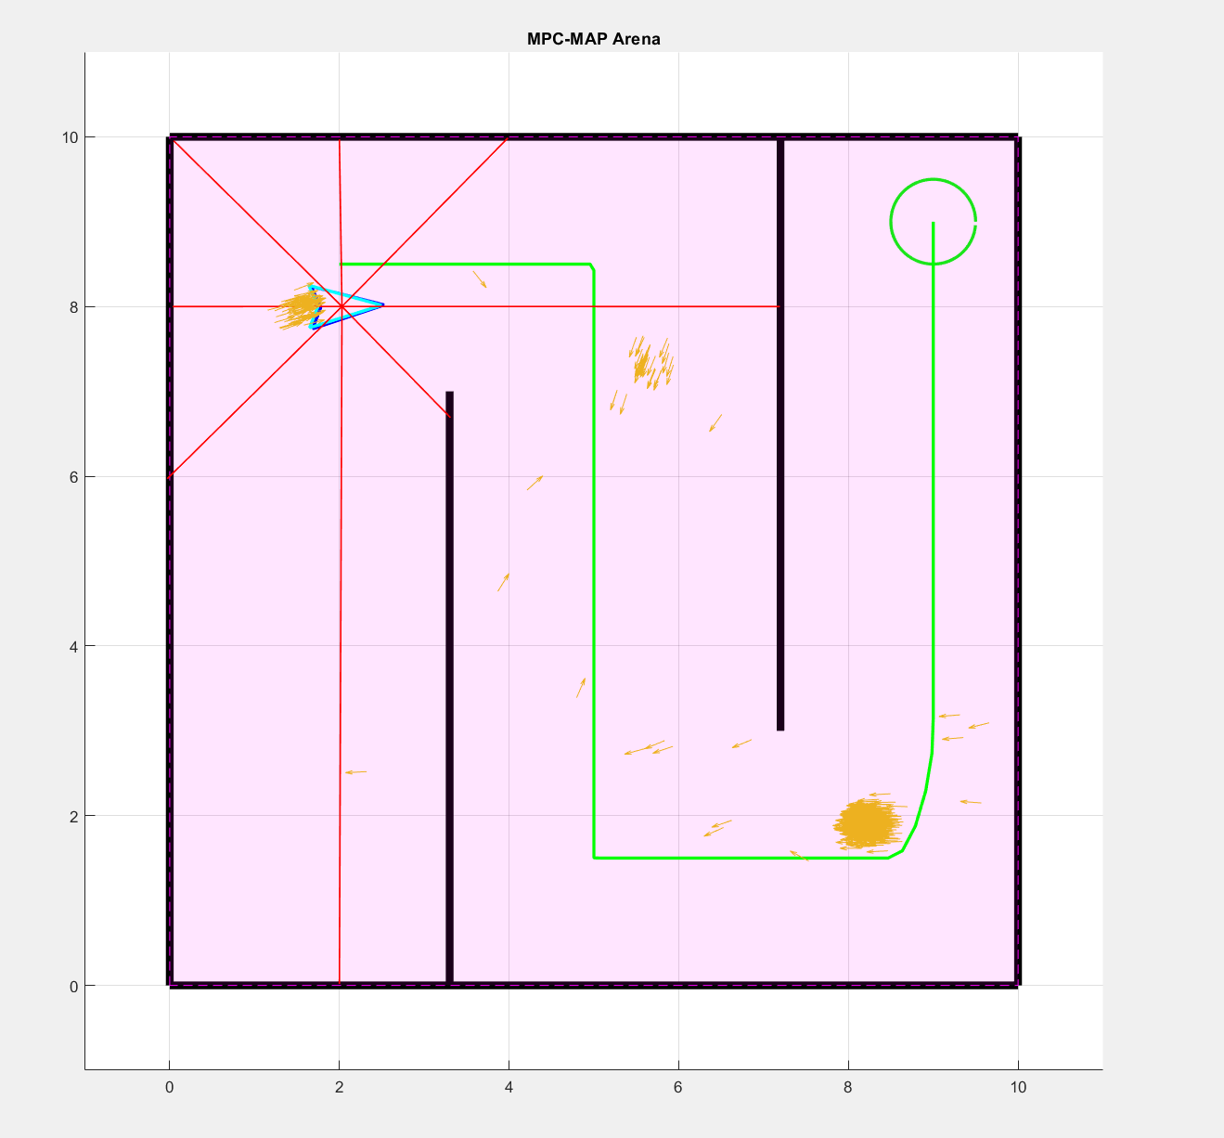

In the middle of simulation:

