Crab Mini Game

Using Python & Turtle

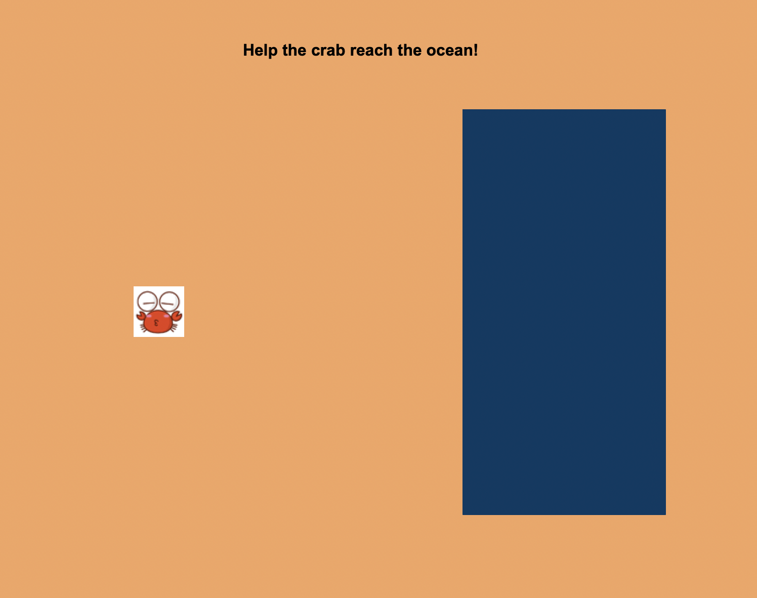

By Sunil Dangal

## Introduction

In this Crab Mini Game project, I am going to create this mini game where we are going to move the crab to reach the objectives. To define the criteria for our project, we have objectives which are:

1. **Creating Crab**

I am going to create a crab that can move to multi directions using up, down, left, and right keyboard.

1. **Game Objective**

So, the crab is born in the sea, came to land to search for a food and in this game, the objective is to go to sea for breeding. So, crab goes to sea from the land is the game objectives.

1. **Game Review**

When the Crab reaches the Sea and game objectives is met, player receives a screen message when game meets the objectives.

## Design

Now, this is a phase we find out what our design requirements look like. We are going to have Diagram, Flowchart, and pseudocode for the visual part.

**Diagram**

Below is the diagram where, crab is in the land with color orange, and the crab must go to the sea with color blue. And the crab is Blue. The blue crab is a player where player can use up, down, left, and right arrow key to move the crab and make it reach the ocean.

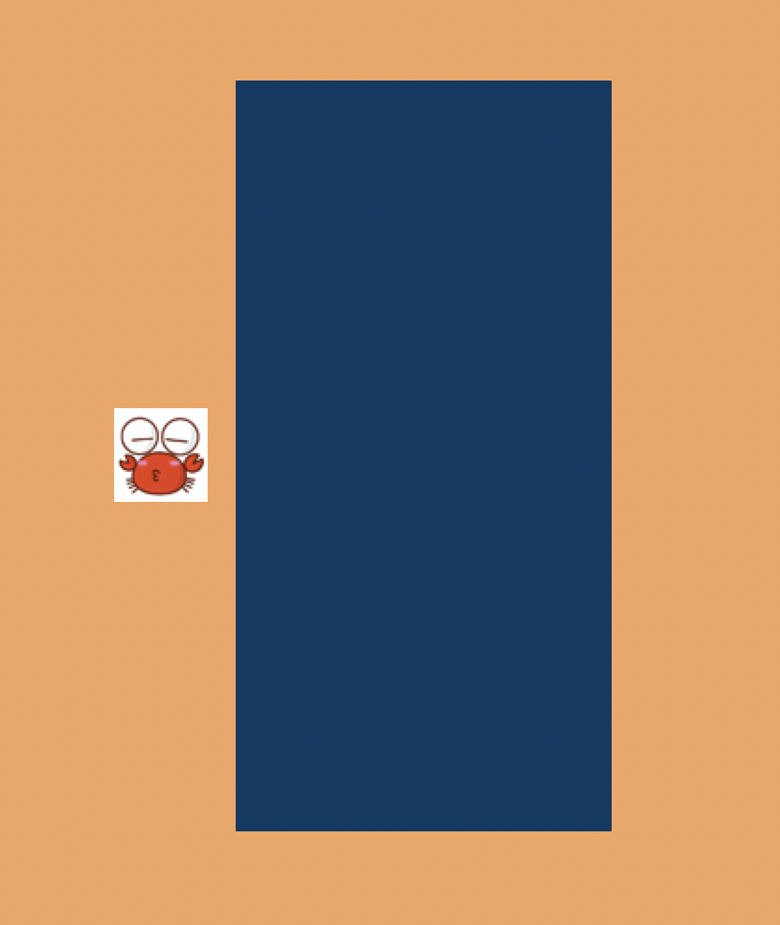

Once the Crab is moved to the Sea then the message will be displayed as “Player Won !!”.



**Flowchart**

Below, is the flowchart for this project.

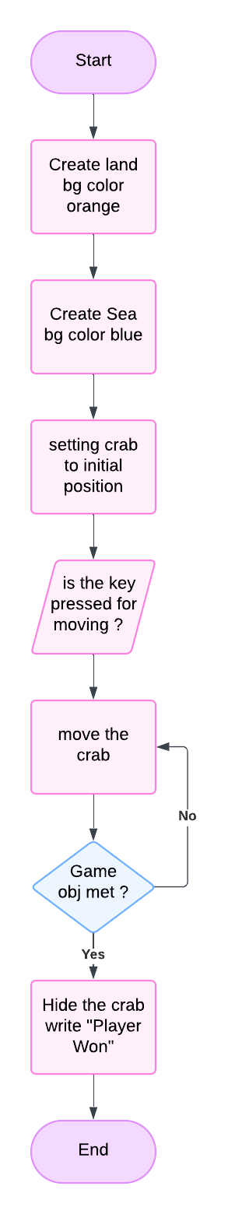

**Pseudocode**

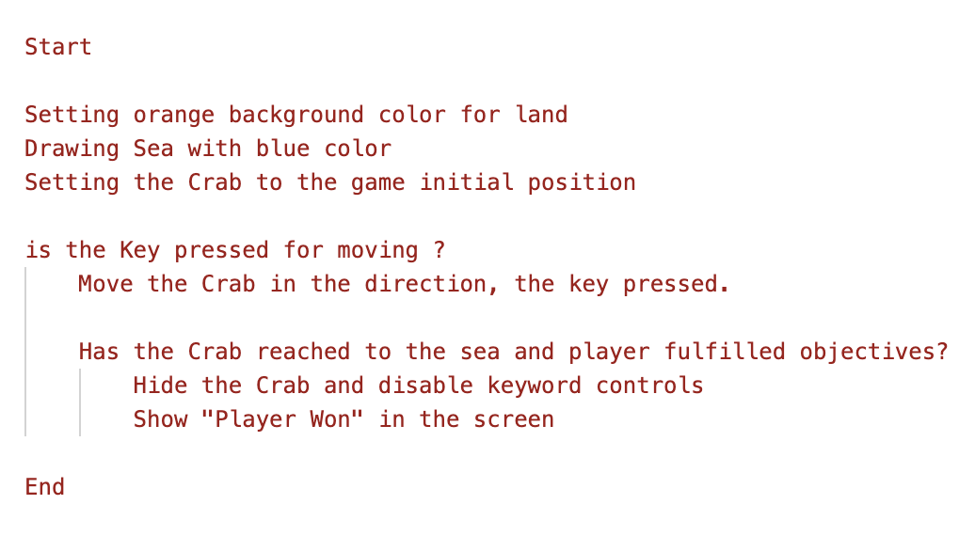

## Implementation

Check the code in *crab_mini_game.py* file to see the code implementation.

Inside the code, we have used goto () function to draw a rectangle to make it a sea later and fill with blue color And after we removed the unnecessary line using penup and pendown function.

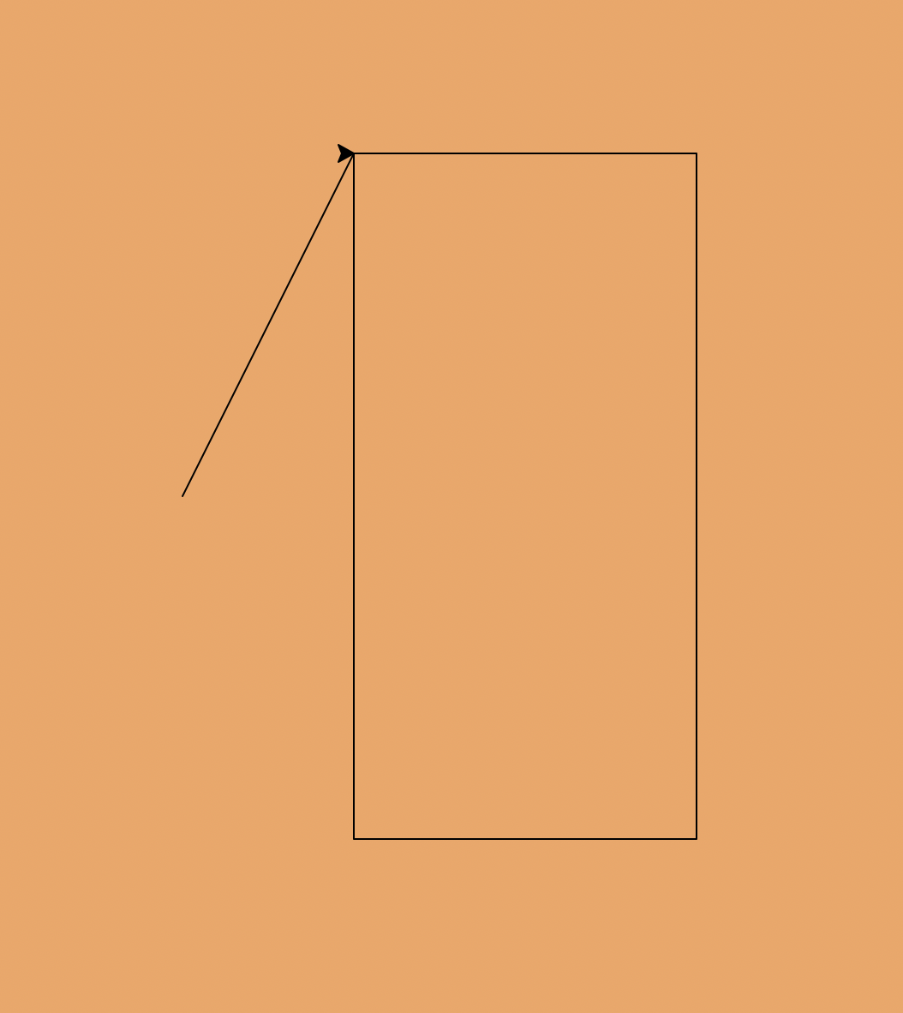

## Evaluate

So, we have created a crab which can be moved to all four-direction using keyboard up, down, left, and right key. We also made a objective to take crab to the sea (blue area) to make the game finish point. And at last, we have message displaying “Crab Won” when the crab reaches the ocean.