Solar System

Using Python

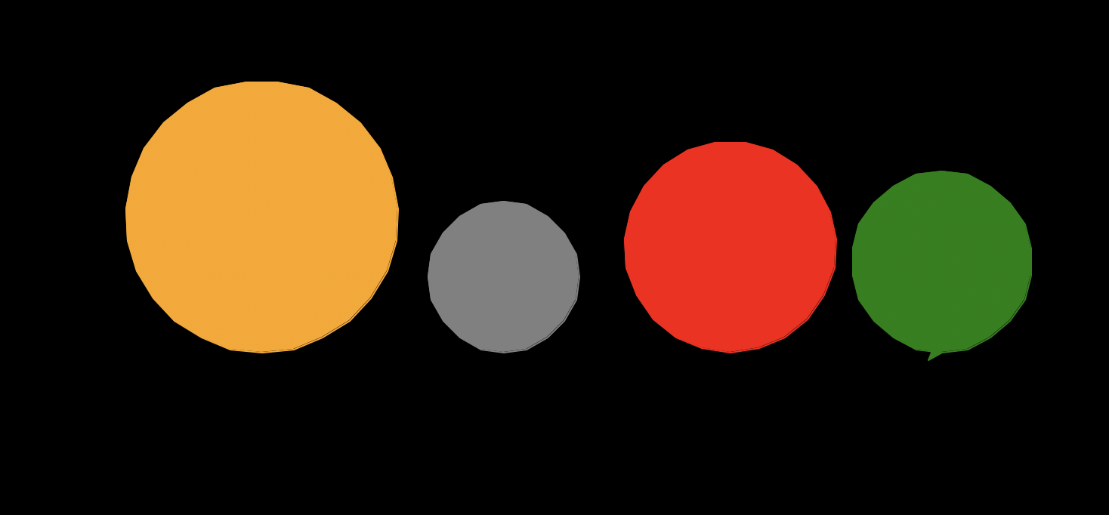

By Sunil Dangal

## Introduction

In this Solar System Project, we are going to make circles like planets revolving to each other using python code. We are making an algorithm using python and turtle for this project. We are using turtle library to use pen to draw the solar system. We are using different colors for circle planets. We are using background color black for space look. This project will demonstrate how we can design and draw using python turtle.

## Design

Now, this is a phase we find out what our design requirements look like. We are going to have Diagram, Flowchart and pseudocode for the visual part, structures, flow, and simplified version of our code respectively.

**Diagram**

We are going to have colored planets with different size and shapes.

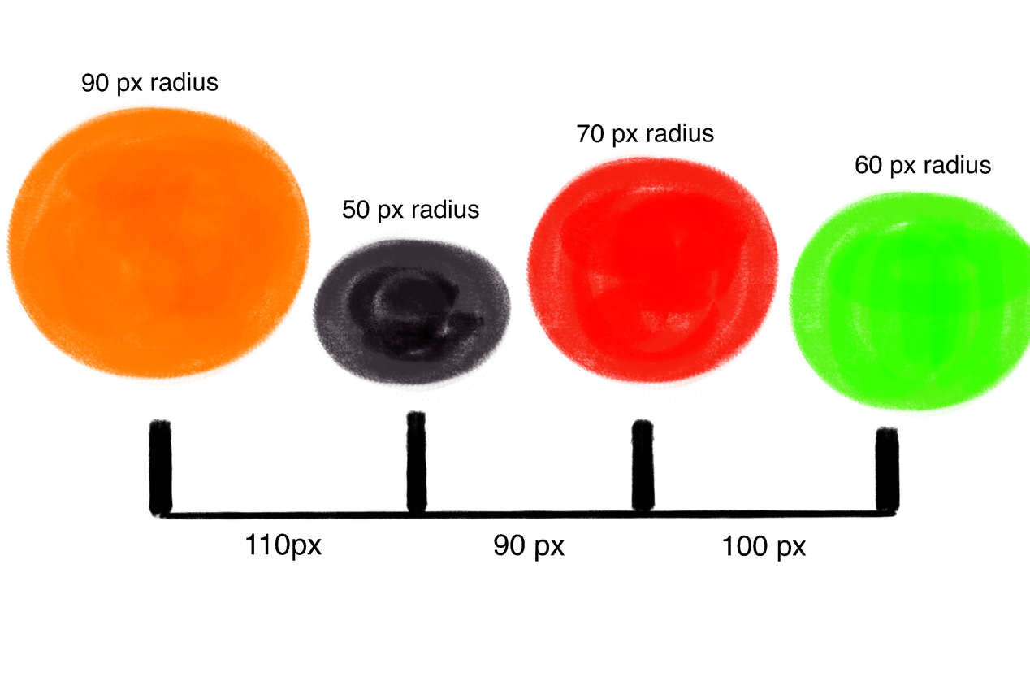

**Flowchart**

So, at first, we are going to have a black background for the space look. After that, we will have orange color tip for the turtle to draw and fill orange color for the first planet. And we move forward after we finish making the first planet. And this what our overall flowchart looks like.

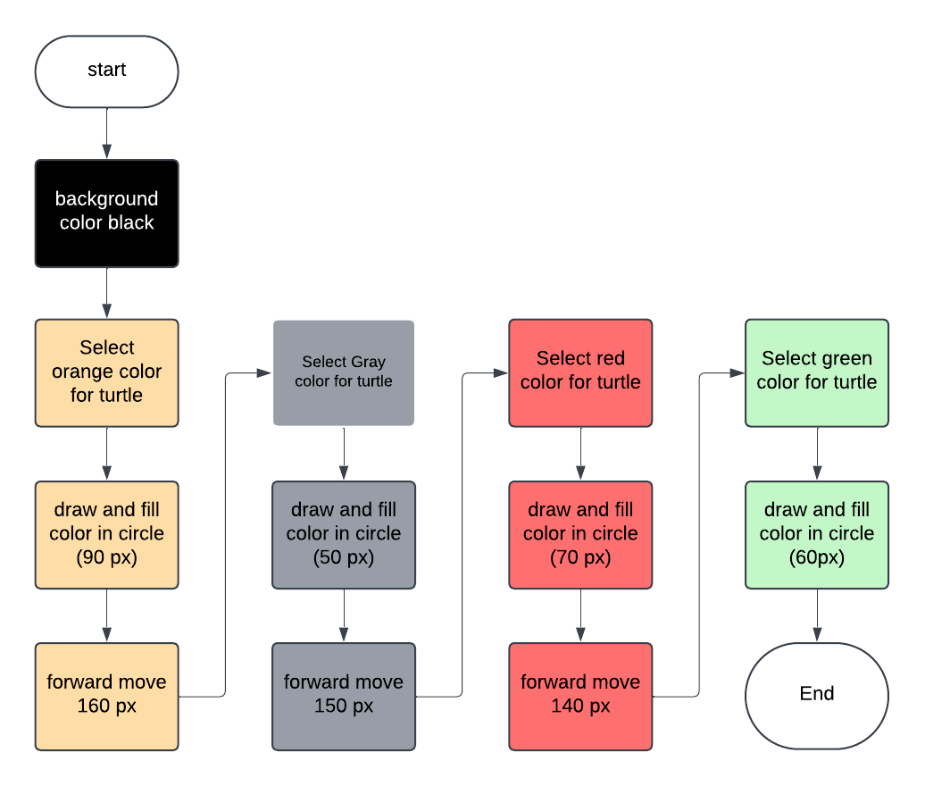

**Pseudocode**

Now, what is pseudocode? it is a way of writing algorithm step by step, in an easy way for us to understand. In pseudocode, we basically write commands and logics for use to understand clearly. For example, for first circle we do:

* Start
* Set the black color for the background.
* Set orange color for the turtle tip
* -------------------------------------
* Begin fill with orange color
* Draw Circle
* End fill
* -------
* Pen up
* Move Forward
* Pen down
* -----------

Now, we write more pseudocode for the rest of the circles. Which are:

* Setting Gray colour for turtle
* --------------------------------
* Begin fill with grey colour
* Draw circle
* End fill
* -------
* pen up
* Move forward
* pen down
* -----------
* Setting RED colour for turtle
* --------------------------------
* Begin fill
* Draw circle
* End fill
* -------
* pen up
* Move forward
* pen down
* ----------
* Setting GREEN colour for turtle
* ----------------------------------
* Begin fill
* Draw circle
* End fill
* END

So, in our design phase, we look check the pseudocode to understand the algorithm.

## Coding Part

Check the solar_system.py project file for the code to draw circle, fill color, pen-up, pen-down, speed and animations.

## Result

So, we have used python turtle to create visuals. We have used colors and created shapes and created solar system. This is a basic project created using python. Now, After doing all these learning, I have created another complete project name as solar_system_project where I have used for loop and lists to make the code easy to read and demonstrated the learning in that code.