SUCAV’s Powerplant

Maximum Take-off Weight = 10 Tonnes = 22046.23 lbf

Operating cruise mach 2 (max speed)

Cruise altitude 16 km (52493.4 ft)

Range (round trip) = 2000 km

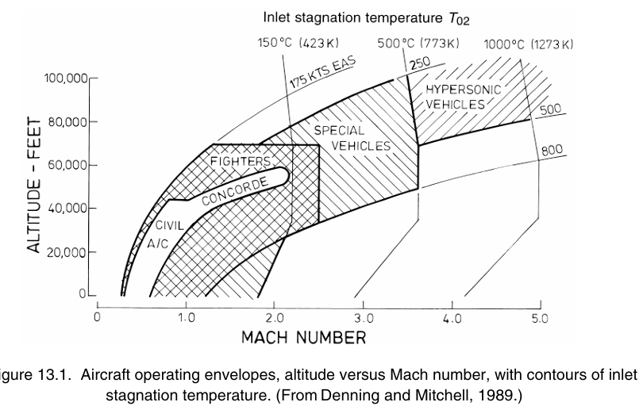



From the plot above:

1. Even high-speed planes don’t normally fly at more than M = 1.2 at SL because of large structural loads and the physiological effects on the crew (not a matter for us) in the high-density air.
2. At high altitudes, high-speed aircrafts don’t normally exceed M = 2.3, because the very stagnation temperatures preclude the use of Al alloys without cooling. (Tt/T = 2.058)
3. Left boundary marks the insufficient speed to generate necessary lift. Stalling boundary flattens at very high altitude to give the operational ceiling.

L/D ~ 6-7 seems realistic for supersonic vehicle. This shifts the optimum engine type from relatively heavy one of a civil transport aircraft with low fuel consumption to a lighter one with high fuel consumption. The requirements in a fighter for acceleration, turning and high-speed demand a much higher T/W.

A rule of thumb at supersonic speeds is that 1 kg of extra weight in each engine of a twin-engine aircraft would increase the aircraft weight by 12-20 kg.

Combat aircraft performance:

* Field requirements (take-off, landing)
* Mission requirements
* Point requirements (acceleration, turning)

# Air superiority:

Manoeuvrability is the key performance issue and speed is less crucial.

Most fight M = 0.7-0.9

At high speeds, M = 2, the fuel consumption is so large that the combat duration is necessarily very short; in addition, the turning circle is so high that conventional fighting maybe impossible.

Combat with afterburner and not fit for Supersonic cruise.

# Interception:

Interceptors are despatched to intercept intruders detected by radar. Modern air-superiority fighters also usually serve as interceptors.

For the specialised interceptor long range is not normally required, but what is needed is high climb rate and speed, with manoeuvrability and fuel consumption being less important.

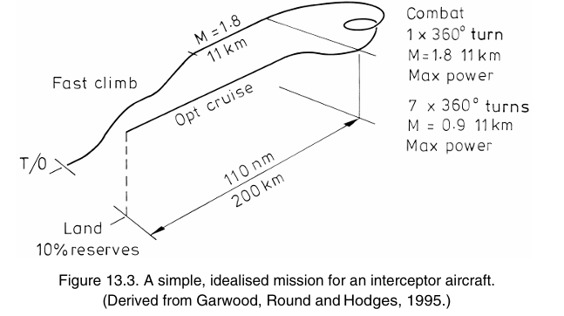

Supercruise, or supersonic flight without afterburner use, reduces fuel consumption and enhances interception beyond visual range (BVR) with missiles. It is also preferable during tight avoidance manoeuvres, as it minimizes heat signature and reduces vulnerability to heat-seeking missiles.

# Meeting the requirements of a new fighter:

In terms of the aerodynamics and thermodynamics of the propulsion, the task is essentially the same as that for manned aircraft.

To make the treatment more concrete a hypothetical aircraft is considered for which the design decisions can be made. So far as **the engines are concerned the most demanding role is for the air-superiority aircraft** and the subject of the design is therefore a New Fighter Aircraft. In fact, it is because there are so many different performance requirements for an air-superiority aircraft that considerable adaptability is needed.

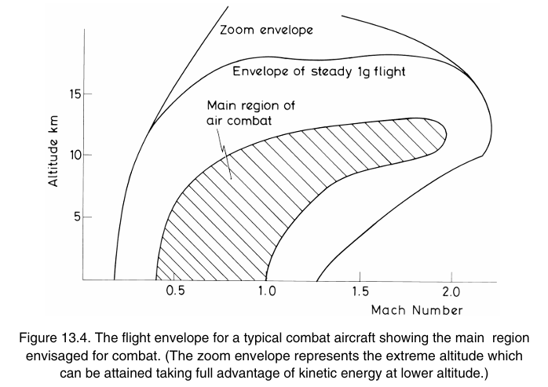

Air-superiority and interception aircraft operate mainly below Mach 1.5 and 11 km altitude, with key operational zones including low-altitude combat (0.5–0.9 M, <4 km) requiring tight turns, sea-level acceleration (0.3–1.2 M), and medium-altitude combat (6 km, 0.7–1.2 M) with rapid acceleration. High-altitude combat (9–11 km, 0.9–1.6 M) demands strong acceleration, while supercruise (M ≥ 1.5, >11 km) enhances efficiency. Finally, sustained supersonic flight (M ≈ 2.0, >11 km) pushes performance limits. Stagnation temperature (T02) significantly affects engine behavior, influenced by altitude and Mach number.

To reduce infrared visibility, afterburner use should be minimized, and the exhaust nozzle should be shielded from the ground by the wing or tailplane. In older aircraft, the engine inlet and exhaust were major sources of radar reflections. Modern designs often use rectangular exhaust nozzles, shielded by the wing or tail, while curved intakes with vanes help absorb radar waves. Additionally, radar-absorbing materials (RAM) are applied to the intake and aircraft surfaces to reduce detection. Advanced stealth aircraft like the **F-117 and F-22** incorporate multiple such features to enhance low observability.

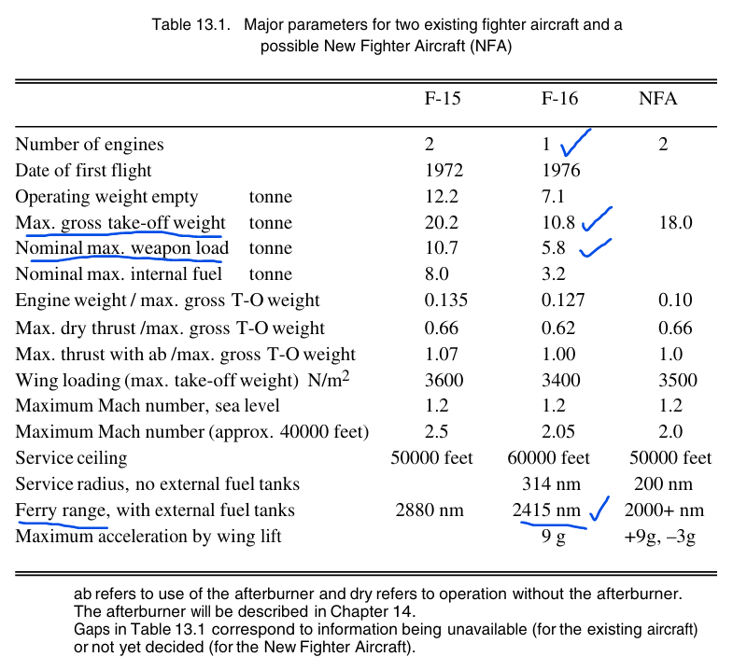

The inferences drawn from the above table are as follows:

* F-16 can be used as reasonable example to start tweaking with.
* Single engine can meet the proposed requirements unless we want to account for added security in case of engine failure.
* Better off in meeting ferry range and payload capacity

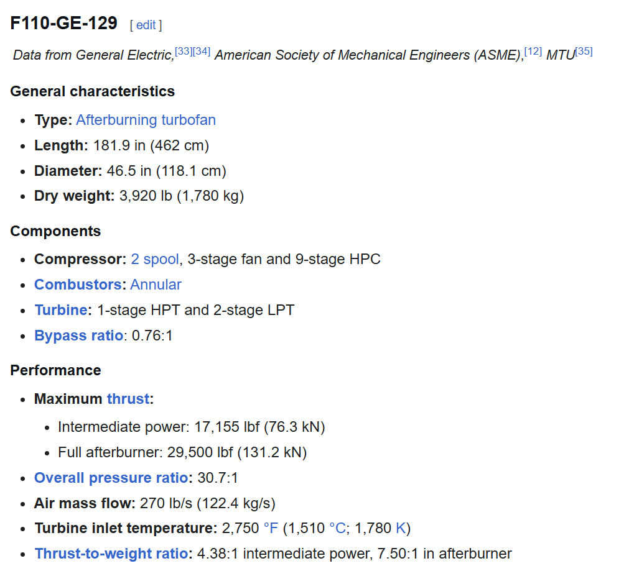

Figure 1. F-16's Powerplant

Combat aircraft engines typically have bypass ratios ranging from **zero** (turbojets) to **around unity**, with most modern designs falling between **0.3 and 0.7** at the design point. However, the bypass ratio can vary significantly under off-design conditions.

Fighter engines have:

* Higher specific thrust
* Mixing of core and bypass streams
* High speed intake
* Afterburner
* Variable nozzle

## Specific Thrust

Fighter engines are characterised by their specific thrust rather than their bypass ratio.

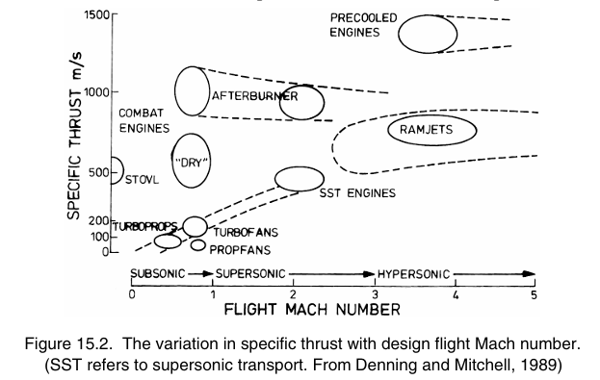

Supersonic fighter engines would need low bypass to have higher specific thrust and the penalty being noise. Low bypass ratio engine has much higher jet velocity leading to high specific thrust but sadly to low propulsive efficiency and large amount of noise.

They require compact engines with high specific thrust to minimize drag and maintain efficiency. Low specific-thrust engines (high bypass ratio) have a larger frontal area, increasing drag and making streamlined design difficult. Additionally, at supersonic speeds, the inlet stagnation pressure drops due to shock losses. Since low specific-thrust engines rely on a large mass flow with a small velocity increase, their jet stagnation pressure remains closer to the inlet, making them more susceptible to pressure losses. As a result, they are inefficient for supersonic applications.

A bypass ratio of at least 0.3 is preferred in modern engines as the bypass air helps cool the engine exterior and facilitates nozzle variations. Higher bypass ratios also enhance afterburning thrust, increasing the difference between dry thrust (efficient cruise operation) and maximum afterburning thrust for peak performance.

## Mixing of Core and Bypass streams

One of the most distinctive features of the majority of combat engines is the mixing of the core and the bypass streams in the jet pipe upstream of the final propelling nozzle.

(1+bpr)cpm = cpe + bpr cp

Mixing happens before the streams enter the final nozzle. A long jet pipe, typically about the same length as the rest of the engine, is used to allow sufficient mixing before the final nozzle. In simplified models, it is often assumed that the flow becomes fully mixed and uniform by this point. The mixing process is most accurately represented by assuming equal static pressure for both streams.

Mixing the core and bypass streams increases thrust because the bypass stream experiences a greater proportional temperature rise than the core stream’s temperature drop. This leads to a higher jet velocity (Vj) for the bypass stream, resulting in a net thrust gain. Although mixing causes some stagnation pressure losses, these are relatively small at low Mach numbers, making it a beneficial approach for enhancing engine performance.

## Afterburner

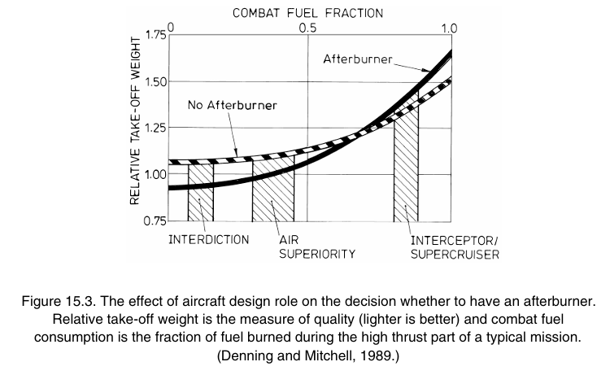

## Supersonic Intakes

Subsonic and low supersonic intakes can be pitot type.

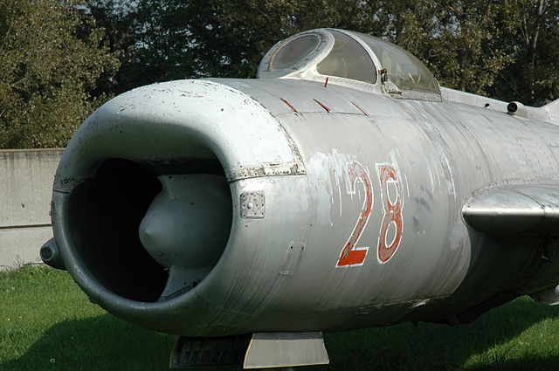 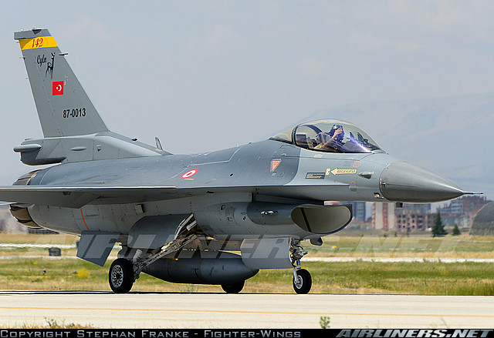

The pitot intakes are normal shock intakes and hence are not suitable for M > 1.8 due to significant loss in total pressure.

For M > 1.8, ramp intakes that cause external compression through a series of oblique shocks are preferred due to reduced loss in pressure recovery.

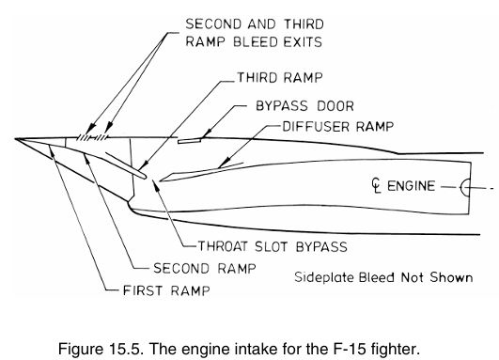

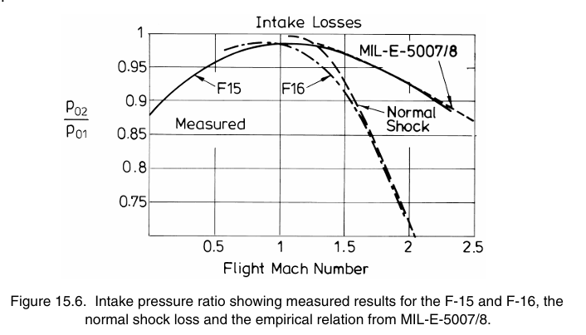

## Propelling Nozzle

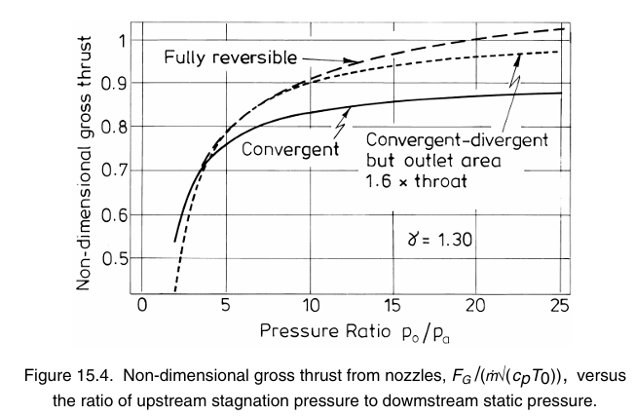

An ideal nozzle would vary the throat area and the exit area independently to maintain the correct area ratio corresponding to the pressure ratio imposed. The required throat area is determined by the mass flow, stagnation pressure and stagnation temperature from the engine so as to keep mass flow rate constant.

Rectangular nozzles (not aerodynamic) are frequent?? for stealth reasons ??.

## Miscellaneous

Military engines now use electronic control systems to ensure that operation does not exceed one of the many restrictions. (FADEC – full authority digital electronic control is the abbreviation for the control system used on recent engines.)

Engine ratings – combat, max dry, intermediate/military, max continuous

## Takeaways

Single low bypass turbofan engine will very likely meet the purpose.

For mach 2 operation, ramp intake is preferred. But stealth considerations might change the decision.

Question about single or dual intake needs to be addressed.

Design point calculations are to be worked out.