Loan Project – Second Sprint

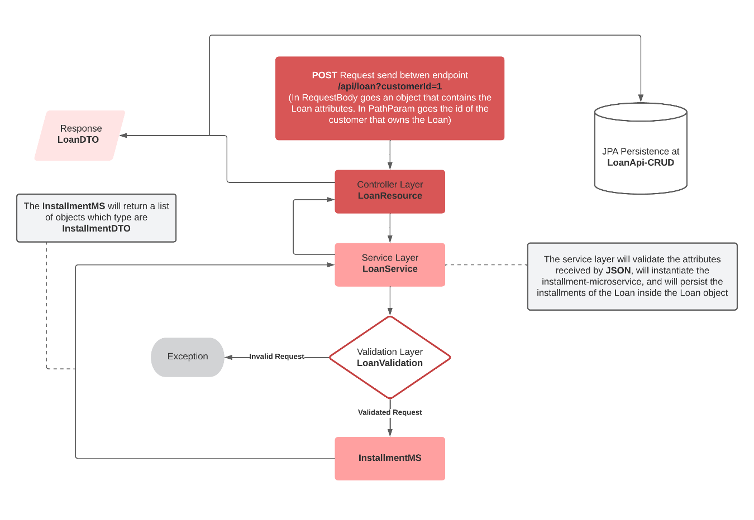

1. Create and configure the profiles: **prod, dev**;
2. Create and configure the **naming-server;**
3. Create and configure the **gateway;**
4. Create a new attribute in installment classes: **notes**;
5. Create a new attribute in installment classes: **creationDate**
6. Add the **complement** attribute in address classes;
7. Exclude enum property **FIFTH_BUSINESS_DAY**;
8. Update .json file with new gateway project requests
9. Review code logs;
10. Update project tests. The goal is **+ 90%** coverage;