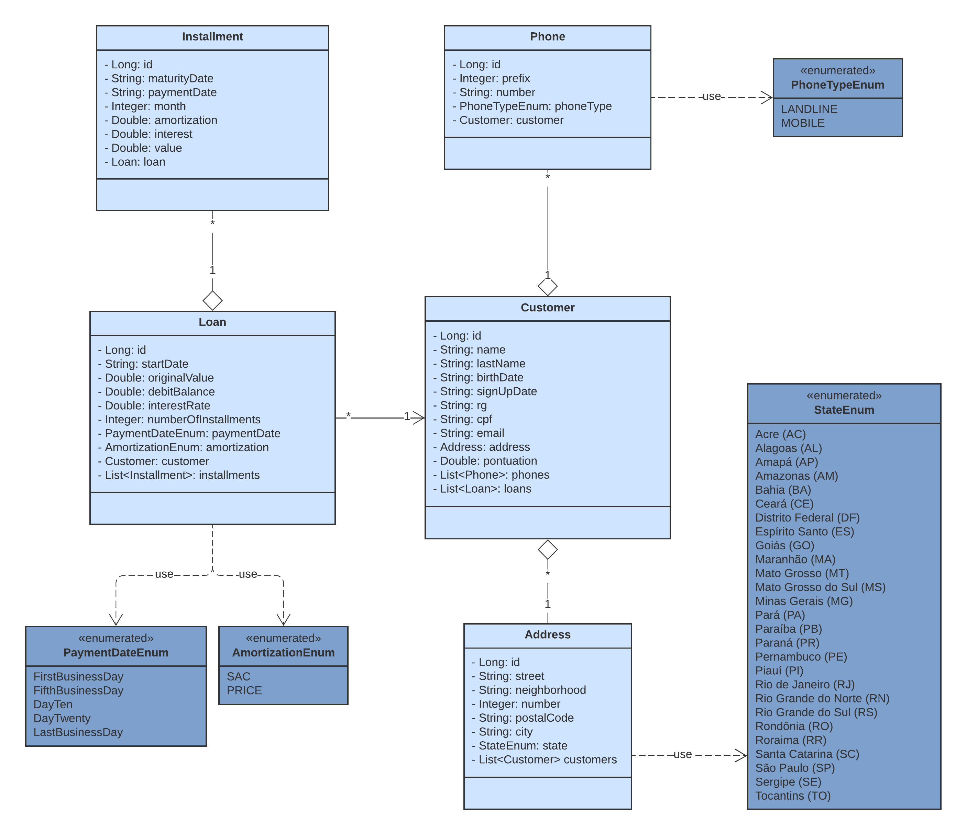

Loan Project – Third Sprint

1. Implement **Resilience4j** – Retry, Rate Limiter and Circuit Breaker;
2. Modify the DTO classes order to beautify JSON;
3. Create the method in **INSTALLMENT-MS** to write off an installment and update the debitBalance attribute of his Loan and Customer pontuation;
4. Create a method to renegotiate a loan;
5. Stress and update exceptions in JSON requests;
6. Review code logs;
7. Implement LoggingFilter class
8. Update project tests. The goal is **+ 90%** coverage;
9. Create the documentation of the classes and methods.