Book ReportMentor-Mentee Matchmaking

short line

Dibyendu Laha  
13th April 2023

# Introduction

1. Problem Statement
2. Requirements
3. Possible Solution

Reading Rainbow Tip: Was the title interesting? Did the cover spark your curiosity? Was it something else? Talk about why you chose the book to help your classmates understand more about you!

# 

# 

# Problem Statement :

To make a recommendation algorithm for MMM platform which will recommend the mentor according to the mentee’s preference.

# Features :

Data from mentor which contains experience, field, job role, skills etc.

Getting query from mentee which will contain Mentor job role, field and experience needed

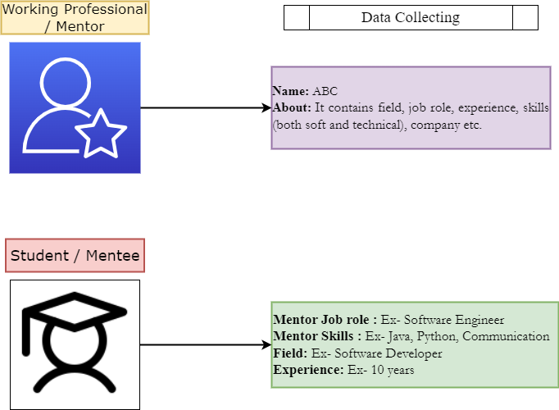

Reading Rainbow Tip: Find an image online that resembles the setting of this story, then replace the image above.

# The WorkFlow :

