1.

program:

AUTOBOXING:

import java.util.ArrayList;

public class Autoboxing

{

public static void main(String[] args)

{

char character = 'a';

Character a = character;

ArrayList<Integer> arrayList = new ArrayList<Integer>();

arrayList.add(25);

System.out.println(arrayList.get(0));

}

}

UNBOXING:

import java.util.ArrayList;

public class Unboxing {

public static void main(String[] args)

{

Character character = 'a';

char a = character;

ArrayList<Integer> arrayList = new ArrayList<Integer>();

arrayList.add(25);

int num = arrayList.get(0);

System.out.println(num);

}

}

OUTPUT:

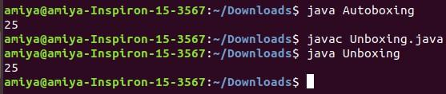

25

2.

public class Student{

int roll;

String dept,name;

25

int marks;

public void setdata(int r,String d,String n,int m){

roll=r;

dept=d;

name=n;

marks=m;

}

public void putdata(){

System.out.println("name: "+name +" roll: "+roll+" department: "+dept+" marks: "+marks);

}

public static void main(){

int k,g,i;

student[] obj=new student[5];

obj[0].setdata("amiya",1,"cse",50);

obj[1].setdata("amiya",2,"cse",50);

obj[2].setdata("amiya",3,"cse",50);

obj[3].setdata("amiya",4,"cse",50);

obj[4].setdata("amiya",5,"cse",50);

int avg=65;

int max=0;

int min=obj[0].marks;

for(i=0;i<5;i++){

if(obj[i].marks>max){

max=obj[i].marks;

k=i;

}

}

for(i=1;i<5;i++){

if(obj[i].marks<min){

min=obj[i].marks;

g=i;

}

}

for(i=0;i<5;i++){

if(obj[i].marks>avg){

System.out.println("avarage marks student: "+obj[i].name);

}

}

System.out.println("maximum marks student "+obj[k].name);

System.out.println("minimum marks student "+obj[g].name);

}

}

OUTPUT:

