Program:

class Ex1

{

public static void main (String [] args)

{

try

{

String s1=args[0];

String s2=args[1];

int n1=Integer.parseInt (s1);

int n2=Integer.parseInt (s2);

int n3=n1/n2;

System.out.println ("DIVISION VALUE = "+n3);

}

catch (ArithmeticException Ae)

{

System.out.println ("DONT ENTER ZERO FOR DENOMINATOR...");

}

catch (NumberFormatException Nfe)

{

System.out.println ("PASS ONLY INTEGER VALUES...");

}

catch (ArrayIndexOutOfBoundsException Aioobe)

{

System.out.println ("PASS DATA FROM COMMAND PROMPT...");

}

finally

{

System.out.println ("I AM FROM FINALLY...");

}

}

}

output:

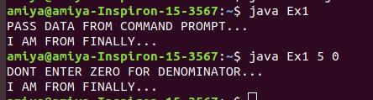

2.

class MyException extends Exception

{

}

// A Class that uses above MyException

public class setText

{

// Driver Program

public static void main(String args[])

{

try

{

// Throw an object of user defined exception

throw new MyException();

}

catch (MyException ex)

{

System.out.println("Caught");

System.out.println(ex.getMessage());

}

}

}

output:  
