**Day 5-Task**

**Step 1:** Creating header.scss in ui.frontend

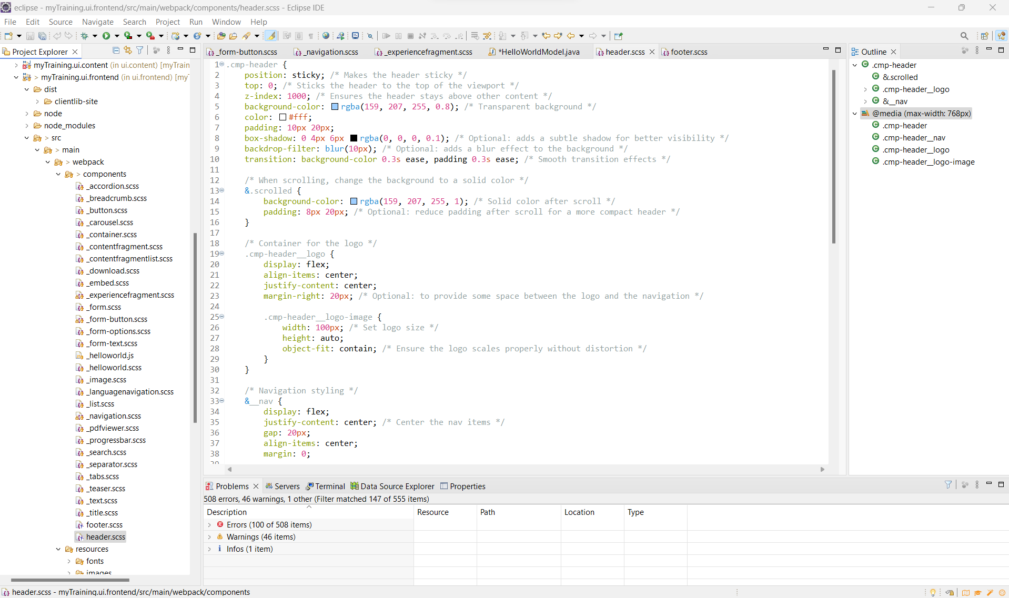

**Step 2:** Creating footer.scss in ui.frontend

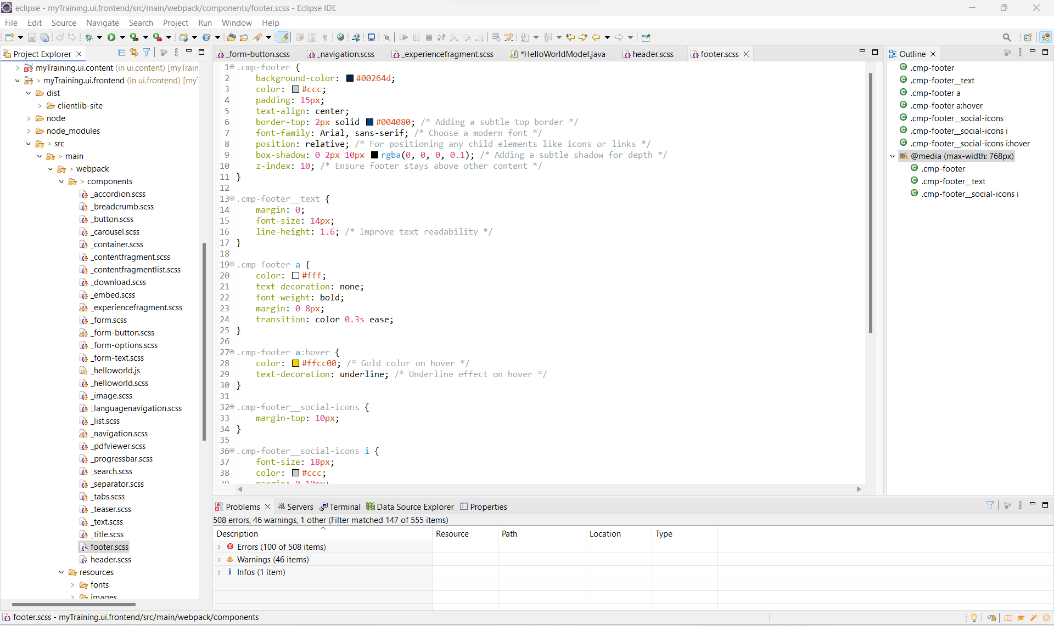

**Step 3:** Building the myTraining from cmd using “mvn clean install -PautoInstallPackage -Dmaven.test.skip=true” command

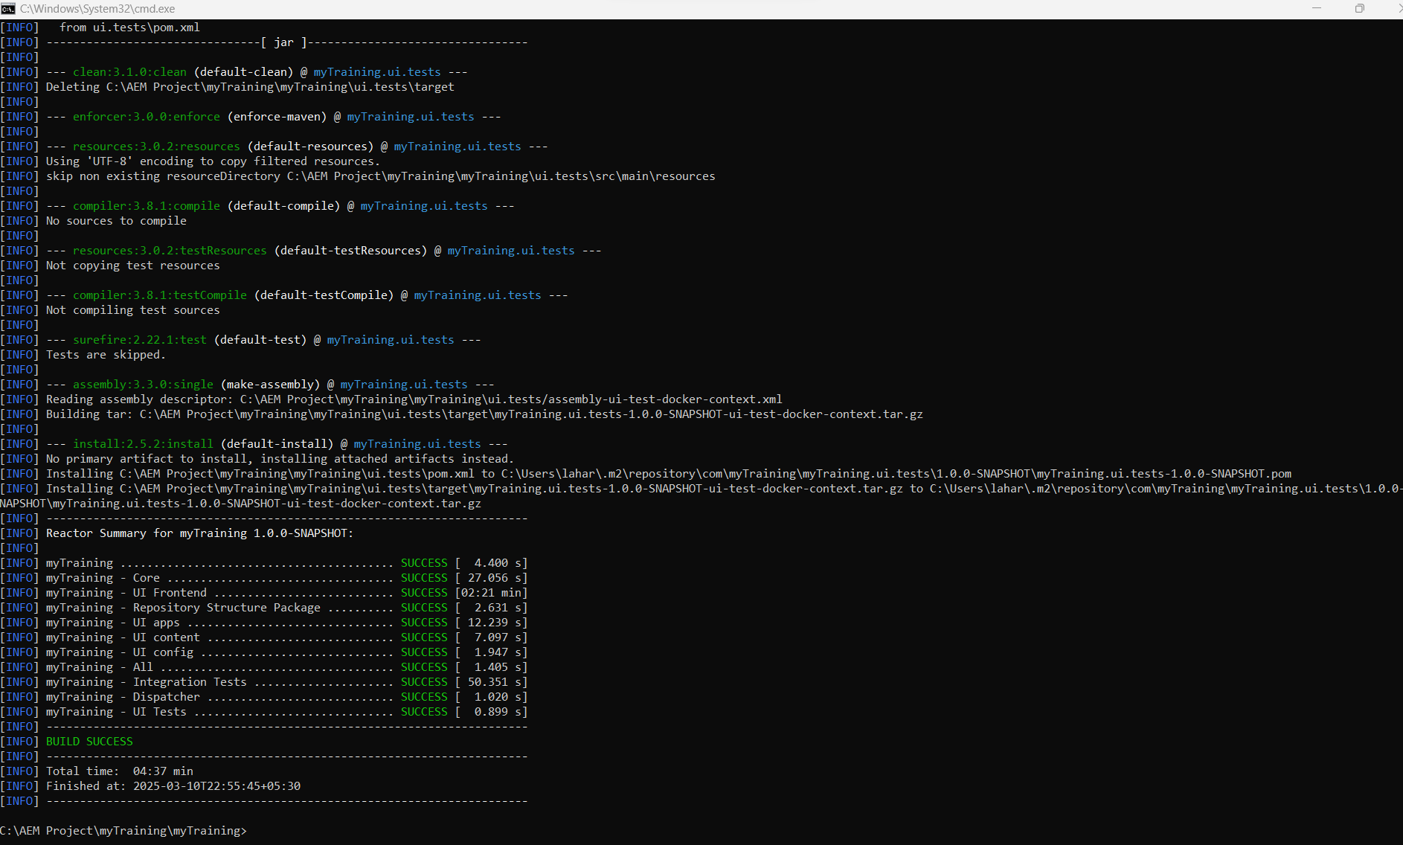

**Step 4:** Going to aem > tools > templates > choosing Book detail template

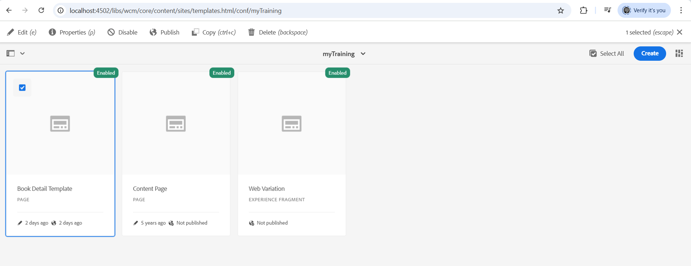

**Step 5:** Creating header

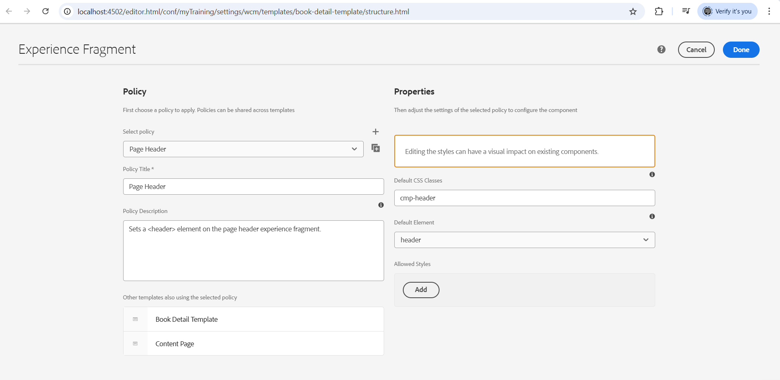

**Step 6:** Creating Footer

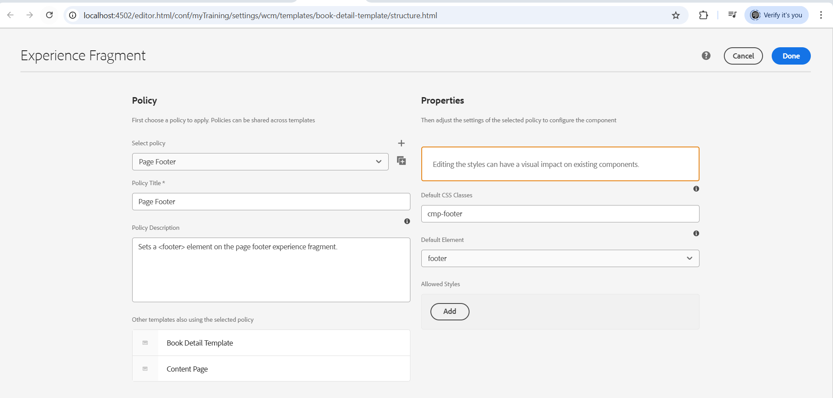

**Step 7:** Preview with adding styles in the header and footer

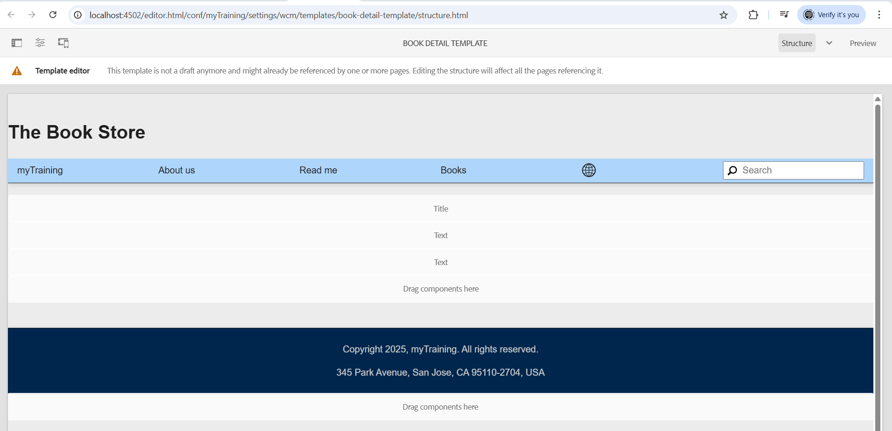

**Step 8:** Output

