INTRODUCTION TO ER DIAGRAMS
"Entity-Relationship (ER) diagrams are employed to provide a visual representation of the data structure within the sales management system. These diagrams illustrate the entities, such as customers, products, and sales, and the relationships between them, facilitating effective database design."
Option 2 (Slightly More Detailed):
"To effectively model and design the database for the sales management system, Entity-Relationship (ER) diagrams are utilized. ER diagrams offer a high-level conceptual representation of the system's data components. They define entities (representing tables like USERS, PRODUCTS, CUSTOMERS, and SALES) and the relationships between them, ensuring a clear understanding of data organization."
Option 3 (More Technical):
"Entity-Relationship (ER) diagrams serve as a fundamental tool for defining the data architecture of the sales management system. These diagrams provide a semantic representation of the system's data, comprising entities and relationships. Entities, such as those depicted in this project (USERS, PRODUCTS, CUSTOMERS, and SALES), represent the core data objects, while relationships illustrate how these entities are associated, enabling the translation of business requirements into a logical database schema."
Key Improvements and Considerations:
- Clarity: The options are written to be clear and easily understandable within a project context.
- Relevance: They directly relate ER diagrams to the "sales management system" mentioned in your file.
- Accuracy: They use terminology ("entities," "relationships") consistent with database design.
- Flexibility: You can choose the level of detail that best suits your project's scope.
- Contextual Examples: Option 2 and 3 include examples of entities (USERS, PRODUCTS, etc.) to make it more specific to your project.

Identification of Entities and Their Relationships
The cornerstone of effective database design is the meticulous identification of the system's fundamental entities and the precise definition of the complex relationships that interweave them. Within the context of the sales management system, this initial phase is of paramount importance, as it dictates the structure, integrity, and overall utility of the database. The Entity-Relationship (ER) model serves as the primary conceptual modeling tool, providing a semantic representation of the data components and their interdependencies.
1. Comprehensive Entity Identification:
Entities represent the distinct, real-world objects, concepts, or events about which the system is designed to capture and store information. Each entity in the ER model will ultimately be implemented as a table within the relational database. The following entities have been identified and rigorously defined as essential building blocks of the sales management system:
- USERS: This entity encapsulates the individuals authorized to interact with the sales management application. It stores the credentials and potentially other profile information necessary for user authentication, authorization, and auditing of system activities. The attributes meticulously defined for the USERS entity are:
  - Username: This attribute serves as a unique identifier for each user within the system. It is typically employed during the login process to distinguish one user from another. The Username attribute is characterized by its non-null constraint, ensuring that every user record has a defined username.
  - Password: This attribute stores the secret code associated with each user, used in conjunction with the Username to verify the user's identity. For security reasons, the Password attribute is handled with specific security measures (e.g., encryption), though this level of detail might be documented elsewhere. Like Username, the Password attribute is non-null.
- PRODUCTS: This entity represents the inventory of goods or services that the business offers for sale. It maintains detailed information about each product, enabling efficient tracking of stock levels, pricing, and product characteristics. The attributes comprehensively defined for the PRODUCTS entity are:
  - Name: This attribute stores the descriptive label or title that uniquely identifies each product within the inventory.
  - Price: This attribute records the selling price of the product, typically represented as a decimal value to accommodate fractional currency units.
  - Quantity: This attribute maintains a numerical value representing the current amount of the product that is available in stock.
- CUSTOMERS: This entity represents the individuals or organizations that engage in purchasing transactions with the business. It stores contact information and other relevant details pertaining to customer interactions and relationships. The attributes meticulously defined for the CUSTOMERS entity are:
  - Name: This attribute stores the full name of an individual customer or the official name of a customer organization.
  - Contact: This attribute stores the customer's contact details, such as phone numbers, email addresses, or mailing addresses, facilitating communication and order fulfillment.
- SALES: This entity forms the core of the transactional data within the system. It records the specifics of each individual sales transaction, capturing what was sold, to whom it was sold, and the circumstances of the sale. The attributes comprehensively defined for the SALES entity are:
  - Quantity: This attribute stores the numerical value representing the number of units of a product that were sold in a given transaction.
  - Sale_date: This attribute records the precise date and time at which the sales transaction occurred, enabling chronological analysis and reporting.
  - Pro_id (Foreign Key): This attribute acts as a foreign key, establishing a crucial link between the SALES entity and the PRODUCTS entity. It stores the unique identifier of the specific product involved in the sales transaction, thus enabling the system to retrieve product details associated with each sale. This foreign key enforces referential integrity, ensuring that a sale cannot be recorded for a non-existent product.
  - C_id (Foreign Key): This attribute functions as another foreign key, creating a vital connection between the SALES entity and the CUSTOMERS entity. It stores the unique identifier of the customer who made the purchase, allowing the system to track customer purchase history and generate customer-specific reports. Similar to Pro_id, this foreign key enforces referential integrity, ensuring that a sale is always associated with a valid customer.
2. Detailed Elaboration of Relationship Identification and Cardinality:
Relationships define the logical associations and dependencies between entities, reflecting how data elements are connected and interact within the system. Cardinality constraints specify the quantitative aspect of these relationships, indicating how many instances of one entity can be related to how many instances of another entity. The following key relationships and their cardinalities are meticulously defined within the sales management system:
- Relationship between SALES and PRODUCTS:
  - A single product (within the PRODUCTS entity) can be involved in numerous sales transactions (within the SALES entity) over time. For example, "Product A" might be sold many times to different customers on different dates.
  - Conversely, each individual sales transaction (within the SALES entity) pertains to one and only one specific product (within the PRODUCTS entity). You cannot have a sale without specifying which product was sold.
  - Therefore, the cardinality of this relationship is one-to-many (1:N). The "one" side is the PRODUCTS entity, and the "many" side is the SALES entity.
  - This relationship is implemented in the database through the Pro_id foreign key within the SALES table, which references the primary key of the PRODUCTS table.
- Relationship between SALES and CUSTOMERS:
  - A single customer (within the CUSTOMERS entity) can engage in multiple purchase activities, resulting in multiple sales transactions (within the SALES entity) throughout their interaction with the business. For instance, "Customer X" might place several orders on different occasions.
  - Conversely, each individual sales transaction (within the SALES entity) is attributed to one and only one specific customer (within the CUSTOMERS entity). A sale cannot occur without a designated customer.
  - Consequently, the cardinality of this relationship is also one-to-many (1:N). The "one" side is the CUSTOMERS entity, and the "many" side is the SALES entity.
  - This relationship is realized in the database through the C_id foreign key within the SALES table, which references the primary key of the CUSTOMERS table.
3. In-Depth Explanation of the Significance of Entity and Relationship Identification:
The accurate, thorough, and precise identification of entities and their relationships is not merely an academic exercise; it is an absolutely fundamental and critical undertaking that has profound implications for the success, efficiency, and reliability of the sales management system. The ramifications of this initial design phase extend across various dimensions of the system:
- Ensuring Data Integrity: A well-defined ER model, with correctly identified entities and relationships, is the cornerstone of data integrity. Data integrity refers to the accuracy, consistency, and validity of the data stored within the database. By meticulously defining entities and their attributes, the ER model minimizes data redundancy (the unnecessary duplication of data), prevents data inconsistencies (conflicting data values), and enforces data validation rules (constraints on data values). This ensures that the database contains reliable and trustworthy information, which is essential for accurate decision-making and business operations.
- Providing a Blueprint for Database Design: The ER model serves as the architectural blueprint for the physical implementation of the database. It provides a clear and unambiguous representation of the tables, columns, data types, and constraints that will be created in the database management system (DBMS). The ER model guides the database administrator and developers in translating the conceptual data requirements into a logical and physical database schema, ensuring that the database structure accurately reflects the system's data needs.
- Supporting Core System Functionality: The identified entities and relationships directly support the core functionalities of the sales management system. For example:
  - The USERS entity enables user authentication and authorization, controlling access to different parts of the system.
  - The PRODUCTS entity facilitates inventory management, allowing the system to track stock levels, pricing, and product information.
  - The CUSTOMERS entity supports customer relationship management, enabling the system to store customer contact details and track purchase history.
  - The SALES entity is essential for recording sales transactions, generating invoices, and calculating sales revenue.
  - The relationships between these entities enable the system to perform crucial operations such as retrieving customer purchase history, generating sales reports by product, and managing product inventory based on sales.
- Enabling Effective Reporting and Analysis: The structure provided by the ER model is essential for generating meaningful reports and performing in-depth analysis of business data. By organizing data into well-defined entities and relationships, the system can efficiently retrieve and aggregate information to produce reports on:
  - Sales trends and patterns.
  - Customer purchasing behavior.
  - Product performance and profitability.
  - Inventory levels and stock management.
This analytical capability empowers business stakeholders to gain valuable insights, make informed decisions, and optimize business strategies.
In conclusion, the identification of entities and their relationships is not a peripheral activity but rather the central and most critical step in designing a successful sales management system. It establishes the foundation for data integrity, database structure, system functionality, and business intelligence, ultimately determining the system's ability to meet its objectives and provide value to the organization.
This expanded explanation provides a very detailed and thorough account of entity and relationship identification, suitable for a comprehensive project document. Remember to adapt the language and level of technical detail to match your specific audience and the overall tone of your project report.

ER DIAGRAM

Pro_id
C_id(fk)

Name
C_id
CUSTOMERS
SALES
Sale_date
Pro_id(fk)
Quantity
Contact
User_id
Username
Quantity
Price
PRODUCTS
Name
Password
USERS
CONVERTING ER DIAGRAM TO RELATIONS
Based on the ER diagram, we have the following entities and attributes:
- USERS:
  - Username
  - Password
- PRODUCTS:
  - Name
  - Price
  - Quantity
- CUSTOMERS:
  - Name
  - Contact
- SALES:
  - Quantity
  - Sale_date
  - Pro_id (Foreign Key referencing PRODUCTS)
  - C_id (Foreign Key referencing CUSTOMERS)
Relational Schema:
Here's how we represent these entities and attributes as relations (tables) in a relational database schema:
- USERS (Username, Password)
- PRODUCTS (Name, Price, Quantity)
- CUSTOMERS (Name, Contact)
- SALES (Quantity, Sale_date, Pro_id, C_id)
Explanation of the Conversion:
- Each entity in the ER diagram becomes a table in the relational schema.
- The attributes of each entity become the columns of the corresponding table.
- Primary keys are typically added to each table to uniquely identify each row. Based on common database design practices and your SQL code (which isn't in the ERD), let's assume Username in USERS, a generated id for PRODUCTS, a generated id for CUSTOMERS, and a generated id for SALES.
- Foreign keys are used to represent the relationships between tables. In this case, Pro_id in the SALES table references the primary key of the PRODUCTS table, and C_id in the SALES table references the primary key of the CUSTOMERS table.
Complete Relational Schema with Assumed Primary Keys:
- USERS (id, Username, Password)
  - id (INT, Primary Key)
  - Username (VARCHAR(50), Unique, Not Null)
  - Password (VARCHAR(50), Not Null)
- PRODUCTS (id, Name, Price, Quantity)
  - id (INT, Primary Key)
  - Name (VARCHAR(100))
  - Price (DECIMAL(10, 2))
  - Quantity (INT)
- CUSTOMERS (id, Name, Contact)
  - id (INT, Primary Key)
  - Name (VARCHAR(100))
  - Contact (VARCHAR(50))
- SALES (id, product_id, customer_id, Quantity, Sale_date)
  - id (INT, Primary Key)
  - product_id (INT, Foreign Key referencing PRODUCTS.id)
  - customer_id (INT, Foreign Key referencing CUSTOMERS.id)
  - Quantity (INT)
  - Sale_date (DATE)

SQL QUERIES:
CREATE DATABASE sales_management;
USE sales_management;
-- Users table
CREATE TABLE users (
id INT AUTO_INCREMENT PRIMARY KEY,
username VARCHAR(50) NOT NULL UNIQUE,
password VARCHAR(50) NOT NULL
);
-- Products table
CREATE TABLE products (
id INT AUTO_INCREMENT PRIMARY KEY,
name VARCHAR(100),
price DECIMAL(10, 2),
quantity INT
);

-- Customers table
CREATE TABLE customers (
id INT AUTO_INCREMENT PRIMARY KEY,
name VARCHAR(100),
contact VARCHAR(50)
);
-- Sales table
CREATE TABLE sales (
id INT AUTO_INCREMENT PRIMARY KEY,
product_id INT,
customer_id INT,
quantity_sold INT,
sale_date DATE,
FOREIGN KEY (product_id) REFERENCES products(id),
FOREIGN KEY (customer_id) REFERENCES customers(id)
);
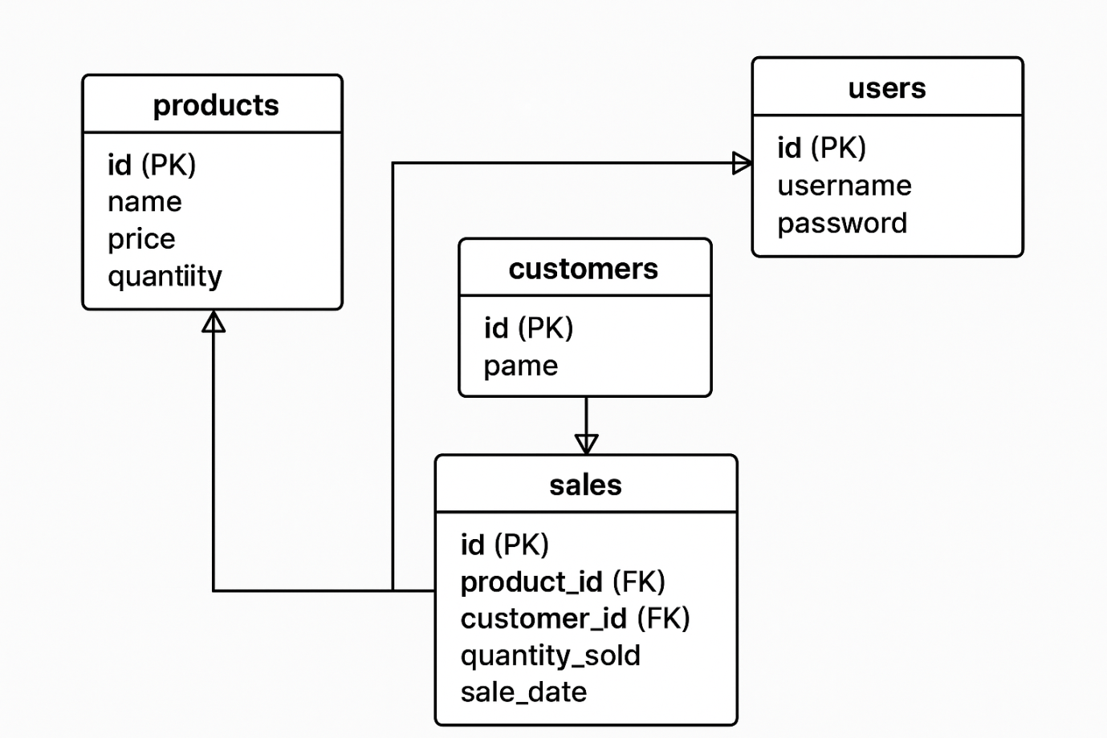

JAVA USING GUI BASED APPLICATION:
LOGIN PAGE:
package com.sales.management;

import javax.swing.*; package com.sales.management;

import javax.swing.*;
import java.awt.*;
import java.awt.event.*;
import java.sql.*;

public class LoginPage extends JFrame implements ActionListener {
JTextField userField;
JPasswordField passField;
JButton loginBtn;
JLabel statusLabel;

public LoginPage() {
setTitle("Login - Sales Management System");
setSize(350, 220);
setDefaultCloseOperation(EXIT_ON_CLOSE);
setLocationRelativeTo(null);
setLayout(new GridLayout(5, 1, 10, 10));

// Username
JPanel userPanel = new JPanel();
userPanel.add(new JLabel("Username:"));
userField = new JTextField(20);
userPanel.add(userField);
add(userPanel);

// Password
JPanel passPanel = new JPanel();
passPanel.add(new JLabel("Password:"));
passField = new JPasswordField(20);
passPanel.add(passField);
add(passPanel);

// Button
JPanel btnPanel = new JPanel();
loginBtn = new JButton("Login");
loginBtn.addActionListener(this);
btnPanel.add(loginBtn);
add(btnPanel);

// Status
JPanel statusPanel = new JPanel();
statusLabel = new JLabel("");
statusPanel.add(statusLabel);
add(statusPanel);

setVisible(true);
}

@Override
public void actionPerformed(ActionEvent e) {
String username = userField.getText();
String password = new String(passField.getPassword());

if (validateLogin(username, password)) {
statusLabel.setText("Login successful!");
JOptionPane.showMessageDialog(this, "Welcome " + username + "!");
// Proceed to next screen or dashboard
} else {
statusLabel.setText("Invalid credentials.");
JOptionPane.showMessageDialog(this, "Incorrect username or password.");
}
}

private boolean validateLogin(String username, String password) {
try (Connection conn = DBConnection.getConnection()) {
String query = "SELECT * FROM users WHERE username=? AND password=?";
PreparedStatement stmt = conn.prepareStatement(query);
stmt.setString(1, username);
stmt.setString(2, password);

ResultSet rs = stmt.executeQuery();
return rs.next(); // true if user exists
} catch (SQLException ex) {
ex.printStackTrace();
statusLabel.setText("DB Error");
return false;
}
}

public static void main(String[] args) {
SwingUtilities.invokeLater(LoginPage::new);
}
}
import java.awt.*;
import java.awt.event.*;
import java.sql.*;

public class LoginPage extends JFrame implements ActionListener {
JTextField userField;
JPasswordField passField;
JButton loginBtn;
JLabel statusLabel;

public LoginPage() {
setTitle("Login - Sales Management System");
setSize(350, 220);
setDefaultCloseOperation(EXIT_ON_CLOSE);
setLocationRelativeTo(null);
setLayout(new GridLayout(5, 1, 10, 10));

// Username
JPanel userPanel = new JPanel();
userPanel.add(new JLabel("Username:"));
userField = new JTextField(20);
userPanel.add(userField);
add(userPanel);

// Password
JPanel passPanel = new JPanel();
passPanel.add(new JLabel("Password:"));
passField = new JPasswordField(20);
passPanel.add(passField);
add(passPanel);

// Button
JPanel btnPanel = new JPanel();
loginBtn = new JButton("Login");
loginBtn.addActionListener(this);
btnPanel.add(loginBtn);
add(btnPanel);

// Status
JPanel statusPanel = new JPanel();
statusLabel = new JLabel("");
statusPanel.add(statusLabel);
add(statusPanel);

setVisible(true);
}

@Override
public void actionPerformed(ActionEvent e) {
String username = userField.getText();
String password = new String(passField.getPassword());

if (validateLogin(username, password)) {
statusLabel.setText("Login successful!");
JOptionPane.showMessageDialog(this, "Welcome " + username + "!");
// Proceed to next screen or dashboard
} else {
statusLabel.setText("Invalid credentials.");
JOptionPane.showMessageDialog(this, "Incorrect username or password.");
}
}

private boolean validateLogin(String username, String password) {
try (Connection conn = DBConnection.getConnection()) {
String query = "SELECT * FROM users WHERE username=? AND password=?";
PreparedStatement stmt = conn.prepareStatement(query);
stmt.setString(1, username);
stmt.setString(2, password);

ResultSet rs = stmt.executeQuery();
return rs.next(); // true if user exists
} catch (SQLException ex) {
ex.printStackTrace();
statusLabel.setText("DB Error");
return false;
}
}
public static void main(String[] args) {
SwingUtilities.invokeLater(LoginPage::new);
}}

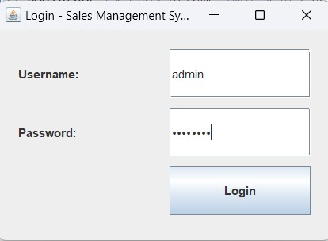
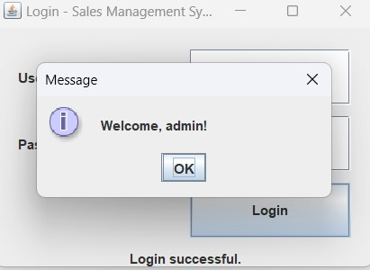
DASHBOARD:
import javax.swing.*;
public class Dashboard extends JFrame {
public Dashboard() {
setTitle("Dashboard");
setSize(400, 200);
setLocationRelativeTo(null);
setDefaultCloseOperation(EXIT_ON_CLOSE);
add(new JLabel("Welcome to the Sales Management System", SwingConstants.CENTER));
setVisible(true);
}}
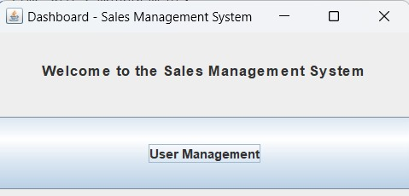
USER MANAGEMENT:
package com.sales.management;

import javax.swing.*;
import javax.swing.table.DefaultTableModel;
import java.awt.*;
import java.awt.event.*;
import java.sql.*;

public class UserManagement extends JFrame {
JTable userTable;
DefaultTableModel model;
JTextField usernameField, passwordField;

public UserManagement() {
setTitle("User Management");
setSize(600, 400);
setLocationRelativeTo(null);
setDefaultCloseOperation(DISPOSE_ON_CLOSE);
setLayout(new BorderLayout());

// Table Setup
model = new DefaultTableModel(new String[]{"ID", "Username", "Password"}, 0);
userTable = new JTable(model);
loadUsers();

add(new JScrollPane(userTable), BorderLayout.CENTER);

// Form Panel
JPanel formPanel = new JPanel(new FlowLayout());
usernameField = new JTextField(10);
passwordField = new JTextField(10);
JButton addButton = new JButton("Add User");
JButton deleteButton = new JButton("Delete Selected");

formPanel.add(new JLabel("Username:"));
formPanel.add(usernameField);
formPanel.add(new JLabel("Password:"));
formPanel.add(passwordField);
formPanel.add(addButton);
formPanel.add(deleteButton);

add(formPanel, BorderLayout.SOUTH);

// Action Listeners
addButton.addActionListener(e -> addUser());
deleteButton.addActionListener(e -> deleteUser());

setVisible(true);
}

private void loadUsers() {
model.setRowCount(0); // clear table
try (Connection conn = DBConnection.getConnection()) {
String sql = "SELECT * FROM users";
Statement stmt = conn.createStatement();
ResultSet rs = stmt.executeQuery(sql);

while (rs.next()) {
model.addRow(new Object[]{
rs.getInt("id"),
rs.getString("username"),
rs.getString("password")
});
}
} catch (SQLException e) {
e.printStackTrace();
}
}

private void addUser() {
String username = usernameField.getText();
String password = passwordField.getText();

if (username.isEmpty() || password.isEmpty()) {
JOptionPane.showMessageDialog(this, "Fields cannot be empty");
return;
}

try (Connection conn = DBConnection.getConnection()) {
String sql = "INSERT INTO users (username, password) VALUES (?, ?)";
PreparedStatement ps = conn.prepareStatement(sql);
ps.setString(1, username);
ps.setString(2, password);
ps.executeUpdate();

JOptionPane.showMessageDialog(this, "User added successfully");
usernameField.setText("");
passwordField.setText("");
loadUsers(); // refresh table
} catch (SQLException e) {
e.printStackTrace();
JOptionPane.showMessageDialog(this, "Error adding user");
}
}

private void deleteUser() {
int selectedRow = userTable.getSelectedRow();
if (selectedRow == -1) {
JOptionPane.showMessageDialog(this, "No user selected");
return;
}

int userId = (int) model.getValueAt(selectedRow, 0);
try (Connection conn = DBConnection.getConnection()) {
String sql = "DELETE FROM users WHERE id = ?";
PreparedStatement ps = conn.prepareStatement(sql);
ps.setInt(1, userId);
ps.executeUpdate();

JOptionPane.showMessageDialog(this, "User deleted");
loadUsers();
} catch (SQLException e) {
e.printStackTrace();
}}}
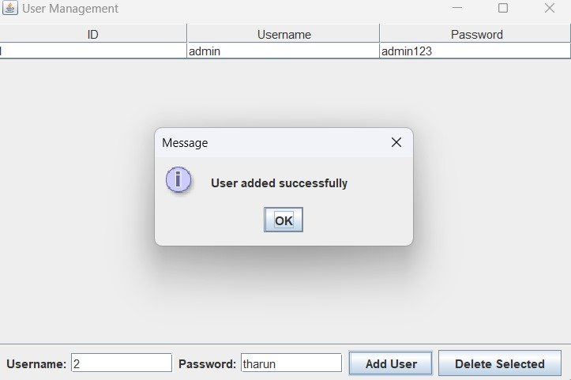
PRODUCT MANAGEMENT:
- UPDATING DASHBOARD:
package com.sales.management;

import javax.swing.*;
import java.awt.*;

public class Dashboard extends JFrame {
public Dashboard() {
setTitle("Dashboard - Sales Management System");
setSize(400, 300);
setLocationRelativeTo(null);
setDefaultCloseOperation(EXIT_ON_CLOSE);
setLayout(new GridLayout(3, 1, 10, 10)); // Neat vertical layout with spacing

JLabel welcomeLabel = new JLabel("Welcome to the Sales Management System", SwingConstants.CENTER);
welcomeLabel.setFont(new Font("Arial", Font.BOLD, 14));
add(welcomeLabel);

// User Management Button
JButton userMgmtBtn = new JButton("User Management");
userMgmtBtn.addActionListener(e -> new UserManagement());
add(userMgmtBtn);

// Product Management Button
JButton productMgmtBtn = new JButton("Product Management");
productMgmtBtn.addActionListener(e -> new ProductManagement());
add(productMgmtBtn);

setVisible(true);
}}
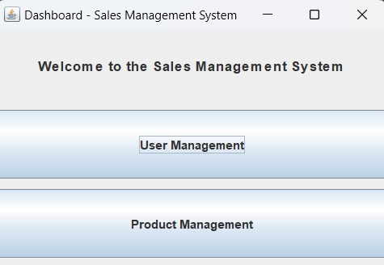
- CREATING PRODUCTMANAGEMENT:
package com.sales.management;

import javax.swing.*;
import javax.swing.table.DefaultTableModel;
import java.awt.*;
import java.awt.event.*;
import java.sql.*;

public class ProductManagement extends JFrame {
JTable productTable;
DefaultTableModel model;
JTextField nameField, priceField, qtyField;

public ProductManagement() {
setTitle("Product Management");
setSize(700, 400);
setLocationRelativeTo(null);
setDefaultCloseOperation(DISPOSE_ON_CLOSE);
setLayout(new BorderLayout());

// Table
model = new DefaultTableModel(new String[]{"ID", "Name", "Price", "Quantity"}, 0);
productTable = new JTable(model);
loadProducts();
add(new JScrollPane(productTable), BorderLayout.CENTER);

// Form panel
JPanel formPanel = new JPanel(new FlowLayout());
nameField = new JTextField(10);
priceField = new JTextField(7);
qtyField = new JTextField(5);
JButton addButton = new JButton("Add Product");
JButton deleteButton = new JButton("Delete Selected");

formPanel.add(new JLabel("Name:"));
formPanel.add(nameField);
formPanel.add(new JLabel("Price:"));
formPanel.add(priceField);
formPanel.add(new JLabel("Qty:"));
formPanel.add(qtyField);
formPanel.add(addButton);
formPanel.add(deleteButton);

add(formPanel, BorderLayout.SOUTH);

// Action Listeners
addButton.addActionListener(e -> addProduct());
deleteButton.addActionListener(e -> deleteProduct());

setVisible(true);
}

private void loadProducts() {
model.setRowCount(0);
try (Connection conn = DBConnection.getConnection()) {
String sql = "SELECT * FROM products";
Statement stmt = conn.createStatement();
ResultSet rs = stmt.executeQuery(sql);

while (rs.next()) {
model.addRow(new Object[]{
rs.getInt("id"),
rs.getString("name"),
rs.getDouble("price"),
rs.getInt("quantity")
});
}
} catch (SQLException e) {
e.printStackTrace();
}
}

private void addProduct() {
String name = nameField.getText();
String priceText = priceField.getText();
String qtyText = qtyField.getText();

if (name.isEmpty() || priceText.isEmpty() || qtyText.isEmpty()) {
JOptionPane.showMessageDialog(this, "Please fill all fields.");
return;
}

try {
double price = Double.parseDouble(priceText);
int qty = Integer.parseInt(qtyText);

try (Connection conn = DBConnection.getConnection()) {
String sql = "INSERT INTO products (name, price, quantity) VALUES (?, ?, ?)";
PreparedStatement ps = conn.prepareStatement(sql);
ps.setString(1, name);
ps.setDouble(2, price);
ps.setInt(3, qty);
ps.executeUpdate();

JOptionPane.showMessageDialog(this, "Product added.");
nameField.setText("");
priceField.setText("");
qtyField.setText("");
loadProducts();
}
} catch (NumberFormatException nfe) {
JOptionPane.showMessageDialog(this, "Invalid price or quantity.");
} catch (SQLException e) {
e.printStackTrace();
}
}

private void deleteProduct() {
int selectedRow = productTable.getSelectedRow();
if (selectedRow == -1) {
JOptionPane.showMessageDialog(this, "No product selected.");
return;
}

int id = (int) model.getValueAt(selectedRow, 0);
try (Connection conn = DBConnection.getConnection()) {
String sql = "DELETE FROM products WHERE id = ?";
PreparedStatement ps = conn.prepareStatement(sql);
ps.setInt(1, id);
ps.executeUpdate();

JOptionPane.showMessageDialog(this, "Product deleted.");
loadProducts();
} catch (SQLException e) {
e.printStackTrace();
}
}
}
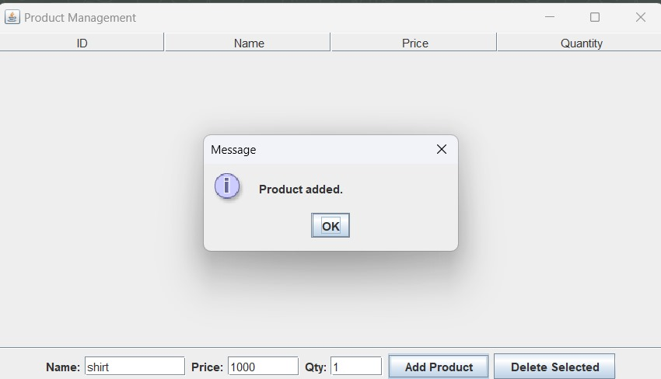
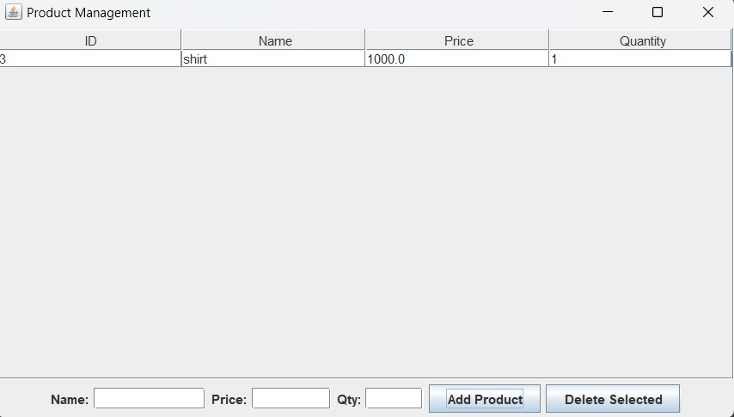

CUSTOMER MANAGEMENT:
- UPDATED DASHBOARD:
package com.sales.management;

import javax.swing.*;
import java.awt.*;

public class Dashboard extends JFrame {
public Dashboard() {
setTitle("Dashboard - Sales Management System");
setSize(400, 350);
setLocationRelativeTo(null);
setDefaultCloseOperation(EXIT_ON_CLOSE);
setLayout(new GridLayout(4, 1, 10, 10)); // 4 rows, 1 column layout

JLabel welcomeLabel = new JLabel("Welcome to the Sales Management System", SwingConstants.CENTER);
welcomeLabel.setFont(new Font("Arial", Font.BOLD, 14));
add(welcomeLabel);

// User Management Button
JButton userMgmtBtn = new JButton("User Management");
userMgmtBtn.addActionListener(e -> new UserManagement());
add(userMgmtBtn);

// Product Management Button
JButton productMgmtBtn = new JButton("Product Management");
productMgmtBtn.addActionListener(e -> new ProductManagement());
add(productMgmtBtn);

// Customer Management Button
JButton customerMgmtBtn = new JButton("Customer Management");
customerMgmtBtn.addActionListener(e -> new CustomerManagement());
add(customerMgmtBtn);

setVisible(true);
}}
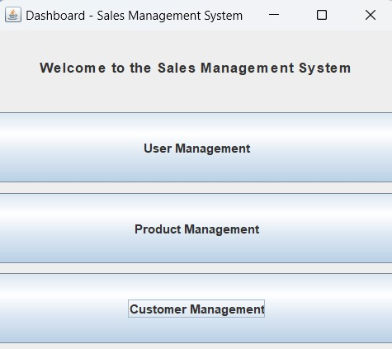
- CREATING CUSTOMERMANAGEMENT:
package com.sales.management;

import javax.swing.*;
import javax.swing.table.DefaultTableModel;
import java.awt.*;
import java.awt.event.*;
import java.sql.*;

public class CustomerManagement extends JFrame {
JTable customerTable;
DefaultTableModel model;
JTextField nameField, emailField, phoneField;

public CustomerManagement() {
setTitle("Customer Management");
setSize(700, 400);
setLocationRelativeTo(null);
setDefaultCloseOperation(DISPOSE_ON_CLOSE);
setLayout(new BorderLayout());

// Table
model = new DefaultTableModel(new String[]{"ID", "Name", "Email", "Phone"}, 0);
customerTable = new JTable(model);
loadCustomers();
add(new JScrollPane(customerTable), BorderLayout.CENTER);

// Form Panel
JPanel formPanel = new JPanel(new FlowLayout());
nameField = new JTextField(10);
emailField = new JTextField(10);
phoneField = new JTextField(10);
JButton addButton = new JButton("Add Customer");
JButton deleteButton = new JButton("Delete Selected");

formPanel.add(new JLabel("Name:"));
formPanel.add(nameField);
formPanel.add(new JLabel("Email:"));
formPanel.add(emailField);
formPanel.add(new JLabel("Phone:"));
formPanel.add(phoneField);
formPanel.add(addButton);
formPanel.add(deleteButton);

add(formPanel, BorderLayout.SOUTH);

// Action Listeners
addButton.addActionListener(e -> addCustomer());
deleteButton.addActionListener(e -> deleteCustomer());

setVisible(true);
}

private void loadCustomers() {
model.setRowCount(0);
try (Connection conn = DBConnection.getConnection()) {
String sql = "SELECT * FROM customers";
Statement stmt = conn.createStatement();
ResultSet rs = stmt.executeQuery(sql);

while (rs.next()) {
model.addRow(new Object[]{
rs.getInt("id"),
rs.getString("name"),
rs.getString("email"),
rs.getString("phone")
});
}
} catch (SQLException e) {
e.printStackTrace();
}
}

private void addCustomer() {
String name = nameField.getText();
String email = emailField.getText();
String phone = phoneField.getText();

if (name.isEmpty()) {
JOptionPane.showMessageDialog(this, "Name is required.");
return;
}

try (Connection conn = DBConnection.getConnection()) {
String sql = "INSERT INTO customers (name, email, phone) VALUES (?, ?, ?)";
PreparedStatement ps = conn.prepareStatement(sql);
ps.setString(1, name);
ps.setString(2, email);
ps.setString(3, phone);
ps.executeUpdate();

JOptionPane.showMessageDialog(this, "Customer added.");
nameField.setText("");
emailField.setText("");
phoneField.setText("");
loadCustomers();
} catch (SQLException e) {
e.printStackTrace();
}
}

private void deleteCustomer() {
int selectedRow = customerTable.getSelectedRow();
if (selectedRow == -1) {
JOptionPane.showMessageDialog(this, "No customer selected.");
return;
}

int id = (int) model.getValueAt(selectedRow, 0);
try (Connection conn = DBConnection.getConnection()) {
String sql = "DELETE FROM customers WHERE id = ?";
PreparedStatement ps = conn.prepareStatement(sql);
ps.setInt(1, id);
ps.executeUpdate();

JOptionPane.showMessageDialog(this, "Customer deleted.");
loadCustomers();
} catch (SQLException e) {
e.printStackTrace();
}}}
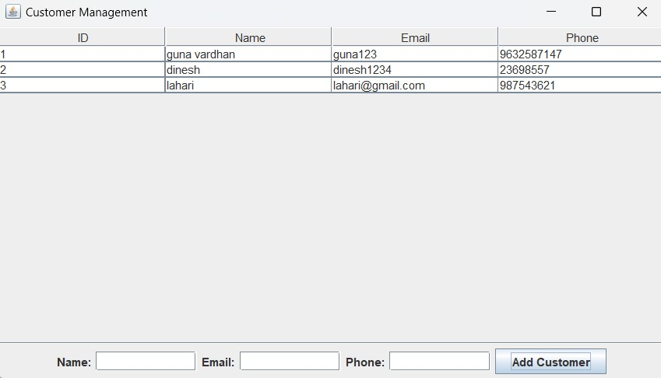
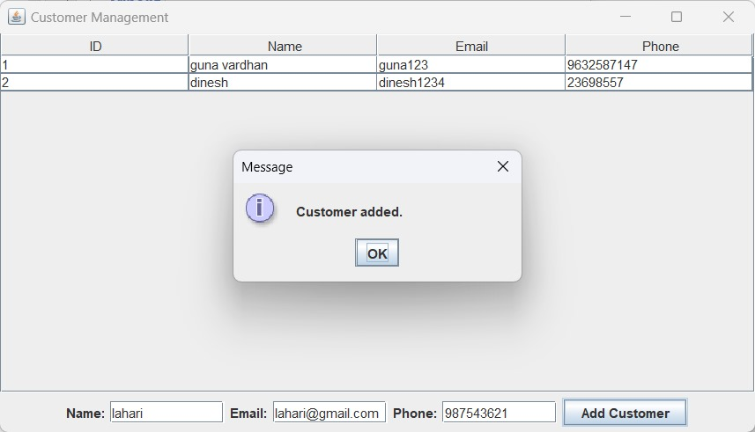

SALES ENTRY:
- UPDATED DASHBOARD:
package com.sales.management;

import javax.swing.*;
import java.awt.*;

public class Dashboard extends JFrame {
public Dashboard() {
setTitle("Dashboard - Sales Management System");
setSize(400, 400);
setLocationRelativeTo(null);
setDefaultCloseOperation(EXIT_ON_CLOSE);
setLayout(new GridLayout(5, 1, 10, 10)); // 5 rows to fit 4 buttons + label

JLabel welcomeLabel = new JLabel("Welcome to the Sales Management System", SwingConstants.CENTER);
welcomeLabel.setFont(new Font("Arial", Font.BOLD, 14));
add(welcomeLabel);

// User Management Button
JButton userMgmtBtn = new JButton("User Management");
userMgmtBtn.addActionListener(e -> new UserManagement());
add(userMgmtBtn);

// Product Management Button
JButton productMgmtBtn = new JButton("Product Management");
productMgmtBtn.addActionListener(e -> new ProductManagement());
add(productMgmtBtn);

// Customer Management Button
JButton customerMgmtBtn = new JButton("Customer Management");
customerMgmtBtn.addActionListener(e -> new CustomerManagement());
add(customerMgmtBtn);

// Sales Entry Button
JButton salesEntryBtn = new JButton("Sales Entry");
salesEntryBtn.addActionListener(e -> new SalesEntry());
add(salesEntryBtn);

setVisible(true);
}}
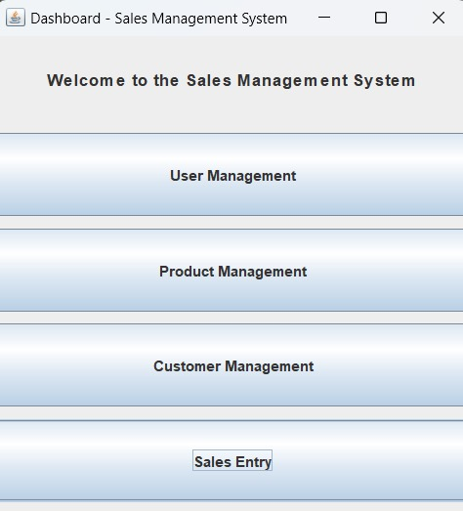
- CREATING SALES ENTRY:
package com.sales.management;

import javax.swing.*;
import java.awt.*;
import java.awt.event.*;
import java.sql.*;

public class SalesEntry extends JFrame {
private JComboBox<String> productDropdown;
private JTextField quantityField;

public SalesEntry() {
setTitle("Sales Entry");
setSize(400, 200);
setLocationRelativeTo(null);
setDefaultCloseOperation(DISPOSE_ON_CLOSE);
setLayout(new GridLayout(4, 2, 10, 10));

// UI Components
add(new JLabel("Product:"));
productDropdown = new JComboBox<>();
loadProducts(); // Load products into dropdown
add(productDropdown);

add(new JLabel("Quantity:"));
quantityField = new JTextField();
add(quantityField);

JButton submitBtn = new JButton("Submit Sale");
submitBtn.addActionListener(e -> submitSale());
add(submitBtn);

setVisible(true);
}

private void loadProducts() {
try (Connection conn = DBConnection.getConnection()) {
String sql = "SELECT name FROM products";
Statement stmt = conn.createStatement();
ResultSet rs = stmt.executeQuery(sql);

while (rs.next()) {
productDropdown.addItem(rs.getString("name"));
}
} catch (SQLException e) {
JOptionPane.showMessageDialog(this, "Failed to load products.");
e.printStackTrace();
}
}

private void submitSale() {
String product = (String) productDropdown.getSelectedItem();
String quantityStr = quantityField.getText();

if (product == null || quantityStr.isEmpty()) {
JOptionPane.showMessageDialog(this, "Please fill in all fields.");
return;
}

try {
int quantity = Integer.parseInt(quantityStr);
try (Connection conn = DBConnection.getConnection()) {
String sql = "INSERT INTO sales (product_name, quantity) VALUES (?, ?)";
PreparedStatement ps = conn.prepareStatement(sql);
ps.setString(1, product);
ps.setInt(2, quantity);
ps.executeUpdate();

JOptionPane.showMessageDialog(this, "Sale recorded!");
quantityField.setText("");
}
} catch (NumberFormatException e) {
JOptionPane.showMessageDialog(this, "Invalid quantity.");
} catch (SQLException e) {
JOptionPane.showMessageDialog(this, "Failed to record sale.");
e.printStackTrace();
}
}
}

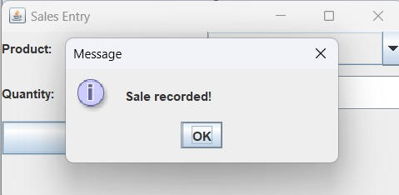
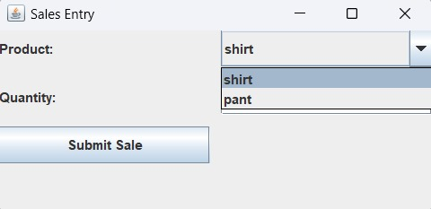

SALES REPORT:
- UPDATED DASHBOARD:
package com.sales.management;

import javax.swing.*;
import java.awt.*;

public class Dashboard extends JFrame {
public Dashboard() {
setTitle("Dashboard - Sales Management System");
setSize(400, 400);
setLocationRelativeTo(null);
setDefaultCloseOperation(EXIT_ON_CLOSE);
setLayout(new GridLayout(5, 1, 10, 10)); // 5 rows to fit 4 buttons + label

JLabel welcomeLabel = new JLabel("Welcome to the Sales Management System", SwingConstants.CENTER);
welcomeLabel.setFont(new Font("Arial", Font.BOLD, 14));
add(welcomeLabel);

// User Management Button
JButton userMgmtBtn = new JButton("User Management");
userMgmtBtn.addActionListener(e -> new UserManagement());
add(userMgmtBtn);

// Product Management Button
JButton productMgmtBtn = new JButton("Product Management");
productMgmtBtn.addActionListener(e -> new ProductManagement());
add(productMgmtBtn);

// Customer Management Button
JButton customerMgmtBtn = new JButton("Customer Management");
customerMgmtBtn.addActionListener(e -> new CustomerManagement());
add(customerMgmtBtn);

// Sales Entry Button
JButton salesEntryBtn = new JButton("Sales Entry");
salesEntryBtn.addActionListener(e -> new SalesEntry());
add(salesEntryBtn);
setVisible(true);
}}
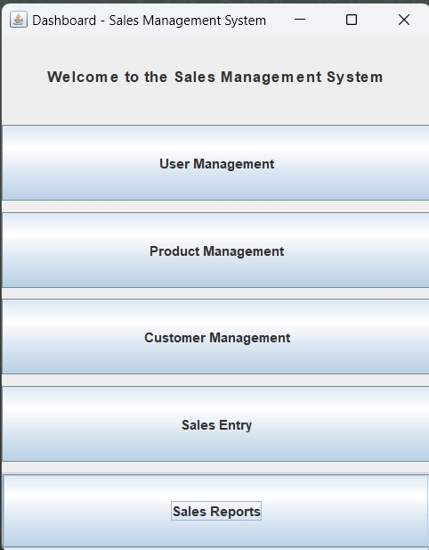
- CREATING SALES REPORT:
package com.sales.management;

import javax.swing.*;
import javax.swing.table.DefaultTableModel;
import java.awt.*;
import java.sql.*;

public class Reports extends JFrame {

JTable salesTable;
DefaultTableModel tableModel;

public Reports() {
setTitle("Sales Reports");
setSize(600, 400);
setLocationRelativeTo(null);
setDefaultCloseOperation(DISPOSE_ON_CLOSE);

String[] columnNames = {"ID", "Product Name", "Quantity", "Sale Date"};
tableModel = new DefaultTableModel(columnNames, 0);
salesTable = new JTable(tableModel);

JScrollPane scrollPane = new JScrollPane(salesTable);
add(scrollPane, BorderLayout.CENTER);

loadSalesData();

setVisible(true);
}
private void loadSalesData() {
try (Connection conn = DBConnection.getConnection()) {
String sql = "SELECT id, product_name, quantity, sale_date FROM sales";
PreparedStatement ps = conn.prepareStatement(sql);
ResultSet rs = ps.executeQuery();
while (rs.next()) {
int id = rs.getInt("id");
String productName = rs.getString("product_name");
int quantity = rs.getInt("quantity");
Timestamp saleDate = rs.getTimestamp("sale_date");

tableModel.addRow(new Object[]{id, productName, quantity, saleDate});
}
} catch (SQLException e) {
JOptionPane.showMessageDialog(this, "Failed to load report data.");
e.printStackTrace();
}}}
