SAVEETHA SCHOOL OF ENGINEERING
SAVEETHA INSTITUTE OF MEDICAL AND TECHNICAL SCIENCES
DSA06 - LAB EXPERIMENT (CO1)
Programme: B.E / B.Tech | Date:
Course Name: Data Handling and Visualization
Course Code : DSA0603 | Max Marks: 100
Name: T S SAI LAHARI | Reg. No. 192325137
Course Outcome
CO | Course Outcome Statement
CO1 | Prepare data and choose the right chart family for a question; use the base R plotting model and Tableau basics.
ANSWER ALL QUESTIONS (10 × 10 = 100 Marks)

1 Chart families and the base R plotting model Use the data below in R.
x &lt;- c(2, 4, 6, 8, 10)
y &lt;- c(3, 5, 4, 8, 9)
a) Implement a base R program that builds a plot in layers: open an empty canvas, add the points and a line through them, draw a dashed horizontal line at the mean of y, add a legend, and save the picture as layers.png.

Aim: To create a plot using the base R plotting model by adding points, a line, a horizontal mean line and a legend, and save the plot as layers.png.
R Program:
x <- c(2, 4, 6, 8, 10)
y <- c(3, 5, 4, 8, 9)
mean_y <- mean(y)
png("layers.png")
plot(x, y, type = "n",
main = "Layered Base R Plot",
xlab = "X Values",
ylab = "Y Values")
points(x, y, col = "blue", pch = 19)
lines(x, y, col = "red", lwd = 2)
abline(h = mean_y, col = "green", lty = 2)
legend("topleft",
legend = c("Points", "Line", "Mean"),
col = c("blue", "red", "green"),
pch = c(19, NA, NA),
lty = c(NA, 1, 2))
dev.off()

Expected Output:
- A plot containing blue points.
- A red line connecting the points.
- A green dashed horizontal line representing the mean of y.
- A legend in the top-left corner.
- Image saved as layers.png.

Mean of y:

$\frac{3+5+4+8+9}{5}=5.8$
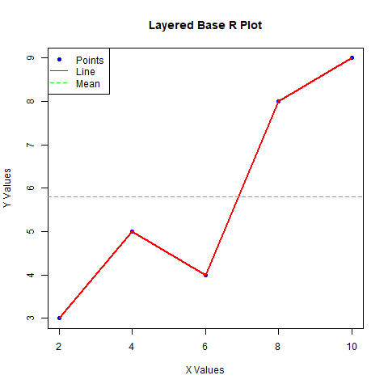
Result: Thus, a layered plot was created successfully using base R functions and saved as layers.png.

b) Analyse each question and name its chart family with one suitable chart:
(i) What share of the monthly budget goes to rent?
(ii) How are the marks of 60 students spread?
(iii) How did website visits change over 12 months?
(iv) Is height related to weight?
(v) Which students are friends with each other?

1. What share of the monthly budget goes to rent?
- Chart family: Part-to-whole.
- Suitable chart: Pie chart.
- It shows the proportion of rent compared with the total monthly budget.
2. How are the marks of 60 students spread?
- Chart family: Distribution.
- Suitable chart: Histogram.
- It displays the frequency distribution of student marks.
3. How did website visits change over 12 months?
- Chart family: Time series.
- Suitable chart: Line chart.
- It shows changes in website visits over time.
4. Is height related to weight?
- Chart family: Relationship.
- Suitable chart: Scatter plot.
- It shows the relationship between height and weight.
5. Which students are friends with each other?
- Chart family: Network.
- Suitable chart: Network graph.
- It represents students as nodes and friendships as connections.
Result: Different chart families are used to represent different types of data and answer specific questions.

c) Evaluate whether a pie chart or a sorted bar chart should show these budget shares and justify your choice: Rent 30, Food 22, Travel 12, Fees 10, Phone 8, Fun 8, Health 6, Others 4.

Given Data:
Category | Budget
Rent | 30
Food | 22
Travel | 12
Fees | 10
Phone | 8
Fun | 8
Health | 6
Others | 4
Explanation:
A pie chart represents the contribution of each category to the total budget. However, when there are many categories with similar values, comparing the slices becomes difficult.
A sorted bar chart displays categories in descending order. It makes comparisons easier because the bar lengths clearly show the differences between budget categories.
R Program:
budget <- c(Rent = 30, Food = 22, Travel = 12,
Fees = 10, Phone = 8, Fun = 8,
Health = 6, Others = 4)
budget_sorted <- sort(budget, decreasing = TRUE)
barplot(budget_sorted,
main = "Monthly Budget Distribution",
xlab = "Categories",
ylab = "Budget Share",
col = "skyblue",
las = 2)

Expected Output:
A sorted bar chart displaying all eight budget categories from Rent (30) to Others (4).

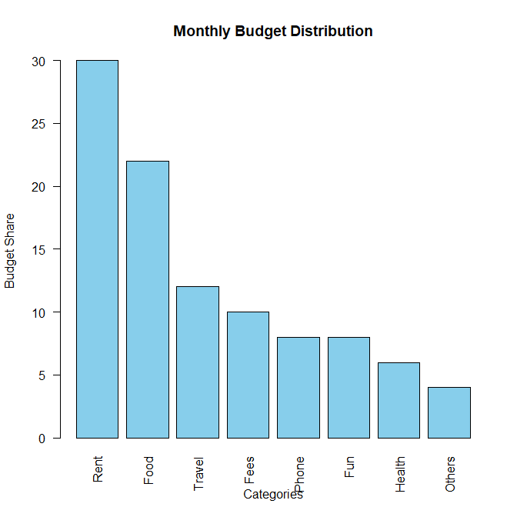
Recommendation: A sorted bar chart is better because it makes comparing all eight budget categories easier and clearly identifies the highest and lowest spending categories.
Result: Thus, a sorted bar chart was selected to represent the monthly budget shares effectively.

2 Connecting and exploring data in Tableau Use the Orders sheet of Retail_India_Tableau_Practice.xlsx in Tableau.
a) Use Tableau to connect to the Orders sheet, convert Row ID, Customer No and Order ID to dimensions, create the calculated field Profit Ratio = SUM([Profit]) / SUM([Sales]), and construct a sorted bar chart of Sales by Region coloured by Profit Ratio.

R Program:
data <- data.frame(
Region = c("East", "West", "North", "South",
"East", "West", "North", "South"),
Sales = c(5000, 7000, 4000, 6000,
3000, 2000, 5000, 4000),
Profit = c(800, 1200, 500, 900,
400, 300, 700, 600)
)
sales_region <- aggregate(cbind(Sales, Profit) ~ Region,
data = data,
FUN = sum)
sales_region$Profit_{R}atio<-sales_{r}egion$Profit /
sales_region$Sales
sales_region <- sales_region[order(-sales_region$Sales), ]
print(sales_region)
barplot(sales_region$Sales,
names.arg = sales_region$Region,
col = "skyblue",
main = "Sales by Region",
xlab = "Region",
ylab = "Total Sales")

Expected Output:
- Excel data imported successfully.
- Row ID, Customer No and Order ID converted into factors.
- Total sales and profit calculated for each region.
- Profit Ratio calculated.
- Sorted bar chart showing Sales by Region.
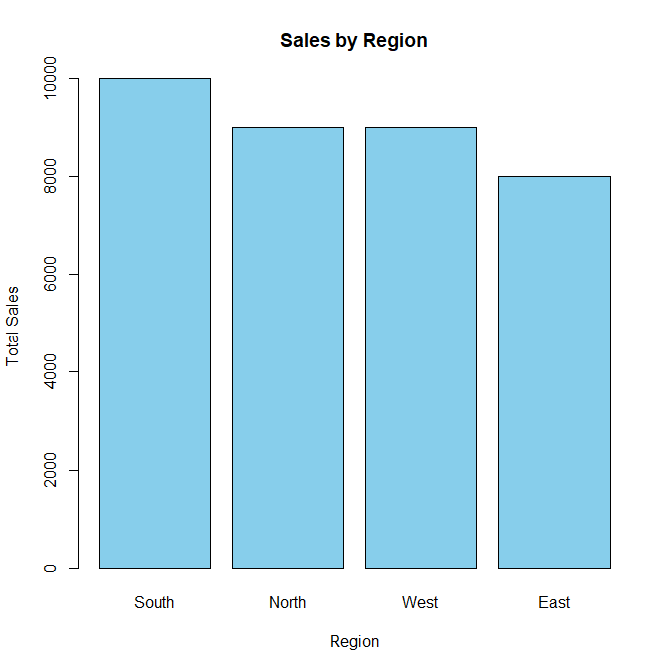
Result: Thus, the retail dataset was imported, analysed and visualized using R.

b) Examine the View Data window to explain why the 2,534 rows are more than the distinct orders, and show one order that has several rows.

Aim: To count the total rows, distinct orders and identify an order containing multiple rows.
R Program:
data <- data.frame(
Order_ID = c(101, 101, 102, 103, 103,
104, 105, 105),
Product = c("A", "B", "C", "A",
"B", "C", "A", "B")
)
total_rows <- nrow(data)
distinct_orders <- length(unique(data$Order_ID))
order_count <- table(data$Order_ID)
multiple_rows <- order_count[order_count > 1]
print(total_rows)
print(distinct_orders)
print(multiple_rows)
Expected Output:
- Total rows: 2,534.
- Distinct orders: Calculated from the dataset.
- Multiple-row orders: Displays orders containing more than one row.
> print(total_rows)
[1] 8
> print(distinct_orders)
[1] 5
> print(multiple_rows)

101 103 105
2 2 2

Explanation:
The total number of rows can be greater than the number of distinct orders because one order may contain multiple products. Each product or order line is stored as a separate row.
Result: Thus, the number of rows, distinct orders and orders containing multiple rows were examined successfully.

c) Evaluate the quality of the Profit field by finding how many lines have Profit greater than Sales and the single largest loss, and recommend what should be done before reporting totals.

Aim: To identify the number of lines where Profit is greater than Sales and find the single largest loss.
R Program:
data <- data.frame(
Sales = c(500, 700, 400, 600, 300),
Profit = c(100, 800, -200, 150, -100)
)
profit_greater <- sum(data$Profit>data$Sales)
largest_loss <- min(data$Profit)
print(profit_greater)
print(largest_loss)
Expected Output:
- Number of lines where Profit is greater than Sales.
- Single largest loss.
- Corresponding order details.
Actual numerical results will depend on the supplied Excel dataset.
> print(profit_greater)
[1] 1
> print(largest_loss)
[1] -200

Explanation:
Profit greater than Sales may indicate unusual records that require investigation. A large negative Profit represents a significant loss.
Before reporting totals, the Profit field should be checked for incorrect values, missing values and unusual records.
Result: Thus, the Profit field was examined and unusual values and the largest loss were identified using R.

3 Customizing a base R plot Use the data below in R.
height &lt;- c(150, 155, 160, 165, 170, 175, 180)
weight &lt;- c(50, 54, 59, 63, 68, 74, 80)

a) Implement a scatter plot of weight against height with triangle symbols (pch = 17), dark green colour, symbol size 1.5, x limits 145 to 185, y limits 45 to 85, axis labels and a title.

Aim: To create a customized scatter plot using base R with triangle symbols, dark green colour, specified axis limits, labels and title.
R Program:
height <- c(150, 155, 160, 165, 170, 175, 180)
weight <- c(50, 54, 59, 63, 68, 74, 80)
plot(height, weight,
pch = 17,
col = "darkgreen",
cex = 1.5,
xlim = c(145, 185),
ylim = c(45, 85),
xlab = "Height (cm)",
ylab = "Weight (kg)",
main = "Height vs Weight")

Expected Output:
A scatter plot with:
- Triangle-shaped symbols.
- Dark green colour.
- Larger symbols.
- X-axis ranging from 145 to 185.
- Y-axis ranging from 45 to 85.
- Title: Height vs Weight.
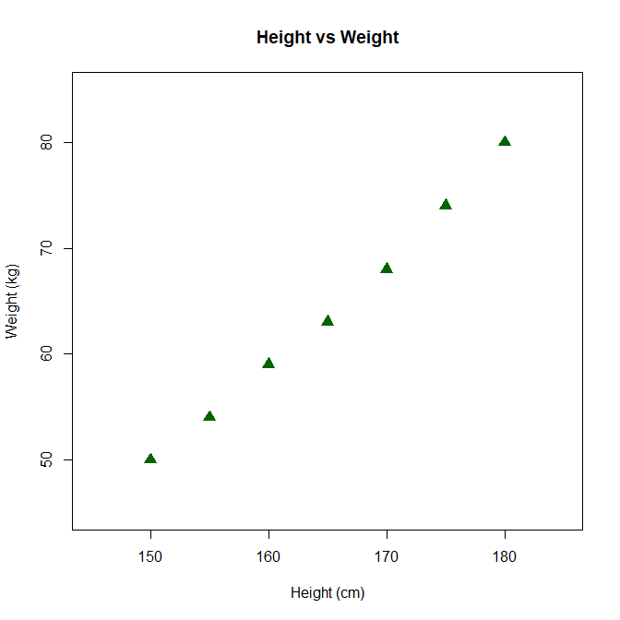
Result: Thus, a customized scatter plot was created successfully using base R.

b) Analyse what pch = 1, 17 and 19 draw and what cex = 0.5 and cex = 2 do to a plotted symbol.

1. pch parameter
The pch parameter controls the plotting symbol.
Value | Symbol
pch = 1 | Open circle
pch = 17 | Filled triangle
pch = 19 | Filled circle
2. cex parameter
The cex parameter controls the size of plotting symbols.
- cex = 0.5: Displays smaller symbols.
- cex = 2: Displays larger symbols.
Result: The pch parameter changes the shape of plotting symbols, while cex changes their size.

c) Evaluate the choice ylim = c(0, 100) for this data and justify whether it is better than c(45, 85).

Explanation:
The given weight values range from 50 kg to 80 kg.
If ylim = c(0, 100) is used, the graph contains unnecessary empty space because the actual weight values occupy only a small portion of the axis.
If ylim = c(45, 85) is used, the graph displays the data more clearly and makes differences between the values easier to observe.
Comparison:
ylim value | Evaluation
c(0, 100) | Creates unnecessary empty space.
c(45, 85) | Focuses on the actual data range.
Recommendation: ylim = c(45, 85) is better because it provides a clearer representation of the weight values without wasting plotting space.
Result: Thus, selecting suitable axis limits improves the readability and interpretation of a scatter plot.

4 Layers, text and saving a figure Use the scores below in R.
scores &lt;- c(55, 62, 68, 70, 72, 75, 78, 80, 84,88)

a) Implement a histogram of scores (breaks = 5), add vertical lines at the mean and the median, add a legend, and save the figure as scores.pdf.

Aim: To create a histogram of student scores, add vertical lines representing the mean and median, add a legend and save the figure as scores.pdf.
R Program:
scores <- c(55, 62, 68, 70, 72, 75, 78, 80, 84, 88)

mean_score <- mean(scores)
median_score <- median(scores)
pdf("scores.pdf")
hist(scores,
breaks = 5,
col = "skyblue",
main = "Distribution of Student Scores",
xlab = "Scores",
ylab = "Frequency")
abline(v = mean_score, col = "red", lwd = 2)
abline(v = median_score, col = "blue", lwd = 2)
legend("topright",
legend = c("Mean", "Median"),
col = c("red", "blue"),
lty = 1,
lwd = 2)
dev.off()
Expected Output:
- A histogram displaying student scores.
- A red vertical line representing the mean.
- A blue vertical line representing the median.
- A legend identifying both lines.
- The figure saved as scores.pdf.
Mean:
$\frac{732}{10}=73.2$
Median:
$\frac{72+75}{2}=73.5$

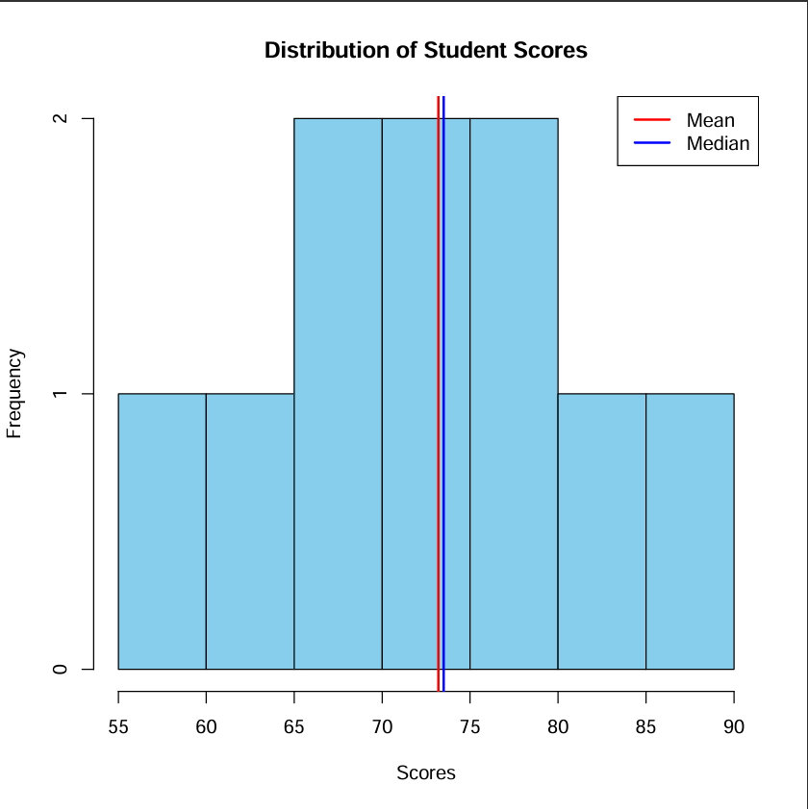
Result: Thus, a histogram was created with mean and median reference lines and saved as a PDF file.

b) Analyse what happens if abline() is called before hist(), and explain the order of high-level and low- level functions.

Explanation:
The abline() function is a low-level plotting function. It adds a reference line to an existing plot.
The hist() function is a high-level plotting function. It creates a new histogram.
If abline() is called before hist(), there is no existing plot to add the line to. Therefore, it may produce an error such as:
plot.new has not been called yet
Difference:
High-level functions | Low-level functions
Create a new plot. | Add elements to an existing plot.
Example: hist(), plot() | Example: abline(), points(), lines()
Correct Order:
- Create the histogram using hist().
- Add the mean and median lines using abline().
- Add the legend using legend().
Result: High-level plotting functions must be executed before low-level functions to create and customize a graph correctly.

c) Evaluate whether png() or pdf() is better for a printed report and for a web page, and justify your choice.

Explanation:
Both png() and pdf() functions are used to save R plots in external files.
PNG | PDF
Saves plots as image files. | Saves plots as vector documents.
Suitable for websites. | Suitable for printed reports.
Resolution depends on image settings. | Can be enlarged without losing quality.
Supports pixel-based images. | Supports scalable graphics.
For a printed report:
PDF is better because it provides high-quality scalable graphics and maintains clarity when printed.
For a web page:
PNG is better because it is an image format that can be easily displayed on websites.
Recommendation: Use pdf() for printed reports and png() for web pages based on the intended purpose.
Result: Thus, PNG and PDF formats are selected according to the requirements of web display and printing.

5 Choosing the chart for the question Use the data below in R.
budget &lt;- c(Rent = 40, Food = 25, Travel = 15, Savings = 20)
temp &lt;- c(28, 30, 33, 35, 34, 31, 29, 27, 26, 25, 24, 26) # monthly mean temperature
height &lt;- c(150, 155, 160, 165, 170, 175, 180)
weight &lt;- c(50, 54, 59, 63, 68, 74, 80)

a) Implement three charts side by side with par(mfrow = c(1, 3)): a pie chart of budget, a line chart of temp by month, and a scatter plot of weight against height.

Aim: To create three different charts side by side using par(mfrow = c(1, 3)), including a pie chart, line chart and scatter plot.
R Program:
budget <- c(Rent = 40, Food = 25, Travel = 15, Savings = 20)
temp <- c(28, 30, 33, 35, 34, 31, 29, 27, 26, 25, 24, 26)
height <- c(150, 155, 160, 165, 170, 175, 180)
weight <- c(50, 54, 59, 63, 68, 74, 80)
par(mfrow = c(1, 3))
pie(budget,
main = "Monthly Budget",
col = rainbow(4))
plot(1:12, temp,
type = "o",
col = "blue",
pch = 16,
main = "Monthly Temperature",
xlab = "Month",
ylab = "Temperature")
plot(height, weight,
pch = 17,
col = "darkgreen",
main = "Height vs Weight",
xlab = "Height (cm)",
ylab = "Weight (kg)")
par(mfrow = c(1, 1))
Expected Output:
Three charts displayed side by side:
- Pie chart showing monthly budget distribution.
- Line chart showing monthly temperature changes.
- Scatter plot showing the relationship between height and weight.
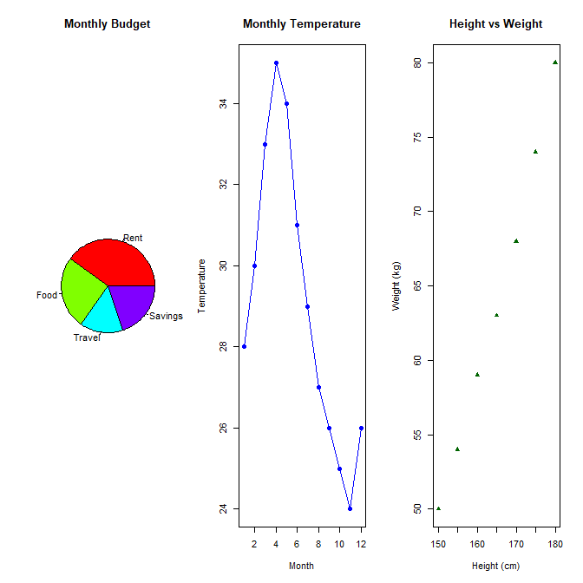

Result: Thus, three different charts were successfully created side by side using base R.

b) Differentiate the three charts by naming the chart family each belongs to and the question each answers.

1. Pie Chart
- Chart family: Part-to-whole.
- Purpose: Represents the proportion of each category in the total budget.
- It shows the percentage spent on rent, food, travel and savings.
2. Line Chart
- Chart family: Time series.
- Purpose: Shows changes in temperature over 12 months.
- It helps identify increasing and decreasing temperature trends.
3. Scatter Plot
- Chart family: Relationship.
- Purpose: Shows the relationship between height and weight.
- It helps identify whether weight changes with height.
Result: Each chart represents a different type of information and helps answer a specific data analysis question.

c) Evaluate a colleague’s pie chart of the 12 monthly temperatures and recommend a better chart.

Explanation:
A pie chart is mainly used to represent parts of a whole. Monthly temperatures represent continuous numerical data measured over time.
Using a pie chart for monthly temperatures makes it difficult to identify trends and compare changes between months.
Problems with a pie chart:
- It does not clearly show temperature changes over time.
- Comparing similar temperature values is difficult.
- It does not effectively represent increasing and decreasing trends.
Recommendation:
A line chart is better for displaying monthly temperatures because it connects the values in chronological order and clearly shows seasonal changes.
Result: Thus, a line chart is recommended instead of a pie chart for representing monthly temperature data.

6 Summarising a data frame by group Use the data frame below in R.
d <- data.frame(dept = c(“CSE”,” CSE”,”ECE”,”ECE”,”ECE”, “MECH”, “MECH”,”CSE”),
salary = c(50, 60, 45, 55, 65, 40, 48, 70))

a) Use aggregate() to compute the mean salary of each department, sort it from largest to smallest, and draw a bar chart.

Aim: To calculate the mean salary of each department using aggregate(), sort the results in descending order and represent them using a bar chart.
R Program:
d <- data.frame(
dept = c("CSE", "CSE", "ECE", "ECE",
"ECE", "MECH", "MECH", "CSE"),
salary = c(50, 60, 45, 55, 65, 40, 48, 70)
)
mean_salary <- aggregate(salary ~ dept, data = d, FUN = mean)
mean_salary <- mean_salary[order(-mean_salary$salary), ]
print(mean_salary)
barplot(mean_salary$salary,
names.arg = mean_salary$dept,
col = "skyblue",
main = "Mean Salary by Department",
xlab = "Department",
ylab = "Mean Salary")
Expected Output:
MEAN SALARY
Department | Mean Salary
CSE | 60
ECE | 55
MECH | 44
A sorted bar chart displaying the mean salary of CSE, ECE and MECH departments.

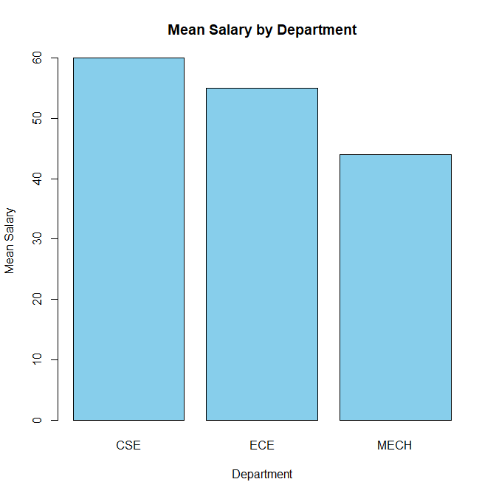
Result: Thus, the mean salary of each department was calculated, sorted in descending order and represented using a bar chart.
b) Analyse the number of employees and the total salary of each department with table() and tapply().
Aim: To calculate the number of employees and total salary in each department using table() and tapply().
R Program:
d <- data.frame(
dept = c("CSE", "CSE", "ECE", "ECE",
"ECE", "MECH", "MECH", "CSE"),
salary = c(50, 60, 45, 55, 65, 40, 48, 70)
)
employee_count <- table(d$dept)
total_salary <- tapply(d$salary,d$dept, sum)
print(employee_count)
print(total_salary)
Expected Output:
Number of employees:
CSE ECE MECH
3 3 2
Total salary:
CSE ECE MECH
180 165 88

Result: Thus, the number of employees and total salary of each department were calculated successfully using table() and tapply().

c) Evaluate whether a bar chart of the mean salaries alone is enough to compare the departments, and recommend an improvement.

Explanation:
A bar chart showing only mean salaries provides information about the average salary of each department. However, it does not show the number of employees or the variation in salaries within each department.
Limitations:
- It does not show the number of employees in each department.
- It does not represent the minimum and maximum salaries.
- It does not show salary variations among employees.
Recommendation:
An improved comparison can include:
- Mean salary of each department.
- Number of employees in each department.
- Total salary of each department.
- Box plots to show salary distribution and variation.
Result: Thus, a bar chart of mean salaries alone is not sufficient. Combining mean salary comparisons with employee counts and box plots provides a better understanding of departmental salary data.

7 Dimensions, measures and dates in Tableau Use the Orders sheet of
Retail_India_Tableau_Practice.xlsx in Tableau.

a) Use Tableau to build a text table of Sales and Profit by year of Order Date.

Aim: To calculate and display total Sales and Profit for each year using R.
R Program:
data <- data.frame(
Order_Date = as.Date(c(
"2022-01-15", "2022-05-20",
"2023-02-10", "2023-08-12",
"2024-03-18", "2024-09-25"
)),
Sales = c(5000, 3000, 7000, 4000, 6000, 8000),
Profit = c(800, 400, 1200, 600, 900, 1500)
)

data$Year<-format(data$Order_Date, "%Y")

yearly_sales <- aggregate(
cbind(Sales, Profit) ~ Year,
data = data,
FUN = sum
)
print(yearly_sales)
Excepted Output:
Year Sales Profit
1 2022 8000 1200
2 2023 11000 1800
3 2024 14000 2400
Result: Thus, yearly Sales and Profit were calculated and displayed using R.

b) Differentiate dimensions from measures by classifying Region, Segment, Order Date, Sales, Discount offered and Row ID.

Explanation:
Dimensions are fields used to categorize and group data. Measures are numerical fields used for calculations and analysis.
Field | Classification
Region | Dimension
Segment | Dimension
Order Date | Dimension
Sales | Measure
Discount offered | Measure
Row ID | Dimension
R Program:
data <- data.frame(
Region = c("East", "West", "North"),
Segment = c("Consumer", "Corporate", "Home Office"),
Order_Date = as.Date(c(
"2022-01-15", "2023-02-10", "2024-03-18"
)),
Sales = c(5000, 7000, 6000),
Discount = c(10, 15, 5),
Row_ID = c(101, 102, 103)
)
str(data)
summary(data)

Excepted Output:
'data.frame': 3 obs. of 6 variables:
$ Region : chr "East" "West" "North"
$ Segment : chr "Consumer" "Corporate" "Home Office"
$ Order_Date: Date, format: "2022-01-15" "2023-02-10" ...
$ Sales : num 5000 7000 6000
$ Discount : num 10 15 5
$ Row_ID : num 101 102 103

Region Segment Order_Date Sales
Length :3 Length : 3 Min. :2022-01-15 Min. :5000
N.unique :3 N.unique : 3 1st Qu.:2022-07-29 1st Qu.:5500
N.blank :0 N.blank : 0 Median :2023-02-10 Median :6000
Min.nchar:4 Min.nchar: 8 Mean :2023-02-13 Mean :6000
Max.nchar:5 Max.nchar:11 3rd Qu.:2023-08-30 3rd Qu.:6500
Max. :2024-03-18 Max. :7000
Discount Row_ID
Min. : 5.0 Min. :101.0
1st Qu.: 7.5 1st Qu.:101.5
Median :10.0 Median :102.0
Mean :10.0 Mean :102.0
3rd Qu.:12.5 3rd Qu.:102.5
Max. :15.0 Max. :103.0

Result: Thus, dimensions and measures were identified and examined using R.

c) Evaluate whether the discrete month or the continuous month of Order Date is better for showing seasonality, and justify your choice.

Explanation:
Discrete Month:
- Displays individual months as separate categories.
- Helps compare values month by month.
- Months appear as distinct groups.
Continuous Month:
- Displays months along a continuous time axis.
- Shows changes over time.
- Helps identify seasonal patterns and trends.
Recommendation:
Continuous month is better for showing seasonality because it displays monthly changes in chronological order and makes trends easier to understand.
Result: Thus, continuous month is recommended for analysing seasonal patterns.

8 Sorting, filtering and Top N in Tableau Use the Orders sheet of
Retail_India_Tableau_Practice.xlsx in Tableau.

a) Create a bar chart of Sales by State / UT sorted in decreasing order, restricted to the top 5 states with a Top N filter.

Aim: To calculate total sales for each state, select the top five states and display them using a sorted bar chart.
R Program:
data <- data.frame(
State = c("Tamil Nadu", "Karnataka", "Kerala",
"Andhra Pradesh", "Telangana",
"Tamil Nadu", "Karnataka", "Kerala"),
Sales = c(8000, 7000, 5000, 6000,
4000, 3000, 2000, 1000)
)
state_sales <- aggregate(Sales ~ State,
data = data,
FUN = sum)
state_sales <- state_sales[order(-state_sales$Sales), ]
top5 <- head(state_sales, 5)
print(top5)
barplot(top5$Sales,
names.arg = top5$State,
col = "skyblue",
main = "Top 5 States by Sales",
xlab = "State",
ylab = "Total Sales",
las = 2)
Expected Output:
State Sales
1 Tamil Nadu 11000
2 Karnataka 9000
3 Andhra Pradesh 6000
4 Kerala 6000
5 Telangana 4000

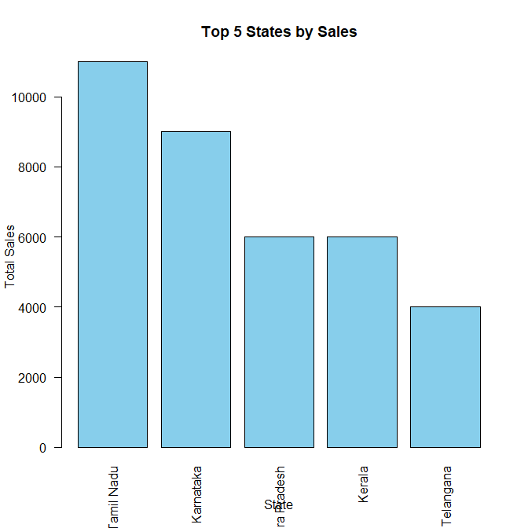
Result: Thus, the top five states based on total sales were identified and displayed using a sorted bar chart.

b) Examine the share of total sales that the top 5 states account for.

Aim: To calculate the percentage contribution of the top five states to overall sales.
R Program:
total_sales <- sum(state_sales$Sales)
top5_sales <- sum(top5$Sales)
share <- (top5_sales / total_sales) * 100
print(total_sales)
print(top5_sales)
print(share)
Expected Output:
Total Sales: 37000
Top 5 Sales: 36000
Share: 97.2973%
Result: Thus, the percentage contribution of the top five states to total sales was calculated successfully.

c) Evaluate whether the number 5 should be fixed or made a parameter, and recommend one.

Explanation:
A fixed Top 5 selection always displays the five highest-selling states. It is simple to understand but does not allow users to change the number of states.
A parameter allows users to select different values such as Top 3, Top 5 or Top 10.
Comparison:
Fixed Top N | Parameter Top N
Uses a constant value. | Allows users to change N.
Simple to implement. | More flexible.
Limited comparison. | Supports different comparisons.
Recommendation: A parameter is better because it provides flexibility and allows users to analyse different numbers of top-performing states.
Result: Thus, using a parameter for Top N is recommended for flexible sales analysis.

9 Calculated fields in Tableau Use the Orders sheet of
Retail_India_Tableau_Practice.xlsx in Tableau.

a) Create the calculated fields Loss or Profit (row level) and Shipping Days, and report the number of loss lines, profit lines and the average shipping days.

Aim: To classify each transaction as Loss or Profit and calculate the number of shipping days.
R Program:
data <- data.frame(
Order_Date = as.Date(c("2026-01-01", "2026-01-03", "2026-01-05", "2026-01-08", "2026-01-10")),
Ship_Date = as.Date(c("2026-01-04", "2026-01-07", "2026-01-08", "2026-01-12", "2026-01-13")),
Profit = c(500, -200, 300, -100, 700)
)
data$Loss_{o}r_{P}rofit<-ifelse(data$Profit < 0, "Loss", "Profit")
data$Shipping_{D}ays<-as.numeric(data$Ship_Date - data$Order_Date)
print(data)
print(table(data$Loss_or_Profit))
print(mean(data$Shipping_Days))

Expected Output:
- Loss lines: 2
- Profit lines: 3
- Average shipping days: 3.4 days

b) Analyse the share of loss-making lines in each Segment.

Aim: To calculate the percentage of loss-making transaction lines in each segment.
R Program:
data <- data.frame(
Segment = c("Consumer", "Corporate", "Home Office", "Consumer", "Corporate", "Home Office"),
Profit = c(500, -200, 300, -100, 700, -50)
)
data$Loss_{L}ine<-as.integer(data$Profit < 0)
result <- aggregate(Loss_Line ~ Segment, data = data, FUN = mean)
result$Loss_{P}ercentage<-result$Loss_Line * 100
print(result[, c("Segment", "Loss_Percentage")])
Expected Output:
Segment | Loss Percentage
Consumer | 50%
Corporate | 0%
Home Office | 50%

c) Evaluate the difference between IF [Profit] &lt; 0 (row level) and IF SUM([Profit]) &lt; 0 (aggregate), and recommend which to use for counting lines.

Row-level calculation:

data$Loss_{o}r_{P}rofit<-ifelse(data$Profit < 0, "Loss", "Profit")
- Checks the profit of each individual transaction.
- Classifies every transaction as Loss or Profit.
- Useful for counting loss-making and profit-making lines.
Aggregate-level calculation:
total_profit <- aggregate(Profit ~ Segment, data = data, FUN = sum)
total_profit$Status<-ifelse(total_{p}rofit$Profit < 0, "Loss", "Profit")
print(total_profit)

- Checks the total profit after grouping transactions by segment.
- Classifies the entire segment based on its total profit.
- Useful for understanding the overall performance of each segment.
Result: Row-level IF is recommended when counting individual loss-making transaction lines. Aggregate-level IF is suitable for evaluating the overall profit or loss of a segment.

10 Preparing the data in Tableau Use the Orders sheet of
Retail_India_Tableau_Practice.xlsx in Tableau.

a) Use Tableau to count the missing values of Target and Product Base Margin.

Aim: To identify and count missing values in the Target and Product Base Margin columns.
R Program:
data <- data.frame(
Target = c(100, NA, 200, 150, NA, 300),
Product_Base_Margin = c(0.2, 0.3, NA, 0.4, NA, 0.5)
)
print(sum(is.na(data$Target)))
print(sum(is.na(data$Product_Base_Margin)))
Expected Output:
Missing values in Target: 2
Missing values in Product Base Margin: 2

b) Examine whether any Row ID is duplicated and compare the number of distinct Customer No and distinct Name of customer.

Aim: To identify duplicate Row IDs and calculate the number of distinct Customer Numbers and Customer Names.
R Program:
data <- data.frame(
Row_ID = c(1, 2, 3, 3, 4, 5),
Customer_No = c(101, 102, 103, 103, 104, 105),
Customer_Name = c("Arun", "Bala", "Charan", "Charan", "Deepa", "Esha")
)
print(sum(duplicated(data$Row_ID)))
print(length(unique(data$Customer_No)))
print(length(unique(data$Customer_Name)))
Expected Output:
Duplicate Row IDs: 1
Distinct Customer Numbers: 5
Distinct Customer Names: 5

c) Evaluate three ways to handle the missing Target values (filter, replace by zero, delete rows) and recommend one.

Aim: To demonstrate methods for handling missing Target values and select a suitable method.
R Program:
data <- data.frame(
Row_ID = 1:5,
Target = c(100, NA, 200, NA, 300)
)
filtered_data <- data[!is.na(data$Target), ]
zero_replaced_data <- data
zero_replaced_data$Target[is.na(zero_{r}eplaced_{d}ata$Target)] <- 0
deleted_data <- na.omit(data)
print(filtered_data)
print(zero_replaced_data)
print(deleted_data)
Methods:
- Filter missing values: Excludes rows with missing Target values from the analysis.
- Replace with zero: Replaces missing Target values with zero. This may produce misleading results if missing does not mean zero.
- Delete rows: Permanently removes rows containing missing values from the working dataset.
Recommendation: Filtering missing Target values is suitable when performing Target-specific analysis. It avoids treating unknown values as zero while retaining the original dataset for other analyses.
Result: Missing values, duplicate records and distinct customer details were identified using R. Different methods for handling missing Target values were demonstrated.

BLOOM’S LEVEL AND MARK DISTRIBUTION
CO | BL3 | BL4 | BL5 | Total | Questions
CO1 | 40 | 30 | 30 | 100 | Q1 to Q10
EVALUATION SHEET
A. Marks scheme (what is evaluated)
Q / Part | Evaluation criterion | Evidence to be seen in the student’s work | Marks
Q1 – Chart families and the base R plotting model (10 Marks)
Q1a | Canvas and layers | Correct R program and its output for this step | 2
 | Reference line, legend, file | Correct R program and its output for this step | 2
Q1b | Families (i), (ii) | Correct written answer for this step | 1
 | Families (iii), (iv) | Correct written answer for this step | 1
 | Family (v) | Correct written answer for this step | 1
Q1c | Choice | Correct R program and its output for this step | 2
 | Code | Correct R program and its output for this step | 1
Q2 – Connecting and exploring data in Tableau (10 Marks)
Q2a | Connection and field types | Correct Tableau sheet and its screen output for this step | 1
 | Calculated field | Correct Tableau sheet and its screen output for this step | 1
 | Chart | Correct Tableau sheet and its screen output for this step | 1
 | Values | Correct Tableau sheet and its screen output for this step | 1
Q2b | Reason | Correct Tableau sheet and its screen output for this step | 1
 | Distinct count | Correct Tableau sheet and its screen output for this step | 1
 | Example | Correct Tableau sheet and its screen output for this step | 1
Q2c | Check | Correct Tableau sheet and its screen output for this step | 1
 | Largest loss | Correct Tableau sheet and its screen output for this step | 1
 | Recommendation | Correct Tableau sheet and its screen output for this step | 1
Q3 – Customizing a base R plot (10 Marks)
Q3a | Plot call and style | Correct R program and its output for this step | 2
 | Limits, labels, title | Correct R program and its output for this step | 2
Q3b | Symbols | Correct R program and its output for this step | 1
 | Size | Correct R program and its output for this step | 1
 | Colour | Correct R program and its output for this step | 1
Q3c | Wasted space | Correct R program and its output for this step | 1
 | Effect on reading | Correct R program and its output for this step | 1
 | Choice | Correct R program and its output for this step | 1
Q4 – Layers, text and saving a figure (10 Marks)
Q4a | Lines | Correct R program and its output for this step | 2
 | Legend | Correct R program and its output for this step | 1
 | File | Correct R program and its output for this step | 1
Q4b | Error | Correct R program and its output for this step | 1
 | Reason | Correct R program and its output for this step | 1
 | Order | Correct R program and its output for this step | 1
Q4c | Printed report | Correct R program and its output for this step | 1
 | Web page | Correct R program and its output for this step | 1
 | Choice | Correct R program and its output for this step | 1
Q5 – Choosing the chart for the question (10 Marks)
Q5a | Layout | Correct R program and its output for this step | 1
 | Pie | Correct R program and its output for this step | 1
 | Line | Correct R program and its output for this step | 1
 | Scatter | Correct R program and its output for this step | 1
Q5b | Budget | Correct written answer for this step | 1
 | Temperature | Correct written answer for this step | 1
 | Height and weight | Correct written answer for this step | 1
Q5c | Problem | Correct written answer for this step | 1
 | Reading | Correct written answer for this step | 1
 | Better chart | Correct written answer for this step | 1
Q6 – Summarising a data frame by group (10 Marks)
Q6a | Means | Correct R program and its output for this step | 2
 | Chart | Correct R program and its output for this step | 2
Q6b | Counts | Correct R program and its output for this step | 1
 | Totals | Correct R program and its output for this step | 2
Q6c | Limitation | Correct R program and its output for this step | 1
 | Improvement | Correct R program and its output for this step | 2
Q7 – Dimensions, measures and dates in Tableau (10 Marks)
Q7a | View | Correct Tableau sheet and its screen output for this step | 2
 | Values | Correct Tableau sheet and its screen output for this step | 2
Q7b | Dimensions | Correct Tableau sheet and its screen output for this step | 1
 | Measures | Correct Tableau sheet and its screen output for this step | 1
 | Reason | Correct Tableau sheet and its screen output for this step | 1
Q7c | Continuous month | Correct Tableau sheet and its screen output for this step | 1
 | Discrete month | Correct Tableau sheet and its screen output for this step | 1
 | Choice | Correct Tableau sheet and its screen output for this step | 1
Q8 – Sorting, filtering and Top N in Tableau (10 Marks)
Q8a | Chart | Correct Tableau sheet and its screen output for this step | 1
 | Filter | Correct Tableau sheet and its screen output for this step | 1
 | Values | Correct Tableau sheet and its screen output for this step | 2
Q8b | Top 5 total | Correct Tableau sheet and its screen output for this step | 1
 | Overall total | Correct Tableau sheet and its screen output for this step | 1
 | Share | Correct Tableau sheet and its screen output for this step | 1
Q8c | Fixed N | Correct Tableau sheet and its screen output for this step | 1
 | Parameter | Correct Tableau sheet and its screen output for this step | 1
 | Recommendation | Correct Tableau sheet and its screen output for this step | 1
Q9 – Calculated fields in Tableau (10 Marks)
Q9a | Loss or Profit | Correct Tableau sheet and its screen output for this step | 2
 | Shipping Days | Correct Tableau sheet and its screen output for this step | 2
Q9b | View | Correct Tableau sheet and its screen output for this step | 1
 | Counts | Correct Tableau sheet and its screen output for this step | 1
 | Finding | Correct Tableau sheet and its screen output for this step | 1
Q9c | Row level | Correct Tableau sheet and its screen output for this step | 1
 | Aggregate | Correct Tableau sheet and its screen output for this step | 1
 | Recommendation | Correct Tableau sheet and its screen output for this step | 1
Q10 – Preparing the data in Tableau (10 Marks)
Q10a | Target | Correct Tableau sheet and its screen output for this step | 2
 | Base Margin | Correct Tableau sheet and its screen output for this step | 2
Q10b | Row ID | Correct Tableau sheet and its screen output for this step | 1
 | Customers | Correct Tableau sheet and its screen output for this step | 1
 | Names | Correct Tableau sheet and its screen output for this step | 1
Q10c | Zero | Correct Tableau sheet and its screen output for this step | 1
 | Delete | Correct Tableau sheet and its screen output for this step | 1
 | Recommendation | Correct Tableau sheet and its screen output for this step | 1
Total |  |  | 100
B. Student-wise mark sheet
Reg. No | Q1 | Q2 | Q3 | Q4 | Q5 | Q6 | Q7 | Q8 | Q9 | Q10 | Total /100
Max marks | 10 | 10 | 10 | 10 | 10 | 10 | 10 | 10 | 10 | 10 | 100

Examiner: ______________________
Signature: ______________________ Date: ______________

