CSA1605- DATA WAREHOUSING AND DATA MINING FOR IMAGE PROCESSING
LAB PROGRAMS
1.The intervals and corresponding frequencies are as follows. age frequency
1-5. 200
5-15 450
15-20 300
20-50 1500
50-80 700
80-110 44
Compute an approximate median value for the data
AIM: To compute the approximate median age from grouped frequency data using R-Studio by applying the formula for the median of a grouped frequency distribution.
ALGORITHM:
- Start
Enter the class lower limits, upper limits, and frequencies.
- Compute total frequency (N)
Then compute N/2 to locate the median position.
- Find cumulative frequencies (CF)
Identify the median class = first class where CF ≥ N/2.
- Extract values of the median class
- L = lower limit
- f = frequency
- CF_before = cumulative frequency before the median class
- h = class width
- Apply grouped-data median formula
- $Median=L+(\frac{N/2-CF_{\text{before}}}{f})×h$
- Display the median value and End

CODE:
lower<-c(1,5,15,20,50,80)
upper<-c(5,15,20,50,80,110)
freq<-c(200,450,300,1500,700,44)
n<-sum(freq)
n<-n/2
cf<-cumsum(freq)
median_class<-which(cf>=n)[1]
l<-lower[median_class]
h<-upper[median_class]-lower[median_class]
cf_before<-ifelse(median_class==1,0,cf[median_class-1])
f<-freq[median_class]
median_value<-l+((n-cf_before)/f)*h
median_value
OUTPUT:
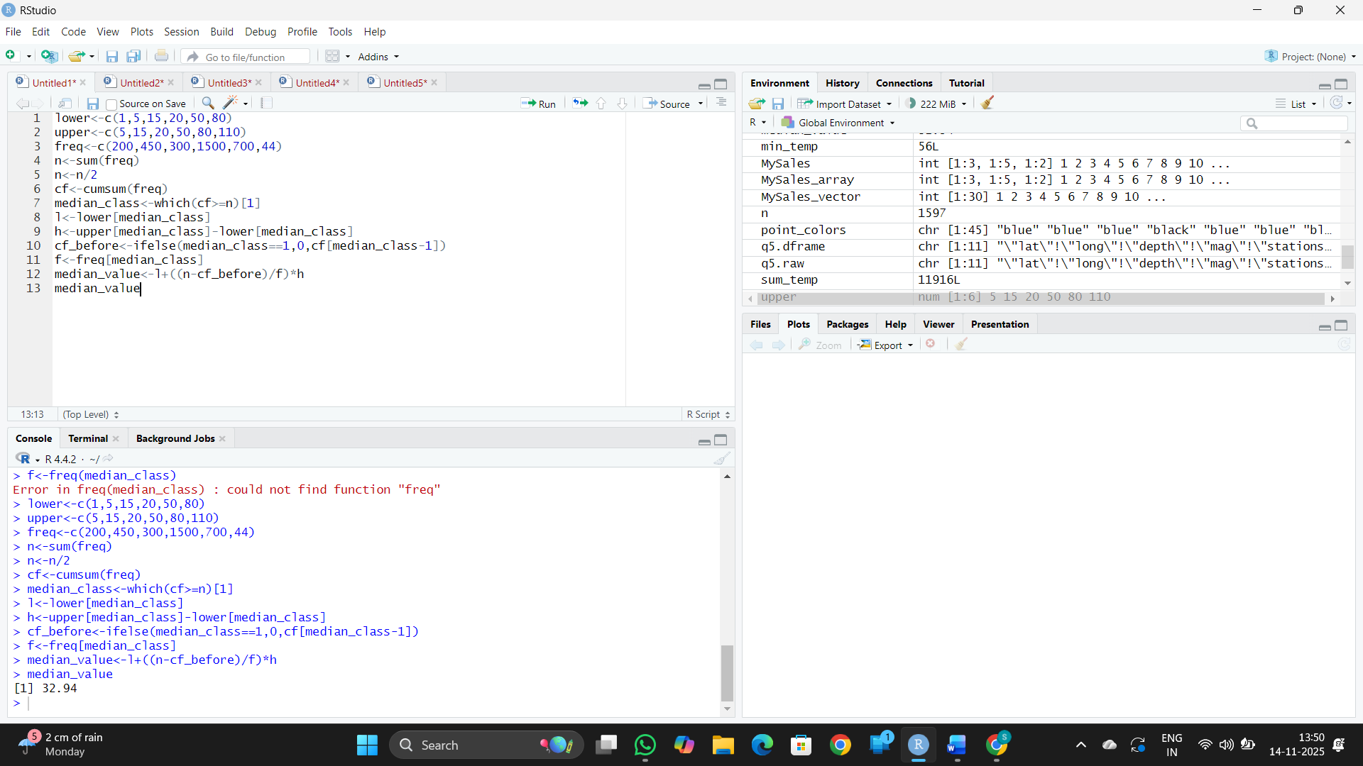

RESULT: Thus, the code was executed successfully.
2.Suppose that the data for analysis includes the attribute age. The age values for the data tuples are (in increasing order) 13, 15, 16, 16, 19, 20, 20, 21, 22, 22, 25, 25, 25, 25, 30, 33, 33, 35, 35, 35, 35, 36, 40, 45, 46, 52, 70.
(a) What is the mean of the data? What is the median?
(b) What is the mode of the data? Comment on the data’s modality (i.e., bimodal, trimodal, etc.).
(c) What is the midrange of the data?
(d) Can you find (roughly) the first quartile (Q1) and the third quartile (Q3) of the data?
AIM: To compute the statistical measures—mean, median, mode, modality, midrange, and quartiles (Q1 and Q3)—for the given age dataset using R, and to analyze the distribution of the data.
ALGORITHM:
- Start
- Input the age data into a vector
- Compute mean using formula ∑x/n
- Compute median by finding the middle value of sorted data
- Compute mode by finding the value(s) with maximum frequency
- Determine modality based on number of modes
- Compute mid-range = (minimum + maximum)/2
- Compute Q1 and Q3 using 25% and 75% positions
- Output all results
- End
CODE:
age<-c(13,15,16,16,19,20,20,21,22,22,25,25,25,25,30,33,33,35,35,35,35,36,40,45,46,52,70)
mean(age)
median(age)
mode_age<-names(table(age))[table(age)==max(table(age))]
mode_age
if(length(mode_age)==1){
modality<-"unimodal"
}else if(length(mode_age)==2){
modality<-"bimodal"
}else if(length(mode_age)==3){
modality<-"trimodal"
}else{
modality<-"multimodal"
}
modality
mid_range<-(min(age)+max(age))/2
mid_range
quantile(age,.25)
quantile(age,.75)
OUTPUT:
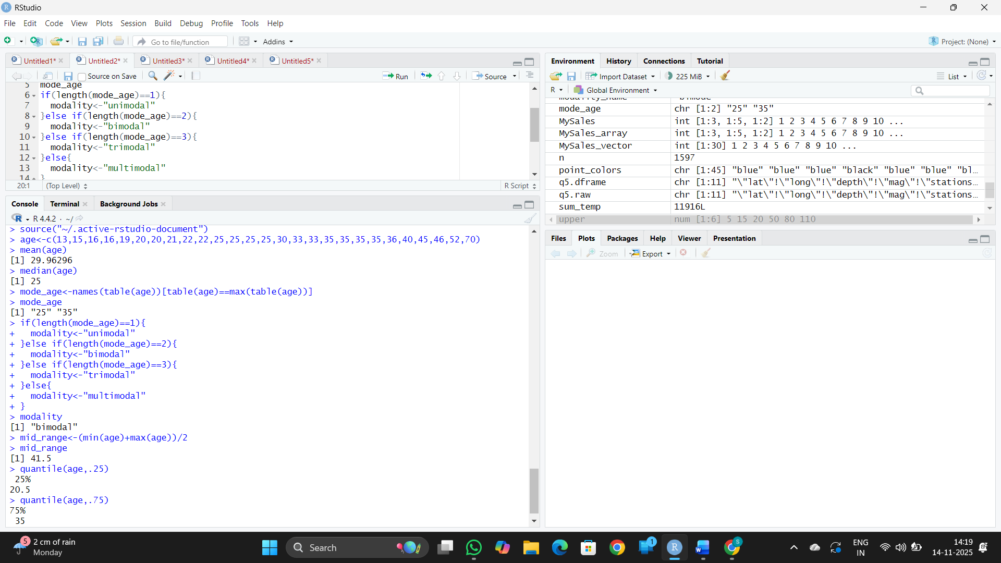

RESULT: Thus, the code was executed successfully.

3.Data Preprocessing :Reduction and Transformation
Use the two methods below to normalize the following group of data: 200, 300, 400, 600, 1000 (a) min-max normalization by setting min = 0 and max = 1 (b) z-score normalization
AIM: To apply Min–Max normalization and Z-Score normalization on the given dataset (200, 300, 400, 600, 1000) using R, in order to transform the data into comparable scales for preprocessing.
ALGORITHM:
- Start
- Take the data values: 200, 300, 400, 600, 1000
- For Min–Max normalization:
- Find min and max of the data
- Apply: (value − min) / (max − min)
- For Z-Score normalization:
- Find mean and standard deviation of the data
- Apply: (value − mean) / sd
- Display the results
- End
CODE:
data <- c(200, 300, 400, 600, 1000)
print("MIN MAX")
min_max<-((data-min(data))/(max(data)-min(data)))
print(min_max)
m<-mean(data)
s<-sd(data)
print("Z SCORE")
z<-((data-m)/s)
print(z)
OUTPUT:
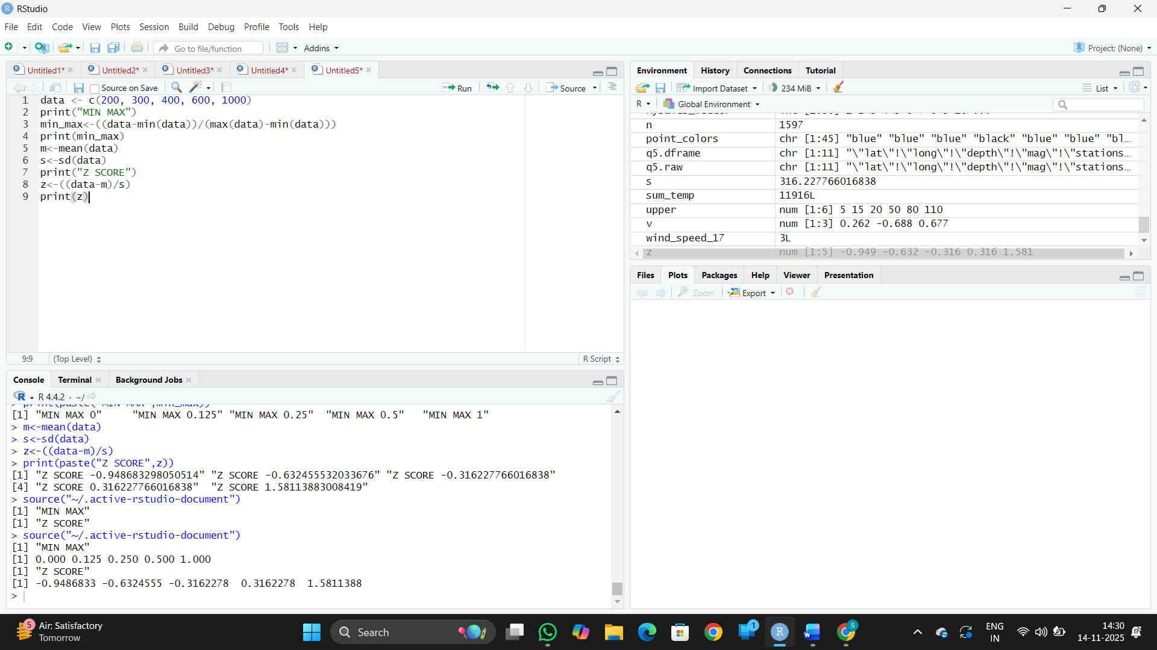

RESULT: Thus, the code was executed successfully.

4. Data:11,13,13,15,15,16,19,20,20,20,21,21,22,23,24,30,40,45,45,45,71,
72,73,75
a) Smoothing by bin mean
b) Smoothing by bin median
c) Smoothing by bin boundaries
AIM: To perform data smoothing on the given dataset using three binning techniques—bin mean, bin median, and bin boundaries—and observe how each method reduces noise in the data.
ALGORITHM:
- Start
- Enter the data values
- Decide the number of bins (equal-width or equal-frequency)
- Divide the data into bins
- For bin mean smoothing:
  - Replace each value in a bin with the mean of that bin
- For bin median smoothing:
  - Replace each value in a bin with the median of that bin
- For bin boundary smoothing:
  - Replace each value with the closest boundary (min or max of bin)
- Display the smoothed results
- End
Code:
data <- c(11,13,13,15,15,16,19,20,20,20,21,21,22,23,24,30,40,45,45,45,71,72,73,75)
bin<-5
bin_data<-split(data,cut(data,bin,include.lowest = TRUE))
bin_data <- bin_data[sapply(bin_data, length) > 0]
bin_mean<-lapply(bin_data,function(x) rep(mean(x),length(x)))
bin_median<-lapply(bin_data,function(x) rep(median(x),length(x)))
bin_boundary<-lapply(bin_data,function(x){
low<-min(x)
high<-max(x)
sapply(x,function(y){
if(abs(y-low)<=abs(y-high)) low else high
})
})
bin_mean
bin_median
bin_boundary

OUTPUT:
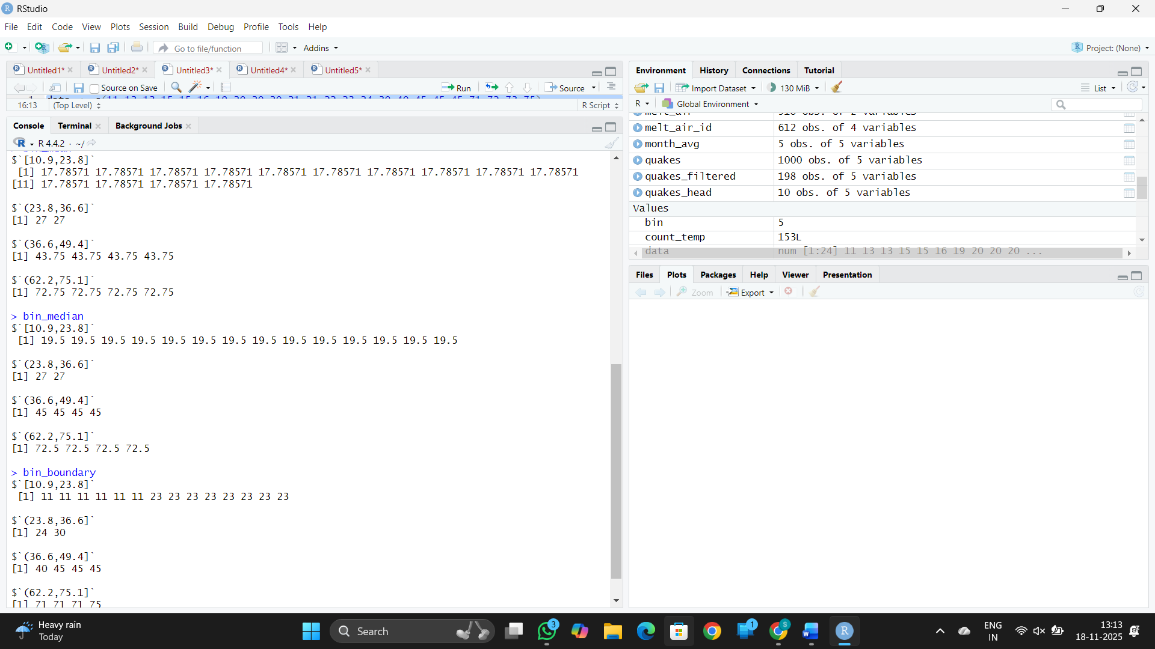

RESULT: Thus, the code was executed successfully.

5. Suppose that a hospital tested the age and body fat data for 18 randomly selected adults with the following results:
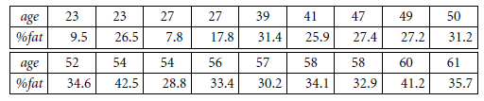
- Calculate the mean, median, and standard deviation of age and %fat.
- Draw the boxplots for age and %fat.
(c) Draw a scatter plot and a q-q plot based on these two variables.



Aim
The aim is to perform exploratory data analysis (EDA) on age and body fat percentage data from 18 adults by computing summary statistics, visualizing distributions, and examining relationships between the variables.

ALGORITHM:
- Start
- Enter the data values
- Decide the number of bins (equal-width or equal-frequency)
- Divide the data into bins
- For bin mean smoothing:
  - Replace each value in a bin with the mean of that bin
- For bin median smoothing:
  - Replace each value in a bin with the median of that bin
- For bin boundary smoothing:
  - Replace each value with the closest boundary (min or max of bin)
- Display the smoothed results
- End

CODE:
age <- c(23,23,27,27,39,41,47,49,50,52,54,54,56,57,58,58,60,61)
percent_fat <- c(9.5,26.5,7.8,17.8,31.4,25.9,27.4,27.2,31.2,34.6,42.5,28.8,33.4,30.2,34.1,32.9,41.2,35.7)
mean_age <- mean(age)
mean_percent_fat <- mean(percent_fat)
median_age <- median(age)
median_percent_fat <- median(percent_fat)
sd_age <- sd(age)
sd_percent_fat <- sd(percent_fat)
cat("Mean Age:", mean_age, "\n")
cat("Median Age:", median_age, "\n")
cat("Standard Deviation Age:", sd_age, "\n")
cat("Mean %Fat:", mean_percent_fat, "\n")
cat("Median %Fat:", median_percent_fat, "\n")
cat("Standard Deviation %Fat:", sd_percent_fat, "\n")
boxplot(age, main="Boxplot of Age")
boxplot(percent_fat, main="Boxplot of %Fat")
plot(age, percent_fat, main="Scatter Plot", xlab="Age", ylab="%Fat")
qqnorm(age, main="Q-Q Plot of Age")
qqline(age, col = 2)
qqnorm(percent_fat, main="Q-Q Plot of %Fat")
qqline(percent_fat, col = 2)

OUTPUT:
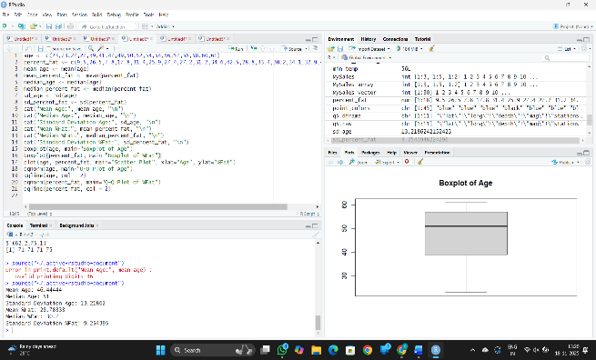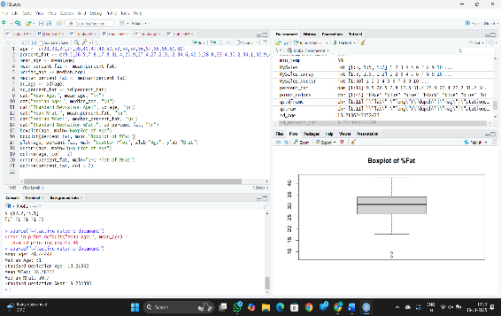
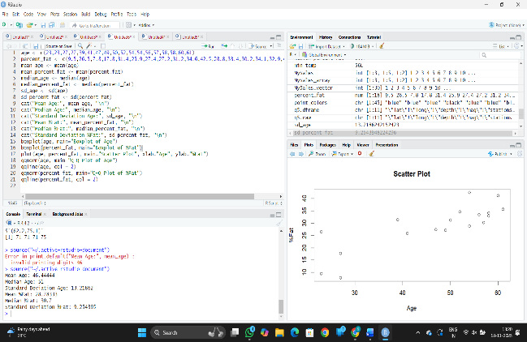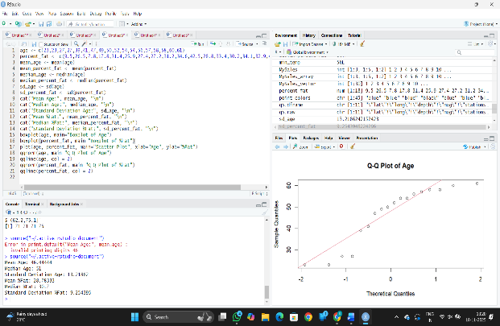

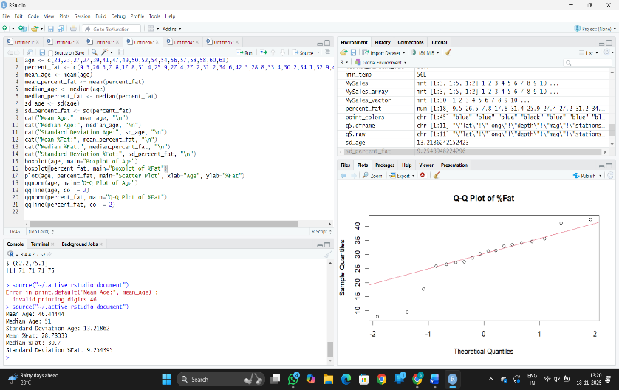

RESULT: Thus, the code was executed successfully.

6.Suppose that a hospital tested the age and body fat data for 18 randomly selected adults with the following results:
(i) Use min-max normalization to transform the value 35 for age onto the range [0.0, 1.0].
(ii) Use z-score normalization to transform the value 35 for age, where the standard deviation of age is 12.94 years.
(iii) Use normalization by decimal scaling to transform the value 35 for age. Perform the above functions using R – tool

Aim
To demonstrate standard normalization techniques (min-max, z-score, and decimal scaling) on hospital age data using R, transforming a specific value (35) for further data analysis or comparison.

Algorithm
- Start
- Input the age data and the target value to transform (35).
- Min-Max Normalization
  - Find the minimum and maximum values in age.
  - Apply $\text{normalized}=\frac{\text{value}-\text{min}}{\text{max}-\text{min}}$.
- Z-Score Normalization
  - Compute the mean of age.
  - Use given standard deviation.
  - Apply $\text{normalized}=\frac{\text{value}-\text{mean}}{\text{sd}}$.
- Decimal Scaling Normalization
  - Find the maximum absolute value in age.
  - Calculate $j$ such that ${10}^{j}>\text{max}∣x∣$.
  - Apply $\text{normalized}=\frac{\text{value}}{{10}^{j}}$.
- Display normalized results for all three techniques.
- End

CODE:

value <- 35
min_value <- 0
max_value<- 1
minmax_normalized <- (value - min_value) / (max_value - min_value)
print(paste("Min-Max Normalized value:", minmax_normalized))
mean_age <- 0
std_deviation_age <- 12.94
zscore_normalized <- (value - mean_age) / std_deviation_age
print(paste("Z-Score Normalized value:", zscore_normalized))
power <- floor(log10(max(abs(value)))) + 1
decimal_scaled <- value / (10 ^ power)
print(paste("Normalization by Decimal Scaling:", decimal_scaled))

OUTPUT:
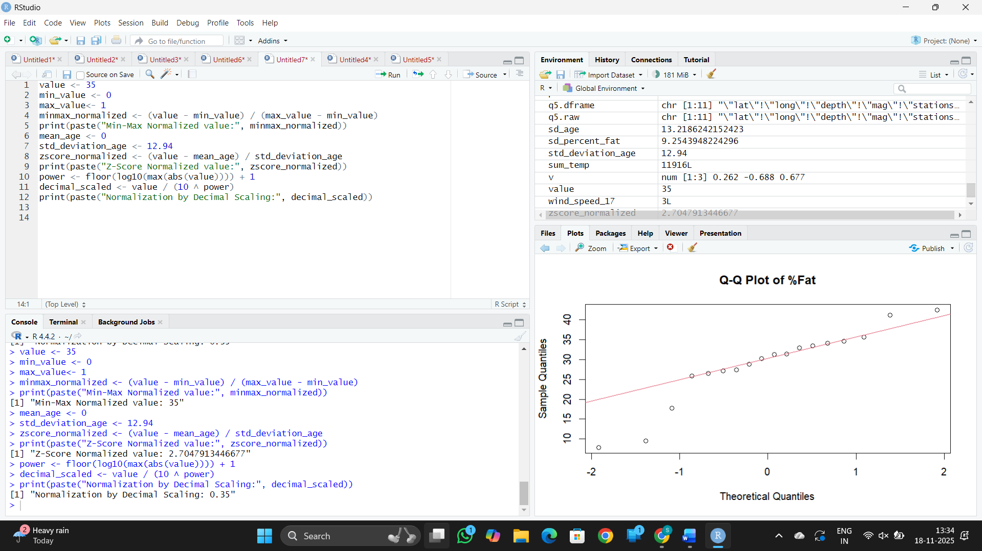

RESULT: Thus, the code was executed successfully.

7.The following values are the number of pencils available in the different boxes. Create a vector and find out the mean, median and mode values of set of pencils in the given data.
Box1 Box2 Box3 Box4 Box5 Box6 Box7 Box8 Box9 Box 10
9 25 23 12 11 6 7 8 9 10

Aim
To create a data vector representing the number of pencils in 10 boxes and compute the mean, median, and mode of this dataset for statistical analysis.

Algorithm
- Start
- Create a vector with the number of pencils for each box
- Calculate the mean value of the vector (average number of pencils)
- Calculate the median value of the vector (middle value when sorted)
- Calculate the mode value of the vector (most frequent number)
- Display the mean, median, and mode values
- End

CODE:

pencils <- c(9, 25, 23, 12, 11, 6, 7, 8, 9, 10)
mean_pencils <- mean(pencils)
median_pencils <- median(pencils)
get_mode <- function(x) {
ux <- unique(x)
ux[which.max(tabulate(match(x, ux)))]
}
mode_pencils <- get_mode(pencils)
print(paste("Mean:", mean_pencils))
print(paste("Median:", median_pencils))
print(paste("Mode:", mode_pencils))

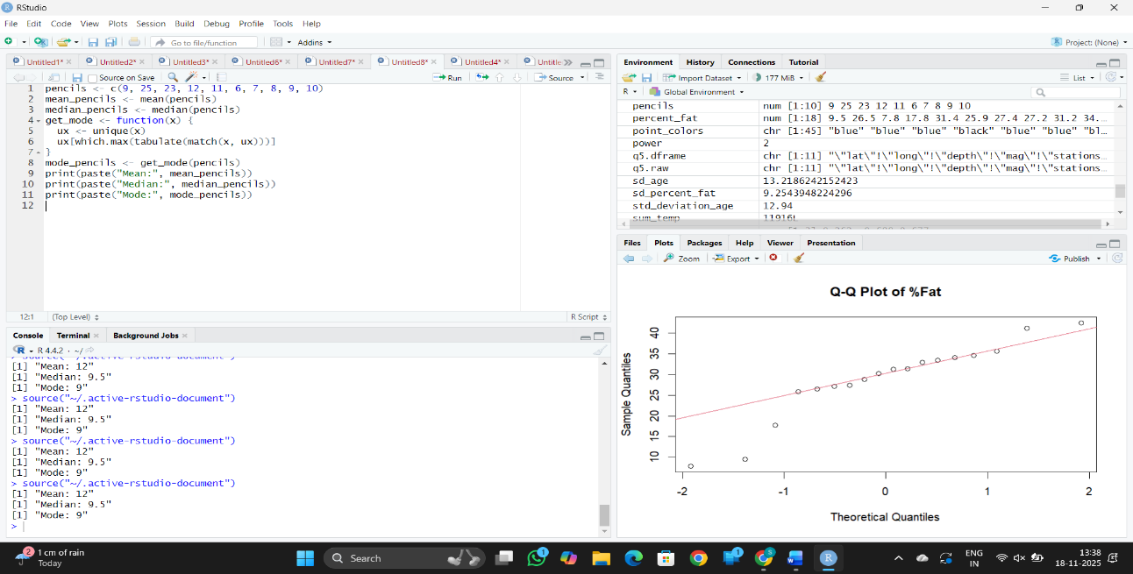

RESULT: Thus, the code was executed successfully.

8. the following table would be plotted as (x,y) points, with the first column being the x values as number of mobile phones sold and the second column being the y values as money. To use the scatter plot for how many mobile phones sold.
x :4 1 5 7 10 2 50 25 90 36
y :12 5 13 19 31 7 153 72 275 110

Aim
To plot a scatter plot of the number of mobile phones sold (x-values) against the corresponding money earned (y-values) to visualize the relationship between sales and earnings.

Algorithm
- Start
- Input the data vectors for number of mobile phones sold (x) and money earned (y)
- Use the x and y values as coordinate pairs (x, y) for plotting
- Create a scatter plot with x on the horizontal axis and y on the vertical axis
- Label the x-axis as "Number of Mobile Phones Sold" and the y-axis as "Money"
- Add a title to the scatter plot for context
- Display the scatter plot
- End

CODE:
x <- c(4, 1, 5, 7, 10, 2, 50, 25, 90, 36)
y <- c(12, 5, 13, 19, 31, 7, 153, 72, 275, 110)
plot(x, y, main="Scatter Plot of Mobile Phones Sold",
xlab="Number of Mobile Phones Sold", ylab="Money")
grid()

OUTPUT:
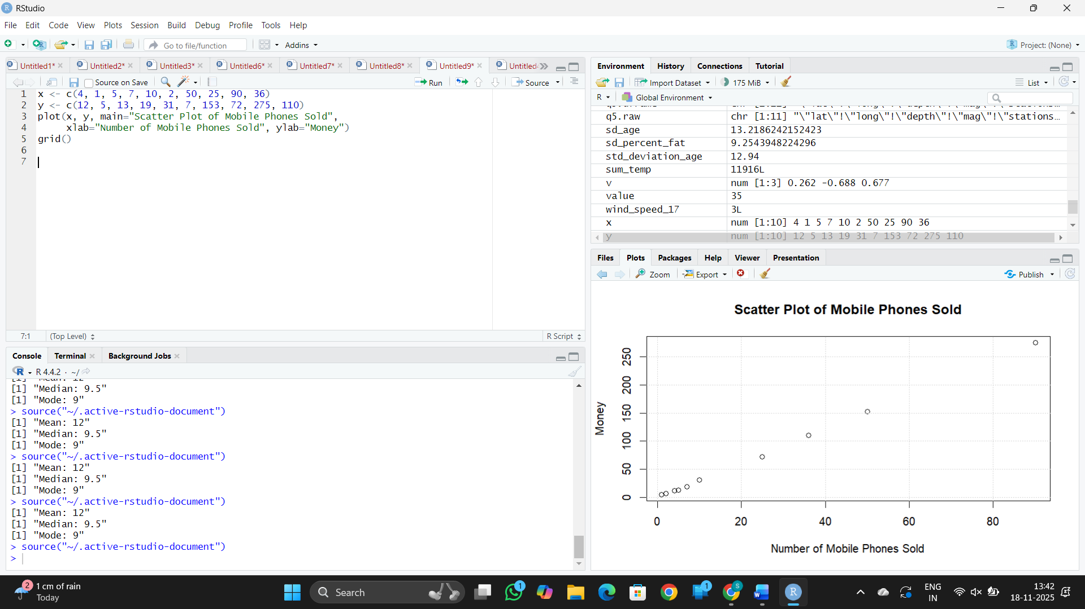

RESULT: Thus, the code was executed successfully.

9. Implement of the R script using marks scored by a student in his model exam has been sorted as follows: 55, 60, 71, 63, 55, 65, 50, 55,58,59,61,63,65,67,71,72,75. Partition them into three bins by each of the following methods. Plot the data points using histogram.
(a) equal-frequency (equi-depth) partitioning (b) equal-width partitioning

Aim
To partition the student's exam marks into three bins using equal-frequency and equal-width methods and visualize the distribution with histograms.

Algorithm
- Start
- Input marks data vector
- Sort the data (for equal-frequency)
- For equal-frequency partitioning:
  - Divide the sorted data into three bins with approximately equal numbers of data points
- For equal-width partitioning:
  - Calculate the range of data
  - Divide the range into three equal width intervals
  - Assign each data point to the corresponding bin based on value
- Plot histograms for each binning method
- Display the histograms for comparison
- End

CODE:
marks <- c(55, 60, 71, 63, 55, 65, 50, 55, 58, 59, 61, 63, 65, 67, 71, 72, 75)
num_bins <- 3
bin_breaks_eq_freq <- quantile(marks, probs = seq(0, 1, length.out = num_bins + 1))
marks_binned_eq_freq <- cut(marks, breaks = bin_breaks_eq_freq, include.lowest = TRUE)
bin_width <- (max(marks) - min(marks)) / num_bins
bin_breaks_eq_width <- seq(min(marks), max(marks) + bin_width, by = bin_width)
marks_binned_eq_width <- cut(marks, breaks = bin_breaks_eq_width, include.lowest = TRUE)
par(mfrow = c(1, 2))
hist(marks, breaks = bin_breaks_eq_freq, main = "Equal-Frequency Partitioning",
xlab = "Marks", ylab = "Frequency", col = "lightblue")
abline(v = bin_breaks_eq_freq, col = "red", lwd = 2)
hist(marks, breaks = bin_breaks_eq_width, main = "Equal-Width Partitioning",
xlab = "Marks", ylab = "Frequency", col = "lightgreen")
abline(v = bin_breaks_eq_width, col = "red", lwd = 2)
OUTPUT:

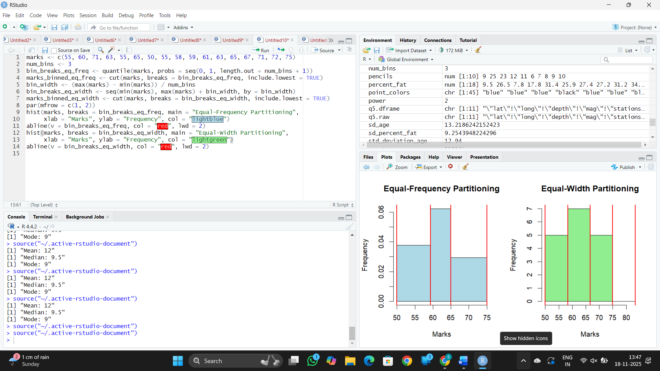

RESULT: Thus, the code was executed successfully.

10. Suppose that the speed car is mentioned in different driving style.
Regular 78.3 81.8 82 74.2 83.4 84.5 82.9 77.5 80.9 70.6 Speed
Calculate the Inter quantile and standard deviation of the given data.
Aim
To calculate the interquartile range (IQR) and standard deviation of the speed of a car under different driving styles for statistical analysis and understanding data dispersion.

Algorithm
- Start
- Input the speed data values
- Sort the data in ascending order
- Calculate the first quartile (Q1, 25th percentile)
- Calculate the third quartile (Q3, 75th percentile)
- Calculate the interquartile range (IQR) = Q3 - Q1
- Calculate the mean of the data
- Calculate the variance and subsequently the standard deviation (square root of variance)
- Display the IQR and standard deviation values
- End

CODE:
speed_data <- c(78.3, 81.8, 82, 74.2, 83.4, 84.5, 82.9, 77.5, 80.9, 70.6)
q1 <- quantile(speed_data, 0.25)
q3 <- quantile(speed_data, 0.75)
iqr <- q3 - q1
sd_speed <- sd(speed_data)
print(paste("Interquartile Range (IQR):", iqr))
print(paste("Standard Deviation:", sd_speed))

OUTPUT:
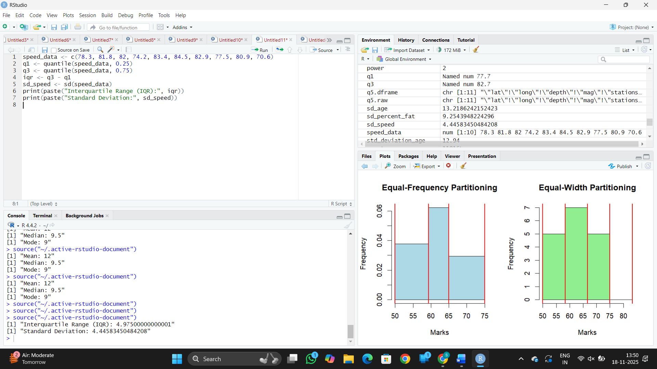

RESULT: Thus, the code was executed successfully.

11.Suppose that the data for analysis includes the attribute age. The age values for the data tuples are (in increasing order) 13, 15, 16, 16, 19, 20, 20, 21, 22, 22, 25, 25, 25, 25, 30, 33, 33, 35, 35, 35, 35, 36, 40, 45, 46, 52, 70.
Can you find (roughly) the first quartile (Q1) and the third quartile (Q3) of the data?
Aim
To find the first quartile (Q1) and third quartile (Q3) of the age dataset for understanding the spread and distribution of the data.

Algorithm
- Start
- Input the sorted age data
- Calculate the position of the first quartile (Q1) = $\frac{1}{4}(n+1)$, where $n$ is the number of data points
- Calculate the position of the third quartile (Q3) = $\frac{3}{4}(n+1)$
- Use linear interpolation if positions are not whole numbers to find approximate values of Q1 and Q3
- Display the values of Q1 and Q3
- End

CODE:
age_data <- c(13, 15, 16, 16, 19, 20, 20, 21, 22, 22, 25, 25, 25, 25, 30, 33, 33, 35, 35, 35, 35, 36, 40, 45, 46, 52, 70)
total_data_points <- length(age_data)
q1_position <- (total_data_points + 1) / 4
q3_position <- 3 * q1_position
q1 <- age_data[ceiling(q1_position)]
q3 <- age_data[ceiling(q3_position)]
print(paste("Approximate First Quartile (Q1):", q1))
print(paste("Approximate Third Quartile (Q3):", q3))

OUTPUT:
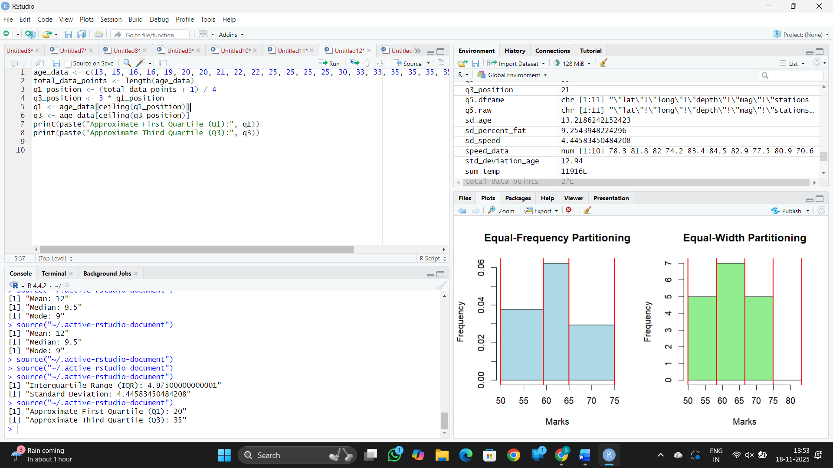
RESULT: Thus, the code was executed successfully.

