CSA1605 DATA WAREHOUSING AND DATA MINING
DAY 2
1.Covariance and correlationChildren of three ages are asked to indicate their preference for three photographs of adults.Do the data suggest that there is a significant relationship between age and photograph preference? What is wrong with this study?Photograph:
Age of child A B C
5-6 years: 18 22 20
7-8 years: 2 28 40
9-10 years: 20 10 40
1. Use cov() to calculate the sample covariance between B and C.
2. Use another call to cov() to calculate the sample covariance matrix for the preferences.
3. Use cor() to calculate the sample correlation between B and C.
4. Use another call to cor() to calculate the sample correlation matrix for the preferences.
AIM: To determine if there is a significant relationship between age and photograph preference using covariance and correlation analysis in R
ALGORITHM: Enter the data
- calculate the covariance and correlation between photograph preferences using cov() and cor()
- then interpret the results to assess relationships between variables.
CODE AND OUTPUT:
A <- c(18, 2, 20)
B <- c(22, 28, 10)
C <- c(20, 40, 40)
prefs <- data.frame(A, B, C)
cov(B, C)
cov(prefs)
cor(B, C)
cor(prefs)
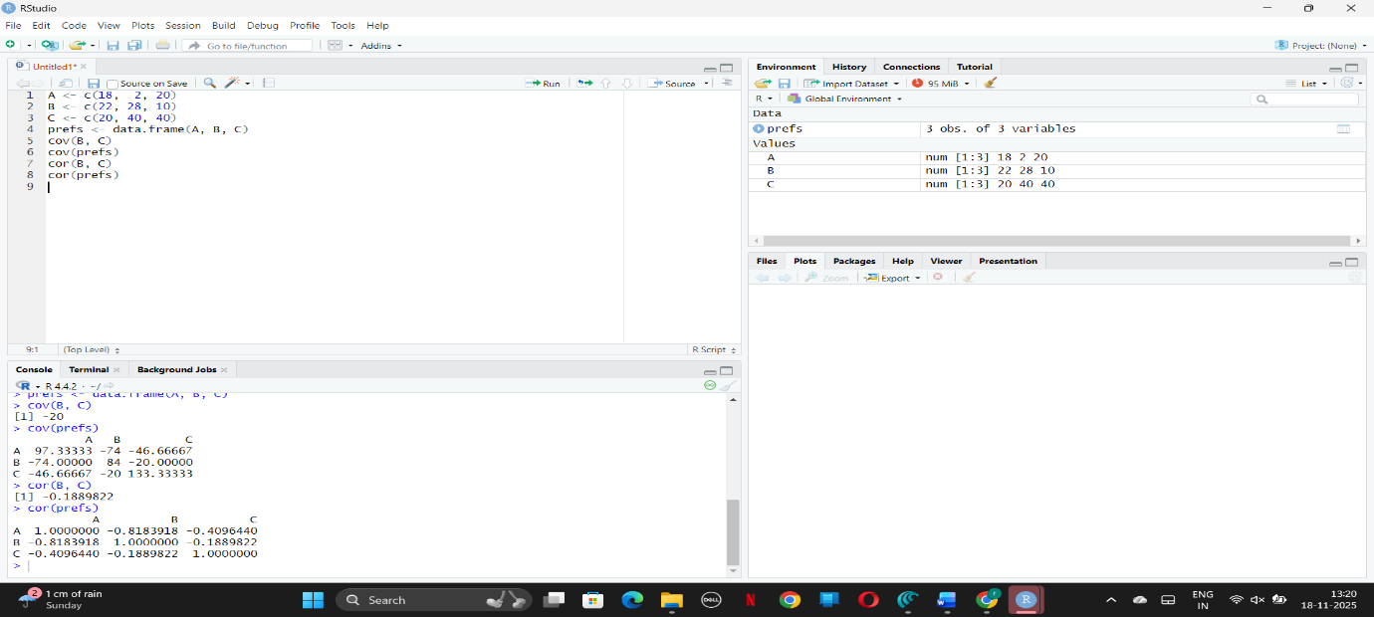
RESULT: Thus, the code was executed successfully.
2. Imagine that you have selected data from the All Electronics data warehouse for analysis.The data set will be huge! The following data are a list of All Electronics prices for commonly sold items (rounded to the nearest dollar). The numbers have been sorted: 1, 1, 5,5, 5, 5, 5, 8, 8, 10, 10, 10, 10, 12, 14, 14, 14, 15, 15, 15, 15, 15, 15, 18, 18, 18, 18, 18, 18, 18,18, 20, 20, 20, 20, 20, 20, 20, 21, 21, 21, 21, 25, 25, 25, 25, 25, 28, 28, 30, 30, 30.
(i) Partition the dataset using an equal-frequency partitioning method with bin equal to 3
(ii) Apply data smoothing using bin means and bin boundary.
(iii) Plot Histogram for the above frequency division
AIM:
To partition a dataset into equal-frequency bins, smooth the data using bin means and boundaries, and plot a histogram.
Algorithm :
- Sort the data
- divide it into three equal-frequency bins
- apply smoothing by replacing values with the bin’s mean or with the closest boundary value
- and plot a histogram to visualize the frequency distribution
CODE AND OUTPUT: prices <- c(1,1,5,5,5,5,5,8,8,10,10,10,10,12,14,14,14,15,15,15,15,15,15,
18,18,18,18,18,18,18,18,20,20,20,20,20,20,20,21,21,21,21,
25,25,25,25,25,28,28,30,30,30)
n <- length(prices)
bin_size <- n / 3
bins <- split(prices, ceiling(seq_along(prices) / bin_size))
bins
bin_means <- lapply(bins, function(b) rep(mean(b), length(b)))
bin_means
bin_boundaries <- lapply(bins, function(b) {
low <- min(b)
high <- max(b)
sapply(b, function(x)
if (abs(x - low) <= abs(x - high)) low else high)
})
bin_boundaries
hist(prices,
main = "Histogram of Prices (Equal-Frequency Concept)",
xlab = "Price",
col = "yellow",
border = "black")
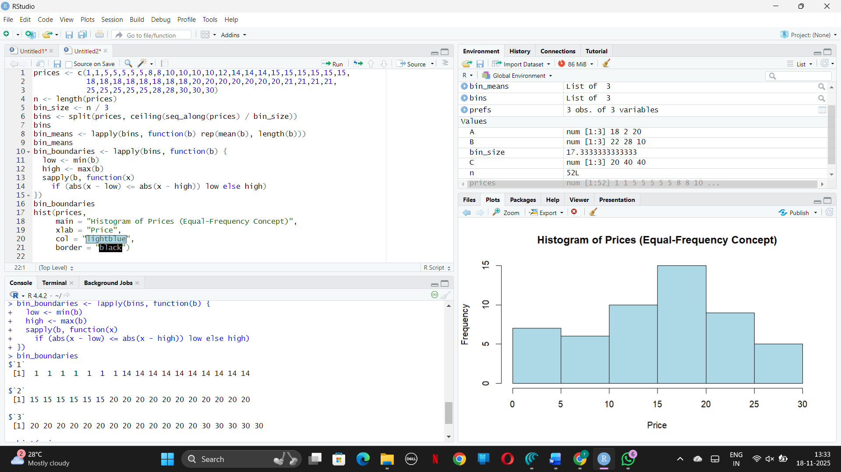
RESULT: Thus, the code was executed successfully.
3.Two Maths teachers are comparing how their Year 9 classes performed in the end of year exams. Their results are as follows:
Class A: 76, 35, 47, 64, 95, 66, 89, 36, 8476,35,47,64,95,66,89,36,84
Class B: 51, 56, 84, 60, 59, 70, 63, 66, 5051,56,84,60,59,70,63,66,50
(i) Find which class had scored higher mean, median and range.
(ii) Plot above in boxplot and give the inferences
Class B: 51, 56, 84, 60, 59, 70, 63, 66, 5051,56,84,60,59,70,63,66,50
AIM:
To compare the mean, median, and range for two Year 9 classes’ exam results and visualize the distributions with a boxplot.
Algorithm (Sentence Form):
- Collect the exam scores for each class,
- calculate the mean, median, and
- range for both classes, and
- plot boxplots to visualize and compare their score distributions.
CODE AND OUTPUT: classA <- c(76, 35, 47, 64, 95, 66, 89, 36, 84)
classB <- c(51, 56, 84, 60, 59, 70, 63, 66, 50)
mean_A <- mean(classA)
mean_B <- mean(classB)
median_A <- median(classA)
median_B <- median(classB)
range_A <- max(classA) - min(classA)
range_B <- max(classB) - min(classB)
mean_A; mean_B
median_A; median_B
range_A; range_B
boxplot(classA, classB,
names = c("Class A", "Class B"),
col = c("lightblue", "lightgreen"),
main = "Boxplot Comparison of Year 9 Maths Scores",
ylab = "Scores")
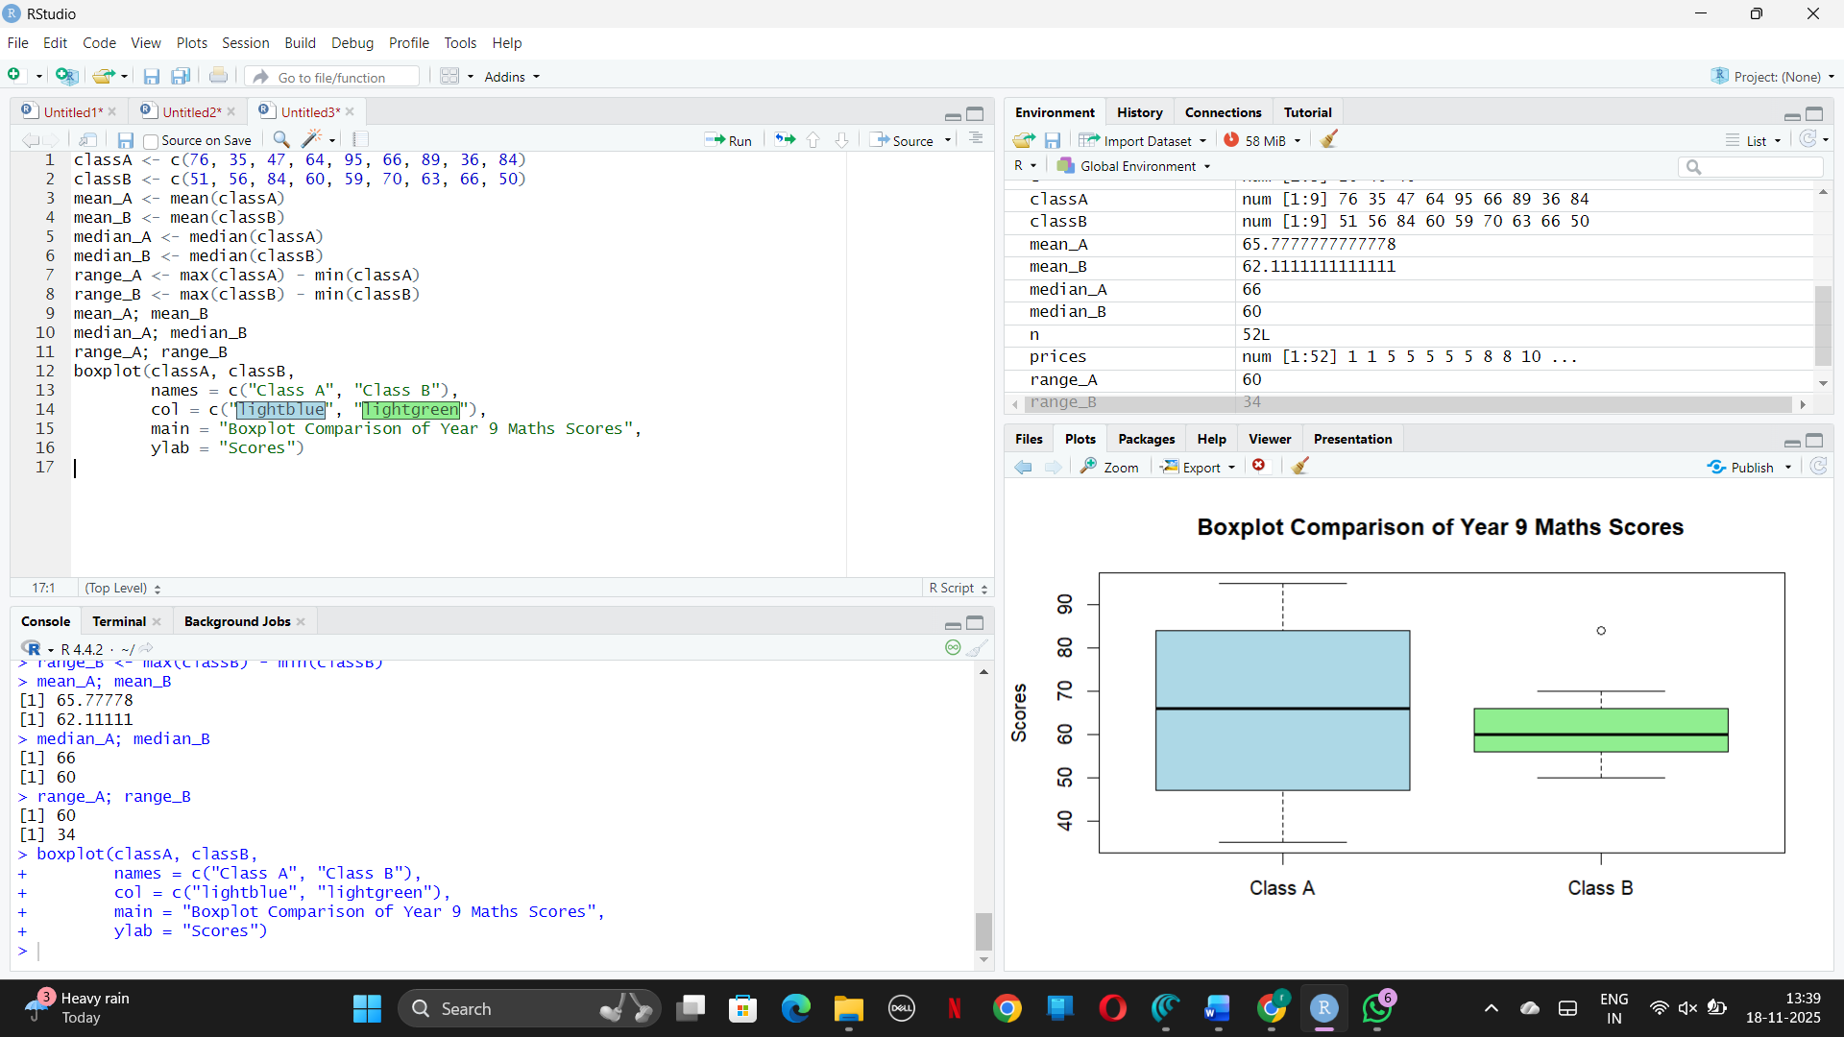
RESULT: Thus, the code was executed successfully.
4.Let us consider one example to make the calculation method clear. Assume that theminimum and maximum values for the feature F are $50,000 and $100,000 correspondingly.It needs to range F from 0 to 1. In accordance with min-max normalization, v = $80,
b) Use the two methods below to normalize the following group of data: 200, 300, 400, 600,
1000
(a) min-max normalization by setting min = 0 and max = 1
(b) z-score normalization
AIM:
To normalize a numerical dataset using (a) min-max normalization and (b) z-score normalization.
Algorithm (Sentence Form):
- For min-max normalization, use the formula $v^{'}=\frac{v-min}{max-min}$ to scale all values between 0 and 1.
- For z-score normalization, use $v^{'}=\frac{v-μ}{σ}$, where $μ$ is the mean and $σ$ is the standard deviation, to standardize the values.
CODE AND OUTPUT:
v <- 80000
minF <- 50000
maxF <- 100000
v_normalized <- (v - minF) / (maxF - minF)
v_normalized
data <- c(200, 300, 400, 600, 1000)
min_data <- min(data)
max_data <- max(data)
minmax_norm <- (data - min_data) / (max_data - min_data)
minmax_norm
zscore_norm <- scale(data)
zscore_norm

RESULT: Thus, the code was executed successfully.
5.Make a histogram for the “AirPassengers “dataset, start at 100 on the x-axis, and from
values 200 to 700, make the bins 150 wide
AIM:
To create a histogram of the “AirPassengers” dataset with the x-axis starting at 100 and bins of width 150 between values 200 and 700.
Algorithm (Sentence Form):
- Load the “AirPassengers” dataset,
- set the x-axis to start at 100, and
- create bins of width 150 for the range 200–700.
- Count the number of observations falling within each bin and plot the histogram showing the frequency distribution.
CODE AND OUTPUT: data(AirPassengers)
breaks <- seq(100, 800, by = 150)
hist(AirPassengers,
breaks = breaks,
main = "Histogram of AirPassengers",
xlab = "Number of Passengers",
col = "lightblue",
border = "black",
xlim = c(100, 800))
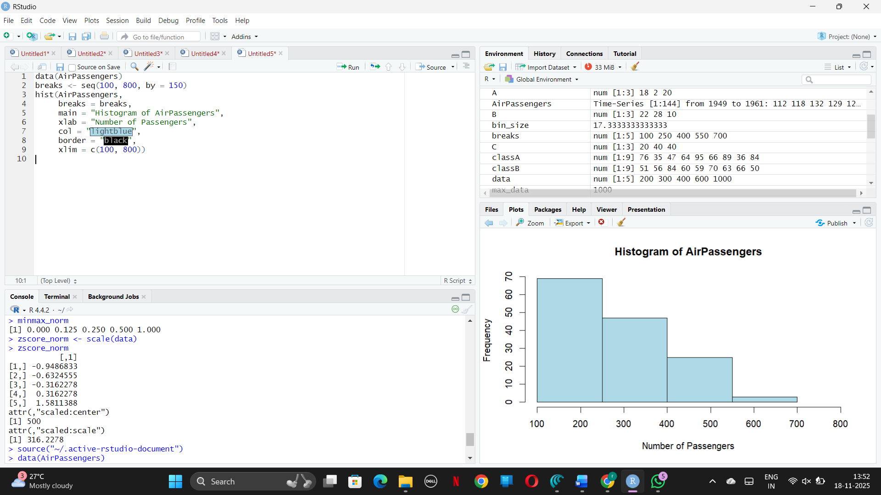
RESULT: Thus, the code was executed successfully.
6.Obtain Multiple Lines in Line Chart using a single Plot Function in R.Use attributes“mpg”and“qsec”of the dataset “mtcars”
AIM:
To plot multiple lines for the “mpg” (miles per gallon) and “qsec” (quarter mile time) attributes from the “mtcars” dataset on a single line chart using R.
Algorithm (Sentence Form):
- Load the “mtcars” dataset, select the “mpg” and “qsec” columns, and use a plot function to display both as lines on the same plot for comparison.
- Add lines and a legend to distinguish between the attributes.
CODE AND OUTPUT: data(mtcars)
mpg_values <- mtcars$mpg
qsec_values <- mtcars$qsec
x <- 1:length(mpg_values)
plot(x, mpg_values, type = "l", col = "blue", lwd = 2,
xlab = "Car Index",
ylab = "Values",
main = "Multiple Lines: MPG and QSEC (mtcars)")
lines(x, qsec_values, col = "red", lwd = 2)
legend("topright",
legend = c("MPG", "QSEC"),
col = c("blue", "red"),
lwd = 2)
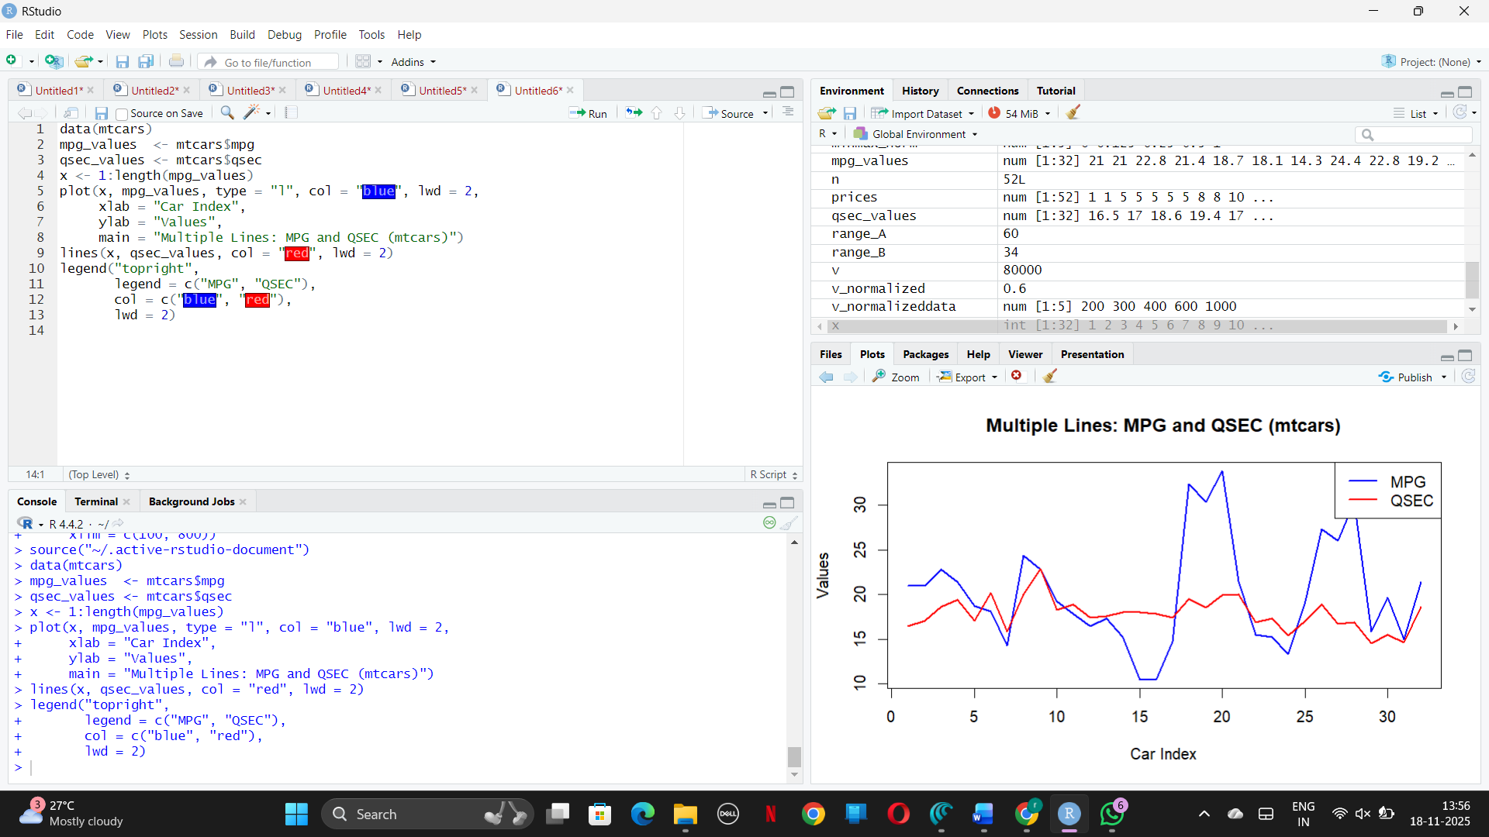

RESULT: Thus, the code was executed successfully.
7.Download the Dataset "water" From R dataset Link.Find out whether there is a linear
relation between attributes"mortality" and"hardness" by plot function.Fit the Data into the
Linear Regression model.Predict the mortality for the hardness=88.
AIM:
To plot multiple lines for “mpg” and “qsec” from the “mtcars” dataset in a single line chart using R.
Algorithm (Sentence Form):
- Load the “mtcars” dataset, extract the values for “mpg” and “qsec,” plot “mpg” as a line,
- then add the “qsec” line using lines() on the same graph,
- and use a legend to identify each line visually.

CODE AND OUTPUT:

if (!requireNamespace("HSAUR2", quietly = TRUE)) {
install.packages("HSAUR2")
}
library(HSAUR2)
data("water", package = "HSAUR2")
head(water)
plot(water$hardness, water$mortality,
main = "Mortality vs Water Hardness",
xlab = "Water Hardness (ppm)",
ylab = "Mortality (per 100,000 males)",
pch = 19, col = "blue")
model <- lm(mortality ~ hardness, data = water)
abline(model, col = "red", lwd = 2)
summary(model)
new_data <- data.frame(hardness = 88)
predicted <- predict(model, new_data)
predicted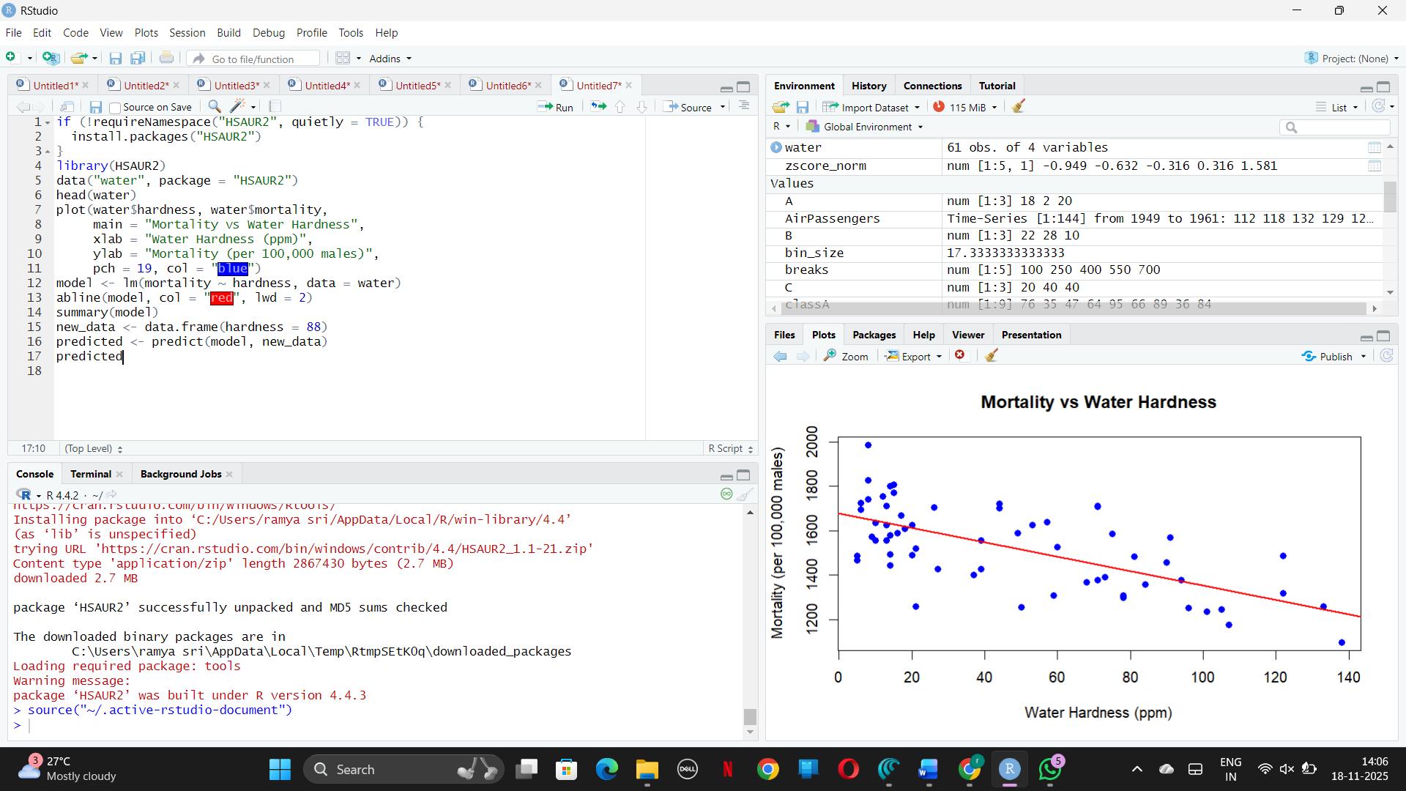
RESULT: Thus, the code was executed successfully.
8.Create a Boxplot graph for the relation between "mpg"(miles per galloon) and "cyl"(number
of Cylinders) for the dataset "mtcars" available in R Environment.
AIM:
To visualize the relationship between miles per gallon (“mpg”) and number of cylinders (“cyl”) using a boxplot in the “mtcars” dataset available in R.
Algorithm (Sentence Form):
- Load the “mtcars” dataset, use the boxplot() function in R to plot “mpg” values grouped by the different values of “cyl,”
- and interpret the boxplot to compare fuel efficiency across cylinder counts.
CODE AND OUTPUT:
data(mtcars)
boxplot(mpg ~ cyl,
data = mtcars,
main = "MPG by Number of Cylinders",
xlab = "Number of Cylinders",
ylab = "Miles per Gallon (MPG)",
col = c("lightblue", "lightgreen", "lightpink"),
border = "black")
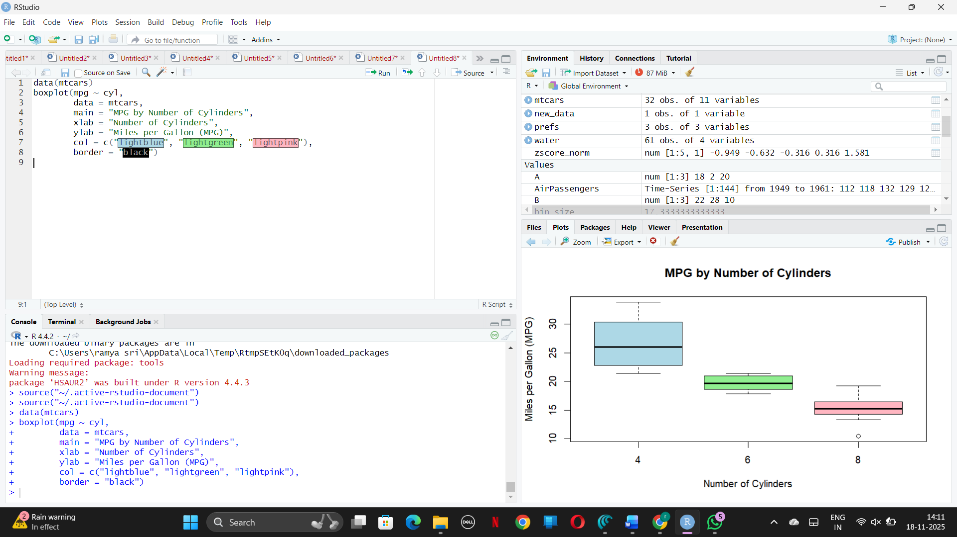
RESULT: Thus, the code was executed successfully.
9. Assume the Tennis coach wants to determine if any of his team players are scoring
outliers. To visualize the distribution of points scored by his players, then how can he
decide to develop the box plot? Give suitable example using Boxplot visualization
technique.
AIM:
To detect outliers and visualize the distribution of players’ scores using a boxplot, helping the tennis coach assess performance across the team.
Algorithm (Sentence Form):
- Collect each player’s scores,
- use the boxplot() function to graphically display their score distribution,
- and identify outliers as points outside the whiskers of the boxplot.
CODE AND OUTPUT:
points <- c(12, 15, 18, 20, 22, 25, 28, 30, 35, 40, 45, 50, 55, 120, 130)
boxplot(points,
main = "Boxplot of Tennis Players' Points",
ylab = "Points Scored",
col = "lightblue",
border = "black",
horizontal = FALSE)
grid()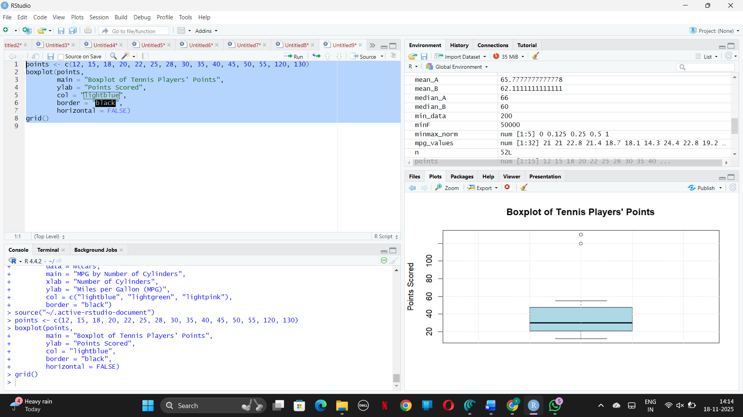
RESULT: Thus, the code was executed successfully.
10. Implement using R language in which age group of people are affected byblood pressure
based on the diabetes dataset show it using scatterplot and bar chart (that is BloodPressure vs
Age using dataset “diabetes.csv”)
AIM:
To analyze and visualize the relationship between age and blood pressure using the “diabetes.csv” dataset, identifying which age group is most affected by blood pressure.
Algorithm (Sentence Form):
- Load the “diabetes.csv” dataset in R, extract the “Age” and “BloodPressure” columns, and plot a scatterplot to observe the relationship between individual ages and blood pressure values.
- Categorize ages into groups (e.g., age brackets), calculate the average blood pressure for each group, and plot a bar chart to compare which age group is most affected.
CODE AND OUTPUT:
library(ggplot2)

# Assuming 'diabetes' data frame is already loaded with columns Age and BloodPressure
# Example synthetic data if needed:
# diabetes <- data.frame(Age = c(25, 35, 45, 55, 65, 75, 85, 40, 50, 60, 70, 80),
# BloodPressure = c(80, 85, 90, 100, 110, 120, 130, 88, 95, 105, 115, 125))

# Define breaks for age groups (3 groups example)
breaks <- seq(min(diabetes$Age), max(diabetes$Age), length.out = 4)
labels <- c("Group1", "Group2", "Group3")
diabetes$AgeGroup <- cut(diabetes$Age, breaks = breaks, include.lowest = TRUE, labels = labels)
ggplot(diabetes, aes(x = Age, y = BloodPressure)) +
geom_point(color = "blue", alpha = 0.6) +
labs(title = "Scatter Plot of Blood Pressure vs Age",
x = "Age (years)",
y = "Blood Pressure (mm Hg)") +
theme_minimal()
avg_bp_by_agegroup <- aggregate(BloodPressure ~ AgeGroup, data = diabetes, FUN = mean)
ggplot(avg_bp_by_agegroup, aes(x = AgeGroup, y = BloodPressure)) +
geom_bar(stat = "identity", fill = "lightblue") +
labs(title = "Average Blood Pressure by Age Group",
x = "Age Group",
y = "Average Blood Pressure (mm Hg)") +
theme_minimal() +
theme(axis.text.x = element_text(angle = 45, hjust = 1))
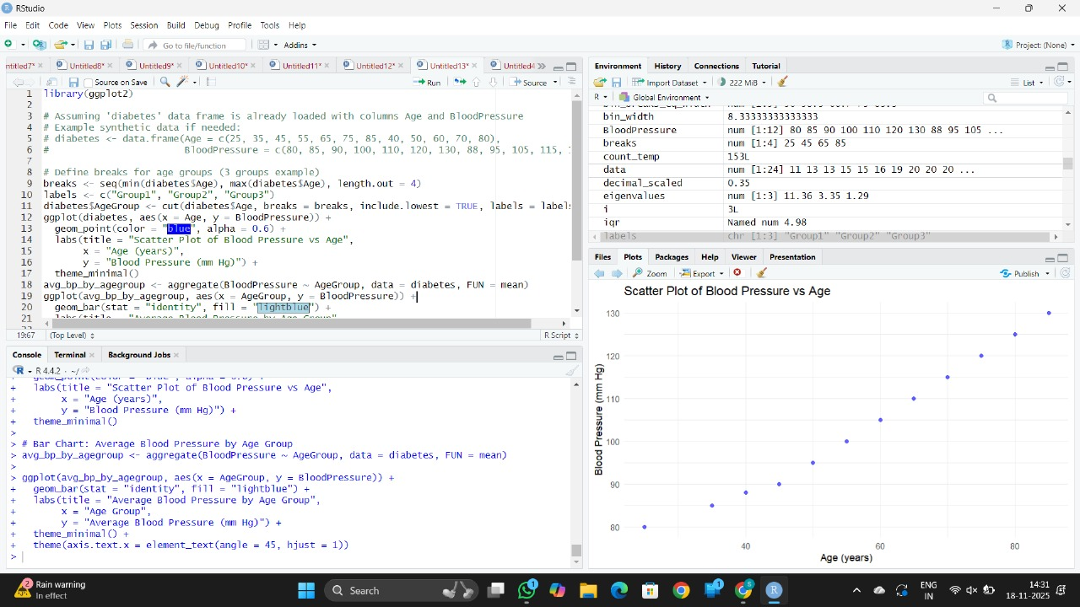
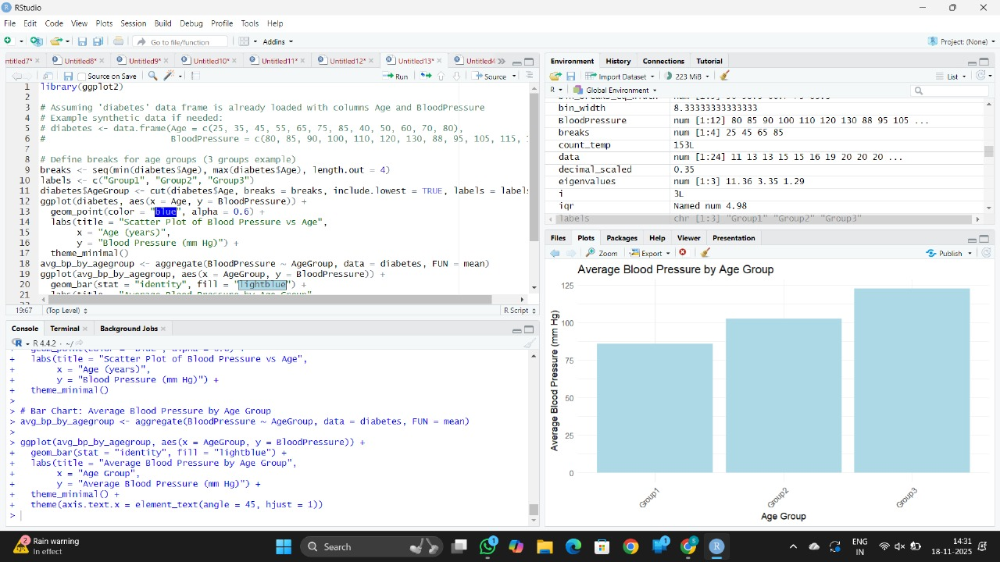
RESULT: Thus, the code was executed successfully.

