WEEK-2
MODULE:Spring Core and Maven
Exercise 1: Configuring a Basic Spring Application
Scenario:
Your company is developing a web application for managing a library. You need to use the Spring Framework to handle the backend operations.
Steps:
- Set Up a Spring Project:
  - Create a Maven project named LibraryManagement.
  - Add Spring Core dependencies in the pom.xml file.
- Configure the Application Context:
  - Create an XML configuration file named applicationContext.xml in the src/main/resources directory.
  - Define beans for BookService and BookRepository in the XML file.
- Define Service and Repository Classes:
  - Create a package com.library.service and add a class BookService.
  - Create a package com.library.repository and add a class BookRepository.
- Run the Application:
  - Create a main class to load the Spring context and test the configuration.

VS Code project structure
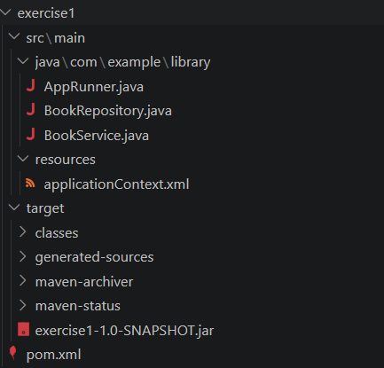
AppRunner.java
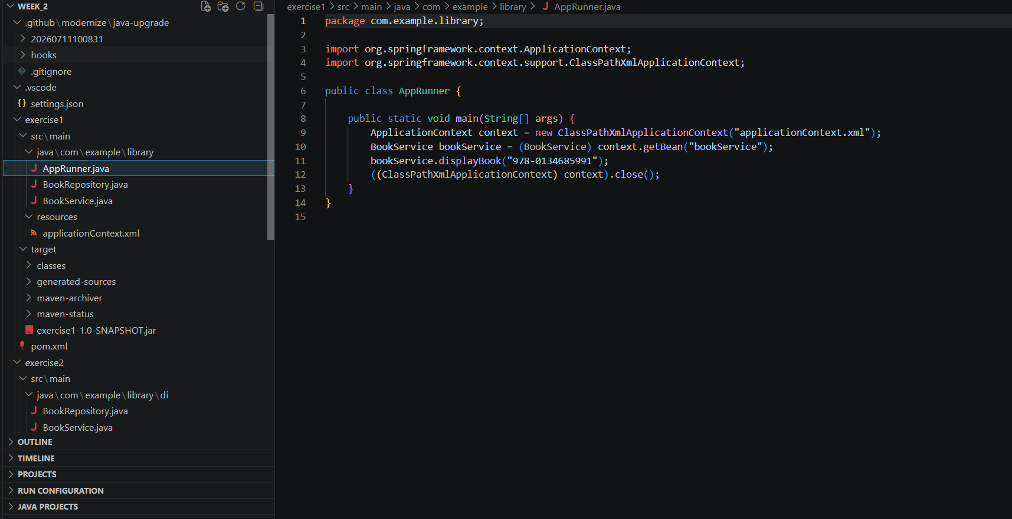

pom.xml
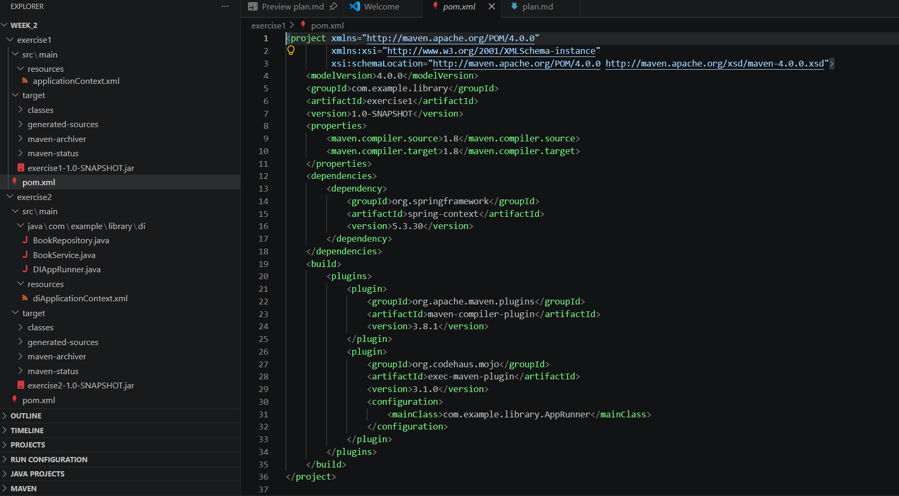

Output
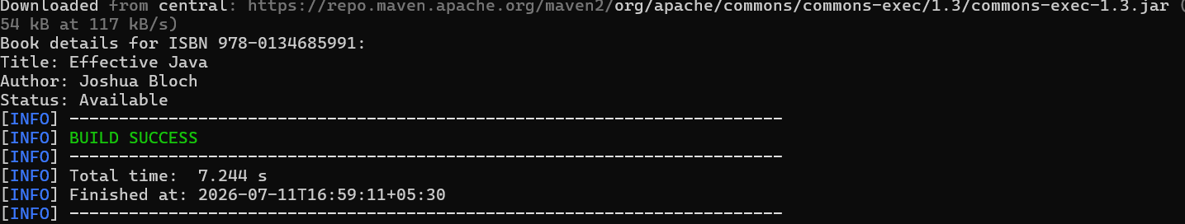

Exercise 2: Implementing Dependency Injection
Scenario:
In the library management application, you need to manage the dependencies between the BookService and BookRepository classes using Spring's IoC and DI.
Steps:
- Modify the XML Configuration:
  - Update applicationContext.xml to wire BookRepository into BookService.
- Update the BookService Class:
  - Ensure that BookService class has a setter method for BookRepository.
- Test the Configuration:
  - Run the LibraryManagementApplication main class to verify the dependency injection.

VS Code project structure
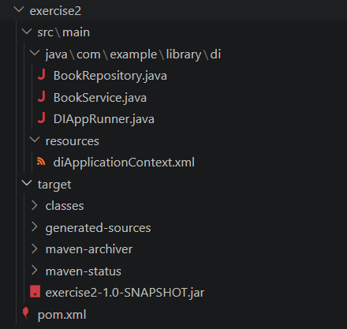
DIAppRunner.java
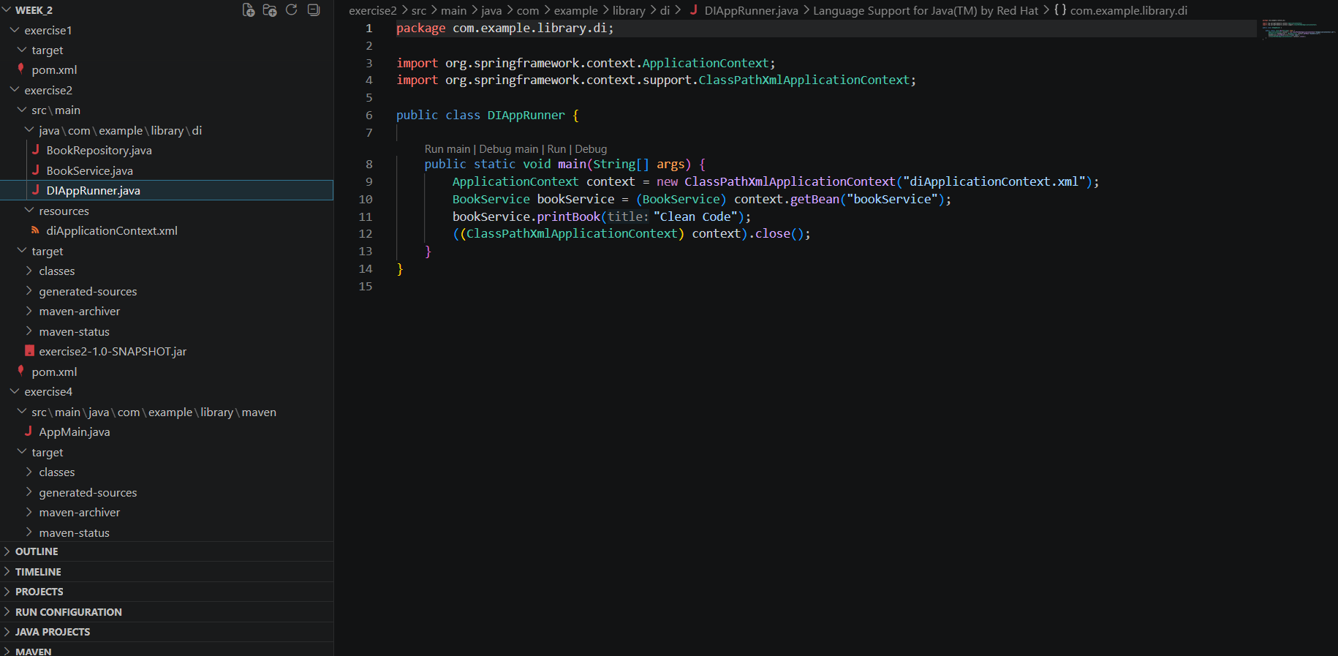
pom.xml
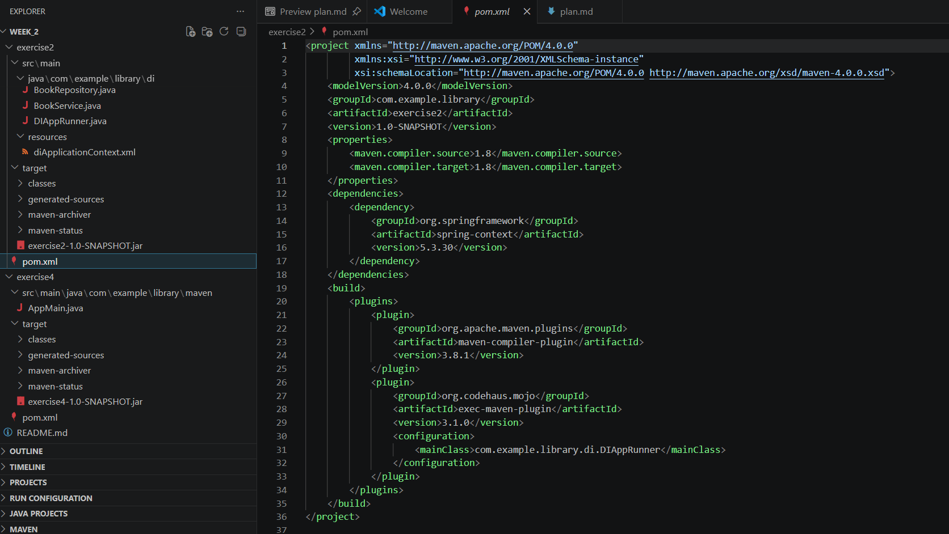
Output
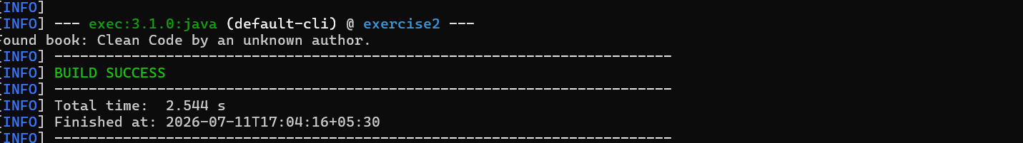
Exercise 4: Creating and Configuring a Maven Project
Scenario:
You need to set up a new Maven project for the library management application and add Spring dependencies.
Steps:
- Create a New Maven Project:
  - Create a new Maven project named LibraryManagement.
- Add Spring Dependencies in pom.xml:
  - Include dependencies for Spring Context, Spring AOP, and Spring WebMVC.
- Configure Maven Plugins:
  - Configure the Maven Compiler Plugin for Java version 1.8 in the pom.xml file.

VS Code project structure
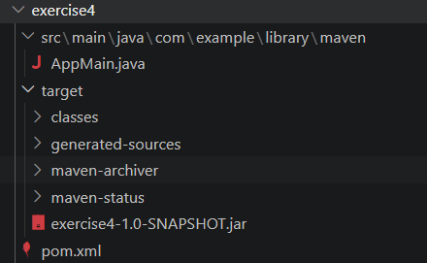
AppMain.class
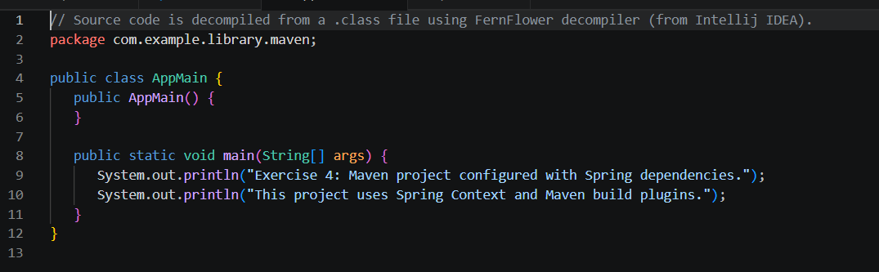
pom.xml
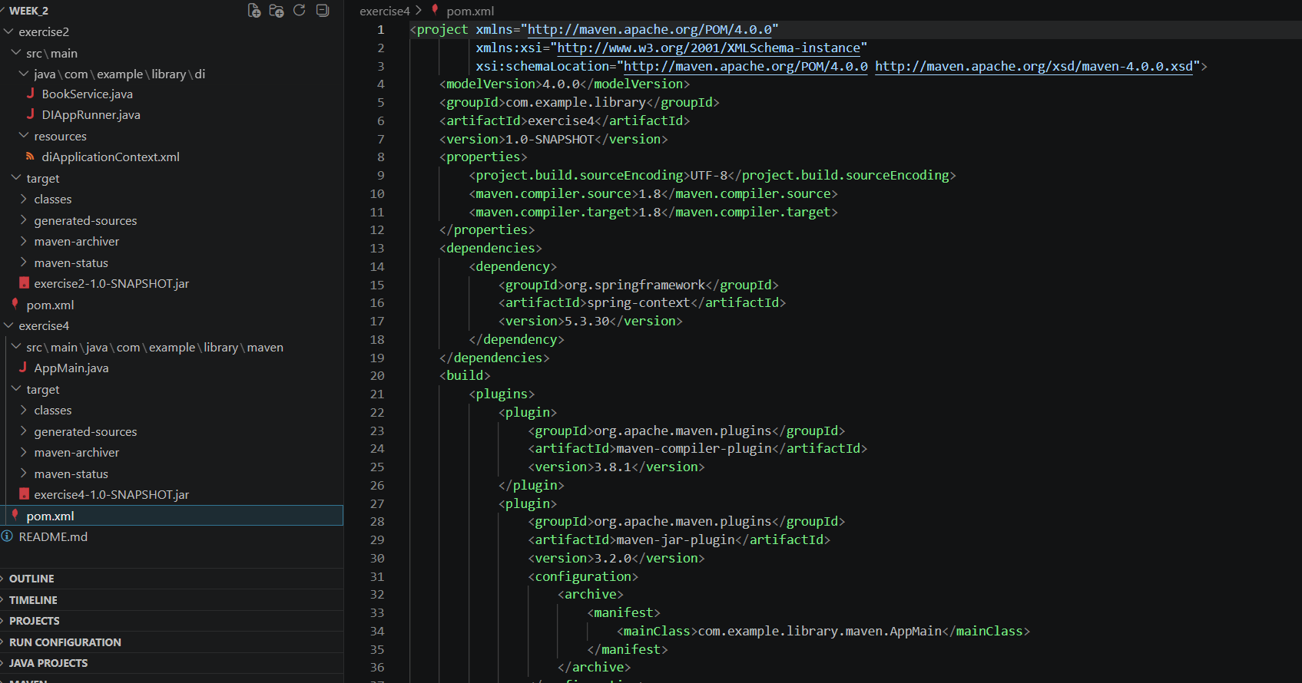
Output
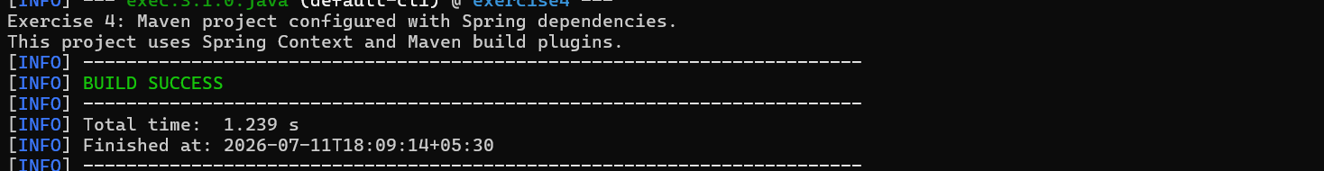

MODULE:Spring Data JPA with Spring Boot, Hibernate
1.Spring Data JPA - Quick Example

Goal: Build a minimal end-to-end Spring Boot application that persists and retrieves data using Spring Data JPA and Hibernate, without writing any SQL or DAO implementation by hand.

  - Project Setup — Dependencies (pom.xml)

A Spring Data JPA project needs three core dependencies: the Spring Data JPA starter, a database driver, and (optionally) Lombok to reduce boilerplate.
<dependencies>
<dependency>
<groupId>org.springframework.boot</groupId>
<artifactId>spring-boot-starter-data-jpa</artifactId>
</dependency>

<dependency>
<groupId>com.h2database</groupId>
<artifactId>h2</artifactId>
<scope>runtime</scope>
</dependency>

<dependency>
<groupId>org.projectlombok</groupId>
<artifactId>lombok</artifactId>
<optional>true</optional>
</dependency>
</dependencies>

1.2 application.properties
spring.datasource.url=jdbc:h2:mem:testdb
spring.datasource.driver-class-name=org.h2.Driver
spring.datasource.username=sa
spring.datasource.password=

spring.jpa.database-platform=org.hibernate.dialect.H2Dialect
spring.jpa.hibernate.ddl-auto=update
spring.jpa.show-sql=true
spring.h2.console.enabled=true
ddl-auto=update tells Hibernate to auto-generate/alter the schema from the entity classes — ideal for hands-on labs, never for production.
1.3 Entity Class
@Entity
@Table(name = "students")
@Data // Lombok: getters, setters, toString
@NoArgsConstructor
@AllArgsConstructor
public class Student {

@Id
@GeneratedValue(strategy = GenerationType.IDENTITY)
private Long id;

@Column(nullable = false)
private String name;

@Column(unique = true)
private String email;

private Integer age;
}

1.4 Repository Interface — The Core of Spring Data JPA

This single interface replaces the entire DAO layer. No implementation class is written by hand — Spring generates a proxy implementation at runtime.
public interface StudentRepository extends JpaRepository<Student, Long> {

// Query derived automatically from the method name
List<Student> findByName(String name);

List<Student> findByAgeGreaterThan(Integer age);

Optional<Student> findByEmail(String email);
}
- JpaRepository<Student, Long> already provides save(), findById(), findAll(), deleteById(), count() — with zero extra code.
- findByName is a derived query — Spring parses the method name and builds the JPQL/SQL automatically.

1.5 Service Layer

@Service
public class StudentService {

private final StudentRepository studentRepository;

public StudentService(StudentRepository studentRepository) {
this.studentRepository = studentRepository;
}

public Student save(Student student) {
return studentRepository.save(student);
}

public List<Student> getAll() {
return studentRepository.findAll();
}

public Student getById(Long id) {
return studentRepository.findById(id)
.orElseThrow(() -> new RuntimeException("Student not found: " + id));
}
}

1.6 REST Controller

@RestController
@RequestMapping("/api/students")
public class StudentController {

private final StudentService studentService;

public StudentController(StudentService studentService) {
this.studentService = studentService;
}

@PostMapping
public Student create(@RequestBody Student student) {
return studentService.save(student);
}

@GetMapping
public List<Student> getAll() {
return studentService.getAll();
}

@GetMapping("/{id}")
public Student getOne(@PathVariable Long id) {
return studentService.getById(id);
}
}

1.7 Application Entry Point

@SpringBootApplication
public class SpringDataJpaHandsonApplication {
public static void main(String[] args) {
SpringApplication.run(SpringDataJpaHandsonApplication.class, args);
}
}

1.8 Test It — Sample Request/Response

POST /api/students
Content-Type: application/json

{ "name": "Bhavya", "email": "bhavya@test.com", "age": 21 }

--- Response ---
{ "id": 1, "name": "Bhavya", "email": "bhavya@test.com", "age": 21 }

1.9 What Happens Under the Hood

- Spring Boot auto-configures a DataSource, an EntityManagerFactory, and a TransactionManager.
- At startup, Spring Data JPA scans interfaces extending JpaRepository and creates dynamic proxy beans implementing them.
- Hibernate (the JPA provider) generates the actual SQL — visible in console via show-sql=true.
- Calling save() triggers Hibernate's persist/merge logic, dirty checking, and flush to the DB inside a transaction.

- Difference between JPA, Hibernate and Spring Data JPA

2.1 The Layered Architecture
Spring Data JPA -> Convenience layer (removes boilerplate)
|
JPA -> Specification (interfaces & rules only)
|
Hibernate -> Implementation (actual ORM engine)
|
JDBC -> Database
2.2 JPA (Java Persistence API)

JPA is a specification defined under Jakarta EE — a formal set of interfaces and annotations that describe how Java objects should be mapped to relational database tables. It does not contain any executable persistence logic of its own.
- Defines standard annotations: @Entity, @Id, @Table, @Column, @OneToMany, @ManyToOne.
- Defines core contracts: EntityManager, EntityManagerFactory, EntityTransaction.
- Defines JPQL (Java Persistence Query Language) — an object-oriented query language independent of SQL dialect.
- Cannot run standalone — a JPA specification needs a provider (Hibernate, EclipseLink, OpenJPA) to actually function.
- Purpose: portability — application code written against JPA interfaces can switch providers without rewriting business logic.

2.3 Hibernate

Hibernate is a concrete ORM framework that implements the JPA specification. It is the engine that actually talks to the database.
- Provides real implementations of EntityManager, converts entity objects into SQL INSERT/UPDATE/DELETE/SELECT statements.
- Handles session management, first-level and second-level caching, lazy loading, dirty checking, and connection pooling integration.
- Predates JPA — JPA's design was heavily influenced by Hibernate's original API.
- Offers extra features beyond the JPA spec: HQL (Hibernate Query Language, superset of JPQL), Criteria API extensions, @NaturalId, custom cache regions.
- Is the default JPA provider auto-configured by Spring Boot when spring-boot-starter-data-jpa is on the classpath.

2.4 Spring Data JPA

Spring Data JPA is a Spring module built on top of JPA (and therefore, transitively, on Hibernate) that removes almost all repository boilerplate.
- Core abstraction: the Repository / JpaRepository interface hierarchy — extend it and get save(), findAll(), findById(), delete() for free.
- Query derivation: method names like findByNameAndAgeGreaterThan(...) are parsed into JPQL automatically — no implementation class needed.
- @Query annotation allows custom JPQL or native SQL when derived queries aren't enough.
- Built-in support for pagination (Pageable), sorting (Sort), and auditing (@CreatedDate, @LastModifiedBy).
- Does not replace Hibernate — it sits above JPA and delegates all real persistence work down to the JPA provider (Hibernate) underneath.

2.5 Side-by-Side Comparison Table

Aspect | JPA | Hibernate | Spring Data JPA
Nature | Specification / API | Implementation of JPA | Abstraction over JPA
Runs standalone? | No — needs a provider | Yes | No — needs a JPA provider
Boilerplate | High (manual EntityManager code) | Medium | Very low (interface only)
Query language | JPQL | HQL (superset of JPQL) | Derived queries + @Query (JPQL/native)
Vendor lock-in | None — portable by design | Tied to Hibernate APIs if used directly | None — works with any JPA provider
Key interface/class | EntityManager | Session / SessionFactory | JpaRepository
Provided by | Jakarta EE spec | Red Hat / Hibernate ORM team | Spring (Broadcom/VMware)
Caching | Not defined by spec | 1st-level & 2nd-level cache built in | Inherits Hibernate's caching
Pagination/Sorting | Not built in | Manual (Criteria/HQL) | Built in (Pageable, Sort)

2.6 Analogy for Quick Recall

- JPA = the interface List — declares add(), remove(), get() without saying how.
- Hibernate = the class ArrayList — the real, working implementation of that interface.
- Spring Data JPA = a smart assistant that writes the ArrayList usage code for you automatically.

2.7 How the Three Connect in This Project

StudentRepository (interface you write)
| Spring Data JPA generates a runtime proxy
v
SimpleJpaRepository (Spring Data JPA's default implementation)
| calls
v
EntityManager (JPA interface)
| implemented by
v
Hibernate Session (actual ORM engine)
| generates SQL, sends via
v
JDBC -> H2 / MySQL / PostgreSQL Database

