**Hands on - Sub Queries**

**Name : Podutur Lahari - DE126**

**Date : 06-11-24**

**Using ROLLUP for Subtotals**

1. **Single Column ROLLUP:**

SELECT

Department,

SUM(Salary) AS TotalSalary

FROM Employees

GROUP BY ROLLUP(Department);

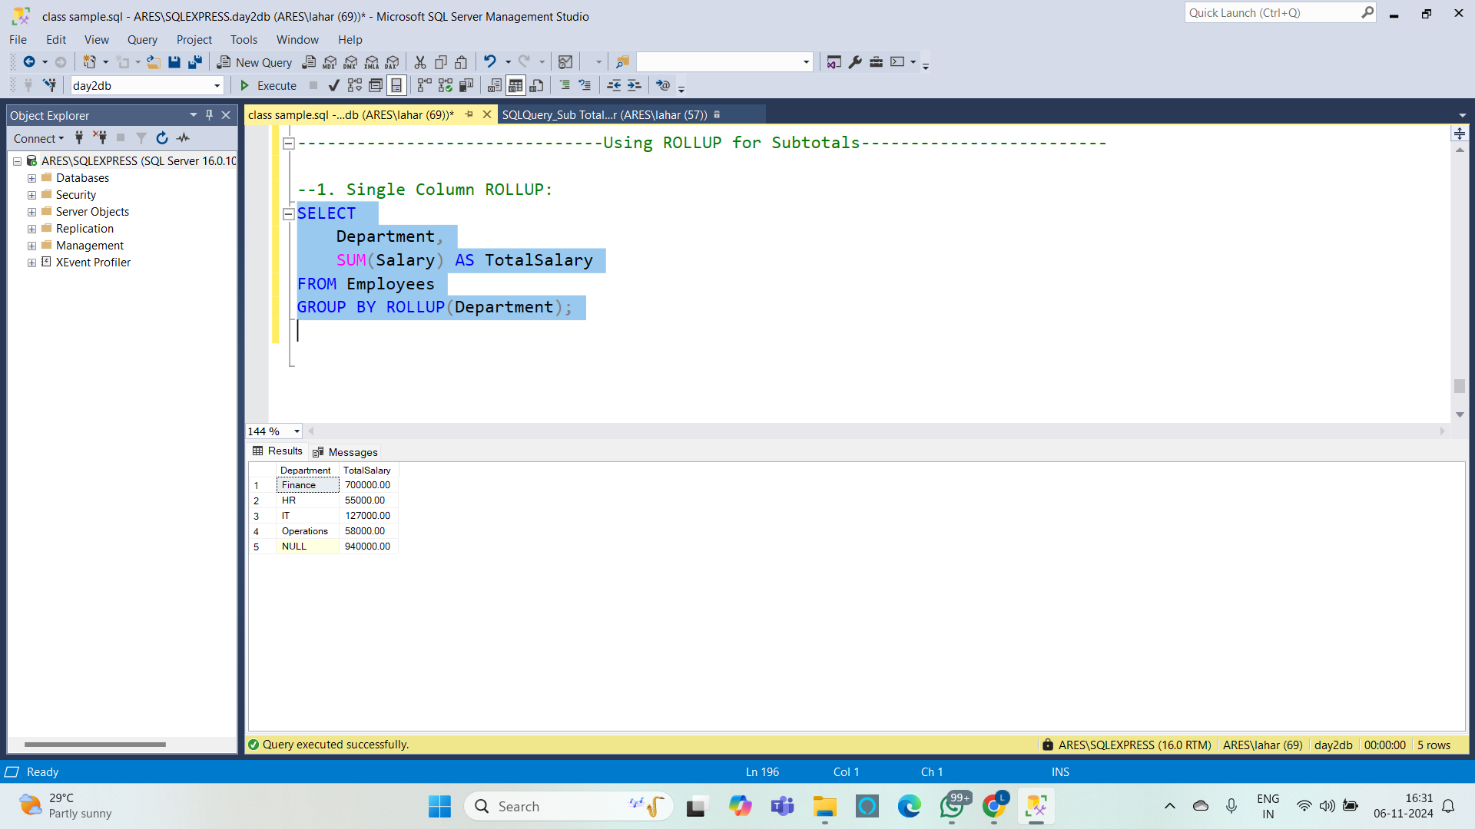

1. **Multiple Columns with ROLLUP:**

SELECT

Department,

Age,

SUM(Salary) AS TotalSalary

FROM Employees

GROUP BY ROLLUP(Department, Age);

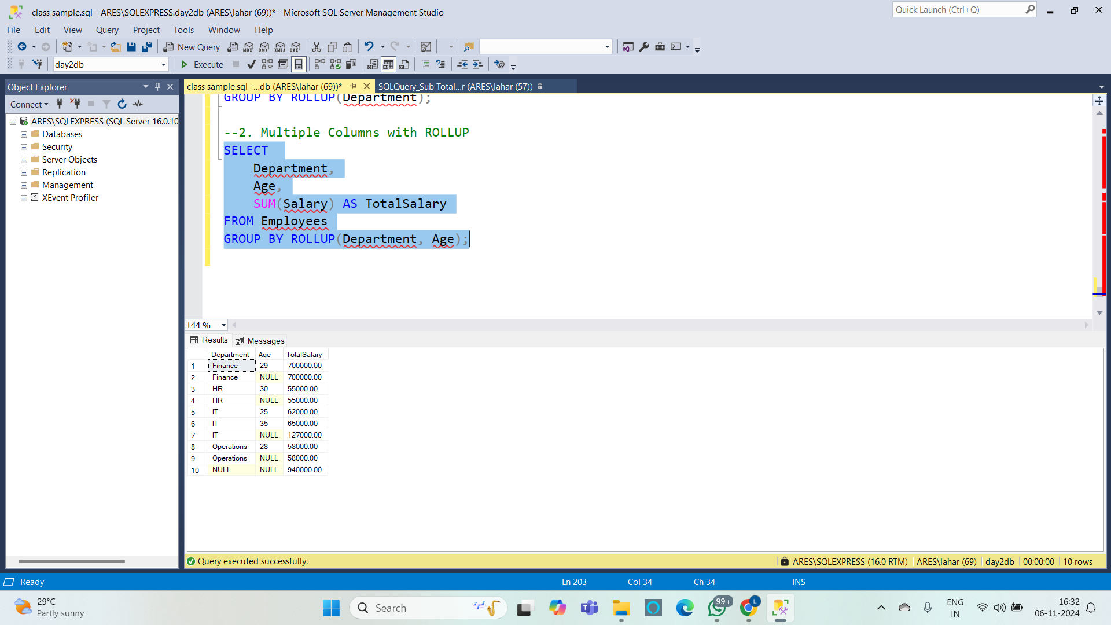

**3. Three-Level ROLLUP:**

SELECT

Department,

Age,

EmployeeID,

SUM(Salary) AS TotalSalary

FROM Employees

GROUP BY ROLLUP(Department, Age, EmployeeID);

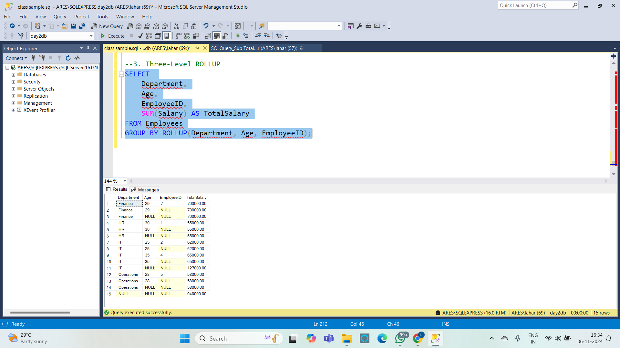

**4. Using the GROUPING Function for NULLs in Subtotals :**

SELECT

Department,

Age,

EmployeeID,

SUM(Salary) AS TotalSalary,

GROUPING(Department) AS IsDepartmentSubtotal,

GROUPING(Age) AS IsAgeSubtotal,

GROUPING(EmployeeID) AS IsEmployeeIDSubtotal

FROM Employees

GROUP BY ROLLUP(Department, Age, EmployeeID);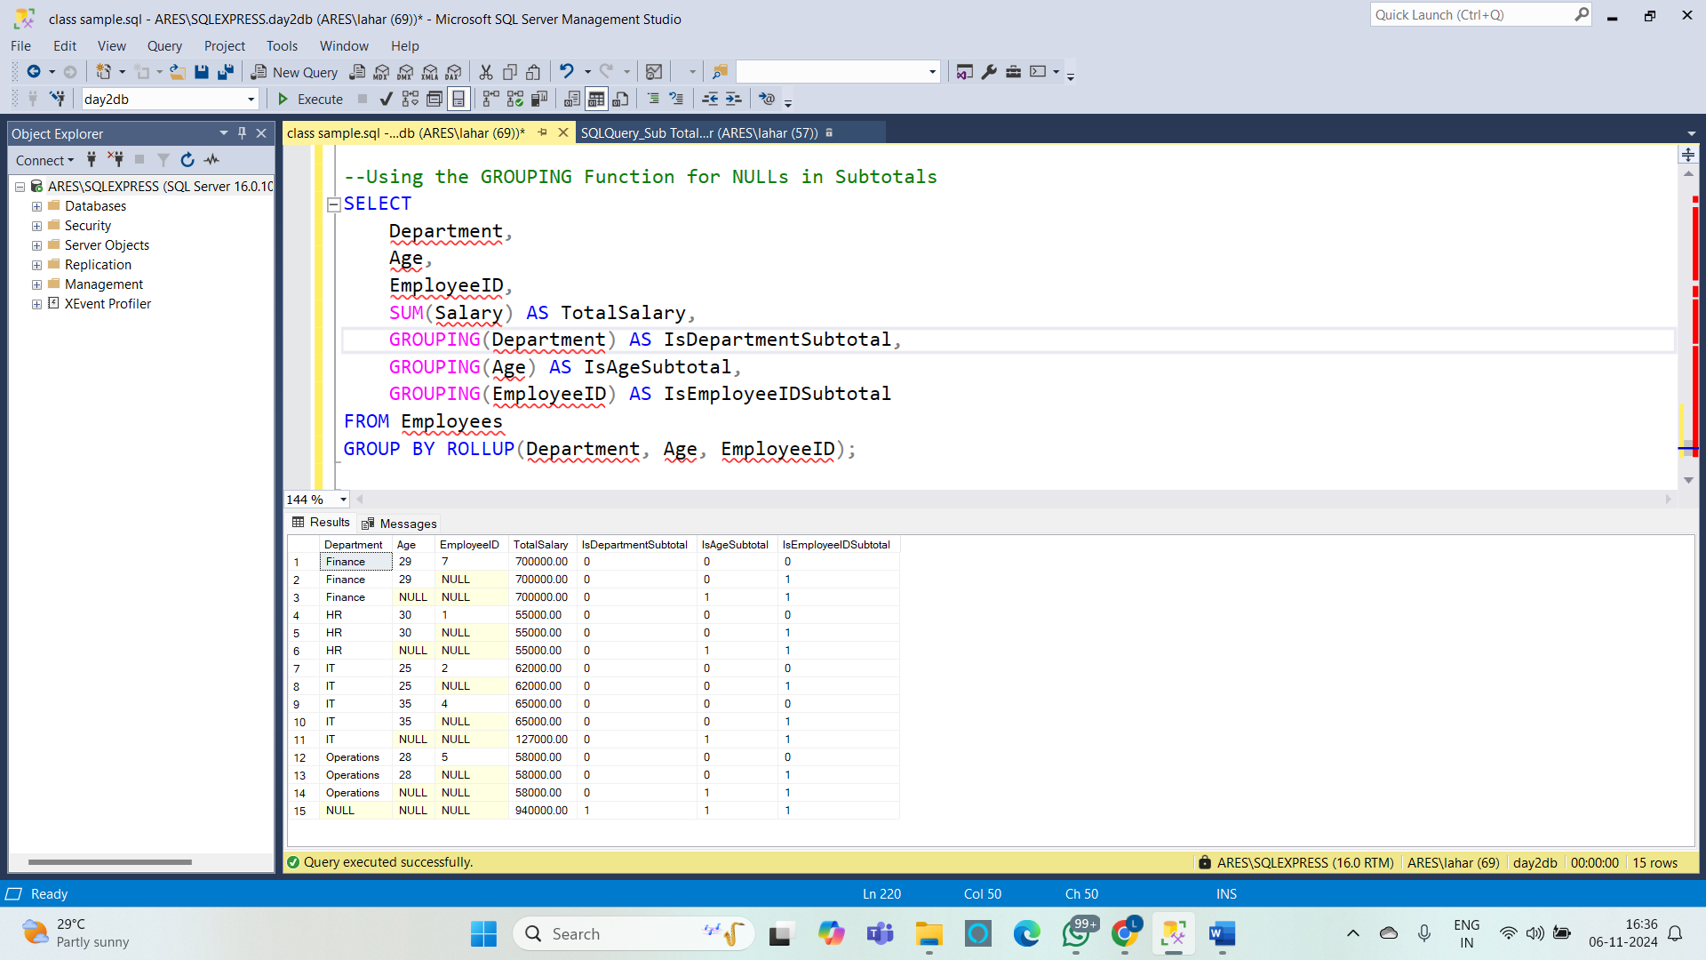

**5. Calculating Subtotals for a Single Column with ROW_NUMBER :**

SELECT

Department,

EmployeeID,

FirstName,

Salary,

ROW_NUMBER() OVER (PARTITION BY Department ORDER BY EmployeeID) AS RowNum

FROM Employees

UNION ALL

SELECT

Department,

NULL AS EmployeeID,

'Subtotal' AS FirstName,

SUM(Salary) AS Salary,

NULL AS RowNum

FROM Employees

GROUP BY Department

ORDER BY Department, RowNum;

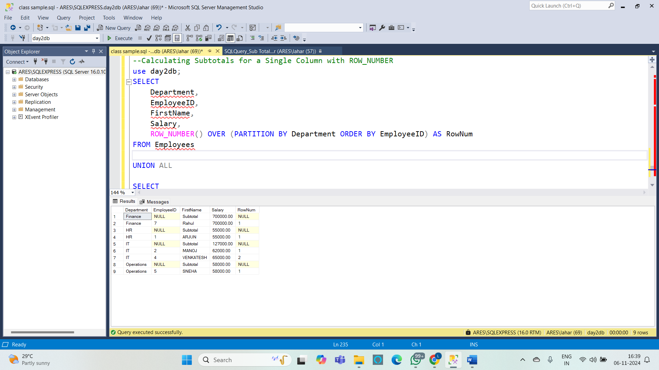

**6. Using GROUPING SETS as an Alternative Method :**

SELECT

Department,

Age,

SUM(Salary) AS TotalSalary

FROM Employees

GROUP BY GROUPING SETS (

(Department, Age), -- Group by Department and Age

(Department), -- Group by Department only

(Age), -- Group by Age only

() -- Grand total

)

ORDER BY Department, Age;

