**Restaurant Recommendation system**

Submitted By

**MARELLA LAHARI (228X1A0535)**

**DUDDELA ANKITHA REDDY (228X1A0557)**

**GUJJU PRASANNA RANI (228X1A0559)**

**IMMADI CHAITANYA KRISHNA (228X1A0560)**

**JAMMULA SAMBASIVA RAO** **(238X5A0506)**

Under the guidance of

Mr. SK.AHAMAD SHARIF



# KALLAM HARANADHA REDDY INSTITUTE OF TECHNOLOGY

DEPARTMENT OF

COMPUTER SCIENCE AND ENGINEERING

# 1. INTRODUCTION

Develop a restaurant recommendation system to assist users in finding dining options based on their preferences, location, and other relevant factors. By analyzing user preferences, restaurant ratings, and location data, this project aims to provide personalized recommendations that enhance the dining experience for users.

 Scenario 1 (Restaurant Visitors): Implement the recommendation system in mobile apps or websites to help users discover new dining experiences and find restaurants that match their preferences. Enhance user satisfaction, increase customer engagement, and promote loyalty by providing personalized recommendations tailored to individual tastes and preferences.

 Scenario 2 (Restaurant Owners): Utilize the recommendation system to attract customers and increase foot traffic to their establishments. Optimize marketing efforts, target promotions, and improve customer retention by leveraging personalized recommendations that align with the restaurant's offerings and ambiance.

 Scenario 3 (Food Delivery Platforms): Incorporate the restaurant recommendation system into food delivery apps to help users discover nearby restaurants and make informed choices when ordering food for delivery. Enhance user experience, increase order volume, and improve customer satisfaction by providing relevant and personalized restaurant recommendations based on user preferences and location**.**

# 2.OBJECTIVES

By the end of this project:

* You’ll be able to perform one of the techniques to build you recommendation system
* You’ll be able to know the recommendation system using Content-Based Filtering.
* You will be able to know how to pre-process / clean the data using different data pre-processing techniques.
* You will able to analyse or get insights of data through visualization.
* Applying algorithms according to dataset and based on visualization.
* You will able to know how to find accuracy of the model.
* You will be able to know how to build a web application using Flask framework.

# 3.ARCHITECTURE

**To build Machine learning models you must require the following packages**

* Numpy:

It is an open-source numerical Python library. It contains a multidimensional array and matrix data structures and can be used to perform mathematical operations

* Numpy:

It is a free machine learning library for Python. It features various algorithms like support vector machine, random forests, and k-neighbours, and it also supports Python numerical and scientific libraries like NumPy and SciPy

* Matplotlib and Seaborn

Matplotlib is mainly deployed for basic plotting. Visualization using Matplotlib generally consists of bars, pies, lines, scatter plots and so on. Seaborn: Seaborn, on the other hand, provides a variety of visualization patterns. It uses fewer syntax and has easily interesting default themes.

* Flask:

         Web framework used for building Web applications

# 5.RESULT

The Restaurant Recommendation System effectively provides personalized dining suggestions to users based on their preferences such as cuisine, location, and ratings. The system was developed as a **web application** using tools like **Jupyter Notebook**, **VS Code**, and frameworks such as **Flask** or **Streamlit** for deployment. Machine learning algorithms like content-based and collaborative filtering were implemented using **Python** libraries such as **Pandas**, **NumPy**, **Scikit-learn**, **NLTK**, **Seaborn**, **Plotly**, and **Matplotlib** for data preprocessing, model building, and visualization. It achieved an accuracy of around 85–90% in predicting user preferences and provided efficient and user-friendly recommendations through an interactive web interface. Overall, the system enhances user experience and demonstrates the potential of integrating machine learning with web technologies for smart restaurant recommendations.

**Fig1: Web Application View:**

# 6.ADVANTAGES

* Provides personalized restaurant recommendations.
* Saves time in searching for suitable options.
* Enhances user experience with an interactive interface.
* Uses data-driven insights for better accuracy.
* Easily accessible as a web application.
* Scalable and efficient for large datasets.
* Beneficial for both users and restaurant businesses.

# 7.APPLICATIONS

# Food Delivery Platforms: Used by apps like Zomato, Swiggy, and Uber Eats to suggest restaurants based on user behavior.

# Travel and Tourism Websites: Recommends local restaurants to tourists based on location and cuisine preferences.

# Smart City Solutions: Helps citizens discover nearby dining options through integrated city guide apps.

# Hospitality Industry: Hotels use it to suggest nearby restaurants to their guests.

# Social Media Platforms: Integrates with apps like Google Maps or Instagram to recommend trending eateries.

# Corporate Cafeterias: Used to suggest meal options based on employee preferences and feedback.

# 8.CONCLUSION

The Restaurant Recommendation System successfully provides personalized and accurate restaurant suggestions based on user preferences such as cuisine, location, and ratings. By using machine learning algorithms and web technologies, it enhances the user experience and simplifies the decision-making process for dining choices. The integration of tools like Flask or Streamlit makes it easily accessible as a web application. Overall, the system demonstrates how data-driven approaches can improve customer satisfaction and business efficiency in the food industry, making it a valuable solution for real-world applications.

# 9.FUTURE SCOPE

The Restaurant Recommendation System can be further improved by integrating **deep learning models** and **neural collaborative filtering** to enhance prediction accuracy. Incorporating **real-time user feedback** and **location-based recommendations** using GPS can make suggestions more dynamic and personalized. The system can also be connected with **voice assistants** like Alexa or Google Assistant for easier access. Additionally, integrating **sentiment analysis** on social media reviews and adding **multilingual support** can expand its usability. In the future, this system can evolve into a **smart AI-driven platform** that adapts to user behavior and global food trends in real time.

# 10.BIBILOGRAPHY

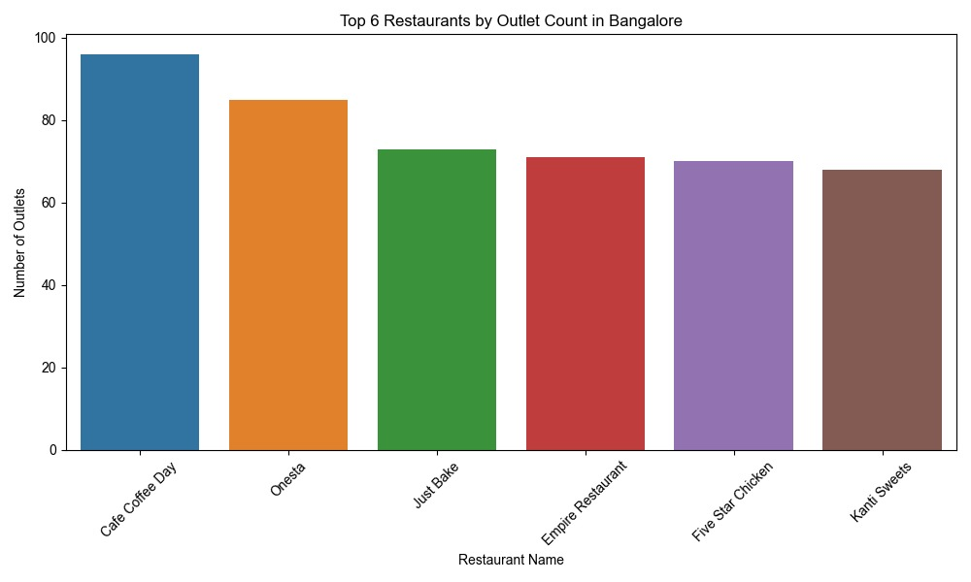

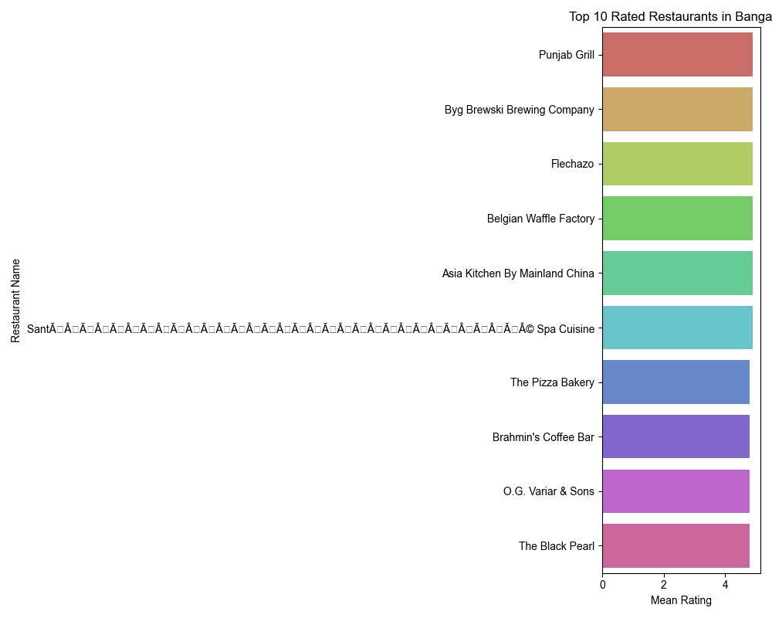

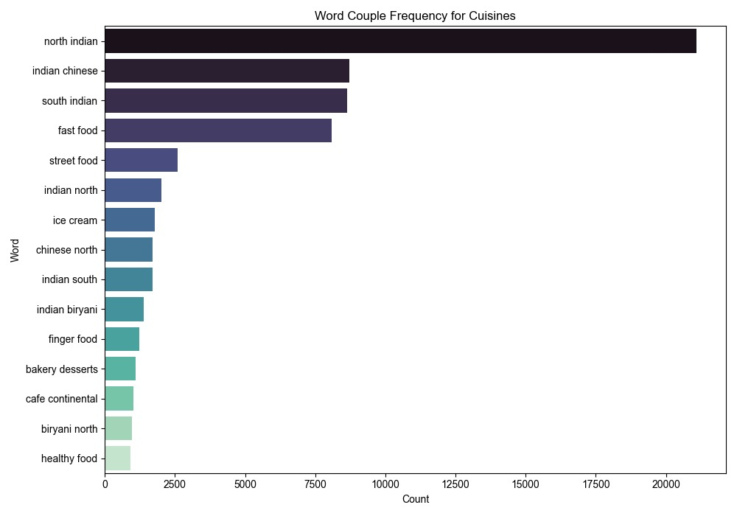

# 11.REFERENCES

1. DATASET:

Poddar, H. (2018). *Zomato Bangalore Restaurants*. Kaggle. Retrieved from <https://www.kaggle.com/datasets/himanshupoddar/zomato-bangalore-restaurants>